### https://mva.microsoft.com/en-us/training-courses/managing-and-troubleshooting-exchange-server-2013-email-delivery-11525?l=r1UYaDsDB_9801937548

### Monitoring and troubleshooting Exchange using powershell

One of the Method of troubleshooting Exchange 2013 is using the various inbuilt cmdlets available.

Through this article, we shall look in detail some of these cmdlets and how they help in troubleshooting.

All the cmdlets in exchange 2013 is execute using the exchange management shell.

**Get-Command Test\*** can be used to list out all the Test commands in the powershell.

**Test-ServiceHealth**

This is the first command you want to run before you start troubleshooting any issues with Exchange. ServicesNotRunning parameter should be blank at any given point.

**Test-ReplicationHealth**

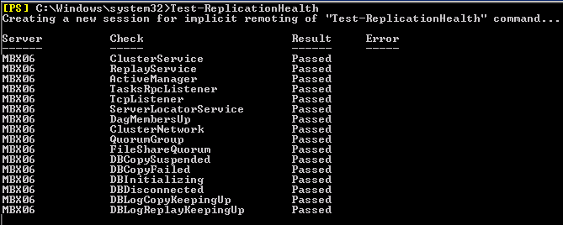

The Test-ReplicationHealth cmdlet will help in identifying the status of mailbox database replication process. All the details of replication can be reviewed using this cmdlet for a particular mailbox server of a Database Avaialability Group.

The main intention behind this cmdlet is to continuously monitor the status of replication process and different parameters linked with the process like ClusterService, ReplayService, ActiveManager availability, etc.

**Parameters Tested Using Test-ReplicationHealth cmdlet**

* ClusterService

The clusterService parameter indicates if the Cluster service is active and available on the specific DAG member (or local server)

* ReplayService

This parameter indicates that exchange replication sercice is active and available on the DAG member.

* ActiveManager

It indicates the status of the role active manager on the DAG is either of the three- Stand Alone, Primary or Secondary.

* TasksRpcListener

This parameter is tested to check if the RPC server is active and available in the DAG or local server.

* TcpListener

A successful test of the TCPListener will indicate that the TCP log copy listener is working on the DAG member or local server

* DagMembersUp

As the name suggests, this parameter will check for the status of DAG members- whether they are up, running and responding.

* ClusterNetwork

This parameter indicates whether the networks managed by clusters on the DAG are reachable.

* QuorumGroup

This parameter indicates the health and online status of the quorum group(which is the default cluster group)

* FileShareQuorum

The FileShareQuorum will check the configurations of witness server, witness directory and share for the DAG.

* DBCopySuspended

A failure of this test will indicate that a particular mailbox copy is currently suspended in the DAG

* DBCopyFailed

This checks if there are failures in database copies in the DAG.

* DBInitializing

DBInitializing parameter indicates the initialization status of database copies in the DAG or local Server. A passed means all copies have finished initializing.

* DBDisconnected

This checks if any of the database copy in the mailbox is disconnected from the DAG.

* DBLogCopyKeepingUp

This parameter indicates if the log generation on the active copy and log copying and inspection in the passive database copies are in sync.

* DBLogReplayKeepingUp

This parameter indicates if the log generation on the active copy and log replaying in the passive database copies are in sync.

**Get-MailboxDatabaseCopyStatus**

Get-MailboxDatabaseCopyStatus cmdlet lets you see the mailbox database copy status. With this cmdlet, you can monitor copy of a database, copy of a database on a particular server or the entire database copies in a server.

**Parameters**

* Failed

If the test returns failed then it means that the copy of the mailbox database is currently not suspended and unable to copy the log files.Under this state, the system monitors the status of the reason behind the copy failure for changes. Once there is a change in the status, the copy status will be reverted to healthy.

* Suspended

The status message- suspended, indicates that the state of the database copy of the mailbox is currently suspended. It might be because of the intervention of an admin or because of execution of the cmdlet Suspend-MailboxDatabaseCopy.

* Healthy

A Healthy status message indicates that the copying and replaying function of mailbox database copy is either completed or running.

* Initializing

The initializing state is returned if the mailbox copy is being created, or if the duplication of the mailbox is just initialized or being initialized. It is also returned if the state is in transit from one to another. During this state, system monitors the consistency in states of the database and log stream. The duration for which a system remains in the initializing state is 15 to 30 seconds.

* Seeding

When the test returns seeding, it means that either the database copy of the mailbox, the content index of the copy or both of them are presently being seeded by exchange.If the seeding is complete, the status will be Initializing instead of seeding.

* SeedingSource

This indicates that the mailbox database copy is presently a source of seeding for another seeding instance.

* ServiceDown

As the name suggests, this means that the replication process is unavailble or inactive presently or is active on server housing mailbox database copy.

* Resynchronizing

This is returned when the mailbox database copy and the log files are being synchronised for changes. Once all the changes are resolved the status changes.

* Mounted

This state is returned if the active mailbox database copy is up and available for clients to connect to.

* Dismounted

This state is returned if the active mailbox database copy is not online and unavailable for clients to connect to.

* Mounting

This state is returned if the active mailbox database copy is about to be online and available for clients so that they can connect to it.

* Dismounting

This state is returned if the active mailbox database copy is about to be offline and unavailable for clients to connect to it.

* DisconnectedAndHealthy

This means that the connection between the active database copy and mailbox database copy has been interrupted and done so when the connection was in a healthy state.They are usually reported when there are network failures in the DAG source and target.

* DisconnectedAndResynchronizing

This means that the connection between the active database copy and mailbox database copy has been interrupted and done so when the connection was in a resynchronization state.They are usually reported when there are network failures in the DAG source and target.

* FailedAndSuspended

This state indicates that there is a failure which requires the intervention of the administrator to be repaired.Here the system do not autmatically monitor the issue and recover but requires intervention from the admin.

* SinglePageRestore

As the name suggests, this means that there is an ongoing restoration operation in the database.

**New-MailboxRepairRequest**

The New-MailboxRepairRequest cmdlet is used to troubleshoot and resolve mailbox corruption issues.This command can be executed for a database or a single mailbox. During the execution of the cmdlet, that particular mailbox access is suspended which is being repaired.

**Parameters**

* CorruptionType

The type of the corruption which is to be repaired is specified using this parameter. It can take the following values:

* + SearchFolder
  + AggregateCounts
  + ProvisionedFolder
  + FolderView

If there is more than one type of corruptions to be detected, each can be entered simultaneously by separating with a comma.

* Database

Database name As obvious, this parameter decides which database is to be checked and repaired. Please note that all mailboxes within the database will be checked while exercising this option. The number of simultaneous repair requests for active databases are limited to one. It can take the values:

* + GUID of the database
  + Database Name

The mailbox parameter and databse parameter cannot be used together.

* Mailbox

As obvious, this parameter decides which mailbox is to be checked and repaired. It can take the values:

* + GUID
  + Distinguished name (DN)
  + Domain\Account
  + User principal name (UPN)
  + LegacyExchangeDN
  + SMTP address
  + Alias
* Archive

This parameter is specified if you are using mailbox checking and need to detect and repair both the original mailbox and the archive mailbox associated with it.

* Confirm

If this parameter is specified, a pop up asking you to confirm the cmdlet execution will not come up.

* DetectOnly

With this parameter, the cmdlet only detects the corruptions and do not repair it.

* Force

This means that the repairing process needs to be run with immediate effect.

* StoreMailbox

This specified the GUID of the mailbox which is to be repaired. This parameter is used in conjunction with the Database parameter. GUID can be retrieved using the Get-MailboxStatistics cmdlet.

**CollectOverMetrics.ps1**

CollectOverMetrics.Ps1 is a script used by exchange during troubleshooting. This script examines the DAG event logs to obtain database operation information like mount, failover etc for a particular duration.

The script then stores certain information from each event in a csv file. The information recorded are:

* Database Identity
* Operation Starting and Ending time
* Database mount server
* Reason for Operation
* Status of completion of Operation-Success/Fail etc.

**Parameters**

* DatabaseAvailabilityGroup

It decides on which DAG the collectovermetrics script be executed. In the absence of this parameter the script will be executed in the DAG for the local server.

* Database

This chooses the databases on which the script is executed.

* StartTime

If this parameter is specified, the script will log the information which began during the specified time. However this may result in partial capturing of information. If end time is not specified the operations are logged for the next 24 hours from specified start time. If neither is specified, the last day’s information is collected.

* EndTime

If this parameter is specified, the script will log the information which ended during the specified time. However this may result in partial capturing of information. If start time is not specified the operations are logged for the previous 24 hours from specified start time. If neither is specified, the last day’s information is collected.

* ReportPath

This indicates the path where the collected information will be stored. In the absence of this parameter, information will be stored in the same directory as that of the script.

* GenerateHtmlReport

This parameter will generate a report based on the collected information. The report will be sorted based on the operation type and will be in HTML format with statistics for every group.

* ShowHtmlReport

This parameter will auto open the generated html report upon completion of operation.

* SummariseCsvFiles

This parameter will ask the script to check for existing csv files to create a report based on them and the newly generated csv files.

* ActionType

This parameter will filter the type of operations whose information will be collected by the script.It can take the following values:

* + Move
  + Mount
  + Dismount
  + Remount.
* ActionTrigger

This parameter will filter the type of administrative operations whose information will be collected by the script.It can take the following values:

* + Admin
  + Automatic
* RawOutput

This will ask the script to output the results on to the output device upon completion.

<http://blog.techtalklive.org/ttlblog/Pages/Exchange-2010-2013-Coexistence.aspx>

<http://www.itninja.com/blog/view/resolution-of-top-10-issues-related-to-exchange-server>

**Errors that I am explaining in the Post**

* Mail flow related issues in Exchange Server
* Connectivity Related issues in Exchange Server
* Exchange Error Code 450 4.7.1
* 550 5.7.1 Unable to relay
* Exchange Server is Unavailable
* Exchange Database (EDB) Corruption Issue
* Troubleshooting DNS Related Problems in Exchange Server
* Jet Engine Error 1018 in Exchange Server
* Exchange Server is in Inconsistent State
* The connection was dropped during the transmission

**1). Mail Flow Related Issues in Exchange Server**

Mail flow issues normally occurs due to the corruption in Metbase or bad configuration of DNS. In such cases users will face problems in sending and receiving emails. Microsoft has developed a Mail Flow Troubleshooter tool with which users can find out the root cause of the problem. Know more about this tool:<http://blogs.technet.com/b/exchange/archive/2006/08/07/3394688.aspx>

**2). Connectivity Related issues in Exchange Server**

Sometime users face problems while connecting Outlook with the Exchange Server. For troubleshooting these kind of issues Microsoft has developed Remote Connectivity Analyzer which performs a set of test series to find out the root cause of the problem. This is a web based solution which can be accessed through web browser by following the link <https://testconnectivity.microsoft.com/>

**3). Exchange Error Code 450 4.7.1**

Exchange users face this error when the message sent by them is discarded by the Exchange Server. Here the error code 450 means that Exchange Server is trying to identify the address from where you are sending email by performing the reverse look up operation and if the server fails in finding the reverse hostname it returns 450 error code.

Check out different scenarios when this error is encountered along with resolution:<http://www.blog.edbtopst.org/resolve-exchange-server-error-code-450-4-7-1.html>

## Possible Situation in Which the Error Code 450 is encountered

1). Sometime users face such kind of error while sending mails because there is a limitation of sending total number of emails that a user can send and is fixed by the administrator of Exchange server

[](http://www.blog.edbtopst.org/wp-content/uploads/2015/06/error-450-quota-exceeded.gif)

2). Exchange users face this error when mail server rejects the mails sent by the user. Only some of the domains face such kind of issue while others are working fine.

[](http://www.blog.edbtopst.org/wp-content/uploads/2015/06/cannot-find-reverse-hostname.gif)

Here the error code 450 indicates that the Exchange server is performing the reverse look ups to identity the address from where you are sending the mail. For better understanding let us consider an Example: Suppose you want to send a mail from abc@domain.com, as you send the mail, your system is stamped with the IP address of your system. Now, when server receives the mail, it first verifies that whether the mail is send through the same domain by verifying its IP address. It checks whether the IP address is pointing to the same domain i.e. abc@domain.com. If server was not able to detect the sender of mail or is not able to identify the hostname, then **Error code 450 4.7.1 Client host rejected: cannot find your reverse hostname**is encountered.

3).This error is also encountered when the address from where you are sending the email is not valid. This may also happens when you are trying to send email to the user which has been blocked by the Exchange server. In such cases, **Error code 450 4.7.1 Recipient address rejected: Access denied error is encountered.**

[](http://www.blog.edbtopst.org/wp-content/uploads/2015/06/access-denied.gif)

## How to resolve Exchange Server Error Code 450

Check the Configuration of Mail server and verify whether domain records of DNS has been setup properly or not.

Verify that you have setup Reverse DNS with a FQDN (not with an ISP). If you don’t have one setup then make contact with ISP and say them to create one connection to the Fully Qualified Domain Name (FQDN). FQDN should always end up with the valid domain name.

If your IP address is blacklisted by the server, then do research and find out the main cause of blocking. IP address are generally marked as blacklisted when they are sending spam link or content. Resolve these issues and request server to remove your IP address from the blacklist.

**4). 550 5.7.1 Unable to relay**

Many a time users encounter an error message ‘550 5.7.1 – Unable to relay’ while sending an email to somebody in another domain. In exchange server this error indicates configured SMTP authentication details that deny to authenticate you as a reliable user, thus prevent you from sending emails outside the domain.

**5). Exchange Server is Unavailable**

Errors like exchange server unavailable are the outcomes generated when an outlook operation fails. There are several reasons behind this issue. Generally such issues are generated due to partial setup of Outlook or corrupted PST file. So you can use ScanPST.exe if you are facing issue due to corrupted PST or reinstall the Outlook if it was not installed correctly in previous attempt.

**6). Exchange Database (EDB) Corruption Issue**

EDB file is the heart of Exchange Server. Whole communication of Exchange Server relays on EDB file. Whole Communication goes down if something wrong happens with this Database file. In case of corruption I would recommend you to resolve the corruption issue as soon as possible. You can use Eseutil and Istinteg command of PowerShell to repair the EDB file. Know More about these commands:<http://www.blog.edbtopst.org/how-to-repair-exchange-database-with-eseutil-and-isinteg-command-lines.html>

Throughout Corruption problem, Exchange Administrators can exploit Eseutil/Isinteg command lines to repair inaccessible or corrupted Exchange database files. Both the utilities inbuilt attribute of MS Exchange Server & can execute both soft and hard recovery from offline Exchange Server. Default drive position of these utilities is shown below:

***C:\Program Files\Exchsrvr\bin***

[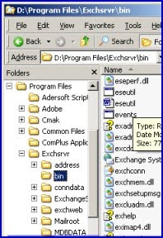](http://www.blog.edbtopst.org/wp-content/uploads/2014/07/eseutil-isinteg-stpe1.jpg)

**Carry out the following directions before using Eseutil/Isinteg Utilities**

* Log in as Exchange Administrator
* Generate copy of healthy or corrupted EDB database files in Backup folder
* From MS Exchange Server, Dismount the complete EDB data
* Shift needless files & folders and free the floppy disk space
* Utilize CHKDSK tool to verify hard disk for awful sectors

Both the commands (Eseutil and Isinteg) only useful on offline Exchange database, so database should be dismounted from the MS Exchange Server before you execute these tools. You can also run the Exeutil.exe command from the DOC command prompt.

**Follow the below steps to run Eseutil command line**

* Hit on Start>>Run
* In the run box, write **“cmd”** & press **“ok”**
* Then go to **C:\Program Files\Exchsrvr\bin**
* Write Eseutil.exe in command line

Eseutil.exe tool has 2 repair modes **“/r”** and **“p”**.

Eseutil/r command is for soft recovery of Exchange Server database.

[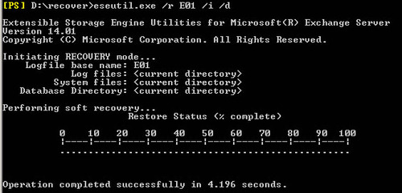](http://www.blog.edbtopst.org/wp-content/uploads/2014/07/eseutil-isinteg-stpe2.jpg)

Apart from this if Exchange database are highly corrupted then you must be use Eseutil/p command line to repair inaccessible priv1.edb and pub1.edb files

***Eseutil /p C:\Program files\Exchsvr\mdbdata\ primary name.EDB***

[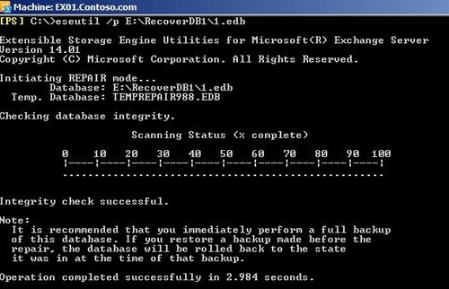](http://www.blog.edbtopst.org/wp-content/uploads/2014/07/eseutil-isinteg-stpe3.jpg)

When you effectively repaired the damaged Exchange database files by Eseutil/p command line then also run Eseutil/d command to defragment the repaired database

[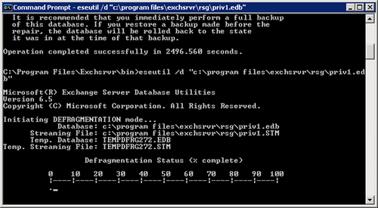](http://www.blog.edbtopst.org/wp-content/uploads/2014/07/eseutil-isinteg-step4.png)

Now run the Eseutil.exe command for check reliability of repaired Exchange database, it will appear like below

**Isinteg –s {Exchange Server name}-fix-test all tests**

[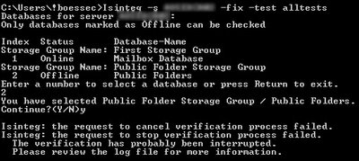](http://www.blog.edbtopst.org/wp-content/uploads/2014/07/eseutil-isinteg-stpe5.jpg)

* Choose the repaired EDB database from the MS Exchange Server directory
* Run the Exeutil.exe command till no threats are shown on the Exchange Server
* Then run Eseutil/G command to verify the reliability of the repaired Exchange database files

[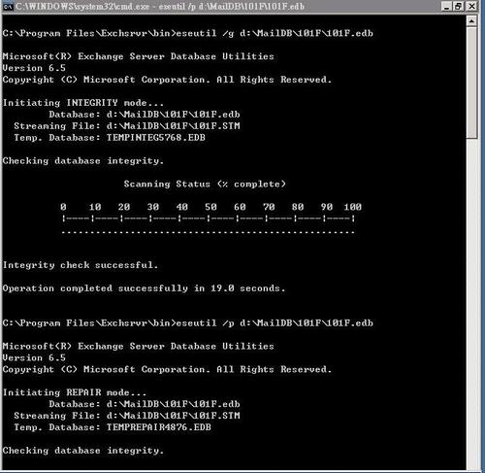](http://www.blog.edbtopst.org/wp-content/uploads/2014/07/eseutil-isinteg-stpe6.jpg)

* Remount the retrieve Exchange database files yet again by using administrator utilities of MS Exchange Server.

**Conclusion:** Facing corruption in Exchange EDB files at high level by jet engine failure or software out of order cannot be repair by Eseutil & Isinteg tools. So, you should be choosing a third party solution as[Exchange EDB to PST Converter](http://www.edbtopst.org/exchange-recovery-software.html). Software has capable to repair, restore & convert healthy or offline database into Outlook PST/Live Exchange Server.

**7). Troubleshooting DNS Related Problems in Exchange Server**

DNS plays an important role in Exchange Server environment. Active directory and Exchange server both depends upon DNS and if DNS is not functioning in a proper manner then both Active Directory and Exchange will not work at all. To resolve the DNS related issues in Exchange server I would like to suggest to Nslookup. Just run the command **nslookup**in the command prompt to use this tool

**8). Jet Engine Error 1018 in Exchange Server**

Normally this error is encountered when Exchange Database has got corrupted. Sometime main components like header part, catalogs, leaf pages etc. of the EDB file is got corrupted. You have to repair the EDB database to resolve these kind of issues. I have already explained solution in the 6th issues to resolve EDB corruptions.

**9). Exchange Server is in Inconsistent State**

This Error is normally encountered when you try to install latest version of Exchange Server and the files of previous version has not been removed successfully.

To resolve this issue Open ADSIEdit.msc and then navigate to

*CN=Configuration, CN=Services, CN=Microsoft Exchange, CN=<Your Organization Name>, CN=Administrative Groups, CN= <Exchange 2010 Administrative Group>, CN=Servers, CN=<Server Name>*

Now just delete the object of server from here and try the installation process again.

**10). The connection was dropped during the transmission**

In Exchange server when people send an email, in many instances they are halted by an error message ‘the connection was dropped during the transmission’. This error indicates a network connection problem that is caused by a router. In order to get rid of the error, you need to check the router device.

<http://msexchangeguru.com/2015/04/15/issues-and-solutions/>

### Exchange 2010/2013 – Issues and solutions

Sharing my troubleshooting notes

**Single User Outlook 2013 new setup fails on “Logging on to the mail server”**

**Issue:**

Issue with one user not able to login to outlook 2013. User attempts to connect & it fails with the following error:

“The Connection to Microsoft Exchange is unavailable.  Outlook must be online or connected to complete this action”. The user is unable to access outlook but can access OWA to check mails.

**Resolution:**

=> Recycle AppPools for both Autodiscover and RPCProxy.

=> Run Get-CasMailbox <user> | fl . Check if MAPIBlockOutlookRpcHttp is set to true.

=> If it is set to true , run Set-CASMailbox <user> -MAPIBlockOutlookRPCHttp $false.

========================================================

**Event ID 4027 MSExchange ADAccess Exchange 2013**

**Issue:** Getting event ID 4027 on Exchange 2013 server.

 Log Name:      Application

 Source:        MSExchange ADAccess

 Event ID:      4027

 Task Category: General

 Level:         Error

 Keywords:      Classic

 User:          N/A

 Description:

  Error Details

  System.ServiceModel.EndpointNotFoundException: Could not connect to

net.tcp://localhost:890/Microsoft.Exchange.Directory.TopologyService. The connection attempt lasted for a time span of

00:00:02.0280035. TCP error code 10061: No connection could be made because the target machine actively refused it

[127.0.0.1:890](http://127.0.0.1:890/).  —> System.Net.Sockets.SocketException: No connection could be made because the target machine actively

refused it [127.0.0.1:890](http://127.0.0.1:890/)

    at System.Net.Sockets.Socket.DoConnect(EndPoint endPointSnapshot, SocketAddress socketAddress)

    at System.Net.Sockets.Socket.Connect(EndPoint remoteEP)

    at System.ServiceModel.Channels.SocketConnectionInitiator.Connect(Uri uri, TimeSpan timeout)

**Resolution:**

=> Enable IPv6.

========================================================

**Exchange 2013 CU2 “old mail.Queue” growing & occupying more space.**

**Issue:**

On Mailbox servers in Queue folder there are multiple folders generated with name “messaging old” with date and inside there is old “mail.queue file” on the mailbox server causing disk space issue. (checked pipeline tracing and transport dumpster setting and its in default setting) You will see Messaging.old-201503231091 folder taking up lot of space in C drive.

**Resolution:**

=> Rename the folder & check if there is any impact.

=> It’s safe to delete the Messaging.old folder. It won’t cause any issues.

========================================================

**451 4.4.0 Primary target IP address responded with: “421 4.4.5 Service not available, connection deferred**

**Issue:**

Issue with sending mails to one specific domain in Exchange 2013 server. Mail flow for a specific domain fails with the following error:

Remote Server at [mail.server.com](http://mail.server.com/)

 (xxx.xxx.xxx.xxx) returned ‘451 4.4.0 Primary target IP address responded with:

 “421 4.4.5 Service not available, connection deferred.” Attempted failover to alternate host, but that did not succeed. Either there are no alternate hosts, or delivery failed to all alternate hosts. The last endpoint attempted was xxx.xxx.xxx.xxx:25′

**Resolution:**

=> Try sending email from a public email a/c like [gmail.com](http://gmail.com/) to the problematic domain & see if the mail goes thru.

=> Try running Set-SendConnector -Identity “<SendConnectorName>” -IgnoreSTARTTLS $true & check.

=> Check the Firewall & network device to make sure if they are blocking it.

========================================================

**Unable to move mailbox to new database in Exchange 2010 server.**

**Issue:**

When migrating mailboxes to new database in Exchange 2010 SP3 RU6, some of them fails with the following error:

 {MapiExceptionNoAccess: Unable to query table rows. (hr=0x80070005, ec=-2147024891)

 ——–

 Operation: IDestinationMailbox.CreateFolder

 OperationSide: Target

 Primary (e8d46f09-1e95-4714-b9be-054c9793e96c)

 Folder: ‘Drafts’, entryId [len=46, data=000000004CAE01205CB53F48985FAD69EC75CAD90100E29AB6F8D3BA694C8DD7E55

 D2CE8175100000004A55B0000], parentId [len=46, data=000000004CAE01205CB53F48985FAD69EC75CAD90100E29AB6F8D3BA69

 4C8DD7E55D2CE817510000000562D80000]

 FailIfExists: False

 ——–

 Folder: ‘/Top of Information Store/Drafts’, entryId [len=46, data=000000004CAE01205CB53F48985FAD69EC75CAD90

 100E29AB6F8D3BA694C8DD7E55D2CE8175100000004A55B0000], parentId [len=46, data=000000004CAE01205CB53F48985FAD69

 EC75CAD90100E29AB6F8D3BA694C8DD7E55D2CE817510000000562D80000]

**Resolution:**

=> Exported mailbox to PST.

=> Delete mailbox, create a new mailbox & import the PST.

=> Add X500 address – to get rid of NDR messages cause of new mailbox legacyExchangeDN.

========================================================

**Find oldest email date on a particular mailbox through exchange management shell command ?**

**Issue:**

How to find oldest email date on a particular mailbox through exchange management shell command ?

**Resolution:**

Get-MailboxFolderStatistics -IncludeOldestAndNewestItems -Identity <mailbox> |

    Where OldestItemReceivedDate -ne $null |

    Sort OldestItemReceivedDate |

    Select -First 1 OldestItemReceivedDate

========================================================

**WebServices connectivity (Internal) transaction failure – The credentials can’t be used to test Web Services**

**Issue:** Unable to test web services or outlook connectivity, keep getting an error stating “credentials cannot be used”.

When running test outlook connectivity we get the following error in CAS server :

Verbose: Target User = ‘[extest_1eb30811639a4@domain.com](mailto:extest_1eb30811639a4@domain.com)‘

 Verbose: Resolved server.  Server Name = ‘CASSERVER’, Server FQDN= ‘[CASSERVER.domain.com](http://casserver.domain.com/)‘

 Verbose: Selected RPC Proxy authentication method = ‘NTLM’

 Verbose: Based on RpcTestType, the cmdlet needs to dynamically look up the endpoint that uses this server as reference point.

 Verbose: Target Client Access server = ‘[CASSERVER.domain.com](http://casserver.domain.com/)‘

 Verbose: Based on RpcProxyTestType, the cmdlet needs to dynamically look up the endpoint that uses this server as

reference point.

 Verbose: Target Client Access server = ‘[CASSERVER.domain.com](http://casserver.domain.com/)‘

 Verbose: Using connection parameters : ‘[domain.com](http://domain.com/)extest_1eb30811639a4: RpcProxy/RPC-over-HTTP,

[[CASSERVER.domain.com/NTLM](http://casserver.domain.com/NTLM)]’

 Verbose: Pinging RpcProxy at the following URL:  [https://CASSERVER.domain.com/rpc/RpcProxy.dll](https://casserver.domain.com/rpc/RpcProxy.dll).

 Verbose: An unexpected exception occurred while pinging RpcProxy. The most common reason for this occurring is that the

IIS DefaultAppPool isn’t running. Exception: The remote server returned an error: (401) Unauthorized.

 Verbose: Mailbox = ‘[domain.com](http://domain.com/)extest_1eb30811639a4′, Owner = ‘/o=company/ou=Exchange Administrative Group

(FYDIBOHF23SPDLT)/cn=Recipients/cn=extest_1eb30811639a4′

 Diagnostic command: “Test-OutlookConnectivity -RpcProxyTestType:Internal -RpcTestType:Server -TrustAnySSLCert:$true –

MonitoringContext:$true”

 TimeWindowStart: 2015-03-18T07:10:07.0437501+02:00

 TimeWindowEnd: 2015-03-18T07:23:27.0437500+02:00

 TimeFirst: 2015-03-18T07:10:07.0437501+02:00

 TimeLast: 2015-03-18T07:15:08.0145501+02:00

 Count: 2

 EventSourceName: MSExchange Monitoring OutlookConnectivity Internal

**Resolution:**

=> Deleted the ac extest_1eb30811639a4 & recreated it.

========================================================

**Exchange 2013: Public Folder Mailbox cannot be deleted:”Cannot open Mailbox”.**

**Issue:**

Unable to delete the public folder Mailbox we get the following error. Also the same happens when trying to delete using the Shell & web interface.

“Cannot open mailbox /o=Test Lab/ou=Exchange Administrative Group … /cn=Servers/cn=EXServer/cn=Microsoft System Attendant”

**Resolution:**

=> Run Remove-Mailbox with -force parameter.

========================================================

**Remove-MailboxDatabase fails**

**Issue:**

Migrating from Exchange 2013 to a new Exchange 2013. When trying to run Remove-MailboxDatabase it fails with the following error:

VERBOSE: [16:02:40.757 GMT] Remove-MailboxDatabase : Mailbox with DistinguishedName <<omitted>> is still present in this database.

**Resolution:**

=> Found users had wrong attribute set.

=> Ran the below command to fix it:

PS AD:DC=mydomain,DC=local> $usersToChange = dir -rec | ? {$_.objectClass -eq “user”} | ? {(get-itemproperty -name

msExchArchiveDatabaseLink -path $_.pspath) -like “*Mailbox Database 1096099116*”}

PS AD:DC=mydomain,DC=local> $usersToChange | foreach {Clear-ItemProperty -Name msExchArchiveDatabaseLink -Path $_.PSPath -verbose}

========================================================

**After migration from exch 2007 to 2013 “show this folder as an e-mail address book not available” client 2007**

**Issue:** After we migrated our exchange from 2007 to 2013 and we are facing some issues with our public folders

we have an address book at our public folders (migrated from 2007)  when i look for “”show this folder as an e-mail address book” tab on outlook 2007 clients its missing , when i look for it on outlook 2013 clients its there, why?

**Resolution:**

=> It is by design that there is no Outlook Address Book tab with the Show this folder as an e-mail Address Book check box for Public Contact in Outlook 2007. Need to update the Outlook 2007 to Outlook 2010 or higher version as a workaround.

========================================================

**Cannot create a new Offline adressbook**

**Issue :** When creating new OAB & arbitration mailbox using the following command it fails:

Get-Mailbox -Arbitration | where {$_.PersistedCapabilities -like “*oab*”} | ft name,servername

After running the above command & while running Update-OfflineAddressBook -Identity “OAB-FAB” it fails with the following error:

+ CategoryInfo          : InvalidResult: (OAB-FAB:OfflineAddressBookIdParameter) [Update-OfflineAddressBook],

LocalizedException

    + FullyQualifiedErrorId : [Server=EXCH-SRV,RequestId=84bb0fb1-d6dd-4718-a704-4e9a20e178b6,TimeStamp=19.02.2015

12:07:00] [FailureCategory=Cmdle

   t-LocalizedException] 12FE7FE1,Microsoft.Exchange.Management.SystemConfigurationTasks.UpdateOfflineAddressBook

    + PSComputerName        : EXCH=SRV.xxx.local

Cannot create a new Offline Address Book “OAB” This may be caused to two reasons: the service “Mailbox Assistant service.” is not started on “EXCH-SRV.xxx.local” server or you do not have permission to perform this operation.

**Resolution:**

Run the following command instead:

1. New-OfflineAddressBook -Identity “OAB-FAB” –GeneratingMailbox “CN= BK Arbitration OAB,CN=Users,DC=contoso,DC=com” –AddressLists “Default Global Address List”

2. Update-OfflineAddressBook -Identity “OAB-FAB”

========================================================

**Move Mailbox error**

**Issue:** Tried moving mailboxes from 2010sp3 to 2013sp1. All mailboxes moved except two & we get the following error

One mailbox error message is “Error: MigrationPermanentException: Mailbox ‘AAA’ has a completed move request associated with it. Before you create a new move request for the mailbox, run the Remove-MoveRequest cmdlet to clear the completed move request.

Another mailbox error message is “Error: MigrationPermanentException: The Mailbox database “BBB”is not the same version as the cmdlet.

**Resolution:**

Run the following command:

New-MoveRequest “username” -TargetDatabase “database” -BadItemLimit 50 -Verbose

========================================================

**Cannot update to CU7 – remote registry error**

**Issue:** When trying to install CU7 from CU6 we get the following error:

“There was a problem accessing the registry on this computer. This may happen if the Remote Registry service is not running. It may also indicate a network problem or that the TCP/IP NetBIOS Helper service is not running”.

**Resolution:**

 =>Start the following services to check this issue.

=>”Remote Registry” Service

=>”TCP/IP NETBIOS Helper” service

=>Computer Browser” service and setting it to “Automatic”

========================================================

**Exchange 2013 CU7 Installation crash on Mailbox role: Transport Service.**

**Issue:**

Started installing CU7 & it fails with the following error:

The following error was generated when “$error.Clear();

            # Apply XML Transforms to FIPS configuration file if schema changed Write-ExchangeSetupLog -Info “Applying XML Transforms to FIPS configuration”;

 $FipsBinPath = [System.IO.Path]::Combine($RoleInstallPath, “FIP-FSbin”);

[Reflection.Assembly]::LoadFile([System.IO.Path]::Combine($FipsBinPath, “FSCConfigurationServerInterfaces.dll”));

            [Reflection.Assembly]::LoadFile([System.IO.Path]::Combine($FipsBinPath, “FSCConfigSupport.dll”));

            $configServer = New-Object Microsoft.FSC.Configuration.ConfigManagerClass;

            if(! $configServer)

            {

              Write-ExchangeSetupLog -Error “Configuration Server object could not be created.”;

            }

            else

            {

              try

              {

                $configServer.Upgrade();

                Write-ExchangeSetupLog -Info “Configuration.xml was upgraded successfully”;

              }

              catch

              {

                Write-ExchangeSetupLog -Error “Upgrade of Configuration.xml was unsuccessfull, $_”;

# Stop the process if it is still running

# We silently continue because if process has already exited, Stop-Process will throw error

# Error is non-terminating and so can be suppressed

Stop-Process -processname FSCConfigurationServer -Force -ErrorAction SilentlyContinue;

         }

          ” was run: “System.Exception: Upgrade of Configuration.xml was unsuccessfull, Exception calling “Upgrade” with

“0” argument(s): “Root element is missing.”

   at Microsoft.Exchange.Configuration.Tasks.Task.WriteError(Exception exception, ErrorCategory category, Object target,

Boolean reThrow, String helpUrl)

   at Microsoft.Exchange.Configuration.Tasks.Task.WriteError(Exception exception, ErrorCategory category, Object target)

   at Microsoft.Exchange.Management.Deployment.WriteExchangeSetupLog.InternalProcessRecord()

   at Microsoft.Exchange.Configuration.Tasks.Task.<ProcessRecord>b__b()

   at Microsoft.Exchange.Configuration.Tasks.Task.InvokeRetryableFunc(String funcName, Action func, Boolean

terminatePipelineIfFailed)”.

**Resolution:**

1.Go to “C:Program FilesMicrosoftExchange ServerV15FIP-FSData”

2.Deleted the file “configurationServer.xml” and renamed “configurationServer.xml.back” to configurationServer.xml.

3.Then try to re-install Exchange Mailbox Server.

========================================================

**After setup of Exchange2013 Exchange Management Shell fails**

**Issue:**

Upgrading from Exchange 2007 to Exchange 2013. After upgrading to Exchange 2013 , we get the following error in the Exchange Management Shell:

VERBOSE: Connecting to [server2013.domain.com](http://server2013.domain.com/).

                                       New-PSSession : [[server2013.domain.com](http://server2013.domain.com/)] Processing data from remote server

[server2013.domain.com](http://server2013.domain.com/) failed with the

                                       following error message:

[ClientAccessServer=SERVER2013,BackEndServer=[SERVER2013.domain.com](http://server2013.domain.com/),RequestId=2d2dcfef-3753-4c3e-b

                                       207-3845ca5d6833,TimeStamp=2/23/2015 08:02:10 AM]

                                       [AuthZRequestId=45093630-4a0f-4c08-a5ff-4d6bf230c5b5][FailureCategory=AuthZ-

SetupVersionInformationCorruptException]

                                       Unable to determine the installed file version from the registry key

                                       ‘HKEY_LOCAL_MACHINESOFTWAREMicrosoftPowerShell1PowerShellEngine’. For more

information, see the

                                       about_Remote_Troubleshooting Help topic.

                                       At line:1 char:1

                                       + New-PSSession -ConnectionURI “$connectionUri” -ConfigurationName Microsoft.Excha

…

                                       + ~~~~~~~~~~~~~~~~~~~~~~~~~~~~~~~~~~~~~~~~~~~~~~~~~~~~~~~~~~~~~~~~~~~~~~~~~~~~~~~~

                                           + CategoryInfo          : OpenError:

(System.Manageme….RemoteRunspace:RemoteRunspace) [New-PSSession], PSRemotin

                                          gTransportException

                                           + FullyQualifiedErrorId : IncorrectProtocolVersion,PSSessionOpenFailed

                                       WARNING: No Exchange servers are available in the Active Directory site A.

Connecting to an Exchange server in another

                                        Active Directory site.

                                       Failed to connect to an Exchange server in the current site.

                                       Enter the server FQDN where you want to connect.

**Resolution:**

Moving these keys from other servers or creating all the 6 strings manually should solve this issue.

1.Created the Key “PowerShellEngine” under HKEY_LOCAL_MACHINESOFTWAREMicrosoftPowerShell1.

2.Created all 6 Strings under “PowerShellEngine”

•ApplicationBase    (C:WindowsSystem32WindowsPowerShellv1.0)

•ConsoleHostAssemblyName    (Microsoft.PowerShell.ConsoleHost, Version=1.0.0.0,

Culture=neutral,PublicKeyToken=31bf3856ad364e35, ProcessorArchitecture=msil)

•ConsoleHostModuleName    (C:WindowsSystem32WindowsPowerShellv1.Microsoft.PowerShell.ConsoleHost.dll)

•PowerShellVersion    (2.0)

•PSCompatibleVersion    (1.0, 2.0)

•RuntimeVersion    (v2.0.50727)

**Exchange: System State Backup Not Required**

Many of us understand that system state back up is one of the important back up of a system so along with domain controller, you might add system state backup of the Exchange.

There are 2 things I would like to highlight in this blog.

1. No need to system state backup of Exchange.
2. Make sure you have not selected Bare Metal Backup.

Now let us see the reasons.

* **No need to system state backup of Exchange.**

**Single Server Crash.**

**I**n the new generation exchange servers which uses DAG you don’t need to restore old Exchange server’s system because we just need a new server and start, install Exchange server on it, add the server to the DAG and start Database replication. So technically we don’t need to restore a backup in case of a single server crash.

**Single Disk Crash.**

Again just add a new disk and start seeding the database from other healthy copy.

**All Exchange Servers Crashed**

No this has never happened in my 18yrs of career but if it happens then you still need to run the exchange setup with /recorverserver switch and restore the database. We still don’t need to restore the system state backup. Starting Exchange 2010, database allow portability which means you can mount the database on another Exchange server of the same version. This means “install a new exchange server”, “restore the database backup” and you are good.

**So overall I don’t see any need of Exchange server’s system state backup. At the same time don’t forget to take Domain Controller’s System state backup.**

**Exchange 2013/2016: CAS Namespace Planning**

There has been a lot of discussion on the CAS namespace planning to know how many namespaces are required for your Exchange 2013 deployment.

In reality it depends on your high – availability requirement and your infrastructure. Here I am highlighting some more facts around the namespace which was originally explained by [Ross Smith IV](https://twitter.com/RossSmithIV) [here.](https://blogs.technet.microsoft.com/exchange/2014/02/28/namespace-planning-in-exchange-2013/)

Exchange 2013 brings some great changes in CAS proxy and redirection which helped us in reducing the namespaces and eventually helped us in reducing SSL certificate cost.

**Reduced Namespaces**

Until today we always recommended on a design of reduced name spaces to maximum 2 namespaces in only Exchange 2013 & Exchange 2010 + 2013 Coexistence and 3 namespaces in Exchange 2007+2013 Coexistence.

To recap we focused and recommended to configure the following names spaces to reduce the cost of the Certificate

    AutodiscoverServiceinternalURI:                                          Autodiscover.domain.com

    Exchange 2013(all)/2010(all)/2007(except OWA and EWS):    mail.domain.com

    Exchange 2007(OWA and EWS):                                            Legacy.domain.com

This configuration will surely work as expected and shown in the diagram, 4 Node DAG(CAS+MBX) spread between 2 AD sites with 4 DB copies:

**Green User is connecting to the internet facing New York Site which will proxy the request to Los Angeles AD Site Exchange server where the mailbox is located**

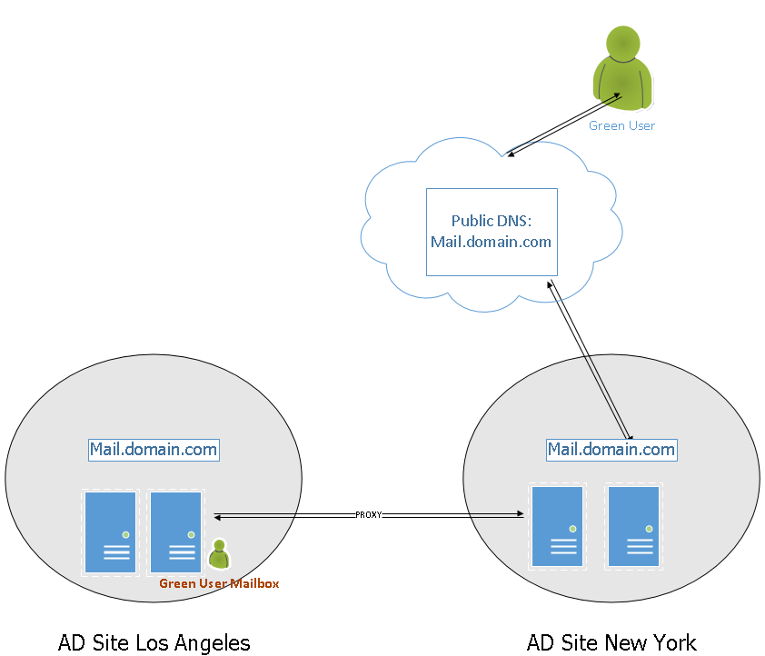

**Best High Availability**

Now we are thinking towards the best High – Availability in reducing the manual effort in case of multiple datacenter with multiple DAGs. One of my customer has 7 datacenters and we are going with the 4 DAG design due to the separate geographical location and connectivity requirements. But today I am taking an example of 2 datacenters to easily explain it with the below diagram. 4 Node DAG(CAS+MBX) spread between 2 AD sites with 4 DB copies:

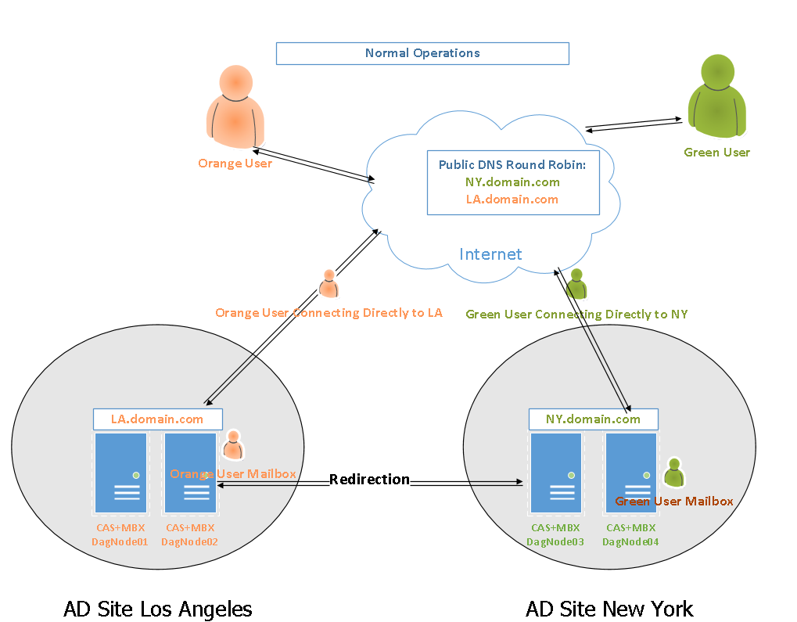

Here the requirement is the High – Availability and connectivity to the local AD Site Exchange servers Directly. So in this case we assign the Regional Name spaces which will ensure local client connections does not use unnecessary WAN traffic.

Imagine you have an org and you have any 2 datacenters 1 in New York and other is Los Angeles. Your Requirement is New York Users to connect to the New York Exchange Server and Los Angeles Users to connect to the Los Angeles Exchange Server in this situation we will use the following namespace.

    AutodiscoverServiceinternalURI:                     Autodiscover.domain.com    2 DNS Records – 1 for each location.

    Los Angeles AD Site Exchange 2013:                LA.domain.com

    Los Angeles AD Site Exchange 2013:                NY.domain.com

Now there can be following 2 Disasters which may occur.

* 1. Any of the Datacenter goes down.

In our example we simulated AD Site Los Angeles has Power Grid Failure and all UPS could not resist so this data center goes down.

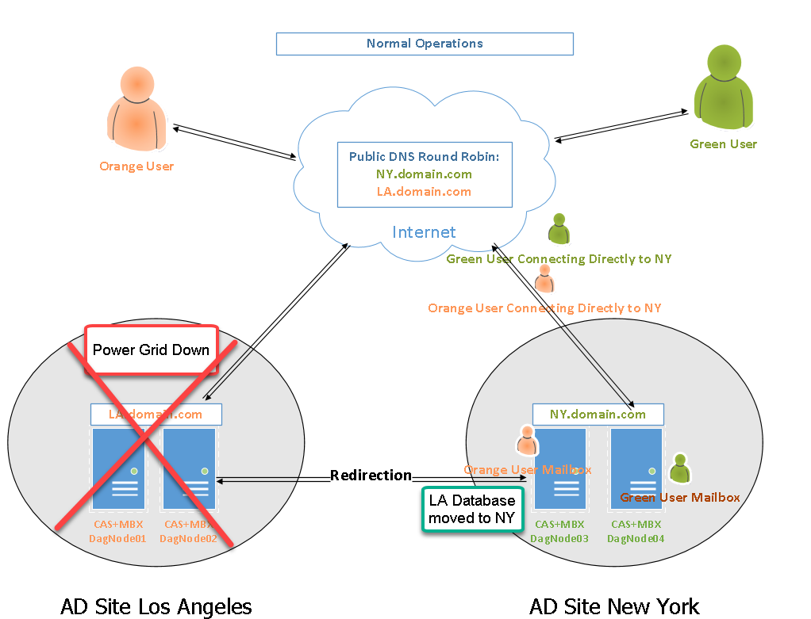

Exchange is configured in 3 datacenter DAG mode which has FSW in the 3rd datacenter which is not part of the diagram. End state is Los Angeles Databases activated at New York AD Site.

This means Orange Users mailbox moved to NY.

Orange user will query for SCP and Auto discover will give NY namespace because his mailbox is in NY.

Hence Orange user directly connects to NY.

* 2. Any of the internet link down.

In our example we simulated AD Site Los Angeles has ISP internet outage which means internet is down but WAN link is up.

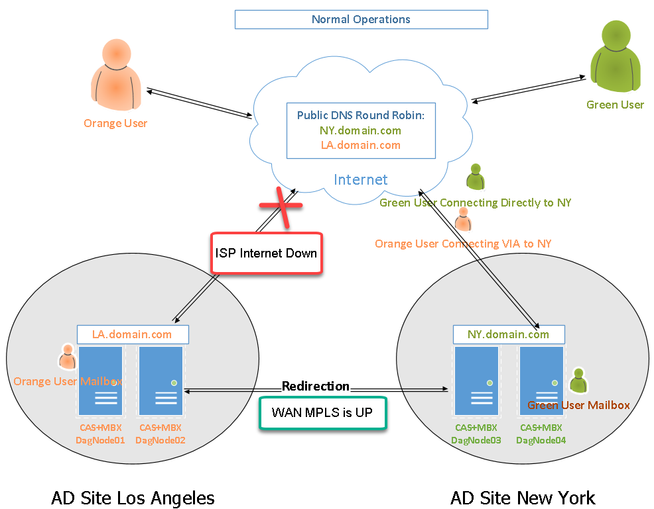

Exchange is configured in 3 datacenter DAG mode which has FSW in the 3rd datacenter which is not part of the diagram. End state is Los Angeles Databases continued to remain activate at Los Angeles AD Site because WAN link is UP.

This means Orange Users Mailbox stays in LA.

Orange user will query for SCP and Auto discover will give NY namespace because NY is connected to the Internet.

Hence Orange user connects to LA via NY Redirection.

I hope this adds name space High Availability open in your design as and where it is required.

**Exchange 2013: Unable to Proxy ActiveSync – HTTP 400**

After doing the cut over in a production of Exchange 2013 and Exchange 2007 multi AD site coexistence some of the users unable to proxy ActiveSync on their mobile devices.

**Issue:**

Some of the user reported that they are unable to connect to the exchange mailboxes after a cut over to Exchange 2013. Their mailboxes were in Exchange 2007 so Exchange 2013 was proxying.

The issue was with few users only

We ran EXRCA.com and we got the below error

**HTTP 400 – Bad Request**

**Resolution:**

After researching and reviewing some logs, we were very sure that this issue is coming because Kerberos token size is too big.

We verified the user and user had many groups membership.

After reviewing the reference link we created following registry key in Exchange 2007 and Exchange 2013 servers.

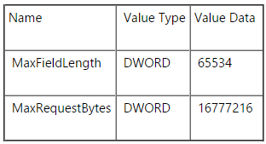

We have created max available value of 16MB for MaxRequestBytes

Restarted Exchange 2007 and then restarted Exchange 2013 servers.

Issue got fixed.

**Reference:**[**https://support.microsoft.com/en-us/kb/2020943**](https://support.microsoft.com/en-us/kb/2020943)

Reference 2: <https://support.microsoft.com/en-us/kb/2988444>

**Hybrid: Unable to Share Full Details and Limited Details Calendar from Outlook**

We configured Hybrid for this customer and Migrated a small Pilot batch of IT users. Now in the big orgs we share calendars with the team to keep transparence and block a time for team meeting together so this customer required to share the full details of the calendar. This is the 1st resolution posted over the internet of this issue and I will add this step in the hybrid configuration blog as well.

Post migration we identified that we were not able to share the full details or limited details calendar from On-Premise to Office 365.

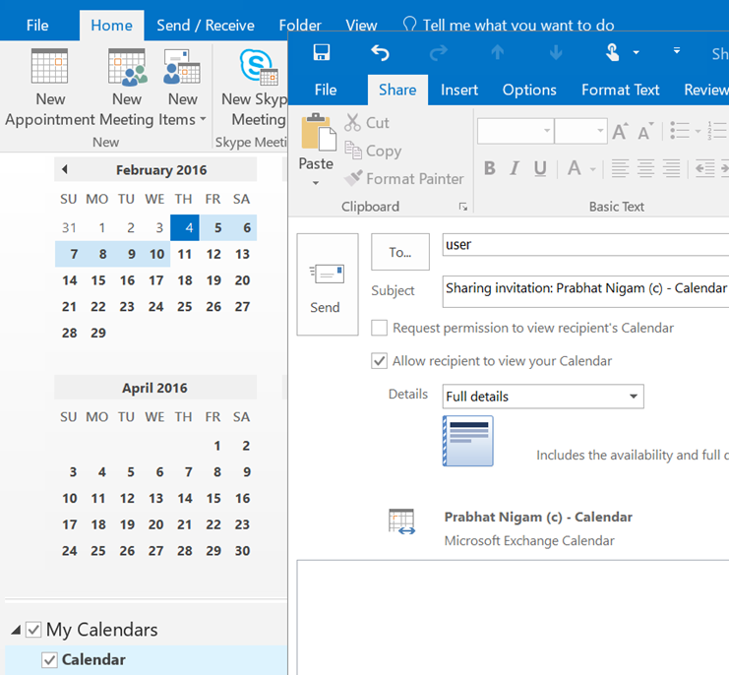

We were getting following popup.

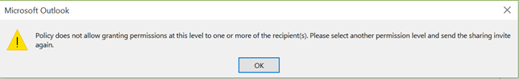

“Policy does not allow granting permissions at this level to one or more of the recipient(s). Please select another permission level and send the sharing invite.”

“Availability Only” was working

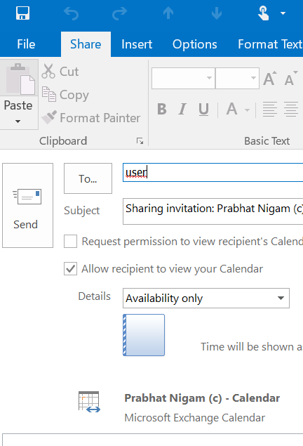

**Resolution:**

If you will search over the internet, you will find the resolution is to remove the autocomplete cache in outlook but this is not the issue.

This is neither a bug nor a configuration issue.

This is how Microsoft Hybrid wizard configure the configuration.

This error is accurate your organization’s sharing rule is configured to share only the availability. It is not configured to share Full Details.

Let me show you what I am talking about. Open ECP and go to Organization → Sharing →“Default Sharing Policy”

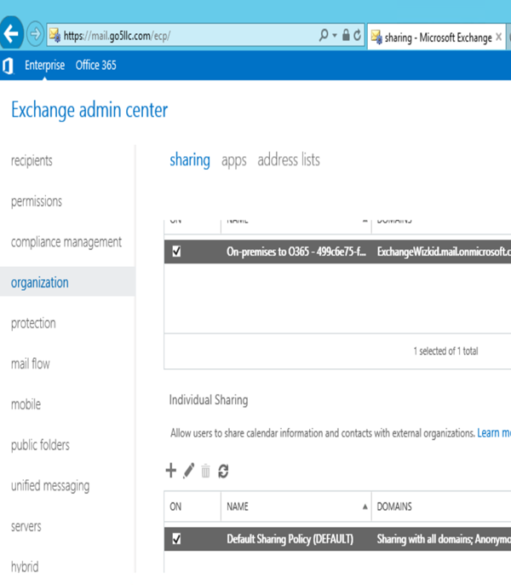

Open Default Sharing Policy from down.

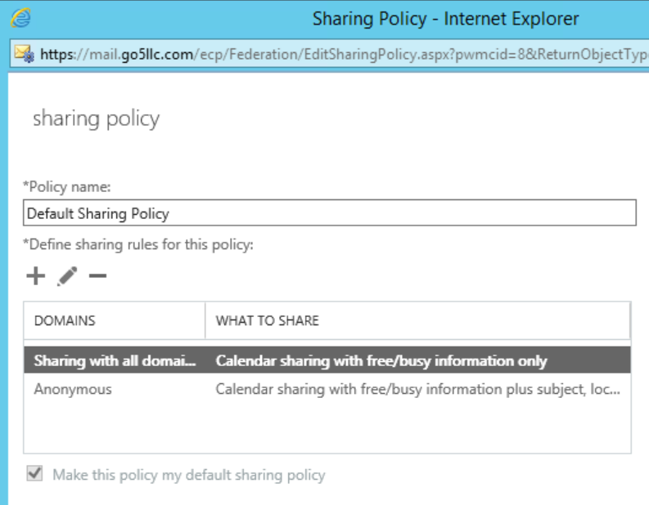

vYou can see anonymous configured for all but sharing with all domain is configured for information only.

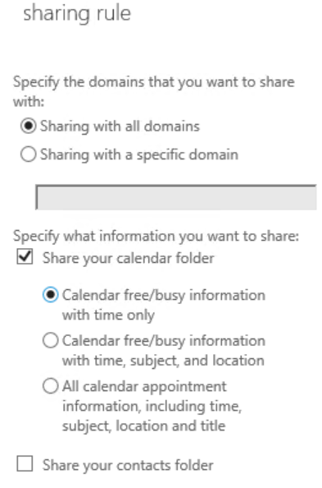

This rule is 1st and telling the outgoing calendar sharing request that you can only share “Availability Only” permission with the other organizations.

We can either change sharing rule in the sharing policy to “**All calendar appointment information, including time, subject, location and title**” for all domains

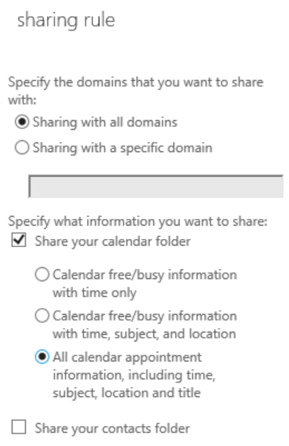

or

Create a new sharing rule for your smtp domain which is shared in the office 365 and assign “**All calendar appointment information, including time, subject, location and title**“.

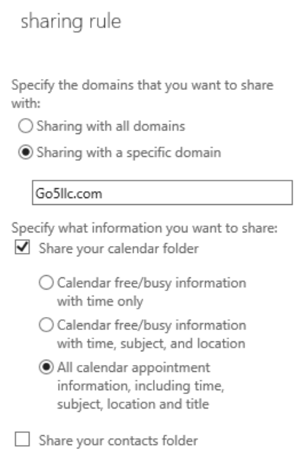

I would recommend going for smtp domain specific which is the requirement. Then click on save.

Now If you will share the calendar with full details or limited details then it will send the email and allow office 365 user to see your calendar.

TechNet reference: <https://technet.microsoft.com/en-us/library/jj657494(v=exchg.150).aspx>

### Exchange 2013: ActiveSync Not Connecting Error 12002

Today I was part of a critical change with one of my customer and witnessed this so sharing it for one and all.

We planned for a simple change of ActiveSync cutover from Exchange 2007 to Exchange 2013.

We updated the Externalurl of Exchange 2013 Internet facing servers.

We removed Externalurl of Exchange 2007 Internet facing servers.

We enabled windows integrated authentication on old Exchange 2007 Internet facing servers.

No Windows Integrated Authentication for Exchange 2013 internet facing servers.

We had NetScaler which had VIP configured for Exchange 2013 internet facing servers.

So everything as per books.

**Issue:**

After changing the NAT pointing to Exchange 2013 VIP. ActiveSync stopped connecting.

When we ran the exrca.com for ActiveSync connectivity, we got the following error.

**“Client certificate authentication couldn’t be determined due to an unexpected failure occured. Winhttpresponse failed with the error 12002”**

**Resolution:**

We were able to trace Exchange active sync traffic was coming to the NetScaler and there was nothing in the IIS Logs.

Error 12002 means The request has timed out.

So we were sure we had an issue before reaching Exchange 2013 servers.

We ran the TCPtrace which showed return traffic.

Network lead reviewed the configuration of the Netscaler and figured out that netscaler rule/VIP was configured for port 443 with HTTP.

**We change it from HTTP to SSL.**

Save all configuration.

The issue got fixed.

### Exchange 2013: Unable to Create A Copy of the Database

I was working on the issue where someone messed up the database. Only 1st copy was mounted and other copies were not healthy.

**Environment:**

3 data center expanded DAG

2 Data center has Exchange servers

1 Data Center has FSW

Only one data center is internet facing.

**Issue:**

While creating a copy of the database on the 2nd server, we got the following errors.

First Error

The seeding operation failed. Error: An error occurred while performing the seed operation. Error: Failed to notify source server “server fqdn ” about the local truncation point. Hresult: 0xc8000713. Error: Unable to find the file.

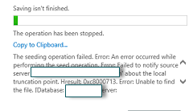2nd error

Failed to open a log truncation context to source server. Hresult: 0xc7ff1004. Error: Error returned from an ESE function call (-1305).

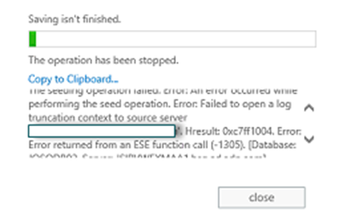

**Resolution:**

This is the issue with the old logs folder which was not in the sync.

For the 1st error.

-Login to the source server

-Remove the 2nd copy of the database

-Dismount the database

-Verify database is clean shutdown by running the command eseutil /mh driveletter:\database\database.edb

-Now rename the logs file folder to logs old.

-Mount the database

-Now the 1st issue will be fixed.

For the 2nd error.

-Login to the destination server where we are creating the 2nd copy

-Now rename the logs and database file folder by adding old prefix.

-Add the 2nd database copy.

-Now the 2nd issue will be fixed.

This environment was not backed up so there was a time when circular logging was enabled then disabled. After this one of the administrator messed up the database copies while expanding the C drive.

**Conclusion:**

This most important thing is to remember the error and its code because error will not clearly tell you the cause of the issue.

Next important thing is to take all precaution even if the environment is not in production.

### Exchange 2013: Recover a DAG and DAG Node from crash Part 1

Today I was in a situation where my system admin restarted the Hyper-V which had my DAG nodes and FSW servers.

**Environment and Overview of the issue:**

In this environment I have 2 DAG nodes and one FSW server.

Restart of the HyperV crashed one of my node and assigned a new IP to FSW Server.

Now I am into 2 issues. One my DAG is down and second Node has crashed.

My priority to bring the DAG up and running with at least one node.

Over All I got 3 Issues here

**Issue 1:**

DAG is down and no one can access mailboxes.

**Troubleshooting:**

-Ran the command Get-DatabaseAvailabilityGroup –status | FL and got the following error

===============================================================================================================================

WARNING: An unexpected error has occurred and a Watson dump is being generated: Object reference not set to an instance of an object.

Object reference not set to an instance of an object.

+ CategoryInfo : NotSpecified: (:) [Get-DatabaseAvailabilityGroup], NullReferenceException

+ FullyQualifiedErrorId : System.NullReferenceException,Microsoft.Exchange.Management.SystemConfigurationTasks.Get DatabaseAvailabilityGroup

+ PSComputerName : 2013vtc1.vtc2013.edu

===============================================================================================================================

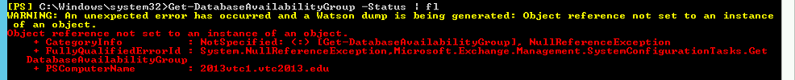

-Checked the Failover cluster but neither I was able to connect to the cluster nor validate it.

-Checked DNS Cluster’s DNS entry was missing and FSW Entry was old IP.

**Resolution 1:**

Changed the FSW server’s new IP and restarted Cluster Service. DAG came up with one Dag node.

Also created DAG host record in the DNS with the checkbox “Allow any authenticated user to update DNS records with the same owner name” which will allow DAG to update the DNS entry.

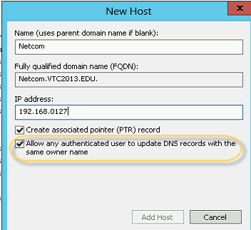

### Exchange 2013: Recover a DAG and DAG Node from crash Part 2

In this blog we will talk about the issue “Databases are not mounting after crash”.

We will continue from Part 1:<http://msexchangeguru.com/2014/02/05/e2013-dr-dag-post-crash1/>

**Issue 2:**

Cluster came up but DAG database is down.

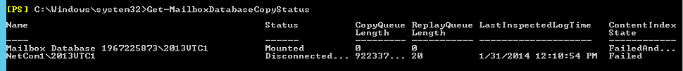

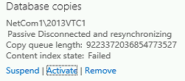

**Troubleshooting:**

Ran the below command to check the required logs

eseutil /mh C:DatabasesNetCom1netcom1.edb

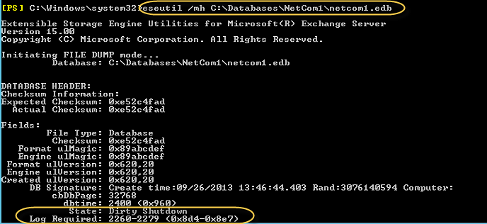

So the required log files are from 8d4 to 8e7

Checked the log location had these files so ran the below cmd

**eseutil /r E01 /d C:DatabasesNetCom1netcom1.edb /l C:DatabasesNetCom1 /i**

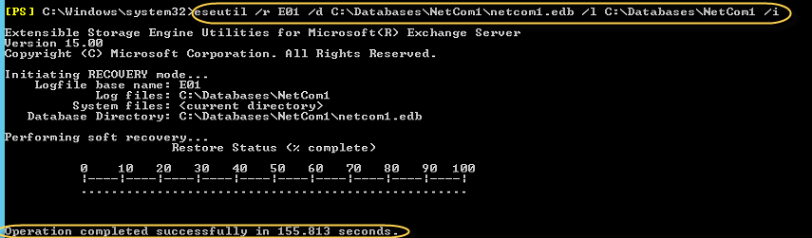

Ran the below command

**Move-ActiveMailboxDatabase -Identity Netcom1 -ActivateOnServer 2013VTC1 –SkipActiveCopyChecks -SkipClientExperienceChecks -MountDialOverride:BestEffort –SkipLagChecks**

Then **A** to confirm.

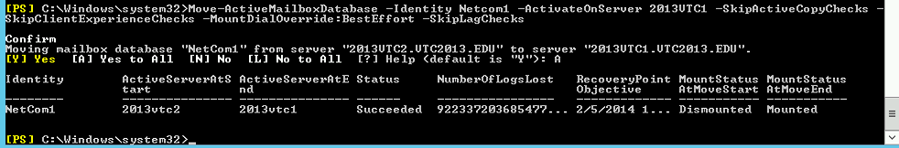

**Resolution 2:**

Following cmds mounted the database

**Eseutil /r E01 /d C:DatabasesNetCom1netcom1.edb /l C:DatabasesNetCom1 /i**

**Move-ActiveMailboxDatabase -Identity Netcom1 -ActivateOnServer 2013VTC1 –SkipActiveCopyChecks -SkipClientExperienceChecks -MountDialOverride:BestEffort –SkipLagChecks**

**Now Databases are mounted**



### Exchange 2013: Recover a DAG and DAG Node from crash Part 3

In this blog we will focus on bringing DAG node back in the DAG.

Check out Part 1 here: <http://msexchangeguru.com/2014/02/05/e2013-dr-dag-post-crash1/>

Check out Part 2 here: [http://msexchangeguru.com/2014/02/05/e2013-dr-dag-post-crash2](http://msexchangeguru.com/2014/02/05/e2013-dr-dag-post-crash2/)/

**Issue 3:**

Dag node 2 has crashed and unable to boot the OS. The only option left to do the installation of the OS, recover exchange, join DAG and reseed database.

If you have only 2 DAG nodes then this is a peace of worry and you would like to fix on the day one of the issue. If you have more than 2 DAG nodes with 2 or more Database copies then you can take this issue to the next day.

**Disaster Recovery Steps for one DAG node recovery:**

1. Install OS and apply windows update.

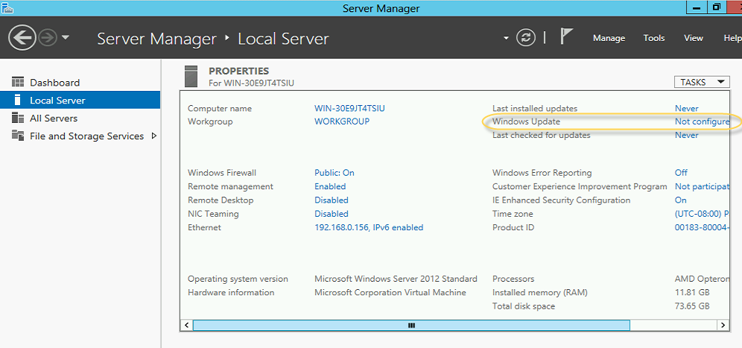

Turn on Automatic updates. We can change this later to manually apply the updates so avoid any update reboot.

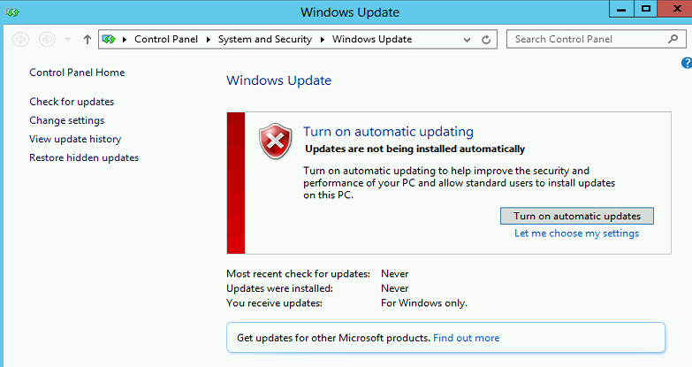

Download and installed the required updates. I had required 70 + updates in Feb 2014.

2. Reset the computer account the in the Active Directory User and computers

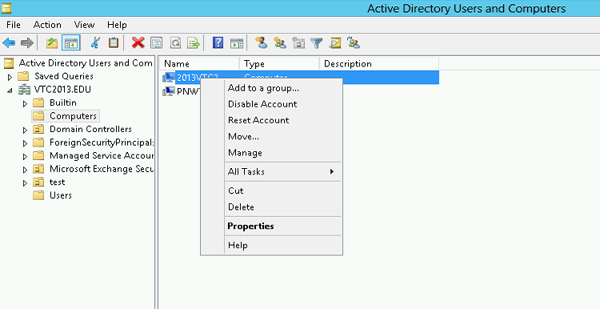

Click yes on this pop up

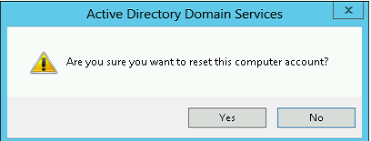

Now you will see below confirmation

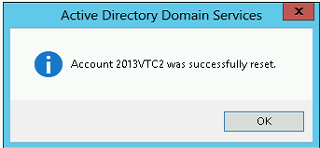

3. Disable Firewall: Click on Public on here.

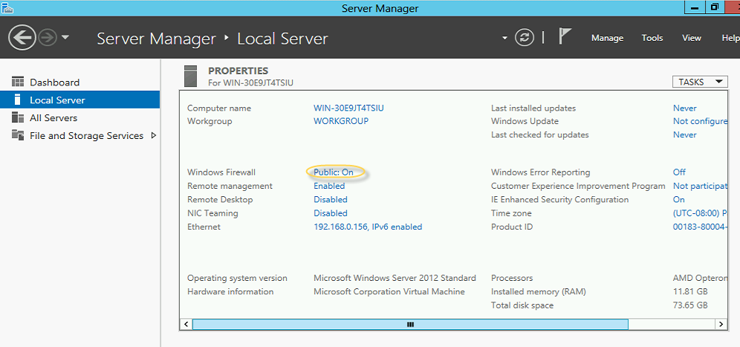

Click on Turn windows firewall on or off here

                     Click on “Turn on Windows Firewall”

4. Turn off IEESC

Click off on both and click ok.

5. Give the old IP and point to the DNS server.

6. Give the same server name and join the domain

Type the user name and password then click ok.

You will see the welcome message

7. Turn on RDP

Click on “Allow remote connections to this computer” then click ok

8. Set the time zone

9. Restart the server

10. Copy the exchange 2013 setup files

11. Open the PowerShell with Run as administrator

12. Run the following cmdlet to install features.

**For Windows 2012:**

Install-WindowsFeature AS-HTTP-Activation, Desktop-Experience, NET-Framework-45-Features, RPC-over-HTTP-proxy, RSAT-Clustering, RSAT-Clustering-CmdInterface, RSAT-Clustering-Mgmt, RSAT-Clustering-PowerShell, Web-Mgmt-Console, WAS-Process-Model, Web-Asp-Net45, Web-Basic-Auth, Web-Client-Auth, Web-Digest-Auth, Web-Dir-Browsing, Web-Dyn-Compression, Web-Http-Errors, Web-Http-Logging, Web-Http-Redirect, Web-Http-Tracing, Web-ISAPI-Ext, Web-ISAPI-Filter, Web-Lgcy-Mgmt-Console, Web-Metabase, Web-Mgmt-Console, Web-Mgmt-Service, Web-Net-Ext45, Web-Request-Monitor, Web-Server, Web-Stat-Compression, Web-Static-Content, Web-Windows-Auth, Web-WMI, Windows-Identity-Foundation

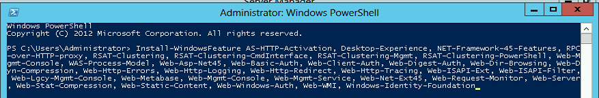

**For Windows 2008:**

**Import-Module ServerManager**

Add-WindowsFeature Desktop-Experience, NET-Framework, NET-HTTP-Activation, RPC-over-HTTP-proxy, RSAT-Clustering, RSAT-Web-Server, WAS-Process-Model, Web-Asp-Net, Web-Basic-Auth, Web-Client-Auth, Web-Digest-Auth, Web-Dir-Browsing, Web-Dyn-Compression, Web-Http-Errors, Web-Http-Logging, Web-Http-Redirect, Web-Http-Tracing, Web-ISAPI-Ext, Web-ISAPI-Filter, Web-Lgcy-Mgmt-Console, Web-Metabase, Web-Mgmt-Console, Web-Mgmt-Service, Web-Net-Ext, Web-Request-Monitor, Web-Server, Web-Stat-Compression, Web-Static-Content, Web-Windows-Auth, Web-WMI

13. Restart the Server

14. Download and install the following softwares :

**For Windows 2012:**

1. [Microsoft Unified Communications Managed API 4.0, Core Runtime 64-bit](http://go.microsoft.com/fwlink/p/?linkId=258269)

<http://www.microsoft.com/en-us/download/details.aspx?id=34992>

1. [Microsoft Office 2010/2007 Filter Pack 64 bit](http://go.microsoft.com/fwlink/p/?linkID=191548): Optional

<http://www.microsoft.com/en-us/download/details.aspx?id=17062>

1. [Microsoft Office 2010/2007 Filter Pack SP1 64 bit](http://go.microsoft.com/fwlink/p/?LinkId=254043): Optional

<http://www.microsoft.com/en-us/download/details.aspx?id=26604>

**For Windows 2008:**

1. [Microsoft .NET Framework 4.5](http://go.microsoft.com/fwlink/p/?LinkId=257868)

<http://msdn.microsoft.com/en-us/library/5a4x27ek(VS.110).aspx>

1. [Windows Management Framework 3.0](http://go.microsoft.com/fwlink/?LinkId=272757)

<http://www.microsoft.com/en-us/download/details.aspx?id=34595>

1. Microsoft Unified Communications Managed API 4.0, Core Runtime 64-bit

<http://www.microsoft.com/en-us/download/details.aspx?id=34992>

1. [Microsoft Office 2010/2007 Filter Pack 64 bit](http://go.microsoft.com/fwlink/p/?linkID=191548): Optional

<http://www.microsoft.com/en-us/download/details.aspx?id=17062>

1. [Microsoft Office 2010/2007 Filter Pack SP1 64 bit](http://go.microsoft.com/fwlink/p/?LinkId=254043): Optional

<http://www.microsoft.com/en-us/download/details.aspx?id=26604>

1. [Microsoft Knowledge Base article KB974405 (Windows Identity Foundation)](http://go.microsoft.com/fwlink/?linkid=3052&kbid=974405)

<http://support.microsoft.com/?kbid=974405&wa=wsignin1.0>

1. [Knowledge Base article KB2619234 (Enable the Association Cookie/GUID that is used by RPC over HTTP to also be used at the RPC layer in Windows 7 and in Windows Server 2008 R2)](http://go.microsoft.com/fwlink/?linkid=3052&kbid=2619234)

<http://support.microsoft.com/?kbid=2619234>

1. [Knowledge Base article KB2533623 (Insecure library loading could allow remote code execution)](http://go.microsoft.com/fwlink/?linkid=3052&kbid=2533623)

<http://support.microsoft.com/?kbid=2533623>

15. Restart the server

16. Remove the copy of the Database copy by running the following command:

**Remove-MailboxDatabasecopy netcom12013vtc2**

Confirm when it prompt

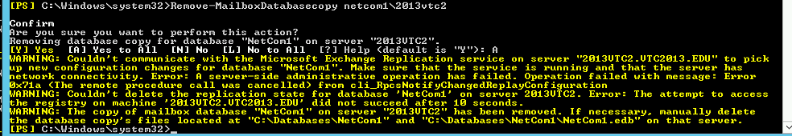

This is expected warning as server it down

17. Remove the DAG node from the DAG by running the below command:

**Remove-DatabaseAvailabilityGroupServer -Identity Netcom -MailboxServer 2013VTC2 –ConfigurationOnly**

Confirm when it prompt

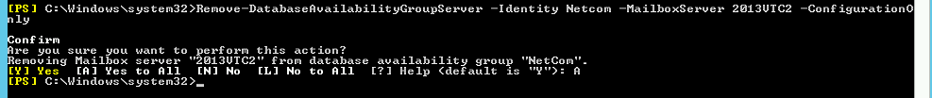

18. DAG node would be required to remove from failover cluster manager.

Open FCM → Expand Nodes → Select the node and right click → Select more actions → Select Evict.

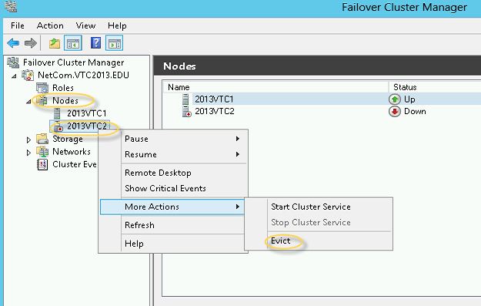

Click yes on this popup window

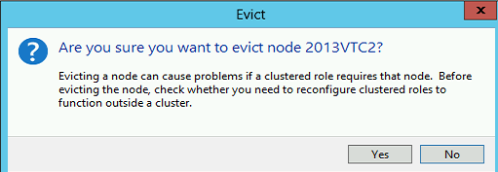

 19. Install the exchange Server setup with Recover switch by running the below command

.setup /m:recoverserver /IacceptExchangeServerLicenseTerms

The important thing is recoverserver switch does not change anything in the active directory.

In the below screen we can see Exchange 2013 is installing 6 components of 2 roles.

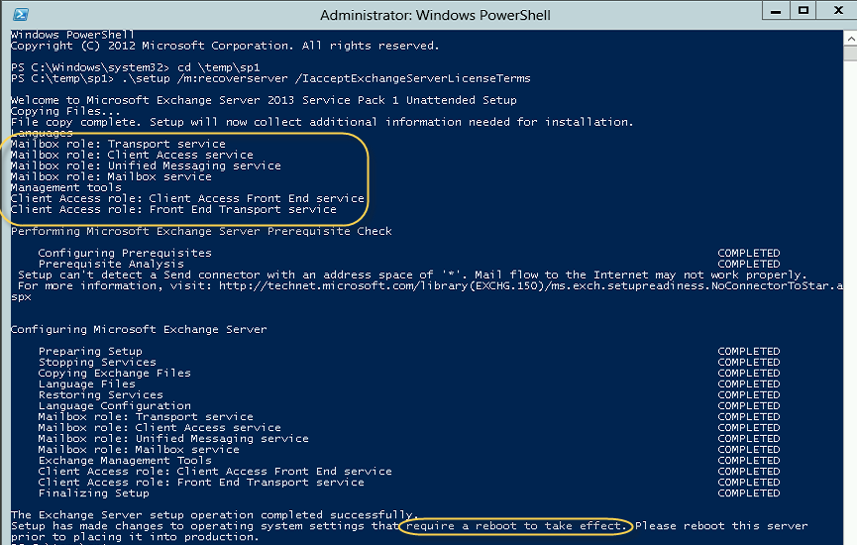

20. Restart the Server

21. Now run the below command to add the Node 2 to the DAG

**Add-DatabaseAvailabilityGroupServer identity DAGName -MailboxServer 2013VTC2**

You will see this screen on your shell. Install the failover cluster manager from add and remove features to avoid this action from shell.



If you see the below error then just wait for sometime, verifiy failover cluster is installed. Then rerun the same command.

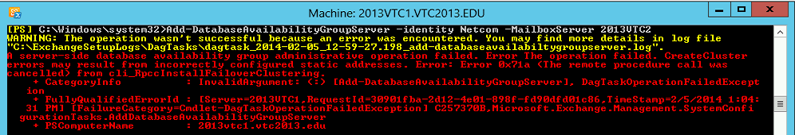

Second time I was able to see my node 2 joined the DAG cluster.



Node 2 has joined the cluster

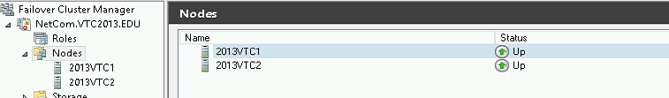

Node 2 is part of DAG as well

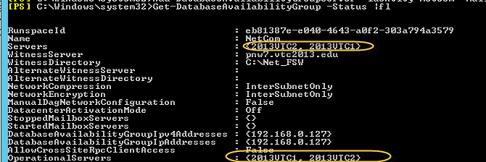

22. Run the below command to start seed of the DAG database copy.

**Add-MailboxDatabaseCopy Netcom1 -MailboxServer 2013VTC2**

You will see the below message while seeding in the Shell. It will take time based on the database size.



After seeding you will see the below message to restart Information store on the Node 2.



23. Restart Information store Service.

24. Run the below command the check the status of the seeding.

**Get-mailboxdatabasecopystatus \*\***

You will resynchronizing is going on for the DAG database



After sync, you will see Healthy



25. You should be able to move the database to the node 2.

We have recovered our node 2 of the DAG.

### How to Remove a DAG Member in Exchange Server 2013 – A Worthy Solution

Sometimes while accessing Exchange Server 2013, end users may face a situation in which they have to remove one of the server from DAG in order to accomplish their tasks.

Therefore, in this blog we are going to discuss about a measure to remove a DAG member in Exchange Server 2013 from server environment.

**TIP:**If users simply try to uninstall the DAG member, then they will encounter an error during the procedure.

To delete a DAG member in Exchange Server 2013, there exists a three-step solution to perform the same.

**Step 1: Removal of Database Copies**

This procedure involves the elimination of database copies. For doing such, there exist following two measures:

1. For removing the server from DAG, users will first have to keep their server as a standalone server hosting database and then remove different copies of database from other DAG members.
2. One will have to remove complete database copies from the server (which is to be uninstalled), in order to successfully uninstall Exchange 2013

User can make use of any one of the two discussed scenarios to perform their elimination procedure. For instance, here we are going to follow second approach for removing DAG member with help of following steps:

1. In the Exchange Admin Center, go to **Server**>> **Databases** for selecting a database, which has a database copy on server in order to perform removal of database copies

**NOTE:** All the database should not be in an active mode.

2. Now click on **Database** tab and select the database by clicking upon it

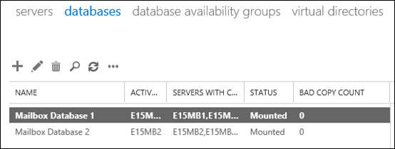

Click on **Remove**option to perform copies elimination

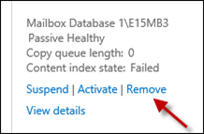

**TIP:**By using PowerShell cmdlets, you can remove multiple database copies at a time. However, this cmdlet will not work if database copies are in active mode.

  
**Step 2: Server Removal From DAG**

Second step involves removal of server from database availability groups. To do so, go through the following steps:

1. In EAC, go to **Servers**>> **Database Availablity Groups**and select the DAG.



1. After performing selection procedure, click on button to enable manage DAG membership option

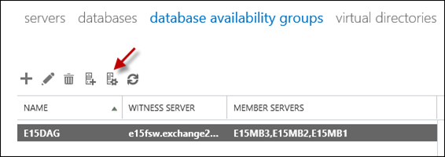

1. Now select the name of the server from drop-down menu and then click on **Remove** button

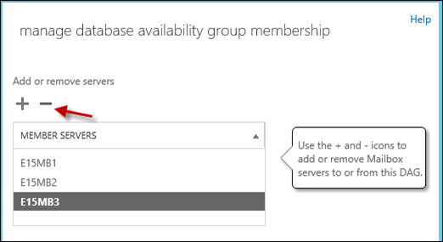

1. For successful completion of removal procedure, click on **Save**button

**TIP:**Users can also make use of PowerShell cmdlets for such removal



**Step 3: Removal of Exchange 2013**

**Step 3: Removal of Exchange 2013**

After removing the database copies and server from DAG, users can now finally remove Exchange 2013 without encountering any error. To do so, go to the **Control Panel**of your machine and uninstall the Microsoft Exchange Server 2013.

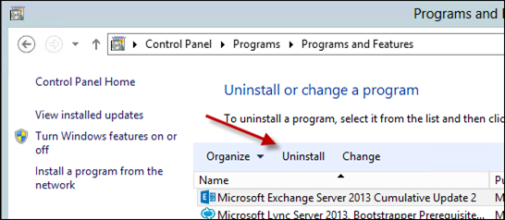

**Conclusion**

The blog illustrates that how to remove a DAG member in Exchange Server 2013 in a customized manner. The database should be inactive in order to perform removal operation. If end users perform the steps correctly, then they will be comfortably be able to perform their removal task.

### Datacenter Activation Coordination (DAC) Mode in Exchange Server

Datacenter Activation Coordination (DAC) mode is an asset of database availability group (DAG) which works using a new protocol called Datacenter Activation Coordination Protocol (DACP).

DAC mode will be disabled by default but should be enabled for all DAGs with two or more members which use continuous replication in order to avoid the “split brain syndrome” that will occur in certain consequence of datacenter switchover.

**Split brain syndrome:** Split brain syndrome is a condition where in a database copy being mounted as an active copy on two members of the same DAG which are unable to communicate each other.

**Example:** Consider a setup where a primary datacenter (A) contains two DAG members and the witness server, and a second datacenter contains two other DAG members. In this scenario, the DAG is not enabled with DAC mode. The primary datacenter went down due to power outage and administrator activates the DAG in the secondary datacenter. Ultimately when power restored in primary datacenter and the DAG members in the primary datacenter, which had quorum before the power failure, will start up and mount their databases. As the primary datacenter was restored when there is no network connectivity with the secondary datacenter, and since the DAG was not enabled with DAC mode, the active databases within the DAG entered a **split brain condition**.

**NOTE:** DAC mode shouldn’t be enabled for DAGs that uses third-party replication mode without indicated by the third-party vendor.

**How DAC mode works**:

As the DAC mode is intended to avoid split brain Syndrome condition, when DAC mode is enabled, DAG members will not automatically mount databases even if they have quorum. Instead DACP bit will be used to determine the current state of the DAG and Active Manager would attempt to mount the databases based on DACP value.

Let us take one example to see how DAC works:

In my Example I have 2 sites, one in India and other in US with a file share witness server and 2 exchange servers on each as shown below:

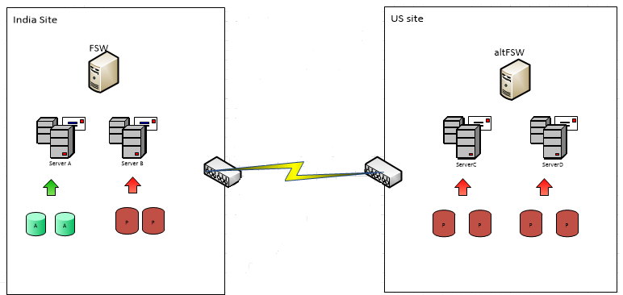

In general if the database is failed on one member, a database copy will be mounted on another DAG member. Here the Best Copy Selection process is efficient in order to select the database copy to be activated. If databases on Server1 failed, then the passive copy on Server 2 will be automatically activated as below:

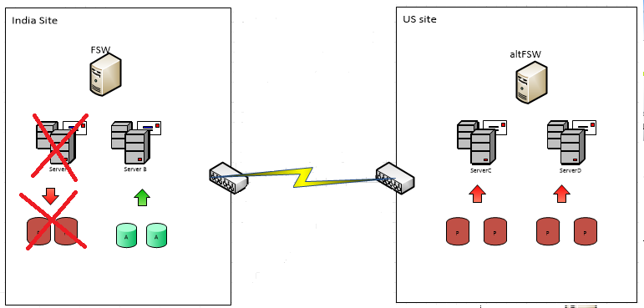

Let’s say, the complete India site is failed due to power failure. As the 2 database copies and File share witness server is offline in India site, the Quorum cannot be maintained due to which the databases copies will fail as shown below:

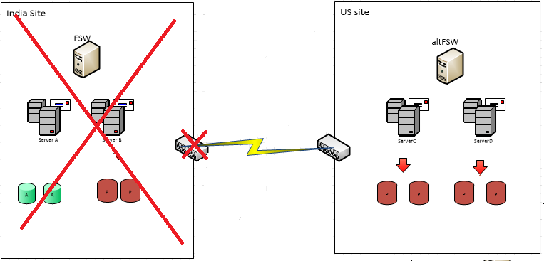

When an entire site is fail, users will not be able to access their mailboxes, administrator has to perform the datacenter switchover manually by activating the File witness Server in Secondary site (US datacenter in my case) and bring the databases online in order to maintain service continuity for business continuity.

Process involved in datacenter switchover:

* Check if the health and readiness of the secondary (disaster recovery) site infrastructure.
* If the messaging infrastructure at the primary site is not completely down; i.e. if any servers are still running but the databases cannot be mounted, active manager on the DAG members at the primary datacenter must be marked as stopped to prevent them from mounting the databases.
* Activate the File Share witness server at the secondary site in order to restore the Quorum.
* Further configuration changes may possibly require like changing the MX records that point to the failed datacenter servers and DNS records for Client Access Server (CAS), HUB transport and Unified Messaging (UM) servers

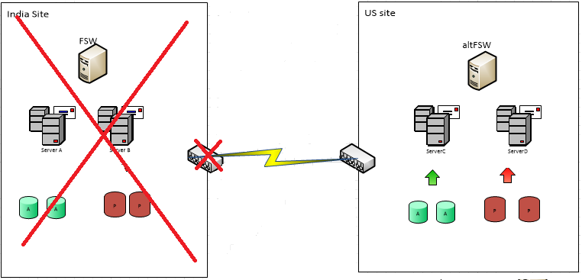

Ultimately the power restored in India site. DAG members and file share witness come back online in India. But, the WAN connection remains offline, preventing the communication between the DAG members in each site.

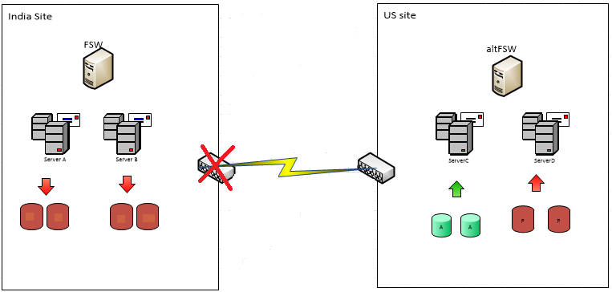

As the DAG members and file share witness have enough votes to achieve quorum, database is brought online in India sit. At this stage we have an active copy of the same database in both India and US datacenters since the DAG members in each site were not able to communicate with each other. This condition is called as “**split brain Syndrome**“.

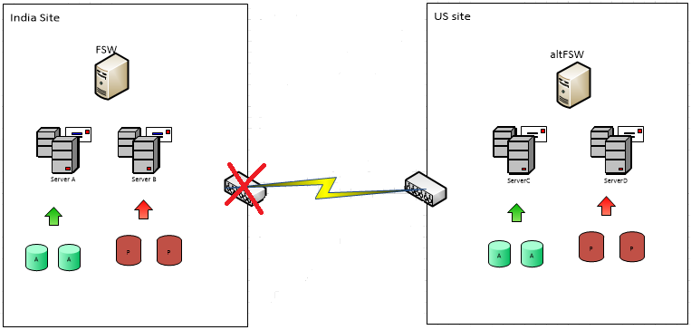

In order to avoid this **split brain syndrome** condition, we need to enable DAC mode. When DAC mode is enabled, it changes the Active manager process and each DAG member starts up with a DACP bit of 0. While waiting for it can communicate with a DAG member that has a DACP bit of 1 or it can communicate with every other member of the DAG, it will not attempt to activate its database copies even though there is an active quorum with sufficient DAG members to mount the databases.

**NOTE:** DAC uses DACP which present as a bit (0 or 1) which is stored in memory.

When the DAC is configured in advance, the DAG members in India site will star up with a DACP bit of 0 and they are unable to communicate with the US DAG members as the WAN link down. As the DAG members are star up with DHCP bit 0, they will not mount the databases in India site.



Once the WAN connection is restored, India DAG members are able to communicate with the US DAG members and their DACP bit is set from 0 to 1. Since the databases are already mounted on US site, the database copies on India become passive copies.

**NOTE:** In DAC mode, if the DAG member responds with a DACP bit of 0, starting up server will not mount its databases. If it responds with a DACP bit of 1, databases are mounted on it.

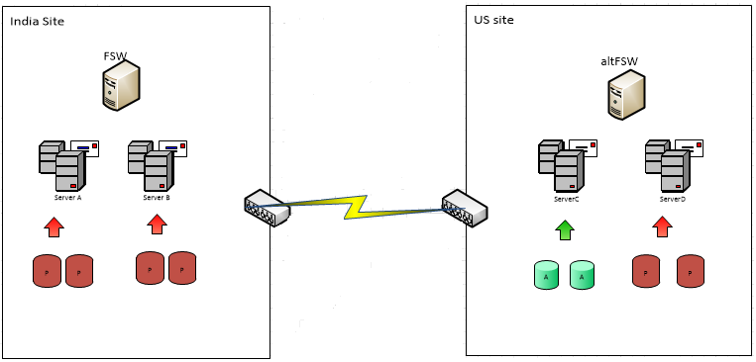

**PowerShell command to enable/Disable DAC mode:**

## To Enable DAC:

**Set-DatabaseAvailabilityGroup  -Identity <DAG name> -DatacenterActivationMode DagOnly**

## To Disable DAC:

**Set-DatabaseAvailabilityGroup  -Identity <DAG name> –DatacenterActivationMode Off**

In Addition, DAC mode also enables the use of the below built-in site resilience cmdlets which are used to perform datacenter switchover:

* [Stop-DatabaseAvailabilityGroup](https://technet.microsoft.com/en-us/library/dd335133(v=exchg.150).aspx)
* [Restore-DatabaseAvailabilityGroup](https://technet.microsoft.com/en-us/library/dd351169(v=exchg.150).aspx)
* [Start-DatabaseAvailabilityGroup](https://technet.microsoft.com/en-us/library/dd335076(v=exchg.150).aspx)

### Exchange 2013 SP1: Impossible to Convert IP Less DAG to IP DAG

Recently I came across with an issue where situation demanded to convert an IP Less DAG to IP DAG. I am sharing the experience so that you are aware about the technology and plan better.

We all know Exchange 2013 SP1 on Windows 2012 R2 had provided us the feature of IP Less Dag which reduced so many components of a cluster and made it a simple cluster exchange. I posted the blog of creating IP Less Dag [here](http://msexchangeguru.com/2014/03/21/e2013sp1-ip-less-dag/) and also delivered a session in Tech Stravaganza Times Square New York Conference. You can watch the Video [here](https://www.youtube.com/watch?v=5bMh5aJ5WT8).

In one of the environment we have IP Less DAG and for the backup we have Backup Exec. At this moment Backup Exec or net backup does not support IP Less DAG and their recommended solutions are mentioned below:

Backup Exec Solution for IP Less DAG: <http://www.symantec.com/business/support/index?page=content&id=TECH218366>

NetBackup Solution for IP Less DAG: <http://www.symantec.com/business/support/index?page=content&id=TECH223843>

Now Backup Exec is telling us to move to the traditional IP DAG which will create CNO and DNS entry for it.

As per my understanding Backup Exec is an application which is not a production application rather an application which just take a backup of production application and there are multiple backup application available to replace Backup Exec if they can’t go along with the technology. So I have posted my query in Symantec Forum [here](https://www-secure.symantec.com/connect/forums/exchange-2013-sp1-ip-less-dag-no-cno). I will post here if I will get any update from the Symantec forum.

**Now Let us talk about converting IP Less DAG to IP DAG.**

## There is no way to convert an IP Less DAG to an IP DAG. Microsoft has clarified [here](http://blogs.technet.com/b/scottschnoll/archive/2014/02/25/database-availability-groups-and-windows-server-2012-r2.aspx) under the topic “converting an Existing DAG”. So if you are willing to use Backup Exec which I agree has been an exchange friendly backup software from years then you need to break the current DAG then form a new cluster and add the database. I will be posting a blog on this sooner and I will add the link here.

As if now, my goal is to share the information that IP Less DAG might not be supported in your backup or other monitoring softwares because they need CNO. The work around is to add a host file entry on the backup exec server with the name of DAG and IP of any DAG member mailbox Server.

**Conclusion:**

**IP LESS DAG can’t be converted to Traditional DAG or visa versa. So it is better to plan ahead and check the compatibility before going for any new solution design.**

### Exchange 2013 certificate error: There is a problem with the proxy server’s security certificate.

Let’s take a look at an issue where users keep getting the following pop up in the outlook client frequently.

There is a problem with the proxy server’s security certificate. The name on the security certificate is invalid or does not match the name of the target site “server.domain.local”

Outlook is unable to connect to the proxy server. (Error Code 10)

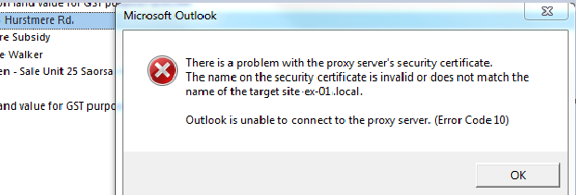

**Possibility 1:**

=> On the user’s machine launch **Outlook**=> Click **File** => **Go** to  
**Account Settings.**

=> Select the **email account** and then click **Change**.

=> Click the **More Settings** button.

=> Now click the **Exchange Proxy Settings**.

=> Copy the URL for “**Only connect to the proxy servers that have this principle name in their certificate**” & try to browse it.

=> You will get a certificate error, click on the top red x mark next to the address bar. It will open a certificate.

=> Check the **DNS**  
**names** listed in the **certificate** & make a note of them.

=> Now go the Exchange Server, Launch **Exchange Management Shell**.’

=> Run the following command:  
  
**Get-OutlookAnywhere**

=> Look for the following options:

**ExternalHostname mail.domain.com**

**InternalHostname     mail.domain.local**

=> Compare these two entries with the list of names we collected from the client machines certificate.

=> You will find that the internal host name is missing in the certificate.

=> To resolve this issue, we can run the following command to match the Internal Host name to the External host name as in the certificate SAN entry:

**Set-OutlookAnywhere -Identity “EXCH201301Rpc (Default Web Site)” -InternalHostname mail.domain.com -InternalClientsRequireSsl $true**

=> Next run IIS reset or simply recycle the AutoDiscover AppPool in the IIS Manager.

=> This change will take effect soon after the user closes & reopens the outlook, however the default autodiscover refresh internal is 1 hour, so it’s better to test after an hour or so.

**Possibility 2:**

Run the following script. Note that not all of this is relevant to the subject matter issue but you need to have your Exchange server tuned this way:

Get-ActiveSyncVirtualDirectory -ADPropertiesOnly | fl Identity, *lurl*, *method*

Get-ECPVirtualDirectory -ADPropertiesOnly | fl Identity, *method*, *lurl*

Get-OWAVirtualDirectory -ADPropertiesOnly | fl Identity, *method*, *lurl*

Get-WebservicesvirtualDirectory -ADPropertiesOnly | fl Identity, *method*, *lurl*

Get-OABvirtualDirectory -ADPropertiesOnly | fl Identity, *method*, *lurl*

Get-ClientAccessServer | fl Name, *uri*

Get-OutlookAnywhere -ADPropertiesOnly | fl Identity, *method*, *lurl*, *hostname*​

Get-MailboxServer | Get-MailboxDatabase | ft Name, *rpc* -AutoSize

Get-ClientAccessArray | ft Name, fqdn, Members -AutoSize

Once you have the output, start by reviewing URL’s and authentication settings on every CAS servers and ensure they are all configured unique.

For example if the Authentication settings or URL’s on OutlookAnywhere are different for CAS servers, that might cause Authentication popups or Certificate pop ups.

The AutoDiscoverServiceInternalUri value should ideally be a URL that is added on the certificate as a SAN.

### Exchange: UPN’s Role in ActiveSync Autodiscover

Today I have fixed another small issue which I would like to share with you to update this critical details which you might not be caring.

Many of deal with split dns name space in the exchange and AD. It is important to understand that you email domain should match to your userprincipalname to let autodiscover work as expected.

**Infrastructure:**

3 AD Sites: Los Angeles, New York and Toronto. They have more but for this infrastructure we are just using 3.

Los Angeles:

2 DCs

4 Exchange 2013 – CAS+MBX – DAG

1 Exchange 2007 – CAS+MBX+HT

New York

2 DCs

4 Exchange 2013 – CAS+MBX – DAG

1 Exchange 2007 – CAS+MBX+HT

Toronto

1 DC for Exchange 2013 FSW

Autodiscover URL for 2013 – Autodiscover.domain.com

Autodiscover URL for 2013 – mail.domain.com

We ran autodiscover test on EXRCA.com which gave us the success. ActiveSync should work on your mobile devices.

**Issue:**

Autodiscover is not configuring Exchange 2013 or Exchange 2007 profile on mobile devices.

Another statement can be activesync is successfully passing the tests on [EXRCA.com](http://msexchangeguru.com/2015/08/18/exchange-upnautodiscover/exrca.com) or <https://testconnectivity.microsoft.com/> but failed to configure mobile devices.

**Troubleshooting:**

1. Configured domain like below in the Exchange 2013 CAS internet facing AD site servers but it didn’t help
   1. On each CAS server, launch Internet Information Services (IIS) Manager
   2. Expand **Sites** | **Default Web Site**
   3. Click on **Microsoft‐Server‐ActiveSync** | **Authentication** | **Basic Authentication**
   4. From the Action menu, click on **Edit**
   5. Enter **\** on the **Default Domain** and **ADDomainname** on the **Realm** field
   6. Click **OK** to save settings
   7. Run **IISRESET** from an elevated command prompt

2. Added alternate UPN under active directory domains and trusts as shown below.

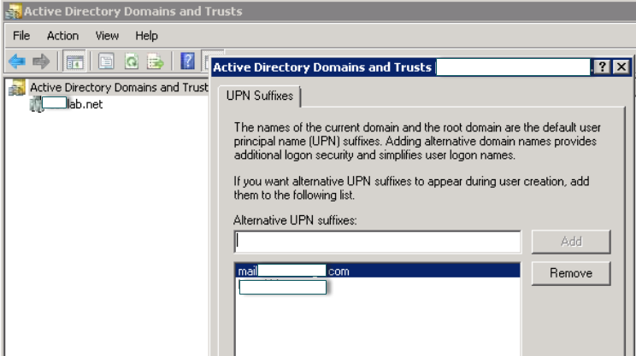

-Then updated user upn by going to their property from active directory users and computers.

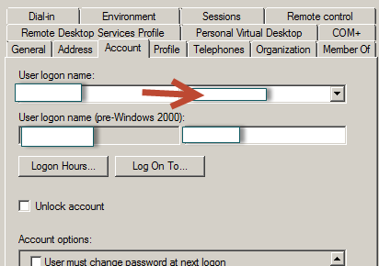

-Now we were able to configure ActiveSync every single time for both 2013 and 2007 users.

You will be concerned how to update all users. There are multiple options

1. Configure per user by going to their properties
2. Use a bulk AD modification tool.
3. Script it in powershell

$users = Get-QADuser -size 0

foreach($user in $users)

{

$UPN = “$($user.sAMAccountName)@emaildomainname.com”

$user | Set-QADUser -UserPrincipalName $UPN

}

1. EMS commands
   1. $users = Get-Mailbox
   2. $users | ForEach {Set-User -Identity $_.Identity -UserPrincipalName $_.WindowsEmailAddress}

Important: Any bulk modification should be tested in the lab.

**Conclusion:**

UserPrincipalName plays big role in the success of autodiscover and other configurations. We should configure UPN correctly for our messaging infrastructure.

### Exchange 2013 Outlook anywhere issues when InternalHostname value is set to Server FQDN

Let’s take a look at an issue where Outlook anywhere doesn’t work when InternalHostname value attribute is set to server FQDN.

This was a multi-site Exchange 2013 deployment with a 10MBPS – 30PMBS dedicated pipe running across site. We had a requirement to ensure local users contact local servers ONLY for any internal Outlook connection.

3 sites as follows:

BOS, NY and CA. In essence, we don’t want a CA user to contact the CAS server in NY for “internal” connections. NY is the internet facing site where a hardware load balancer accepts connections made to “webmail.exchguru.com”, hence changing InternalHostname value on Outlook Anywhere means all clients will go to NY at all times. You may also specify AutoDiscoverSiteScope.

One of the main drawback of doing this that you need to add the Server FQDN’s (or the DNS entry/InternalHostName URL) as a SAN in the SSL certificate on Exchange 2013. Most of the public accepted ROOT Certification authorities will not allow this. Also ensure the certificate is current on the server and it is properly selected in IIS Default website under “Bindings – Https 443”.

The first issue I faced was to retrieve virtual directory settings from servers. Every time you fire up EMS to run a cmdlet to retrieve VDir (virtual directory) settings, it will contact the IIS on that server and based upon how fast your network connectivity is, you may experience extreme slowness. So, Exchange management shell or EAC takes ages to retrieve settings. To resolve this, we can point shell to retrieve settings from Active Directory and “not to” query IIS on each and every CAS server.

Use the switch –ADPropertiesOnly to retrieve settings from Active directory if powershell is slow.

To do that, type in:

Get-OutlookAnywhere -ADPropertiesOnly |fl Identity, *auth*, *hostname

Identity : Exch2013-BOS2\Rpc (Default Web Site)

ExternalClientAuthenticationMethod : Ntlm

InternalClientAuthenticationMethod : Ntlm

IISAuthenticationMethods : {Basic, Ntlm, Negotiate}

ExternalHostname : webmail.exchguru.com

InternalHostname : Exch2013-BOS2.exchguru.local

Identity : Exch2013-BOS1\Rpc (Default Web Site)

ExternalClientAuthenticationMethod : Ntlm

InternalClientAuthenticationMethod : Ntlm

IISAuthenticationMethods : {Basic, Ntlm, Negotiate}

ExternalHostname : webmail.exchguru.com

InternalHostname : Exch2013-BOS1.exchguru.local

Identity : Exch2013-NY2\Rpc (Default Web Site)

ExternalClientAuthenticationMethod : Ntlm

InternalClientAuthenticationMethod : Ntlm

IISAuthenticationMethods : {Basic, Ntlm, Negotiate}

ExternalHostname : webmail.exchguru.com

InternalHostname : Exch2013-NY2.exchguru.local

Identity : Exch2013-NY1\Rpc (Default Web Site)

ExternalClientAuthenticationMethod : Ntlm

InternalClientAuthenticationMethod : Ntlm

IISAuthenticationMethods : {Basic, Ntlm, Negotiate}

ExternalHostname : webmail.exchguru.com

InternalHostname : Exch2013-NY1.exchguru.local

Identity : Exch2013-CA2\Rpc (Default Web Site)

ExternalClientAuthenticationMethod : Ntlm

InternalClientAuthenticationMethod : Ntlm

IISAuthenticationMethods : {Basic, Ntlm, Negotiate}

ExternalHostname : webmail.exchguru.com

InternalHostname : Exch2013-CA2.exchguru.local

Identity : Exch2013-CA1\Rpc (Default Web Site)

ExternalClientAuthenticationMethod : Ntlm

InternalClientAuthenticationMethod : Ntlm

IISAuthenticationMethods : {Basic, Ntlm, Negotiate}

ExternalHostname : webmail.exchguru.com

InternalHostname : Exch2013-CA1.exchguru.local

Now that you settings retrieved from all the CAS servers, compare and ensure “all” authentication settings are unique across servers. You may chose NTLM or Negotiate for Outlook anywhere, I don’t recommend Basic.

Now that we have all settings, let’s configure an internal Outlook client. Once the client is configured, do (Control + right click Outlook icon) on Task Bar and click TestEmailAutoConfiguration.

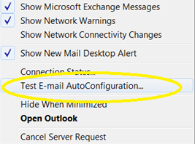

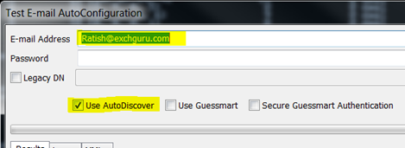

Once you have the XML file returned, take a look at the Exchange HTTP (internal) and Exchange HTTP (external) URL’s and ensure it is all configured as per requirement.

Ideally it would be https://servername/servicename for internal settings and

https://ExternalURL/servicename for External HTTP settings.

If the External HTTP settings are showing “externally” resolvable DNS value, then you don’t have to worry about what comes up in Outlook proxy connections. Even if it shows internal servername, Outlook knows what to do when it cannot contact internal server.

In my case, both where correct but Outlook still wouldn’t connect from External internet and kept giving certificate warnings.

**Solution:**

What worked for me was to setup OutlookProvider EXPR settings to MSSTD:webmail.exchguru.com so you are forcing Outlook to grab the EXPR (external connection) to use the public DNS value.

This should be set to the “Issued to value” on the certificate and not SAN name.

To do this,

**Set-OutlookProvider EXPR -CertPrincipalName MSSTD:webmail.exchguru.com**

My conclusion is that if the InternalHostname is set to “Server FQDN” and that “FQDN” is also added as SAN on the cert, I had to force the EXPR CertPrincipalName for OA to work externally.

Please contact Microsoft support if you have questions on this.

### Exchange 2010/2007 to 2013 Migration and Co-existence Guide

<http://msexchangeguru.com/2013/05/10/exchange2013-migration/>

We don’t have a lot of guides out there helping with a step by step guide for the migration and co-existence of Exchange 2010/2007 to Exchange 2013So, here you go !!!

Update:

If you are planning to employ a third party product for migration – look no further. CodeTwo is a mature and reliable product for full blown Exchange migraiton from

Exchange 2003/2007/2010 – cross forest or cross domain migration:

**Take a look here:**

**CodeTwo Exchange migration for Exchange 2003 to 2010/2013: Operational review:** <http://msexchangeguru.com/2013/11/24/codetwo-exchange-migration>/

**Download here:**

**Download Codetwo for free:**[**http://www.codetwo.com/exchange-migration/**](http://www.codetwo.com/exchange-migration/?sts=3459)

**Before you proceed with the actual migration steps, these articles may be of interest to you:**

Exchange 2013 CAS Role Demystified: <http://msexchangeguru.com/2013/05/22/exchange-2013-cas/>  
Exchange 2013 High Availability demystified: <http://msexchangeguru.com/2013/05/23/e2013-ha-demystified/>  
Load Balancing Exchange Server 2013 – Good to know stuff: <http://msexchangeguru.com/2013/06/05/load-balancing/>  
Public Folders Migration from Exchange 2007/2010 to Exchange 2013: <http://msexchangeguru.com/2013/04/18/exchange2013-public-folders/>  
Upgrade from Exchange 2013 CU1 or RTM to CU2: <http://msexchangeguru.com/2013/07/10/install-e2013-cu2/>  
**Monitoring and troubleshooting Exchange using powershell**: <http://msexchangeguru.com/2013/07/23/monitoring-powershell/>

For Complex Exchange 2007 migration check the common errors here – <http://blogs.technet.com/b/exchange/archive/2007/09/10/3403885.aspx>

Check our multisite url and authentication blog here – <http://msexchangeguru.com/2015/08/22/e20132007-urlsauth-multiadsite/>

**Preparing Exchange 2010/2007**

1. Install the hotfix 2550886 for DAG failover improvements on Exchange 2010/2007 DAG servers.

<http://support.microsoft.com/?kbid=2550886>

1. Login to the Exchange 2010/2007 server with Schema Admins, enterprise admins, domain admins and organization management group member id as SP 3 will extend the schema.
2. Install Exchange 2010/2007 SP3 on all the exchange 2010/2007 servers in CAS then HT then mailbox role order if they are not on the same server

SP3 can be downloaded from the below link:

<http://www.microsoft.com/en-us/download/details.aspx?id=36768>

1. Check the below link for SP3 installation steps

[http://msexchangeguru.com/2013/04/03/exchange-2010/2007-sp3/](http://msexchangeguru.com/2013/04/03/exchange-2010-sp3/)

**Installing Exchange 2013**

1. I would suggest going for Windows 2012 for Exchange 2013 but you can use windows 2008 R2 SP1 as well.
2. Install the windows 2012 server or Windows 2008 R2 SP1 on a new server and join the domain. It can be virtual or physical. Now Microsoft support virtualized mailbox role.
3. Run the windows update and install all the recommended updates.
4. You might like to configure windows NLB if you don’t have NLB hardware. Check the below blog on it. (optional)  <http://msexchangeguru.com/2013/08/14/windowsnlb/>
5. For Active Directory preparation check the “step 3 preparing active directory” at the blog mentioned below:       <http://msexchangeguru.com/2013/04/29/install-e2013/>
6. Install the following prerequisites for Exchange 2013

**For Windows 2012:**

1. Open Windows PowerShell.
2. Run the following command to install the required Windows components.

Install-WindowsFeature AS-HTTP-Activation, Desktop-Experience, NET-Framework-45-Features, RPC-over-HTTP-proxy, RSAT-Clustering, RSAT-Clustering-CmdInterface, RSAT-Clustering-Mgmt, RSAT-Clustering-PowerShell, Web-Mgmt-Console, WAS-Process-Model, Web-Asp-Net45, Web-Basic-Auth, Web-Client-Auth, Web-Digest-Auth, Web-Dir-Browsing, Web-Dyn-Compression, Web-Http-Errors, Web-Http-Logging, Web-Http-Redirect, Web-Http-Tracing, Web-ISAPI-Ext, Web-ISAPI-Filter, Web-Lgcy-Mgmt-Console, Web-Metabase, Web-Mgmt-Console, Web-Mgmt-Service, Web-Net-Ext45, Web-Request-Monitor, Web-Server, Web-Stat-Compression, Web-Static-Content, Web-Windows-Auth, Web-WMI, Windows-Identity-Foundation

1. Restart the server.
2. [Microsoft Unified Communications Managed API 4.0, Core Runtime 64-bit](http://go.microsoft.com/fwlink/p/?linkId=258269)

<http://www.microsoft.com/en-us/download/details.aspx?id=34992>

1. [Microsoft Office 2010/2007 Filter Pack 64 bit](http://go.microsoft.com/fwlink/p/?linkID=191548): Optional

<http://www.microsoft.com/en-us/download/details.aspx?id=17062>

1. [Microsoft Office 2010/2007 Filter Pack SP1 64 bit](http://go.microsoft.com/fwlink/p/?LinkId=254043): Optional

<http://www.microsoft.com/en-us/download/details.aspx?id=26604>

**For Windows 2008:**

1. Open Windows PowerShell.
2. Run the following command to load the Server Manager module.

**Import-Module ServerManager**

1. Run the following command to install the required Windows components.

    Add-WindowsFeature Desktop-Experience, NET-Framework, NET-HTTP-Activation, RPC-over-HTTP-proxy, RSAT-Clustering, RSAT-Web-Server, WAS-Process-Model, Web-Asp-Net, Web-Basic-Auth, Web-Client-Auth, Web-Digest-Auth, Web-Dir-Browsing, Web-Dyn-Compression, Web-Http-Errors, Web-Http-Logging, Web-Http-Redirect, Web-Http-Tracing, Web-ISAPI-Ext, Web-ISAPI-Filter, Web-Lgcy-Mgmt-Console, Web-Metabase, Web-Mgmt-Console, Web-Mgmt-Service, Web-Net-Ext, Web-Request-Monitor, Web-Server, Web-Stat-Compression, Web-Static-Content, Web-Windows-Auth, Web-WMI

1. Restart the server
2. [Microsoft .NET Framework 4.5](http://go.microsoft.com/fwlink/p/?LinkId=257868)

<http://msdn.microsoft.com/en-us/library/5a4x27ek(VS.110).aspx>

1. [Windows Management Framework 3.0](http://go.microsoft.com/fwlink/?LinkId=272757)

<http://www.microsoft.com/en-us/download/details.aspx?id=34595>

1. Microsoft Unified Communications Managed API 4.0, Core Runtime 64-bit

<http://www.microsoft.com/en-us/download/details.aspx?id=34992>

1. [Microsoft Office 2010/2007 Filter Pack 64 bit](http://go.microsoft.com/fwlink/p/?linkID=191548): Optional

<http://www.microsoft.com/en-us/download/details.aspx?id=17062>

1. [Microsoft Office 2010/2007 Filter Pack SP1 64 bit](http://go.microsoft.com/fwlink/p/?LinkId=254043): Optional

<http://www.microsoft.com/en-us/download/details.aspx?id=26604>

1. [Microsoft Knowledge Base article KB974405 (Windows Identity Foundation)](http://go.microsoft.com/fwlink/?linkid=3052&kbid=974405)

<http://support.microsoft.com/?kbid=974405&wa=wsignin1.0>

1. [Knowledge Base article KB2619234 (Enable the Association Cookie/GUID that is used by RPC over HTTP to also be used at the RPC layer in Windows 7 and in Windows Server 2008 R2)](http://go.microsoft.com/fwlink/?linkid=3052&kbid=2619234)

<http://support.microsoft.com/?kbid=2619234>

1. [Knowledge Base article KB2533623 (Insecure library loading could allow remote code execution)](http://go.microsoft.com/fwlink/?linkid=3052&kbid=2533623)

<http://support.microsoft.com/?kbid=2533623>

   6. Restart the server

   7. Exchange 2013 Installation – Please follow the below link for the Exchange 2013 installation: [**http://msexchangeguru.com/2013/04/29/install-e2013/**](http://msexchangeguru.com/2013/04/29/install-e2013/)or Exchange 2013 SP1installation:[**http://msexchangeguru.com/2014/03/02/e2013sp1-installationupgrade/**](http://msexchangeguru.com/2014/03/02/e2013sp1-installationupgrade/)

Imp: You can directly install Exchange 2013 CU1 as well. If you directly install CU1 then you can skip step 12 – Testing mailbox move without CU1. If you are installing CU2 make sure you are installing CU2 V2.

If you are doing new installation then you can directly install Exchange 2013 CU1 which itself is a full setup. You can follow same schema update and AD preparation steps.

**After Exchange 2013 installation the biggest challenge will be how to login to the EAC, there is no mailbox on Exchange 2013 and redirection or proxy is not configured to use the existing Exchange admin user.**

**If you are trying to access EAC for the first time and your mailbox is on Exchange 2010, you need to use the URL in the format:**

[https://Exchange2013ServerName/ecp?ExchClientVer=15](https://exchange2013servername/ecp?ExchClientVer=15)

This is because in a co-existence scenario, your mailbox is still housed on the Exchange 2010 mailbox server, the browser will default to the Exchange Server 2010 ECP. Now if you want to access the Exchange 2010 ECP and your mailbox resides on an Exchange 2013 mailbox server, use the following URL:

[https://Exchange2010ServerName/ecp?ExchClientVer=14](https://exchange2010servername/ecp?ExchClientVer=14).

Take a look at:

**Working with EAC or Exchange administration center in Exchange 2013 – Part1:** <http://msexchangeguru.com/2013/01/16/eac-exchange-2013/>

**So you need to create a mailbox to administer Exchange 2013. We will follow the below steps:**

* 1. Create a mailbox in Exchange 2013 mailbox database.
  2. “New-Mailbox –name 2013Admin –userPrincipalName [2013Admin@domain.com](mailto:2013Admin@domain.com) –Database “2013 DBName””
  3. Run Get-mailboxdatabase to check the database name

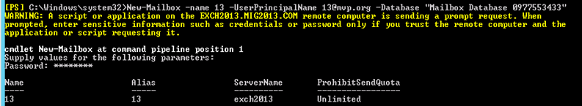

4. Give the permission to the mailbox to Administrate EAC.

               Add the following group membership:

**Domain Admins**

**Schema Admins**

**Enterprise Admins**

**Organization Management**

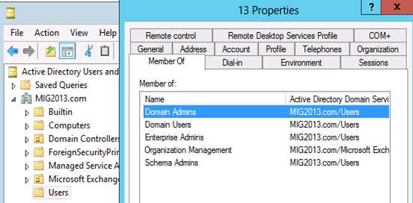

**Test mailbox migration without CU1 for Exchange 2013**

1. Now, you should be able to login to EAC by going to the url https://localhost/ECP. If you will test the mailbox migration from Exchange 2010/2007 to Exchange 2013 before CU1 for Exchange 2013, it will be working but full co-existence will not work so it is a necessity to install CU1. As an example my Servers are mentioned below:

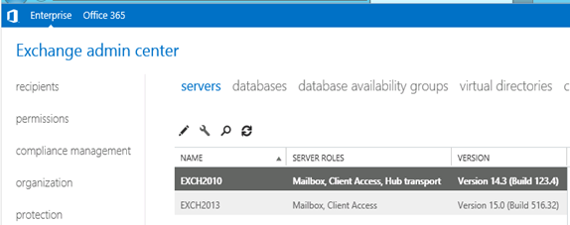

1. EAC will show Databases from both the servers

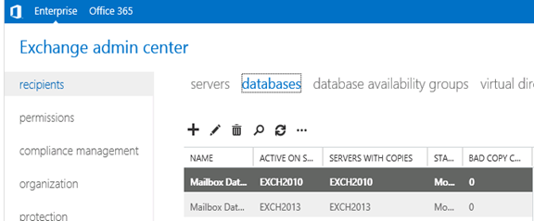

* Now I am migrating the mailbox being Exchange 2010/2007 on SP3 and Exchange 2013 without CU1.

Created new mailbox in Exchange 2010/2007, you can see 2013 database is not showing here

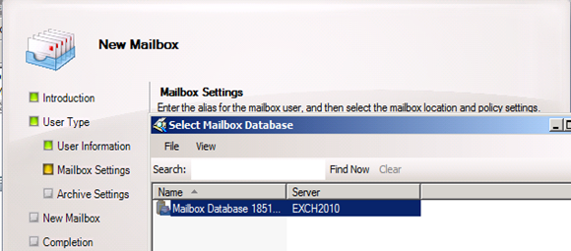

* Database before move

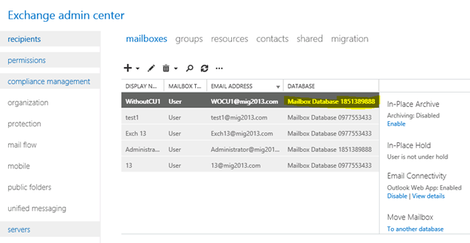

* I have moved the mailbox from Exchange 2013 EAC to Exchange 2013 database. Now click on migration to check the status

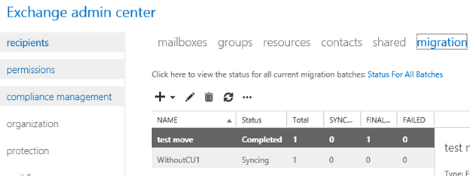

* Now Refresh and you will see completed depends on the size of mailbox.

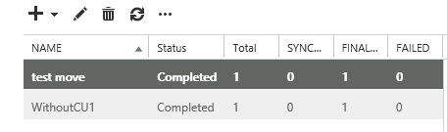

* Check the Database name has changed

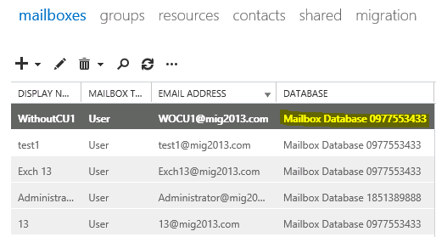

**Continue the Exchange 2013 CU1 installation**

       5. If you have not install CU1 version of exchange 2013 then this is the time to install Exchange 2013 Cumulative update 1 so that we avoid any co-existence issue. If you are doing new installation then you can directly install Exchange 2013 CU1 which itself is a full setup. You can follow same schema update and AD preparation steps mentioned in the Exchange 2013 installation article

Update 4/7/2014: Now – We can go for SP1 – http://msexchangeguru.com/2014/03/02/e2013sp1-installationupgrade/

       6. Download the Exchange 2013 from the below link which is an Exchange 2013 setup with Cumulative update

<http://www.microsoft.com/en-us/download/details.aspx?id=38176>

       7. Install the Exchange 2013 CU 1 with the help of below link:

<http://msexchangeguru.com/2013/04/15/e2013-cu1-2/>

**Configuring Exchange 2013 and network**

1. Transport Configuration
2. **Send connector**

         1. Exchange 2013 reads exchange 2010/2007 send connector information. Click on the pencil icon to check and add exchange 2013 in the same send connector.

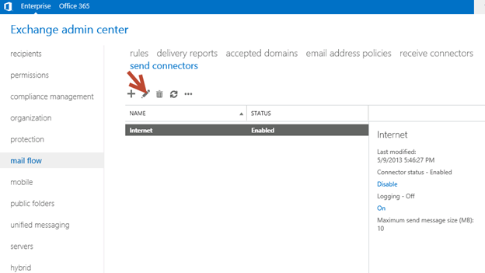

         2. Click on scoping and + icon to add the server

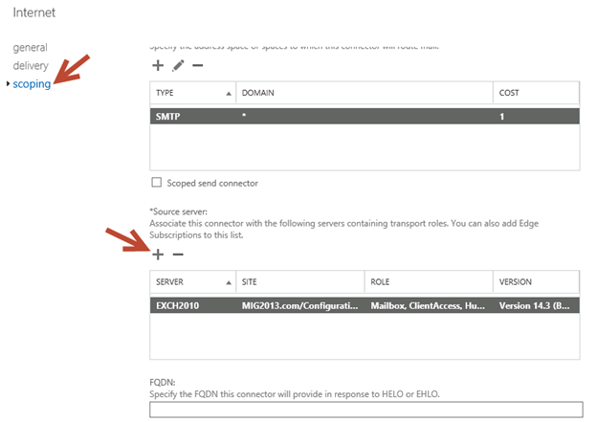

         3. Select the server and add, then click on and save. Send connector configuration completed.

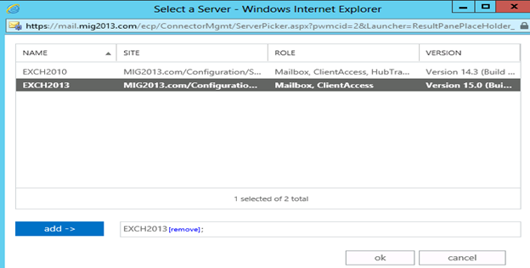

     3. **Receive Connector**

        1. Add a receive connector as per the current connector configuration.

        2. Select the 2013 server, oh what we have 5 connectors for what. Let me explain here.

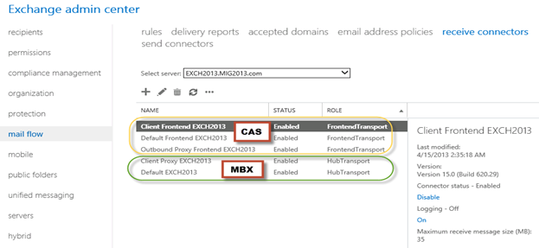

         3. You can see all 5 together here as I have CAS and Mailbox on same server. First 3 are for the CAS connector and remain 2 are for mailbox role.

         4. I would link to explain the transport pipe line here which consists of the following services:

**Front End Transport service –** This service runs on all Client Access servers and acts as a stateless proxy for all inbound and outbound external SMTP traffic for the Exchange 2013 organization.  The Front End Transport service doesn’t inspect message content, only communicates with the Transport service on a Mailbox server, and doesn’t queue any messages locally.

**Transport service**– This service runs on all Mailbox servers and is virtually identical to the Hub Transport server role in previous versions of Exchange. The Transport service handles all SMTP mail flow for the organization, performs message categorization, and performs message content inspection. Unlike previous versions of Exchange, the Transport service never communicates directly with mailbox databases. That task is now handled by the Mailbox Transport service. The Transport service routes messages between the Mailbox Transport service, the Transport service, and the Front End Transport service.

**Mailbox Transport service –**This service runs on all Mailbox servers and consists of two separate services: the Mailbox Transport Submission service and Mailbox Transport Delivery service. The Mailbox Transport Delivery service receives SMTP messages from the Transport service on the local Mailbox server or on other Mailbox servers, and connects to the local mailbox database using an Exchange remote procedure call (RPC) to deliver the message. The Mailbox Transport Submission service connects to the local mailbox database using RPC to retrieve messages, and submits the messages over SMTP to the Transport service on the local Mailbox server, or on other Mailbox servers. The Mailbox Transport Submission service has access to the same routing topology information as the Transport service. Like the Front End Transport service, the Mailbox Transport service also doesn’t queue any messages locally.

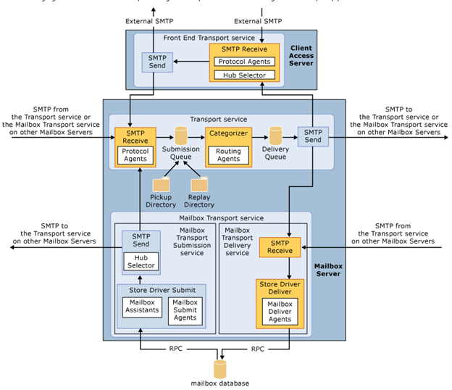(from TechNet)

5. Here are the details about the receive connectors

         When you install a Mailbox server running the Transport service, two Receive connectors are created. No additional Receive connectors are needed for typical operation, and in most cases the default  Receive connectors don’t require a configuration change. These connectors are the following:

**Default <server name>**   Accepts connections from Mailbox servers running the Transport service and from Edge servers.

**Client Proxy <server name>**   Accepts connections from front-end servers. Typically, messages are sent to a front-end server over SMTP.

          During installation, three Receive connectors are created on the Front End transport, or Client Access server. The default Front End Receive connector is configured to accept SMTP communications from all IP address ranges. Additionally, there is a Receive connector that can act as an outbound proxy for messages sent to the front-end server from Mailbox servers. Finally, there is a secure Receive connector configured to accept messages encrypted with Transport Layer Security (TLS). These connectors are the following:

**Default FrontEnd <server name>**   Accepts connections from SMTP senders over port 25. This is the common messaging entry point into your organization.

**Outbound Proxy Frontend <server name>**   Accepts messages from a Send Connector on a back-end server, with front-end proxy enabled.

         By default we don’t route the outgoing email to CAS. If we have some mailgaurd or compliance requirement on a separate CAS server then we can use it. If we have CAS and mailbox role on the  same server then we don’t need to configure this connector. We can simply disable it.

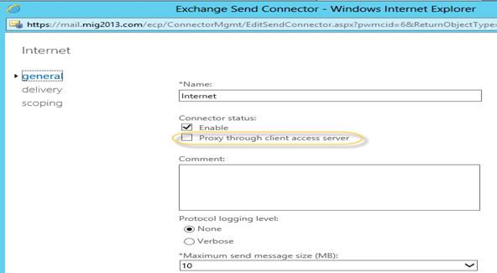

**Client Frontend <server name>**   Accepts secure connections, with Transport Layer Security (TLS) applied.

  6. So we have to configure “Default Frontend Servername” connector which is accepting the emails on port 25. Yes this is very important when you have both role on one server then Frontend will be 25 and backend will be 2525

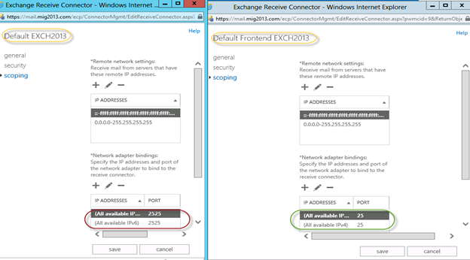

         7. You might need to check email address policies, this might needs to re-apply. If we have more than 3000 mailboxes then it is suggest applying from EMS.

         To understand the mailflow we can read the below article: [**http://msexchangeguru.com/2012/08/09/e2013-mailflow/**](http://msexchangeguru.com/2012/08/09/e2013-mailflow/)

**Exchange 2013 Certificates**

**Create a new Exchange certificate on Exchange 2013:**[**http://msexchangeguru.com/2013/01/18/e2013-certificate/**](http://msexchangeguru.com/2013/01/18/e2013-certificate/)

Certificates and CAS: Now this is the time when we need to focus on CAS certificate and ensure the CAS 2013 is reachable from internet. We have 2 options:

Use current certificate

For Export and import of the cert Please check here – <http://msexchangeguru.com/2013/06/29/import-cert-e2013/>

1. Export the cert from Exchange 2010
2. Import the cert to Exchange 2013
3. Configure the external url. This is very simple in exchange 2013. You don’t need to go to every virtual directory property.
4. Select the wrench mentioned below windows

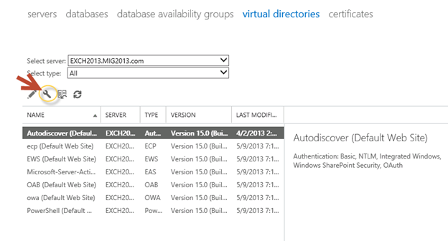

                          5. Then this wizard will open, select the exchange 2013 server and give the external url and save it.

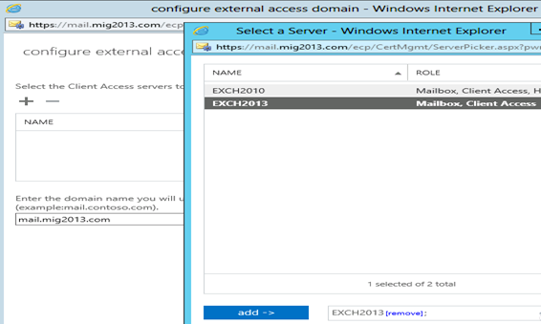

                        6. CAS Authentication will be “Use form-based authentication” on both Exchange 2013 and Exchange 2010/2007.

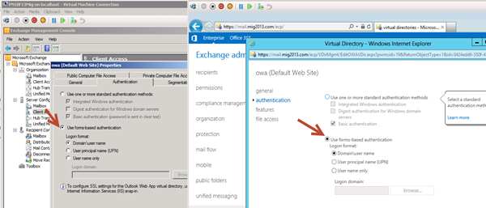

                              Now you will see every directory got the same External url.

**Database availability Group**

We would like to configure a DAG for high availability with multiple databases. So we have 2 options.

1. DAG with IP. Check the below link to create a DAG with IP

<http://msexchangeguru.com/2013/01/17/e2013-dag/>

2. DAG without IP – This needs Exchange 2013 SP1 on Windows 2012 R2

Check the below link to create IP less DAG

<http://msexchangeguru.com/2014/03/21/e2013sp1-ip-less-dag/>

Update Feb 2015: If you have 2 datacenters expanded DAG then now you can configure your FSW in Azure which means your DAG can be configurable to 3 Data center expanded automated DAG. This will allow you to completely shut down the data center without loosing production connectivity. Here is the link to configure FSW in Azure – [Using a Microsoft Azure VM as a DAG witness server](https://technet.microsoft.com/en-us/library/dn903504(v=exchg.150).aspx)

**Move Arbitration and Discovery Search mailboxes**

Follow the below steps to move all arbitration and discovery search mailboxes to final 2013 database.

Open EMS with run as administrator and run the following cmds

**Get‐Mailbox –Arbitration | New‐MoveRequest –TargetDatabase TargetDBName**

**Get-Mailbox “*Discovery*” | New‐MoveRequest  –TargetDatabase TargetDBName**

**Unified Messaging: Upgrade Exchange 2010 UM to Exchange 2013 UM**

**This is the optional step only for unified messaging configured organizations.**

Please follow the below link to upgrade exchange 2010 UM to Exchange 2013 UM

<http://technet.microsoft.com/en-us/library/dn169226(v=exchg.150).aspx>

**Configure Enabled Outlook Anywhere**

For Exchange 2007  
**Set-OutlookAnywhere -Identity “2010 CasServerNameRpc (Default Web Site)” -ClientAuthenticationMethod Basic -SSLOffloading $False -ExternalHostName mail.domain.com -IISAuthenticationMethods {NTLM,Basic}**

For Exchange 2010  
**Set-OutlookAnywhere -Identity “2010 CasServerNameRpc (Default Web Site)” -ClientAuthenticationMethod Basic -SSLOffloading $False -ExternalHostName mail.domain.com -IISAuthenticationMethods NTLM, Basic**

**Configure OAB**

Run the below command to configure OAB for all databases

**Get-MailboxDatabase | Set-MailboxDatabase -OfflineAddressBook “Default Offline Address List (Ex2013)”**

Default Offline Address List (Ex2013) can be replaced by your custom named OAB.

**Enabling and Configuring Outlook Anywhere**

For Exchange 2007  
**Get-ExchangeServer | Where {($_.AdminDisplayVersion -Like “Version 8*”) -And ($_.ServerRole -Like “*ClientAccess*”)} | Get-ClientAccessServer | Where {$_.OutlookAnywhereEnabled -Eq $False} | Enable-OutlookAnywhere -ClientAuthenticationMethod Basic -SSLOffloading $False -ExternalHostName mail.domain.com -IISAuthenticationMethods NTLM, Basic**

For Exchange 2010  
**Get-ExchangeServer | Where {($_.AdminDisplayVersion -Like “Version 14*”) -And ($_.ServerRole -Like “*ClientAccess*”)} | Get-ClientAccessServer | Where {$_.OutlookAnywhereEnabled -Eq $False} | Enable-OutlookAnywhere -ClientAuthenticationMethod Basic -SSLOffloading $False -ExternalHostName mail.domain.com -IISAuthenticationMethods NTLM, Basic**

**SCP – Service Connection Point Configuration:**

Run the below command to configure SCP on Exchange Management Shell of 2007/2010/2013 separately:

**get-ClientAccessServer | Set-ClientAccessServer -AutoDiscoverServiceInternalUri https://autodiscover.domainname/autodiscover/autodiscover.xml**

SCP might be already configured on 2007/2010 server so you can also check it and use the same -AutoDiscoverServiceInternalUri. Run the below cmd to get current SCP on 2013 Shell  
**get-ClientAccessServer | fl name,AutoDiscoverServiceInternalUri**

**RemoteDomain:**

Run the below cmd in EMS to allow auto forwarding, oof, auto reply and disable the possibility of winmail.dat from domino server.

**Set-remoteDomain -AutoReplyEnabled $True -AutoForwardEnabled $True -TNEFEnabled $False -AllowedOOFType External**

**Pop/IMAP:**

If you have pop3/imap4 users then you might like to configure 2013 for some addition configuration.

1. Configure the Basic authentication on EAC for CAS 2013

2. Start the services and change them to automatic.

**Email address policy:**

You might need this step if you organization was initially created on Exchange 2003.

1. Create a new email address policy if there is only one “Default Policy”.

2. Change the attributes of existing email address policy by running the below cmd  
**Get-emailaddresspolicy | Set-EmailAddressPolicy -RecipientFilter “Alias -ne $null” -IncludedRecipients AllRecipients**

3. If you see the below error for the default policy then Remove “Default Policy” which was created in 2003 and will be in ready only mode in Exchange 2013.

[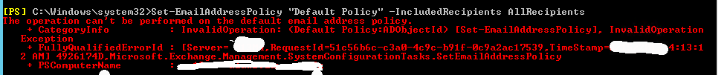](http://msexchangeguru.com/wp-content/uploads/2013/05/emailaddresspolicy-error1.png)

**Clean up health mailboxes:**

When you remove default mailbox database, it does not remove health mailboxes which we can check by running the cmd and below warning will come. Health mailboxes are for the health service and they are specific for every database so we don’t need to move them rather we need to remove them.

**Get-mailbox –monitoring**

Mailboxes/HealthMailbox94863fe5394447619ec45c4e6b2dd971 has been corrupted, and it’s in an inconsistent state.

The following validation errors happened: WARNING: Database is mandatory on UserMailbox.

**To fix this we need to delete user account in dsa.msc at yourdomain/Microsoft Exchange System Objects/Monitoring Mailboxes**

**Important:** At the point configure your outlook for Exchange 2007/2010 mailbox and 2013 mailbox. If both are working from Internet then move to the next step.

**CutOver :Updated 2007 part Feb 2015**

Now it is the time to do cutover means point the connections to Exchange 2013. It can be done in few simple steps.

1. Create or change Public and Private DNS pointers.

a. autodiscover.domain.com will be pointing to the CAS 2010/2007 or Load balancer of CAS 2010/2007. So change the IP from  Exchange  2010/2007 to 2013. In case of new installation or exchange 2007 environment we need to create new host record in DNS. This will be done on both internal and external

b. mail.domain.com (OWA/activesync/RPCoverhttp/mapioverhttp) Change the IP from Exchange 2010/2007 to Exchange 2013 CAS servers or Load balancer.

c. Create Legacy.domain.com host record in case of exchange 2007 co-existence in both public and private DNS. This will point to Exchange 2007 CAS servers or  Exchange 2007 l0ad balancer CAS VIP.

2. Point your Spam Guard to forward all the emails to exchange 2013 to receive incoming mail via Exchange 2013.

3. Configure Spam Guard to accept emails from all Exchange 2013 Mailbox servers.

4. Configure all other application to send email to the Exchange 2013 Mailbox Servers.

5. Update PTR and SPF record if Exchange 2013 are sending the emails out directly.

6. In case of Exchange 2007, we need to update the following URLs and Authentications as well.

* EWS – Run the below cmd on Exchange 2007 EMS

Get-WebServicesVirtualDirectory | Set-WebServicesVirtualDirectory -ExternalUrl [https://legacy.Domain.com/EWS/Exchange.asmx](https://legacy.wmhs.com/EWS/Exchange.asmx) -internalurl[https://legacy.Domain.com/EWS/Exchange.asmx](https://legacy.wmhs.com/EWS/Exchange.asmx)

* OWA – Run the below cmd on Exchange 2007 EMS

Get-OWAVirtualDirectory | Set-OWAVirtualDirectory -ExternalUrl [https://legacy.Domain.com/OWA](https://legacy.wmhs.com/OWA) -internalurl [https://legacy.Domain.com/OWA](https://legacy.wmhs.com/OWA)

* OWA – Run the below command to change the authentication method in Exchange 2007 EMS

Get-owaVirtualDirectory -identity “CASName1OWA (Default web site)” | Set-OwaVirtualDirectory -ExternalAuthenticationMethods FBA,basic

**Exchange 2013 Mailbox Migration**

So what are we waiting for… Let us begin the mailbox migration.

1. Now you can run the following cmdlet to move bulk or single mailbox

**Get-Mailbox –Database “Exchange 2010/2007/2007 Database” –OrganizationUnit “DN of the OU” | New-Move Request –TargetDatabase “Exchange 2013 Database”**

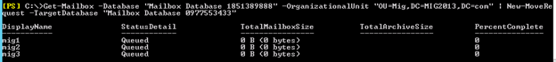

    2. You can monitor the migration by running the following cmdlet or going to the migration tab in EAC:

       Get-MoveRequest

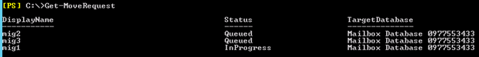

    3. Once completed it will show the below window

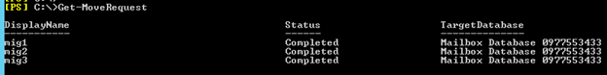

For Cross forest mailbox migration check this link: <http://msexchangeguru.com/2013/11/02/e2013crossforestmigration/>

**Public Folder Migration**

1. Once we complete all mailbox migration then we can start the Public Folders migration.

For Public Folder migration use the below Link:

<http://msexchangeguru.com/2013/04/18/exchange2013-public-folders/>

1. Test everything working and shutdown Exchange 2010/2007 server for 1 production week and observe if no issue reported then go ahead with the Exchange 2010/2007 removal process.

**Known Issues:**

Active Sync Config without Domain Name: <http://msexchangeguru.com/2013/08/06/e2013mobiledomain/>

OWA redirection broken page and SSL: <http://www.expta.com/2013/05/owa-2013-cu1-redirection-is-broken-for.html> – This was fixed in CU3

If you have pop/imap user go for CU2: <http://msexchangeguru.com/2013/08/04/e2013popimapauth/>

Mailflow misconfiguration: <http://msexchangeguru.com/2013/08/03/e2013-2010mailflowissue/>

Certifacate and cryptographic provider Issue: <http://msitpros.com/?p=1770>

**Legacy Removal**

1. Now we are in a position to remove exchange 2010. We can follow the below link for the exchange 2010/2007 removal.

<http://msexchangeguru.com/2013/09/01/e20102007decomposte2013mig/>

### Exchange 2013 CAS Role Demystified

Let’s take a deeper look into the Exchange 2013 Client Access Server Role through this article.

Even though the client access server roles where very much present in the exchange 2010 and exchange 2007, it has been transformed a lot in the latest exchange release. Exchange 2013 CAS role consists of Client Access front end role (CAFE) and the Front-End Transport (FET). The functions of CAS role has evolved from authentication, proxy/redirection logic, and performed data rendering for various Internet protocol clients in exchange 2007 to an additional data rendering for MAPI in exchange 2010. However, in exchange 2013, CAS does not have any data rendering capability any more. The functions of CAS role is now limited to authenticating and proxy redirection logic, supporting

In Exchange 2013, the Client Access server (CAS) role no longer performs any data rendering functionality. The Client Access server role now only provides authentication and proxy/redirection logic, supporting the client Internet protocols, transport, and Unified Messaging.

**Session Affinity**

Exchange 2013 does not require session affinity at the load balancer end any more. Taking a closer look at the CAS 2013 functioning will help us understand this better. The following steps happen:

1. The namespace to the load balanced virtual IP address is resolved by the client.
2. The session is assigned to a particular member of the CAS in the load balancer pool by the load balancer.
3. The request is authenticated by the CAS. it then access the Active directory to do a service discovery so that the following information can be furnished:
   1. The version of the Mailbox
   2. The location information about the Mailbox like database information, External URL values, etc.
4. Now a decision is made on if the request is to be redirected to another CAS or proxy the request by itself.
5. The CAS now determines which mailbox server is hosting the active copy by initiating an active manager instance.
6. Finally, the request is proxied to the active copy mailbox server by the CAS proxies the request to the Mailbox server hosting the active copy.

The CAS proxies the request to the mailbox server hosting the active copy using the same protocol as the one used to connect to the CAS. For example if it is HTTP that is being used by the cllient, then the CAS also utilises HTTP (via SSL).

There is an exception for 6 in case of Telephony requests. Since the telephony device requires establishing its RTP and SIP sessions with the Unified Messaging components directly, instead of proxying the request, the request is redirected to the mailbox server that hosts the active user database copy.

The fact that session affinity is no longer required by the load balancer is mainly facilitated by the step 5. During any session, CAS can now maintain an equal ratio relation with the user’s Mailbox server. Whenever the location of the active database copy changes, the CAS terminates the present session to establish a new session with the server to which the active database copy is moved. All these result in the fact that all sessions running shall be at the Mailbox server hosting the active database copy.

If the incoming request is HTTP, POP or IMAP then the request for authentication is passed through the HTTP payload. If the authentication is Forms-Based Authentication (FBA) then the encryption decryption process becomes complex. FBA cookies use a different key for different servers while encrypting. So when another server receives a request, it cannot decrypt the session. The per server decryption key is no longer used in exchange 2013. The key is now obtained from the certificates installed on the CAS. If same certificates are deployed throughout the CAS, then the decryption is possible.

**Proxy vs. Redirection**

Now the step 4 we discussed earlier deals with the decision whether the request is to be proxied or redirected. Now the redirection of requests is performed under the following circumstances:

* If the Client is a Telephony Client.
* When the mailbox location for an OWA request is in a distant active directory site and an ExternalURL is associated with the CAS in that particular active directory site then the request is redirected. However if the ExternalURL has the same value as that of the CAS to which the request was originally received then the request is proxied.
* If the mailbox version of OWA is 2007 then the request is redirected.

**Outlook Connectivity**

In order to increase the stability and the connectivity reliability, exchange 2013 houses an important architectural change. RPC/TCP is no longer an available connectivity solution. Instead, exchange now uses RPC/HTTP (Outlook Anywhere).

To understand this clearly, keep these points in mind

* The CAS role in exchange 2013 is restricted to just authentication and proxy/redirection. The data is no longer processed by the CAS. It only manages the proxying or redirection part using a specific protocol.
* CAS2013 and MBX2013 are not inter dependant on the affinity front nor are they co-located geographically. CAS can perform authentication and proxying from a particular location to a MBX2013 server located in any datacenter. For this reason the communication protocols have been modified from RPC to the protocols that offer tolerance of throughput & latency over the WAN/Internet connections – HTTPS.
* The protocol by which the request is processed is now the protocol which is being used by the mailbox server which is being used by the user’s mailbox as the active directory. This hence eliminates the need to deploy CAS2010, HT2010, and MBX2010 together to avail functionalities. And because of this shift in protocol use, FQDN is no longer required for the RPC endpoint. **This is substituted by the mailbox GUID** which is unique for an organization. Hence CAS can now detect the location and proxy the request to the correct MBX2013 server not considering of where the database is enabled and stored.

With these architectural changes comes an improved reliability in the connection model. During any session, CAS can now maintain an equal ratio relation with the user’s Mailbox server. The job of decrypting the RPC from HTTP now is rested within the mailbox server responsible for the user’s database.

Further the architectural changes now facilitate internal and external namespaces for Outlook Anywhere, hence avoiding the need to use the external firewall or load balancer to deploy split-brain DNS or deal with all Outlook clients during MAPI connectivity.

**Third-Party MAPI Products**

With all the architectural changes, third party MAPI products suffer some blows. They now have to leverage RPC/HTTP to connect to CAS in exchange 2013. Users can download MAPI/CDO which support for RPC/HTTP connectivity to facilitate third party MAPI products. However, your third-party vendor should now support RPC/HTTP.

Having said that, it is to be noted that custom MAPI/CDO solutions are supported by the exchange 2013 which may, in future require the third-party products to move to Exchange Web Services (EWS) to access Exchange data.

**Namespace Simplification**

Another distinct advantage of the improved architecture is the simplification offered to the namespace model. The previous version of exchange (Exchange 2010) used as many as 9 namespaces, namely:

1. Primary datacenter Internet protocol namespace
2. Secondary datacenter Internet protocol namespace
3. Primary datacenter Outlook Web App failback namespace
4. Secondary datacenter Outlook Web App failback namespace
5. Primary datacenter RPC Client Access namespace
6. Secondary datacenter RPC Client Access namespace
7. Autodiscover namespace
8. Legacy namespace
9. Transport namespace (if doing ad-hoc encryption or partner-to-partner encryption)

Since exchange 2013 no longer utilises RPC, the 5th and 6th namespaces are eliminated. Now, since the request is proxied to the active database copy’s mailbox server, the proxy logic spans beyond the active directory site borders. CAS can now proxy requests across multiple mailbox servers and AD sites. This in turn results in the elimination of 3 more namespaces- 2nd, 3rd and 4th.

**Transport**

All SMTP sessions in the exchange 2013 is handled by the Front-End Transport service. Besides managing the incoming and outgoing SMTP traffic for the organization, it act as a client endpoint for SMTP traffic. It act as a layer 7 proxy and has full access to the protocol conversation. It is stateless, cannot perform message bifurcation and does not have a message queue.

With the front end transport service, the exchange avails a centralized and load balanced egress or ingress terminal, a network protected system, regardless of the kind of client accessing it – sharepoint, POP/IMAP Clients, third-party or even external SMTP systems.

Front end transport service act as a proxy for outgoing messages if the FrontEndProxyEnabled property is set for Send Connecters located on the mailbox server. These messages will look like they are coming from a CAS of exchange 2013 system.

If there is an incoming message to the front end transport service, it should reach an unoccupied transport service on a mailbox service so as to receive the incoming message without considering the type of recipients:

* If the message is to a single recipient, a mailbox server in the delivery group is selected and the one closest in proximity to the active directory site is preferred.
* If there are more than one recipients, the first twenty recipients are used to select the closest to the active directory site.
* The message is transferred to a random mailbox server if the recipient is not specified.

**Conclusion**

Through this article we have seen that the CAS role in Exchange 2013 removes the requirement of session affinity at load balancer, simplifies the network layer and also achieve namespace simplification and hence deployment flexibility.

### RPC Client Access Service keeps restarting in Exchange 2013

Let’s see how to address and issue where RPC Client Access Service keeps restarting on Exchange 2013 server with / without CU1.

Event log will show the below error:

**The Microsoft Exchange RPC Client Access service terminated unexpectedly.  It has done this 1 time(s).  The following corrective action will be taken in 5000 milliseconds: Restart the service.**

The service restarts by itself but it becomes annoying for the users because they will get an offline/online popup box in outlook.

This is an issue which occurs in only few environments and not in every environment so this might not occur in your environment.

There is no need of applying this fix until you face this issue.

**Solution:**

1. This can be fixed by adding the following registry key. Here are the steps:

1. On windows 2008 → Click on start → Run or on windows 2012 open command prompt with run as administrator
2. Type regedit and hit enter
3. Go to the following location

HKEY_LOCAL_MACHINESoftwarePoliciesMicrosoftWindows NT

1. Right Click and select new Dword Value
2. Type MinimumConnectionTimeout with the decimal value 120
3. Close regedit and restart the server.

or

2. This can also be fixed by the below solution:

Change the log on account of MS Exchange RPC Client Access service from “system account” to “Netwotk Service” account.

or

3. Another fix for this issue is here:

Stop and Start the Microsoft Exchange Health Manager service.

Issue should get fixed. **use at your own risk**

**What the Health Manager Service does?**

Exchange 2013 introduced “managed availability process” which monitors the server and performs automated troubleshooting tasks if it finds an issue with any of the components. MA runs within the Microsoft Exchange Health Manager service. Play with Get-ServerComponentState –Identity ServerName to know about Server Components and its current state.

### Exchange 2013 High Availability demystified

With the emerging global economy, organizations of every kind in any part of the world are evidently becoming more and more dependent on IT to be connected. The very popular and significant form of being connected is email. Having said that, it establishes clearly that how significant Exchange as a business critical application is for an organization. Microsoft has been bringing about radical changes with every version of Exchange resulting in unprecedented performance benefits armed with availability. With Exchange 2010, we experienced stupendous features like DAG for high availability within single/multiple datacenter coupled with dedicated site resilient and disaster recovery capabilities across multiple datacenter’s.

What Microsoft gets on the table this time for us with Exchange 2013, is exciting enhancements for High Availability, definitely this is in addition to architectural enhancements. In this article, we are going to focus exclusively around various aspects of High Availability in Exchange 2013.

High Availability is a very convenient, loosely used term. It definitely isn’t a technology or a product feature, rather a state that needs to be achieved in times of failure or disruptions.

In this article, we are trying to present to very specifically how Microsoft’s Exchange 2013’s High Availability works in the background scenes to give you a comprehensive experience for your IT and Business requirements.

Exchange 2013 uses a combination of workload-sharing solutions spread across multiple elements listed below

a. Managed Availability

b. Maintenance mode

c. Best Copy Selection Changes

d. Cmdlet Enhancements

e. DAG Network Auto-Config

f. Auto Reseed

g. Site Resilience

h. Multiple Databases per volume

i. Safety Net

**Managed Availability**

The architectural enhancement in Exchange 2013, calls for a more superior HA mechanism. Managed availability provides a monitoring framework for all Exchange components. It provides a broader perspective in reliability and scalability across servers. It is a proactive mechanism that lets you manage availability thru a series of sequencing operations to control when recovery actions are performed rather than in a scenario when alert is issued. In short, Managed Availability is all about the activity that helps you to “recover”, and not “find out” the root cause of an issue.

Managed Availability is process that runs internally on all servers in two forms,

1. Exchange Health Manager Service (MSExchangeHMHost.exe) which manages the workers process (which could range from start, stop, build, execute). It also prevents the worker process from being a single of point of failure by assisting in recovery.
2. Exchange Health Manager Worker (MSExchangeHMHost.exe) process which performs the runtime tasks.

Let’s now understand how Managed Availability achieves this recovery process!

Managed Availability has three components namely-> probe engine, monitor and responder engine. The probe engine works with the servers to collect data probes, checks and notification logic. Probes are the activities done to detect the user experience, Checks are the infrastructure that perform the analysis on traffic, spikes and the Notification Logic enables the logic on which decisions can be made for action by the system.

The probe engine then passes this information to Monitor. What Monitor does is, it attempts finding out a pattern in the submitted data. Monitor achieves the pattern identification on the basis of predefined business logic to determine if a system is healthy or not. It also defines the time and the workflow process in case of a recovery. From a system perspective, Monitor has two states -> healthy and unhealthy and from an admin perspective, Monitor has four states -> degraded, disabled, repairing and unavailable.

Responder enginegets into the picture when a servers gets labeled as being in a “unhealthy state”. In short, it is responsible for executing the response action to the alert detected.

**Health Set= Probe Engine+Monitor+Responder Engine**

NOTE: Probe Engine, Monitor and Responder engine have all threshold values which can be adjusted based on your environment requirements.

**Maintenance Mode**

This functionality lets you designate a server as in-service or out-of-service thru the cmdlet Set-ServerComponentState.

Separate tracking for:

Health –> MA triggered

Sidelined –> operator initiated

Functional –> setup running

Deployment –> machine being configured

**Best Copy Selection Changes:**

In Exchange 2010, scenarios of fail-over or seamless transition, the would allocate the server for transition without an analysis on the current capacity of the server. Chances are that if the server’s current capacity if full, the transition would fail during the mount point and again another server would have to be tried upon. We could however use the cmdlet:

**Set-MailboxServer “ServerName” –MaximumActiveDatabases 20**

to ensure no more than 20 mailbox database will be active on that server at any given point.

In Exchange 2013, the Primary Active Manager keeps track of the number of active databases/server. Thus when Exchange replication service is restarted or Primary Active Manager moves to a different server, this information gets rebuilt from cluster database. Thus this enhancement definitely allows us to isolate fully loaded servers in the first place.

But the question still remains, how does this work behind the scenes? Let’s try to understand this.

Exchange 2013 uses “Best Copy and Server Selection (BCSS) algorithm” to choose the best copy of a database and in Exchange 2010, Best Copy Selection (BCS) algorithm was used. The factors that are taken into account in BCSS make the failover much more smarter involving health of the hosting server at its focus. This strongly indicates that no failover will try to push a server to a state beyond what it can hold. Exchange 2013 evaluates the entire protocol stack thru Managed Availability sets. It examines the destination server. As a result of taking multiple factors for server, it is appropriately called as **Best Copy and Server Selection** in Exchange 2013.

Furthermore, let’s find out now how does the identification/checks happen.

i. All Healthy– checks for server hosting a copy of the database having all monitoring elements in a healthy state.

ii. Up to Normal Healthy– checks for a server hosting a copy of the database having all monitoring elements with a Normal priority in a healthy state.

iii. All Better than Source- checks for server hosting a copy of the database having all monitoring elements in a state better than the current server.

iv. Same as Source- checks for server hosting a copy of the database having all monitoring elements in a state same as the current server.

**Cmdlet Enhancements:**

Today health benefits are vital not just for human beings but servers too. Keeping a health check on your Exchange Server to a deeper extent is now possible thru the cmdlets introduced in this version. There are multiple cmdlets that are available but we will discuss few significant ones -> Get-ServerHealth and Get-HealthReport.

Managed Availabilityis the new monitoring and recovery framework in this version.

**Get-ServerHealth** cmdlet displays the various health stats with values as degraded, repairing, unhealthy, disabled, uninitialised or unavailable.

**Get-HealthReport** cmdlet provides a summary report of health by using an Identity parameter,instead of InputObject/InputEntries. It returns health values as online, partially online, offline, sidelined, functional, or unavailable.

**Update-MailboxDatabaseCopy** cmdlet has multiple parameters for enable automation in seeding activities. The parameter that can be used are BeginSeed, MaximumSeedsInParallel, Server and SafeDeleteExistingFiles.

**DAG Network Auto-Config**

Exchange 2013 provides DAG Network Auto-Config, which means the manual tasks that had to be performed in Exchange 2010 are no longer required. Based on configuration settings, DAG’s can be automatically configured. They also have the capability to distinguish between a MAPI and replication networks.

Exchange 2013 automatically collapses DAG networks provided the config settings are correct.

Exchange Management Shell lets you view DAG Network settings in auto-config mode and Exchange Administration Center lets you to view, create, edit in manual mode.

**Exchange 2013 database AutoReseed:**

This feature lets you automatically restore a database redundancy in case of a disk failure by using spare disks available on the system. It supports 8 databases per volume. It has been added in AD, which essentially means that you could enable/disable it in AD itself. But the question remains, how does this feature detect a failure and how does it do the restoration? Let’s understand that.

The condition that needs to enable AutoReseed feature is that it should detect a database copy in “Failed & Suspended” state for 15 minutes. The system will first try to resume database copy until 3 occasions, with a lag of 5 minutes sleep each. So during this time frame, if the database copy doesn’t resume within 10 minutes, AutoReseed assumes that it has to execute the next step of allocating a spare disk. But before doing that, it performs a series of pre-checks which are as below:

i. Naming conventions match

ii. Database and log files are on the same volume

iii. Availability of a spare disk

iv. Verify that all copies are in a F&S State

Post all this, the AutoReseed will try to allocate a spare disk upto 5 times, with a lag of one hour each. It will now try to perform the InPlaceSeed operation.

This feature additionally also provides better tracking mechanism for mount paths and Exchange volume path.

In short, this feature will let you remap multiple databases for reseeding in parallel.

**Site Resilience:**

Exchange 2010 employed DAC mode for site resiliency and disaster recovery purposes. With Exchange 2013 the exchange product team has taken this to the next level allowing an automatic failover in the event of a failure. This means, there is no manual intervention to perform switch overs during datacenter failovers. Say in Exchange 2010 if the load balancer fails or the VIP of the CAS Array isn’t available, we had to perform datacenter switchover in most cases. This was mainly because Exchange 2010 DAG’s and CAS array were coupled together. With Exchange 2013 if you lose your CASArray, with proper planning in place your Outlook clients are automatically redirected to a second datacenter that has Client Access servers, and those Client Access servers proxy the requests back to the user’s Mailbox server, which remains unaffected by the outage.

With Exchange 2013, the namespace doesn’t need to move with the DAG. Exchange 2013 uses multiple ip addresses which helps with fault tolerance for namespace. This means the namespace is no longer a single point of failure as it was in Exchange 2010. In Exchange 2010, perhaps the biggest single point of failure in the messaging system is the FQDN that you give to users because it tells the user where to go. In the Exchange 2010 paradigm, changing where that FQDN goes isn’t easy because you have to change DNS, and then handle DNS latency, which in some parts of the world is challenging. And you have name caches in browsers that are typically about 30 minutes or more that also have to be handled.

**Multiple Databases per volume:**

This feature lets you have both active and passive databases on the same volume.

**Exchange 2013 Safety Net**

A feature that facilitates data recovery as well as provide for compliances in previous versions of Exchange 2010 and Exchange 2007 was set on the Hub transport server. All incoming and outgoing messages must go through the Hub transport before it reaches a mailbox.

Transport Dumpster is a feature of the Hub Transport of Exchange 2010 which limits the data losses during a lossy failover occurrence while mail delivery to a DAG. Transport dumpster was first seen in CCR and LCR mailboxes of exchange 2007.

One of the limitations of transport dumpster is that it can be used only for replicated mailboxes and not public folders or mailboxes that aren’t a part of the DAG. All Hub transport servers in the active directory sites of the DAG contains the transport dumpster queue for a particular mailbox and the dumpster is stored inside the mail.que file.

With the Exchange 2013, Microsoft replaced the transport dumpster with an improved and even better – Safety Net.

How Safety Net Works

Safety Net can be considered to be having two parts- Shadow Redundancy and Safety Net Redundancy.

While the safety Net keeps a redundant copy of a message after it is successfully processed, shadow redundancy keeps a redundant copy of the message which is in transit. All features of shadow redundancy like transport high availability boundary, primary messages, primary servers, shadow messages and shadow servers will be applicable to Safety Net.

The Primary Safety Net is applicable for a Mailbox server that holds the primary message before the Transport service completely processes the message. Once the processing of the message is over, the primary server moves the message to the Primary Safety Net from the active queue on the same server.

The Shadow Safety Net is applicable to the Mailbox server which holds the shadow message. Once the shadow server receives the information that the primary server has successfully processed the primary message, the shadow message is moved to the shadow safety net from the shadow queue on the server. For the Shadow Safety Net operation, shadow redundancy should be enabled, and shadow redundancy is enabled by default in Exchange 2013.

Similarities between Safety Net and Transport Dumpster

Just as in a transport dumpster, safety Net is also a queue that is related to the Transport service on a Mailbox server

It stores copies of messages already processed by the mailbox

The duration for which the messages remain in the queue can be specified as in a dumpster. The default is 2 days

Why Safety Net is better than Transport Dumpster

Safety Net is not just applicable for DAGs but also for Public Folders and other Mailboxes which are not a part of DAGs unlike a transport dumpster

Due to the redundant nature of Safety Net it is never a single point of failure. Because of the availability of the Primary Safety Net and the Shadow Safety Net, even if the Primary Safety Net is unavailable for more than 12 hours, resubmit requests are forwarded to shadow resubmit and act as shadow resubmit requests, and messages are re-delivered from the Shadow Safety Net thus ensuring message delivery even if one of the safety net fails

Another advantage of safety net is that safety net do net limit the message storage based on size but only by duration. For example if you set 12 days as the duration limit, the messages will be deleted only after 12 days of being in the inbox

Safety Net does not require manual resubmission of messages. Message resubmission is initiated by the Active Manager component of the Microsoft Exchange Replication service.

**Conclusion:**

Email is undoubtedly the most mission critical application in organizations of any size. With a properly architected Exchange 2013 deployment coupled with these many stupendous high availability features, Microsoft has indeed taken Exchange Server 2013 to new heights in order to retain, protect and make your corporate messaging data secure and available at all times.

### Load Balancing Exchange Server 2013 – Good to know stuff

Load Balancing is the distribution of workload across different available servers, so as to accomplish optimal resource utilization, maximized throughput, minimized response time and avoidance of overload. They are referred to as Application Delivery Controller.

With Load Balancing we can increase the capacity by allocating more servers under the load balancing thereby enhancing the traffic handling capacity. This will also result in High availability. When a server failure occurs, the load balancer will redirect traffic to other servers under the load balancer.

SSL Offloading is supported in Exchange 2013 post service pack 1. – update 7/4/2014

**Additional Options Available Under Load Balancing**

* SSL Offloading- Through SSL offloading, the load balancer will re-crypt/decrypt the SSL traffic from clients. This thus offloads the task of decryption/re-cryption from the application server saving essential application server resources.
* Maintenance Mode- When a server is marked under maintenance mode, no traffic is sent to that server. This can be particularly useful in cache servers.
* Caching- Facilitates cache application items that are required frequently eliminating the need to reload them.
* Compression- Enables traffic Compression
* Pre-Authentication- As the name suggests, with this option exchange can pre authenticate users before allowing them access to servers.
* Service Aware- With this feature, the load balancer checks the availability status of a server before sending traffic to it.

**update 7/4/2014**

**Essential Components**

Service has its own Persistence settings, Distribution Settings, Time Out Settings and SSL Offloading settings. Multiple services can be configured in the load balancer to publish the exchange services. Virtual IP Address (VIP) is attached to the service. Each service will have a unique VIP. It is through this VIP that applications connect to its attached service. Behind the service are the Server/Nodes/Members. These can be given to more than one service.

* VIP
* Services
* Server/Nodes/Members

**Principals**

We shall now look into the different principles involved in Load Balancer in Exchange 2013.

**Persistence / Affinity / Stickiness**

Since there are multiple servers available when using load balancer, traffic may not always be sent to the same server which will result in increased network traffic. But to avoid this, persistence is used in load balancer which ensures that traffic is sent to the same server.

Different Types of Persistence Are:

* Source IP
* HTTP Cookie
* SSL ID
* Hash Persistence

In Source IP, persistence is based on the source IP address.

In HTTP Cookie based persistence, an http cookie is generated to track the server by identifying the session.

In SSL ID based persistence, an SSL ID is used to track the session.

In Hash Persistence a Hash is used to track the server.

**Distribution**

Load balancing of traffic among servers is done by distribution. Different types of distribution are:

* Round Robin- It uses basic round robin technique to choose the server.
* Weighted Round Robin- In weighted round robin, the weight pulled on the server is also considered while performing round robin calculations.
* Least Connections- It routes the traffic to the server with least connections. This mechanism however shows issues while rebooting the cache server as cache server will use many connections while rebooting.
* Least Response Time- It routes traffic to the server with quickest response time.

**SSL Offloading**

Through SSL offloading, the load balancers will re-crypt/decrypt the SSL traffic from clients. This thus offloads the task of decryption/re-cryption from the application server saving essential application server resources. Thus the CAS is now free from performing decryption and encryption, hence freeing considerable amount of processor utilization from it. Also, SSL can be applied between Load Balancer and Exchange. Here, exchange will send SSL encrypted data to load balancer. Load balancer encrypts it, re crypts it and sends it to exchange. And finally system without Offloading only permits 2 types of persistence- Source IP and SSL Session whereas a system with SSL Offloading permits all persistence schemes.

**Layer 4**

Layer 4 is the external network layer. It works on the data in the network and transport layer. They require lesser resources and have a better performance.

**Layer 7**

Layer 7 acts in the application layer of the server model. It is application aware, requiring decryption of the traffic.

**Routing Options**

* Source Address Network Translation (SNAT)

The Source address of the incoming packet is modified. The IP address of the client is hidden. This however poises issues while trouble shooting.

* Load Balancer Default Gateway

In this technique, the default gateway of the server is pointed to the VIP of load balancer.

* Direct Server Return

In this schema, all incoming requests are passed through the load balancer. This requires a local loopback interface on server, which does not answer to ARP requests. The loopback interface is configured with the VIP of the load balancer.

**Possible Configurations**

* One Armed

In ONE ARMED configurations both clients/servers and VIP are housed in the same subnet. The available routing options are:

* + SNAT
  + Direct Server Return
* Two Armed

A two armed configuration requires 2 networks and separate VLAN for each exchange servers. The routing options available are:

* + Load Balancer Default Gateway
  + Direct Server Return.

**What’s New In Exchange 2013 Load balancing**

* Session Affinity No Longer required
* Layer 7 Load balancing no longer required
* Only CAS needs to be load balanced
* Health Check for Workloads

**Features Retained**

Can load balance same workloads

**Available Configurations**

* Single VIP

In single VIP a single VIP is used to publish all protocols and they share the same settings. Layer 7 of the network model will be used to find out the destination.

* Multiple VIP

A separate VIP can be assigned to each protocol. Each protocol can hence be assigned specific settings.

While single VIP is easier to configure as it has only one rule, features like scale out and scale up, logging options, client traffic segmentation are not available in single VIP. Multiple VIP has all these features and enhanced persistence capabilities and multiple availability protocols. But it requires multiple IP address.

### Exchange CAS high availability with Windows NLB

Application availability is getting super critical these days. Most of them can be clustered but there are still few applications which can’t be clustered. So we have Network load balance hardware devices but not every organization is happy to invest in NLB device just for Exchange CAS. For these organizations the solution is windows NLB and Microsoft fully support it. Let us see how we configure Windows NLB for 2 nodes.

**Infrastructure Configuration for this article:**

Yes, prepare the below values for your NLB.

1. Server Names: **CAS1 and CAS1**
2. CAS1 NLB NIC IP Address:**10.10.10.10**
3. CAS2 NLB NIC IP Address**: 10.10.10.20**
4. NLB IP Address:**10.10.10.40**
5. Subnet mask:**255.255.255.0**
6. CAS URL/NLB NAME:**mail.msexchangeguru.com**

**Configure NLB Cluster –**Follow the below steps on both the Servers.

* 1. This should be the Secondary NIC for NLB but in the same production network.
  2. Configure the IP address and subnet mask only. No DNS and WINS.
     1. In Advanced’s DNS tab, confirm checkbox for **Register this connection’s addresses in DNS** is unchecked
     2. In Advanced’s WINS tab, ensure **Disable NetBIOS over TCP/IP** is checked
  3. NLB Configuration Steps:
     + 1. Validate required NICbinding order onCAS1 andCAS2
       2. Otherwise, reorder the NICs so they occupy the first and second positions
       3. Save settings by clicking **OK** and close Network Connections Applet

**Install Network Load –**Follow the below steps on both the Servers

* + 1. Click on **Start | Administrative Tools | Server Manager**Balancing Service on Click on **Features | Add Features**  In the Add Features wizard, check **Network Load Balancing** checkbox Click **Install**
    2. Close once installed.

**Create a new NLB**

* + 1. On **CAS1**, click on **Start | Administrative Tools | Network Load** **Balancing Manager**
    2. From the NLB console, right‐click **Network Load Balancing Clusters**
    3. Click **New Cluster**
    4. In **Host** field, enter **CAS1 FQDN**; cas1.msexchangeguru.com click **Connect**
    5. Choose the **NLB NIC** (Interface IP 10.10.10.10); click **Next** | **Add**
    6. In **Add IP Address** dialog box, enter **10.10.10.40** on IPv4 address
    7. For Subnet mask, enter **255.255.255.0**; click **OK | Next**
    8. In **New cluster: Cluster Parameters** dialog box, confirm cluster IP address
    9. On Full Internet name, enter **OWA URL “mail.msexchangeguru.com”**
    10. On Client operations mode, choose **unicast**; click **Next**[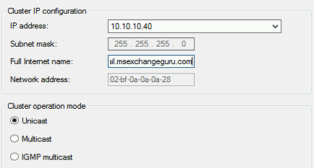](http://msexchangeguru.com/wp-content/uploads/2013/08/NLB1.png)
    11. In **Add/Edit Port Rule** dialog box, allow all port then Click **Finish**
    12. Allow the new NLB cluster to converge; after convergence, the cluster status should say **Success** and with a **GREEN** icon next to it.
    13. From CAS**2**, confirm **OWA URL “mail.msexchangeguru.com”** responds with the cluster IP **10.10.10.40**; otherwise determine dns issue and resolve the issue.
    14. Add the second node On NLB Manager console.
    15. Right‐click **OWA URL** Cluster Name
    16. Click **Add Host to Cluster**
    17. Type in **Server 2 FQDN** cas2.msexchangeguru.com in the Host field then click **Connect**
    18. Choose the **NLB NIC** (interface IP 10.10.10.20) then click **Next and Next**
    19. Leave all settings at default; click **Finish**
    20. Allow CAS2 to converge with the cluster; after convergence, the cluster status should say **Success** and with a **GREEN** icon next to it

**Verify NLB:**

* + 1. Stop Windows NLB service on CAS1 then From CAS**2**, confirm OWA URL responds with the cluster IP **10.10.10.40 and owa page is opening**; otherwise determine and resolve the issue.
    2. Restart Windows NLB service on CAS1 and allow the cluster nodes to converge successfully.
    3. Stop Windows NLB service on CAS2 then From CAS1, confirm OWA URL responds with the cluster IP **10.10.10.40 and owa page is opening**; otherwise determine and resolve the issue.
    4. Restart Windows NLB service on CAS2 and allow the cluster nodes to converge successfully.

**Configure the MAC address to the VM NLB NIC**

If you have virtualized CAS then follow this step

* + 1. Go to NLB Manager à Cluster Properties à Clusters Parameters Tab and write down the Network address for the NLB cluster. Which is like 02-BF-0A-0A-0A-28
    2. Shut down the NLB cluster VMs one by one (make sure you don’t shutdown both CAS at a time) then in Hyper-V Manager, manually configure the network adapters that you added to the VMs for the NLB cluster to use a static MAC address that matches the NLB network address: 02-BF-0A-0A-0A-28.
    3. Check the checkbox “Enable Spoofing of MAC Addresses”[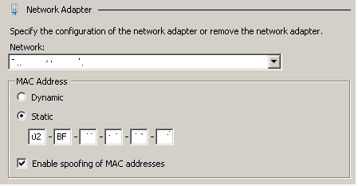](http://msexchangeguru.com/wp-content/uploads/2013/08/NLB.png)
    4. Restart the CAS Server VMs in Hyper-V Manager.
    5. Confirm successful NLB cluster convergence status one more time.

**NIC Forwarding**

Run the below command on both the servers so that NLB can forward OWA request to Prod NIC

This is a very important step, if you have missed this then NLB will not be able to forward the CAS request to Production NIC and no app will open.

1. Open the cmd prompt with Run as Administrator and run the below cmd.

**netsh interface ipv4 set interface “NLB Interface” forwarding=enabled**

**NLB should be working fine at this moment.**

Recently I was helping a customer who decided to stick to only 2 servers with all the roles in it. Then he end up asking high availability for CAS as well on the same setup. I decide to explain the unsupported configuration which I am mentioning here but **Microsoft/MsExchangeGuru will not support any issue or loss caused by this**. So use this configuration at your own risk.

**For such setup we can change their CAS/Transport internal NAT IP to the DAG Cluster IP/Name (CNO).**

### How to install Exchange 2013

Follow the below steps to install Exchange 2013 RTM

**Step 1: Windows Installation**

1. Install the windows 2012 server or Windows 2008 R2 SP1.
2. Run the windows update and install all the recommended updates.
3. Join the server to the Domain
4. Restart the server

**Step 2: Preparing windows server for the Exchange 2013**

1. Install the following prerequisites

**For Windows 2012:**

* 1. Open Windows PowerShell.
  2. Run the following command to install the required Windows components.

Install-WindowsFeature AS-HTTP-Activation, Desktop-Experience, NET-Framework-45-Features, RPC-over-HTTP-proxy, RSAT-Clustering, RSAT-Clustering-CmdInterface, RSAT-Clustering-Mgmt, RSAT-Clustering-PowerShell, Web-Mgmt-Console, WAS-Process-Model, Web-Asp-Net45, Web-Basic-Auth, Web-Client-Auth, Web-Digest-Auth, Web-Dir-Browsing, Web-Dyn-Compression, Web-Http-Errors, Web-Http-Logging, Web-Http-Redirect, Web-Http-Tracing, Web-ISAPI-Ext, Web-ISAPI-Filter, Web-Lgcy-Mgmt-Console, Web-Metabase, Web-Mgmt-Console, Web-Mgmt-Service, Web-Net-Ext45, Web-Request-Monitor, Web-Server, Web-Stat-Compression, Web-Static-Content, Web-Windows-Auth, Web-WMI, Windows-Identity-Foundation

* 1. Restart the server.
  2. [Microsoft Unified Communications Managed API 4.0, Core Runtime 64-bit](http://go.microsoft.com/fwlink/p/?linkId=258269)

<http://www.microsoft.com/en-us/download/details.aspx?id=34992>

* 1. [Microsoft Office 2010 Filter Pack 64 bit](http://go.microsoft.com/fwlink/p/?linkID=191548)

<http://www.microsoft.com/en-us/download/details.aspx?id=17062>

* 1. [Microsoft Office 2010 Filter Pack SP1 64 bit](http://go.microsoft.com/fwlink/p/?LinkId=254043)

<http://www.microsoft.com/en-us/download/details.aspx?id=26604>

**For Windows 2008:**

* 1. Open Windows PowerShell.
  2. Run the following command to load the Server Manager module.

Import-Module ServerManager

* 1. Run the following command to install the required Windows components.

    Add-WindowsFeature Desktop-Experience, NET-Framework, NET-HTTP-Activation, RPC-over-HTTP-proxy, RSAT-Clustering, RSAT-Web-Server, WAS-Process-Model, Web-Asp-Net, Web-Basic-Auth, Web-Client-Auth, Web-Digest-Auth, Web-Dir-Browsing, Web-Dyn-Compression, Web-Http-Errors, Web-Http-Logging, Web-Http-Redirect, Web-Http-Tracing, Web-ISAPI-Ext, Web-ISAPI-Filter, Web-Lgcy-Mgmt-Console, Web-Metabase, Web-Mgmt-Console, Web-Mgmt-Service, Web-Net-Ext, Web-Request-Monitor, Web-Server, Web-Stat-Compression, Web-Static-Content, Web-Windows-Auth, Web-WMI

* 1. Restart the server
  2. [Microsoft .NET Framework 4.5](http://go.microsoft.com/fwlink/p/?LinkId=257868)

<http://msdn.microsoft.com/en-us/library/5a4x27ek(VS.110).aspx>

* 1. [Windows Management Framework 3.0](http://go.microsoft.com/fwlink/?LinkId=272757)

<http://www.microsoft.com/en-us/download/details.aspx?id=34595>

* 1. Microsoft Unified Communications Managed API 4.0, Core Runtime 64-bit

<http://www.microsoft.com/en-us/download/details.aspx?id=34992>

* 1. [Microsoft Office 2010 Filter Pack 64 bit](http://go.microsoft.com/fwlink/p/?linkID=191548)

<http://www.microsoft.com/en-us/download/details.aspx?id=17062>

* 1. [Microsoft Office 2010 Filter Pack SP1 64 bit](http://go.microsoft.com/fwlink/p/?LinkId=254043)

<http://www.microsoft.com/en-us/download/details.aspx?id=26604>

* 1. [Microsoft Knowledge Base article KB974405 (Windows Identity Foundation)](http://go.microsoft.com/fwlink/?linkid=3052&kbid=974405)

<http://support.microsoft.com/?kbid=974405&wa=wsignin1.0>

* 1. [Knowledge Base article KB2619234 (Enable the Association Cookie/GUID that is used by RPC over HTTP to also be used at the RPC layer in Windows 7 and in Windows Server 2008 R2)](http://go.microsoft.com/fwlink/?linkid=3052&kbid=2619234)

<http://support.microsoft.com/?kbid=2619234>

* 1. [Knowledge Base article KB2533623 (Insecure library loading could allow remote code execution)](http://go.microsoft.com/fwlink/?linkid=3052&kbid=2533623)

<http://support.microsoft.com/?kbid=2533623>

1. Restart the server before next step.

**Step 3: Preparing Active Directory:**

           Points to be noted:

-We need to update the schema on the schema master.

-We need to use Schema Admins and Enterprise Admins permission user account for future task.

-We need to update the AD domains in multiple domain environment. We can use different switch for different requirement.

-First deploy Exchange 2013 in the internet facing site then other site.

-Active Directory pepareation Server should have following software installed if it is 2008. 2012 comes ready with it and need to added from roles and features.

* [Microsoft .NET Framework 4.5](http://go.microsoft.com/fwlink/p/?LinkId=257868)
* [Windows Management Framework 3.0](http://go.microsoft.com/fwlink/?LinkId=272757)

Steps:

1. Log in to the Member server, open the command prompt with run as administrator and run the following cmdlet to update schema.

-We need to install AD management tool to update schema so that it can read ldf files.  Open powershell with run as administrator and run the below command.

            On 2012:  Install-WindowsFeature RSAT-ADDS

           On 2008: Add-WindowsFeature RSAT-ADDS

-There is no setup.com and it is only setup.exe

           “Setup.exe /prepareschema /IAcceptExchangeServerLicenseTerms”

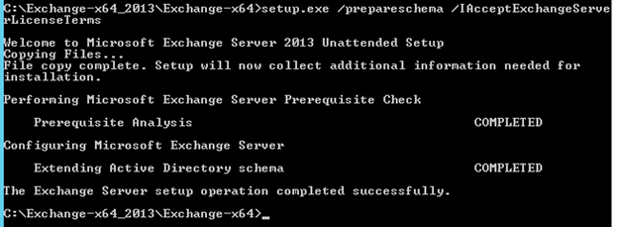

2. Run the below command to update Active Directory

**Important:** We will not be able install exchange 2010 after this step. See the warning.

**“setup.exe /PrepareAD /IAcceptExchangeServerLicenseTerms /OrganizationName:”GiveTheORGName””**

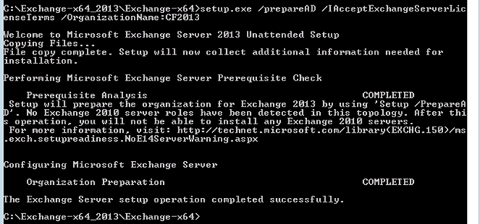

3. Run the below command in every Exchange user domain

 -If we have only one domain then this command is not required.

 -If we have to multiple domain and some of the domain will not use exchange then run the below command in all the exchange domains.

**“setup.exe /PrepareDomain /IAcceptExchangeServerLicenseTerms”**

Else run the below command to prepare all domains.

**“setup.exe /PrepareAllDomains /IAcceptExchangeServerLicenseTerms”**

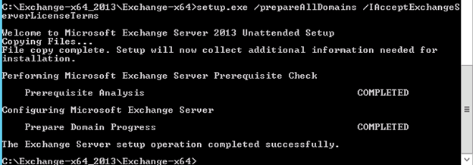

**Step 4: Exchange 2013 Deployment:**

        1. Run the setup.exe with run as administrator and click next on the below screen

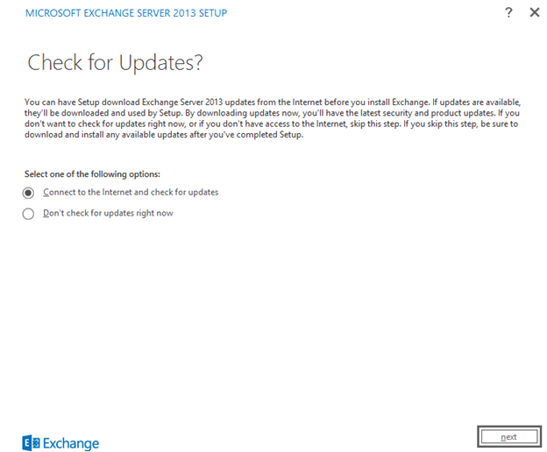

        2. Click next here

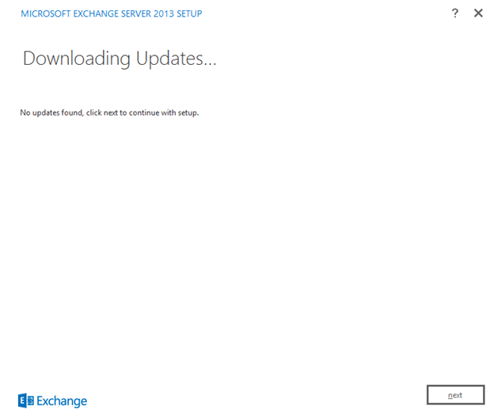

        3. Now setup will copy the files and initialize the setup. Click next once setup initialize and you see Introduction page.

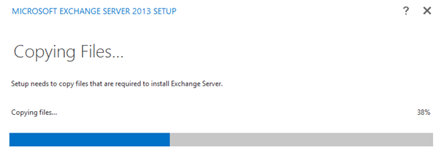

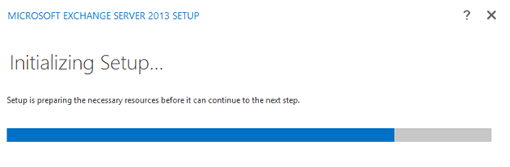

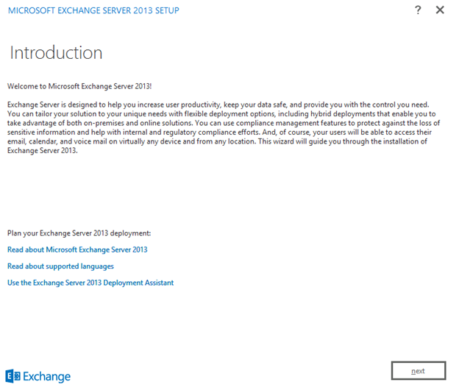

        4. Select the license term and click next here.

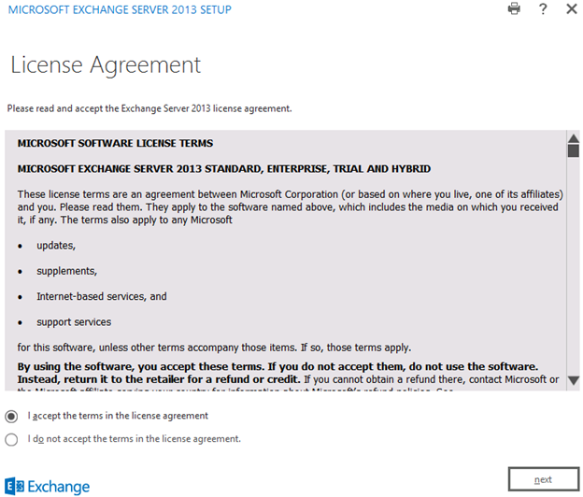

        5. Select “Don’t use recommended settings” and click next.

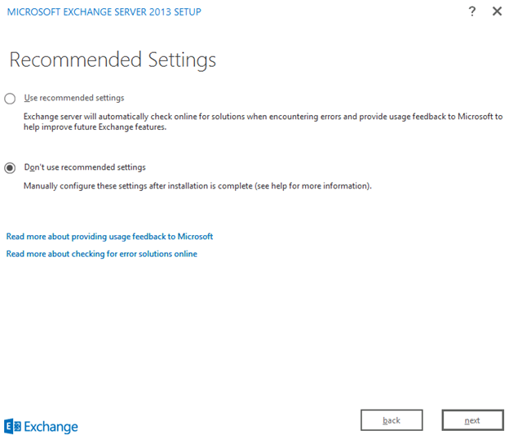

        6. Select the Role and click next. I am installing both CAS and MBX on the same server.

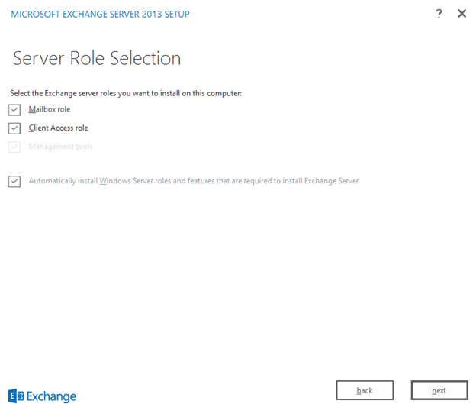

        7. Select the installation drivedirectory then click next.

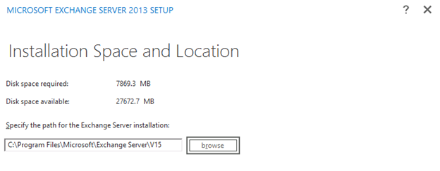

        8. Change if you wish to do mailware scanning and click next

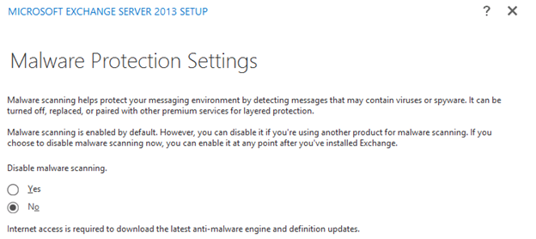

        9. Now Readiness check will run. Once Readiness check completes, click Install

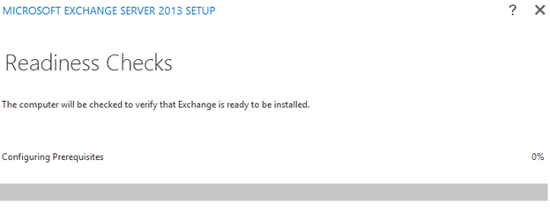

        10. I have my lab Exchange on a Domain Controller so I got this warning but in production we should not see any warning or error

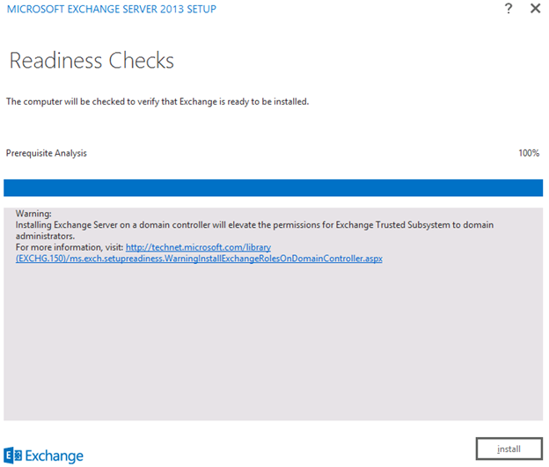

        11. Now Exchange will Run 14 steps for the Installation. This will take an hour or so depends on the hardware so you can take a lunch break and when you will be back you will see your exchange   server is ready for use.

        12. When you see then below screen, click on finish.

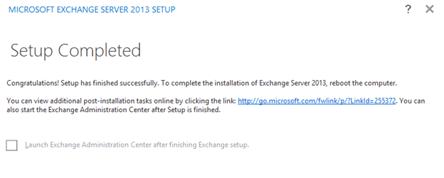

        13. Restart the server

        14. Login to OWA for administrator account and test.

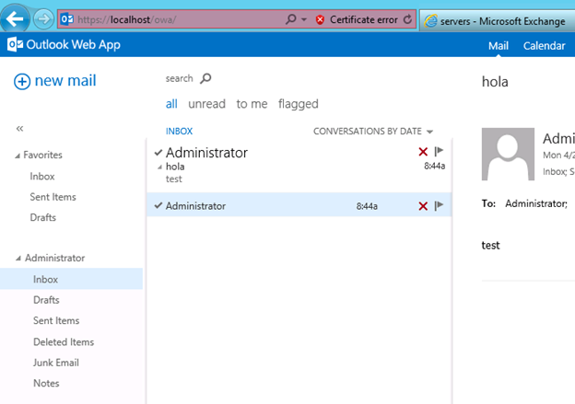

        15. Login to <https://yourdomain.com/ECP> and check new EAC.

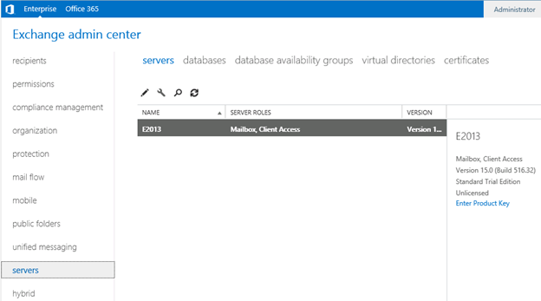

**This ends the Exchange 2013 Deployment.**

# **Load balancing**

**Exchange 2013**

***Topic Last Modified:***2014-02-10

Load balancing is a way to manage which of your servers receive traffic. Load balancing helps distribute incoming client connections over a variety of endpoints—for example, Client Access servers—to ensure that no one endpoint takes on a disproportional share of the load. Load balancing can also provide failover redundancy in case one or more endpoints fails. By using load balancing with Exchange Server 2013, you ensure that your users continue to receive Exchange service in case of a computer failure. Load balancing also enables your deployment to handle more traffic than one server can process while offering a single host name for your clients.

Load balancing serves two primary purposes. It reduces the impact of a single Client Access server failure within one of your Active Directory sites. In addition, load balancing ensures that the load on each of your Client Access servers is evenly distributed.

Exchange 2013 also includes the following solutions for switchover and failover redundancy:

* **High availability** Exchange 2013 uses database availability groups (DAGs) to keep multiple copies of your mailboxes on different servers synchronized. That way, if a mailbox database fails on one server, users can connect to a synchronized copy of the database on another server.
* **Site resilience** You can deploy two Active Directory sites in separate geographic locations, keep the mailbox data synchronized between the two, and have one of the sites take on the entire load if the other fails.
* **Online mailbox moves** In an online mailbox move, users can access their email accounts during the move. Users are locked out of their accounts for only a brief time at the end of the process, when the final synchronization occurs. You can perform online mailbox moves across forests or in the same forest.
* **Shadow redundancy** Shadow redundancy protects the availability and recoverability of messages while they're in transit. With shadow redundancy, the deletion of a message from the transport databases is delayed until the transport server verifies that all the next hops for that message have completed. If any of the next hops fail before reporting successful delivery, the message is resubmitted for delivery to the hop that didn't complete.

## [**Architectural changes in load balancing for Exchange Server 2013**](javascript:void(0))

In Exchange Server 2010, client connections and processing were handled by the Client Access server role. This required that both external and internal Outlook connections, as well as mobile device and third-party client connections, be load balanced across the array of Client Access servers in a deployment to achieve fault tolerance and efficient utilization of servers. Many Exchange 2010 Client Access protocols required affinity—a relationship between the client and a particular Client Access server. In particular, Outlook Web App, the Exchange Control Panel, Exchange Web Services, Outlook Anywhere, Outlook TCP/IP MAPI connections, Exchange ActiveSync, the Exchange Address Book Service, and Remote PowerShell either required or benefited from client-to-Client Access server affinity. Load balancing options in Exchange 2010 included the following:

* Windows Network Load Balancing with source IP affinity
* Hardware load balancing

Because of the differing needs of client protocols in Exchange 2010, we recommended using a Layer 7 load balancing solution. Layer 7, also known as application-level load balancing, allowed the load balancing solution to use complex rules to determine how to balance each request entering the system, given that the entire conversation between client and server would be available to the load balancer logic. These complex rules ensured that all requests from a specific client went to the same Client Access server endpoint. In Exchange 2010, if all requests from a specific client did not go to the same endpoint for protocols that required affinity, the user experience would be negatively affected. For more information about Exchange 2010 load balancing options, see [Understanding Load Balancing in Exchange 2010](http://go.microsoft.com/fwlink/p/?linkid=196447).

In Exchange Server 2013, there are two primary types of servers—the Client Access server and the Mailbox server. The Client Access servers in Exchange 2013 serve as lightweight, stateless proxy servers, allowing clients to connect to Exchange 2013 Mailbox servers. Exchange 2013 Client Access servers provide a unified namespace and authentication. In addition, Exchange 2013 Client Access servers:

* Support proxy and redirection logic for client protocols.
* Support the use of Layer 4 load balancing.

With session affinity and Layer 7 load balancing, all requests between the client and the server are sent to the same endpoint, as required by various protocols. Requests are distributed at the application layer. With Layer 4 load balancing, the requests are distributed at the transport layer. The load balancing solution distributes requests from the client, which is aware of a single IP address (sometimes called the virtual IP address or VIP), to a set of servers that perform the work. The connection between the client and server must be established before the content of the request is determined, so the load balancer selects a server to receive the request before examining the content of the request. The selection of the target server can be made in various ways such as “round-robin,” in which each inbound connection goes to the next target server in a circular list, or “least connections,” in which the load balancer sends each new connection to the server that has the fewest established connections at that time. Now that session affinity isn’t required, you have more flexibility, choice, and simplicity with respect to the load balancing architecture you deploy. Load balancing without session affinity lets you increase the capacity and utilization of the load balancer, because processing isn’t used to maintain more involved affinity options such as cookie-based load balancing or Secure Sockets Layer (SSL) session ID.

### [Client Access server arrays and Exchange 2013](javascript:void(0))

In Exchange 2010, we introduced the concept of a Client Access array. After a Client Access array was configured for an Active Directory site, all Client Access servers in the site automatically became members of the array. In current builds of Exchange 2013, no configuration of a Client Access array is required, because the deployment of a load balanced and highly available service is much simpler.

## [**Load balancing solutions**](javascript:void(0))

The use of hardware load balancers is still supported for Exchange 2013. For information about the hardware load balancing solutions that have completed solution testing with Exchange 2010 and will likely work just as well with Exchange 2013, see [Exchange Server 2010 load balancer deployment](http://go.microsoft.com/fwlink/p/?LinkId=261834). Keep in mind that this page shows the more complex Layer-7 configuration of hardware load balancers with Exchange 2010. Load balancing Exchange 2013 traffic can be much simpler, given the architectural changes discussed earlier in this topic. Rather than configuring session affinity for each of the Exchange protocols, inbound connections to Exchange 2013 Client Access Servers can be directed to an available server by the load balancer with no additional affinity processing necessary. The hardware load balancer still has an important role in providing high availability of the Exchange service because it can detect when a specific Client Access server has become unavailable and remove it from the set of servers that will handle inbound connections.

### [Windows Network Load Balancing](javascript:void(0))

Windows Network Load Balancing (WNLB) is a common software load balancer used for Exchange servers. There are several limitations associated with deploying WNLB with Microsoft Exchange.

* WNLB can't be used on Exchange servers where mailbox DAGs are also being used because WNLB is incompatible with Windows failover clustering. If you're using an Exchange 2013 DAG and you want to use WNLB, you need to have the Client Access server role and the Mailbox server role running on separate servers.
* WNLB doesn't detect service outages. WNLB only detects server outages by IP address. This means that if a particular web service, such as Outlook Web App, fails, but the server is still functioning, WNLB won’t detect the failure and will still route requests to that Client Access server. Manual intervention is required to remove the Client Access server experiencing the outage from the load balancing pool.
* Using WNLB can result in port flooding, which can overwhelm networks.
* Because WNLB only performs client affinity using the source IP address, it's not an effective solution when the source IP pool is small. This can occur when the source IP pool is from a remote network subnet or when your organization is using network address translation.

# **Exchange admin center in Exchange 2013**

**Exchange 2013**

[Other Versions](javascript:;)



***Applies to:***Exchange Server 2013

***Topic Last Modified:***2015-03-17

The Exchange Admin Center (EAC) is the web-based management console in Microsoft Exchange Server 2013 that’s optimized for on-premises, online, and hybrid Exchange deployments. The EAC replaces the Exchange Management Console (EMC) and the Exchange Control Panel (ECP), which were the two interfaces used to manage Exchange Server 2010.

One advantage a web-based EAC provides is that you can partition Internet and intranet access from within the ECP IIS virtual directory. With this functionality, you can control whether users are allowed to have Internet access to the EAC from outside of your organization, while still allowing an end user to access Outlook Web App Options. For more information, see [Turn off access to the Exchange admin center](https://technet.microsoft.com/en-us/library/jj218639(v=exchg.150).aspx).

Looking for the Exchange Online version of this topic? See [Exchange admin center in Exchange Online](https://technet.microsoft.com/en-us/library/jj200743(v=exchg.150).aspx).

Looking for the Exchange Online Protection version of this topic? See [Exchange admin center in Exchange Online Protection](https://technet.microsoft.com/en-us/library/jj723141(v=exchg.150).aspx).

Contents

[Accessing the EAC](https://technet.microsoft.com/en-us/library/jj150562(v=exchg.150).aspx#access)

[Common user interface elements in the EAC](https://technet.microsoft.com/en-us/library/jj150562(v=exchg.150).aspx#common)

[Supported browsers](https://technet.microsoft.com/en-us/library/jj150562(v=exchg.150).aspx#SB)

## [**Accessing the EAC**](javascript:void(0))

Because the EAC is now a web-based management console, you’ll need to use the ECP virtual directory URL to access the console from your web browser. In most cases the EAC’s URL will look similar to the following:

* **Internal URL: https://<CASServerName>/ecp**   The internal URL is used to access the EAC from within your organization’s firewall.
* **External URL: https://mail.contoso.com/ecp**   The external URL is used to access the EAC from outside of your organization’s firewall. Some organizations may want to turn off external access to the EAC. For details, see [Turn off access to the Exchange admin center](https://technet.microsoft.com/en-us/library/jj218639(v=exchg.150).aspx).

To locate the internal or external URL for the EAC, you can use the [Get-EcpVirtualDirectory](https://technet.microsoft.com/en-us/library/dd351058(v=exchg.150).aspx) cmdlet. For details, see [Find the internal and external URLs for the Exchange admin center](https://technet.microsoft.com/en-us/library/jj680108(v=exchg.150).aspx).

If you’re in a coexistence scenario, where you’re running Exchange 2010 and Exchange 2013 in the same organization, and your mailbox is still housed on the Exchange 2010 Mailbox server, the browser will default to the Exchange 2010 ECP. You can access the EAC by adding the Exchange version to the URL. For example, to access the EAC whose virtual directory is hosted on the Client Access server CAS15-NA, use the following URL: https://CAS15-NA/ecp/?ExchClientVer=15. Conversely, if you want to access the Exchange 2010 ECP and your mailbox resides on an Exchange 2013 Mailbox server, use the following URL: https://CAS14-NA/ecp/?ExchClientVer=14.

## [**Common user interface elements in the EAC**](javascript:void(0))

The section describes the user interface elements that are common across the EAC.

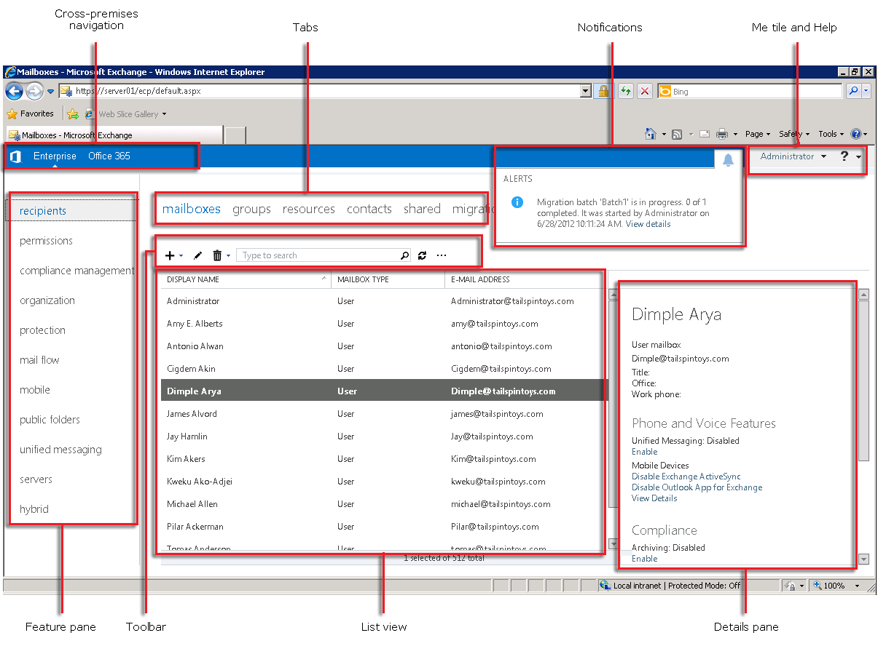

### [Cross-premises navigation](javascript:void(0))

The cross-premises navigation allows you to easily switch between your Exchange Online and on-premises Exchange deployments. If you don’t have an Exchange Online organization, the link will direct you to the Office 365 sign-up page. To learn more, see [Exchange Server Hybrid Deployments](https://technet.microsoft.com/en-us/library/jj200581(v=exchg.150).aspx).

### [Feature pane](javascript:void(0))

This is the first level of navigation for most of the tasks that you’ll perform in the EAC. The feature pane is similar to the console tree from the EMC in Exchange 2010. However, in Exchange 2013 the feature pane is organized by feature areas as opposed to server roles, and there are fewer clicks to find what you need.

* **Recipients**This is where you’ll manage mailboxes, groups, resource mailboxes, contacts, shared mailboxes, and mailbox migrations and moves.
* **Permissions**This is where you’ll manage administrator roles, user roles, and Outlook Web App policies.
* **Compliance management**This is where you’ll manage In-Place eDiscovery, In-Place Hold, auditing, data loss prevention (DLP), retention policies, retention tags, and journal rules.
* **Organization**This is where you’ll manage the tasks that pertain to your Exchange Organization, including federated sharing, Outlook Apps, and address lists.
* **Protection**This is where you’ll manage anti-malware protection for your organization.
* **Mail flow**This is where you’ll manage rules, delivery reports, accepted domains, email address policies, and send and receive connectors.
* **Mobile**This is where you’ll manage the mobile devices that you allow to connect to your organization. You can manage mobile device access and mobile device mailbox policies.
* **Public folders**In Exchange 2010, you had to manage public folders by using the Public Folder Management Console, which was located outside of the EMC in the Toolbox. In Exchange 2013, public folders can be managed from within the **public folders** feature area.
* **Unified Messaging**This is where you’ll manage UM dial plans and UM IP gateways.
* **Servers**This is where you’ll manage your Mailbox and Client Access servers, databases, database availability groups (DAGs), virtual directories, and certificates.
* **Hybrid**This is where you’ll set up and configure a Hybrid organization.

### [Tabs](javascript:void(0))

The tabs are your second level of navigation. Each of the feature areas contains various tabs, each representing a complete feature. The only exception to this rule is the Hybrid feature area. You must first enable your organization for a hybrid deployment by using the Hybrid Configuration wizard.

### [Toolbar](javascript:void(0))

When you click most tabs, you’ll see a toolbar. The toolbar has icons that perform a specific action. The following table describes the most common icons and their actions. To display the action associated with an icon, simply hover over the icon.

|  |  |  |
| --- | --- | --- |
| **Icon** | **Name** | **Action** |
| Add Icon | Add, New | Use this icon to create a new object. Some of these icons have an associated down arrow you can click to show additional objects you can create. For example, in **Recipients** > **Mailboxes**, clicking the down arrow displays **User mailbox** and **Linked mailbox** as additional options. |
| Edit icon | Edit | Use this icon to edit an object. |
| Delete icon | Delete | Use this icon to delete an object. Some delete icons have a down arrow you can click to show additional options. |
| Search icon | Search | Use this icon to open a search box in which you can type the search phrase for an object you want to find. Check out [[Recipients > ] Advanced search](https://technet.microsoft.com/en-us/library/ms.exch.eac.editrecipientadvfilter(v=exchg.150).aspx) for more search options. |
| Refresh Icon | Refresh | Use this icon to refresh the list view. |
| More Options Icon | More options | Use this icon to view more actions you can perform for that tab’s objects. For example, in **Recipients** >**Mailboxes** clicking this icon shows the following options: **Disable**, **Add/Remove columns**, **Export data to a CSV file**, **Connect a mailbox**, and **Advanced search**. |
| Up Arrow Icon   Down Arrow Icon | Up arrow and down arrow | Use these icons to move an object’s priority up or down. For example, in **Mail flow** > **Email address policies** click the up arrow to raise the priority of an email address policy. You can also use these arrows to navigate the public folder hierarchy and to move rules up or down in the list view. |
| Copy Icon | Copy | Use this icon to copy an object so you can make changes to it without changing the original object. For example, in **Permissions** > **Admin roles**, select a role from the list view, and then click this icon to create a new role group based on an existing one. |
| Remove icon | Remove | Use this icon to remove an item from a list. For example, in the **Public Folder Permissions** dialog box, you can remove users from the list of users allowed to access the public folder by selecting the user and clicking this icon. |

### [List view](javascript:void(0))

When you select a tab, in most cases you’ll see a list view. The list view in EAC is designed to remove limitations that existed in ECP. ECP can only display up to 500 objects, and if you want to view objects that aren’t listed in the details pane, you need to use search and filter options to find those specific objects. In Exchange 2013, the viewable limit from within the EAC list view is approximately 20,000 objects for on-premises deployments and 10,000 objects in Exchange Online. In addition, paging is included so you can page to the results. In the**Recipients** list view, you can also configure page size and export the data to a CSV file.

### [Details pane](javascript:void(0))

When you select an object from the list view, information about that object is displayed in the details pane. In some cases (for example, with recipient objects) the details pane includes quick management tasks. For example, if you navigate to **Recipients** > **Mailboxes** and select a mailbox from the list view, the details pane displays an option to enable or disable the archive for that mailbox. The details pane can also be used to bulk edit several objects. Simply press the CTRL key, select the objects you want to bulk edit, and use the options in the details pane. For example, selecting multiple mailboxes allows you to bulk update users’ contact and organization information, custom attributes, mailbox quota, Outlook Web App settings, and more.

### [Notifications](javascript:void(0))

The EAC includes a notification viewer that displays the status of long-running processes and provides notifications when the process completes. In addition, for particularly long-running processes (such as a move requests), you can opt-in to receive email notifications.

### [Me tile and Help](javascript:void(0))

The Me tile allows you to sign out of the EAC and sign in as a different user. From the Help  drop-down menu, you can perform the following actions:

* **Help**   Click  to view the online help content.
* **Disable Help bubble**   The Help bubble displays contextual help for fields when you create or edit and object. You can turn off the Help bubble help or turn it on if it has been disabled.
* **Copyright and Privacy**Click the privacy or copyright link to read the copyright and privacy information for Exchange 2013.

## [**Supported browsers**](javascript:void(0))

For the best experience with the EAC, use one of the operating system and browser combinations labeled “Premium”.

|  |
| --- |
| **NoteNote:** |
| Other operating system and browser combinations not listed in the table are unsupported, including touch. |

* **Premium:** All functional features are supported and fully tested.
* **Supported:** Has same functional feature support as premium. However, supported browsers will be missing features that the browser and operating system combination doesn’t support.
* **Unsupported:** The browser and operating system isn’t supported or tested.

# **FAQ: Exchange admin center**

**Exchange 2013**

***Applies to:***Exchange Server 2013

***Topic Last Modified:***2015-03-09

This topic provides you with a list of frequently asked questions for the new Exchange admin center (EAC) in Microsoft Exchange Server 2013. Have other questions about EAC not answered here? Send us an email at [Ex2013HelpFeedback@microsoft.com](mailto:Ex2013HelpFeedback@microsoft.com).

## [**Was the EAC developed solely for Exchange Online?**](javascript:void(0))

The EAC serves all deployment options for Exchange 2013, including customers who want to deploy on-premises, in the cloud with Exchange Online, or a hybrid deployment.

## [**Did you remove the Exchange Management Console (EMC) because you’re building the interface primarily for small and mid-sized customers?**](javascript:void(0))

The EAC was developed to provide a single, intuitive management experience for all our customers and was designed to help make the execution of the most common administration tasks simpler.

We created a single interface that provides a superset of scenario coverage over the Exchange Management Console (EMC) and the Exchange Control Panel (ECP) and one that addressed key challenges and scenarios for customers.

Additionally, we listened to customers of all sizes and their primary concerns were the following:

* Maintaining and downloading patches in order to operate an administrative tool is an operational overhead for customers which, in turn, increases operational costs.
* As the IT workforce becomes increasingly mobile, customers wanted to be able to manage their environments from anywhere, not only from the desktops and servers where their administrative tools are installed.
* Using multiple tools for different deployment options becomes confusing and increases training and operational costs

## [**Is PowerShell logging and cmdlet exposure coming back to EAC?**](javascript:void(0))

We have taken early customer feedback on this and are evaluating the possibility of addressing this in a future update.

## [**Will the EMC be reintroduced an upcoming service pack?**](javascript:void(0))

No. We fully support the EAC experience.

## [**Can you use the Exchange 2010 EMC to manage Exchange 2013 objects?**](javascript:void(0))

No. You can’t use the Exchange 2010 EMC to manage Exchange 2013 objects and servers. While customers upgrade to Exchange 2013, we encourage them to use the EAC to:

1. Manage Exchange 2013 mailboxes, servers, and corresponding services.
2. View and update Exchange 2010 mailboxes and properties.
3. View and update Exchange 2007 mailboxes and properties.

We encourage customers to use Exchange 2010 EMC to create and manage Exchange 2010 mailboxes.

We encourage customers to use Exchange 2007 EMC to create and manage Exchange 2007 mailboxes.

Customers can continue to perform management tasks using the Exchange Management Shell and script tasks.

## [**Why isn’t the search box always visible?**](javascript:void(0))

As part of our design principles for Exchange 2013, we wanted to help make sure that nothing is in your way until you need it. This simplicity is represented in all our end user experiences (including the EAC). The search box slides out after you click the icon. This provides more room for the user to type their query in the text box, and also provides type-downs that display once real-time query matching occurs. This improvement allows us to hide unnecessary complexity without diminishing the management experience. We will continue to enhance all of our experiences based on feedback.

## [**Will EAC work on tablets?**](javascript:void(0))

Administration through tablets and mobile devices isn’t supported at this time.

## [**Why does Exchange 2010 ECP open when I try to access the Exchange 2013 EAC?**](javascript:void(0))

If your mailbox exists on an Exchange 2010 Mailbox server, the Exchange 2010 ECP will automatically load in your browser. This is by design. You can access the EAC by adding the Exchange version to the URL. For example, to access the EAC whose virtual directory is hosted on the Client Access server CAS01-NA, use the following URL: https://CAS01-NA/ecp?ExchClientVer=15.

## [**How do you limit where EAC can be used?**](javascript:void(0))

To limit Internet versus intranet access, Exchange provides partitioning at the level of the virtual directory in IIS. Administrators can explicitly allow or deny IT management scenarios from being performed by external internet clients (for example, from clients not joined to a domain within the corporate firewall). For more information, see [Turn off access to the Exchange admin center](https://technet.microsoft.com/en-us/library/jj218639(v=exchg.150).aspx).

## [**What’s changed for the Exchange 2013 Toolbox?**](javascript:void(0))

In Exchange 2007 and Exchange 2010, the EMC contained the Toolbox, which provided access to various tools for managing your Exchange organization. The Exchange 2013 Toolbox is considerably pared down from the previous versions. The Details Templates Editor, Remote Connectivity Analyzer, and the Queue Viewer are still available in the Exchange 2013 Toolbox. The remaining tools were either repurposed or moved into the EAC.

The following table lists the changes to the Exchange 2013 Toolbox:

|  |  |
| --- | --- |
| **Tool** | **Where is it now?** |
| Exchange Best Practices Analyzer (ExBPA) | The ExBPA has been retired. Readiness checks have replaced the ExBPA to make sure that your Active Directory forest and Exchange servers are ready for Exchange 2013. Each readiness check topic describes the actions that you can take to resolve issues that are found when the readiness checks are run. You should only perform the steps outlined in a readiness check topic if that readiness check was displayed during setup. |
| Mail Flow Troubleshooter | The Mail Flow Troubleshooter has been retired. You can now use the messaging tracking feature in the EAC. Go to **Mail flow**> **Delivery reports**. |
| Performance Monitor | The Performance Monitor has been retired from the Toolbox. You can still find the Performance Monitor under**Administrative Tools** in Windows Server 2008 and Windows Server 2012. |
| Performance Troubleshooter | The Performance Troubleshooter has been retired from the Toolbox. |
| Routing Log Viewer | The Routing Log Viewer has been retired. |
| Public Folder Management Console | Public folders are now managed from within the EAC. In the EAC, go to **Public Folders**. |
| Role Based Access Control (RBAC) User Editor | RBAC is now managed from within the EAC. In the EAC, go to **Permissions**. |

### Exchange 2013 mailflow explained

I’ve been playing with Exchange 2013 for a while now and overall – I love all the new features.

Let’s take a closer look at mailflow architecture in Exchange 2013…

The Exchange team calls the overall mailflow happening through a transport pipeline. A transport pipeline is nothing but a collection of windows services, some connections and some components and messages queues that act together to make the overall email flow through the categorizer in the Hub transport Service which now reside on the Mailbox server.

I thought of creating a chart to help you understand various services, where they are homed and their function:

|  |  |  |
| --- | --- | --- |
| **Server role** | **Service Name** | **Functions** |
| **Mailbox Server Role** | **Hub Transport service** | Handles all incoming and outgoing SMTP email messages |
| Message content inspection |
| Message Categorization |
| Acts as a middle man and routes messages between Mailbox Transport service and the Front End Transport service |
| Is identical to the Hub Transport Server role in Exchange 2010 |
| Never contacts the mailbox databases directly |
| Accepts external messages from the front end transport service |
| **Mailbox Server Role** | **Mailbox Transport service** | 2 services treated like one – Mailbox Transport Submission service and Mailbox Transport Delivery service |
| The Mailbox Transport Delivery service receives SMTP messages from the Hub Transport service, and connects to the mailbox database using an Exchange remote procedure call (RPC) to deliver the message |
| The Mailbox Transport Submission service connects to the mailbox database using RPC to retrieve messages, and submits the messages over SMTP to the Hub Transport service |
| Mailbox Transport service doesn’t queue any messages locally |
| Communicates directly with mailbox databases |
| **CAS Server Role** | **Front End Transport service** | Runs on all Client Access servers |
| Acts like a proxy for all inbound and outbound external SMTP traffic |
| Can filter messages based on connections, domains, senders, and recipients |
| Cannot read the message content |
| Only communicates with the Hub Transport service |
| Accepts external messages through a receive connector |

Messages inside the organization enter the Hub Transport service on a Mailbox server in one of the following ways:

**Through a Receive connector.**

**From the Pickup directory or the Replay directory.**

**From the Mailbox Transport service.**

**Through agent submission.**

Every message that’s sent or received in an Exchange 2013 Preview organization must be categorized in the Hub Transport service on a Mailbox server before it can be routed and delivered. After a message has been categorized, it’s put in a delivery queue for delivery to the destination mailbox database, the destination database availability group (DAG), Active Directory site, or Active Directory forest, or to the destination domain outside the organization.

The Hub Transport service on a Mailbox server consists of the following components and processes:

**SMTP Receive**:

When messages are received by the Hub Transport service, message content inspection is performed, transport rules are applied, and anti-spam and anti-malware inspection is performed if they are enabled. The SMTP session has a series of events that work together in a specific order to validate the contents of a message before it’s accepted. After a message has passed completely through SMTP Receive and isn’t rejected by receive events, or by an anti-spam and anti-malware agent, it’s put in the Submission queue.

**Submission**:

Submission is the process of putting messages into the Submission queue. The categorizer picks up one message at a time for categorization.

Submission happens in three ways:

Through an SMTP Receive connector.

Through the Pickup directory or the Replay directory. These directories exist on the Mailbox server. Correctly formatted message files that are copied into the Pickup directory or the Replay directory are put directly into the Submission queue.

Through an agent.

**Categorizer**:

The categorizer picks up one message at a time from the Submission queue. The categorizer completes the following steps:

Recipient resolution, which includes top-level addressing, expansion, and bifurcation.

Routing resolution.

Content conversion.

Additionally, mail flow rules that are defined by the organization are applied. After messages have been categorized, they’re put into a delivery queue that’s based on the destination of the message. Messages are queued by the destination mailbox database, DAG, Active Directory site, Active Directory forest or external domain.

**SMTP Send:** How messages are routed from the Hub Transport service depends on the location of the message recipients relative to the Mailbox server where categorization occurred. The message could be routed to the Mailbox Transport service on the same Mailbox server, the Mailbox Transport service on a different Mailbox server that’s part of the same DAG, the Hub Transport service on a Mailbox server in a different DAG, Active Directory site, or Active Directory forest, or to the Front End Transport service on a Client Access server for delivery to the Internet.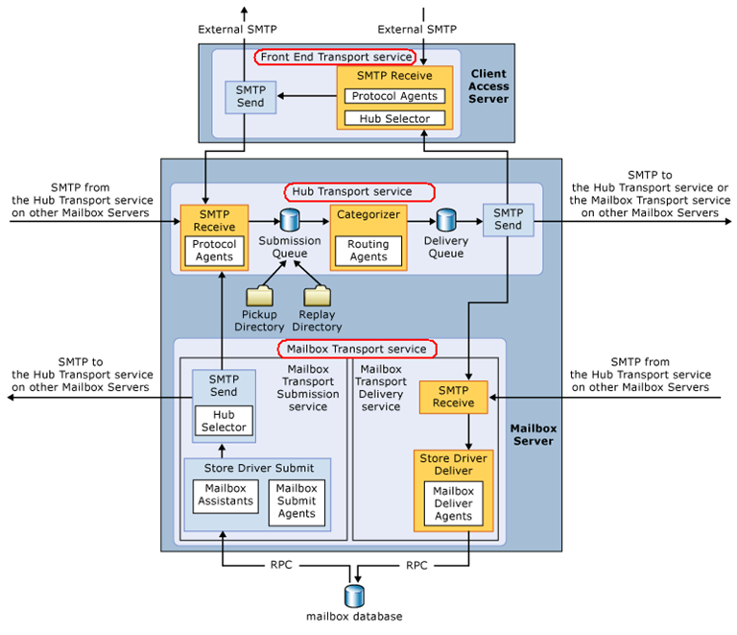

Most of the content in this article is taken from the E2013 help file. I just thought of formatting in a way easy to understand.

### Working with EAC or Exchange administration center in Exchange 2013 – Part1

Exchange Administration Center (EAC) replaces the Exchange Management Console (EMC) and the Exchange Control Panel (ECP), which were the two interfaces that were used to manage Exchange Server 2010. It is the web-based management console in Microsoft Exchange Server 2013 that allows for ease of use and is optimized for on-premises, online, or hybrid Exchange deployments.

One of the advantages of having the web-based EAC is that you can partition access from the Internet/Intranet from within the ECP IIS virtual directory to allow or disallow management features. This allows you to permit or deny access to users trying to access the EAC from the Internet outside of your organizational environment, while still allowing access to an end-user’s Outlook Web App Options

Because the EAC is now a web-based management console, you will need to access it by using your web browser using the ECP virtual directory URL. To find the ECP virtual director URL that you need to access the EAC in most cases the EAC’s URL will look similar to the following:

**Internal URL: https://<CASServerName>/ecp**   the internal URL is the URL that user’s access the EAC from within your organization’s firewall.

**External URL: https://mail.contoso.com/ecp**   the external URL is the URL that user’s access the EAC from outside of your organization’s firewall.

To find the Internal or External URL for the EAC, use the **Get-ECPVirtualDirectory** cmdlet

**Get-ECPVirtualDirectory | Format-List Name,InternalURL,ExternalURL**

**If you are trying to access EAC for the first time and your mailbox is on Exchange 2010, you need to use the URL in the format:**

[https://Exchange2013ServerName/ecp?ExchClientVer=15](https://exchange2013servername/ecp?ExchClientVer=15)

This is because in a co-existence scenario, your mailbox is still housed on the Exchange 2010 mailbox server, the browser will default to the Exchange Server 2010 ECP. Now if you want to access the Exchange 2010 ECP and your mailbox resides on an Exchange 2013 mailbox server, use the following URL:

[https://Exchange2010ServerName/ecp?ExchClientVer=14](https://exchange2010servername/ecp?ExchClientVer=14).

Now let’s take a look at the tool and learn the new EAC. As soon as you launch EAC, you get the screen displaying options available in EAC. I have collated them all to give you an idea what different tabs display.

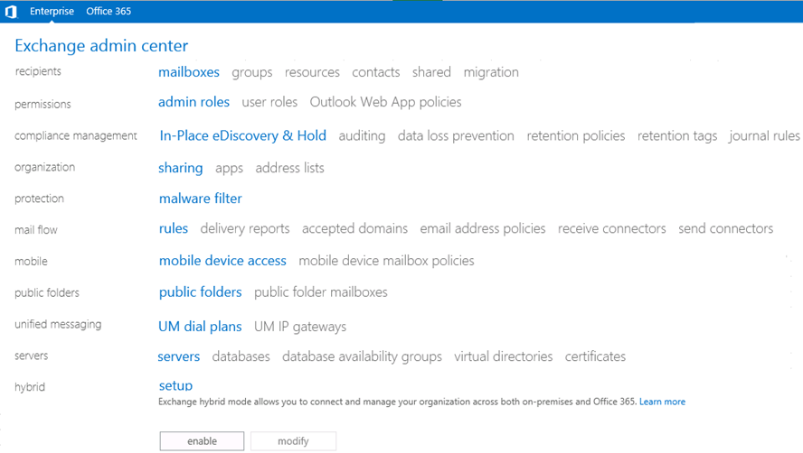

**Recipients Tab:**

Here, you have the option of managing recipients and their mailbox information. Other options include working with Groups, resource mailboxes and room mailboxes, creating and configuring contacts, Setup and manage shared mailboxes and configure Migration jobs called Migration batches.

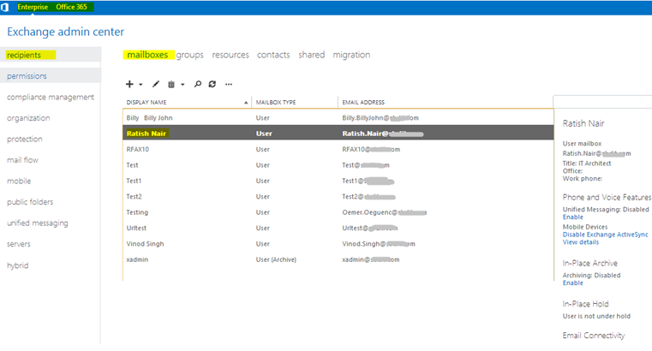

To know which mailbox database a user is residing in Exchange 2013 you need to double click the user and click “More Options”

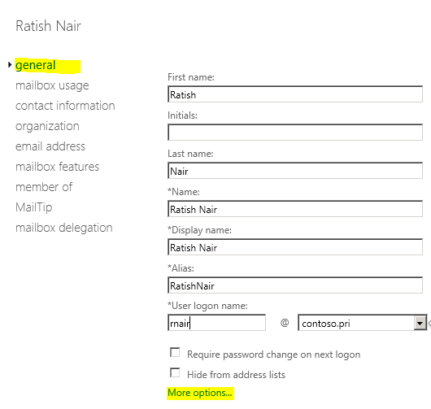

Now you can view:

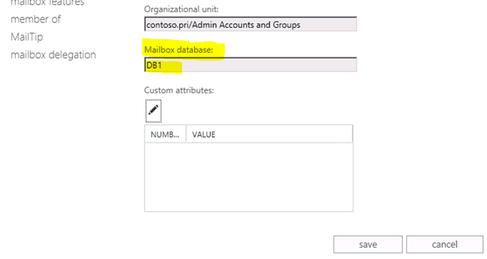

Remember that Database is no longer a Server object but an entity of DAG, so you won’t see a specific server name here.

When you look at a mailbox object you may see several options to configure accordingly.

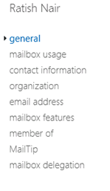

**Permissions Tab**

In the Permissions tab, you have an option to view all the default Admin roles as shown. You may also add your own admin roles. Here you can also configure User Roles and Outlook Web App policies

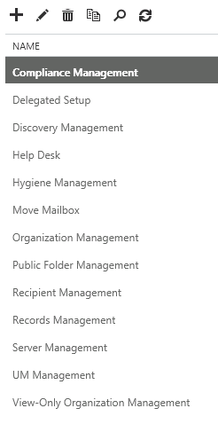

**Compliance Management**

This role group will allow a specified user, responsible for compliance, to properly configure and manage compliance settings within Exchange in accordance with their policy.

**Delegated Setup**

Members of this management role group have permissions to install and uninstall Exchange on provisioned servers. This role group shouldn’t be deleted.

**Discovery Management**

Members of this management role group can perform searches of mailboxes in the Exchange organization for data that meets specific criteria.

**Help Desk**

Members of this management role group can view and manage the configuration for individual recipients and view recipients in an Exchange organization. Members of this role group can only manage the configuration each user can manage on his or her own mailbox. Additional permissions can be added by assigning additional management roles to this role group.

**Hygiene Management**

Members of this management role group can manage Exchange anti-spam features and grant permissions for antivirus products to integrate with Exchange.

**Move Mailbox**

Members of this management role group can Move Mailboxes

**Organization Management**

Members of this management role group have permissions to manage Exchange objects and their properties in the Exchange organization. Members can also delegate role groups and management roles in the organization. This role group shouldn’t be deleted.

**Public Folder Management**

Members of this management role group can manage public folders. Members can create and delete public folders and manage public folder settings such as replicas, quotas, age limits, and permissions as well as mail-enable and mail-disable public folders.

**Recipient Management**

Members of this management role group have rights to create, manage, and remove Exchange recipient objects in the Exchange organization.

**Records Management**

Members of this management role group can configure compliance features such as retention policy tags, message classifications, transport rules, and more.

**Server Management**

Members of this management role group have permissions to manage all Exchange servers within the Exchange organization, but members don’t have permissions to perform operations that have global impact in the Exchange organization.

**UM Management**

Members of this management role group can manage Unified Messaging organization, server, and recipient configuration.

**View-Only Organization Management**

Members of this management role group can view recipient and configuration objects and their properties in the Exchange organization.

**Compliance Management Tab**

This feature is one of the primary reasons organizations would employ Exchange 2013. With this version of Exchange, Microsoft has taken Security practices to the next level. Prior to Exchange 2013, organizations had to invest substantial amount of money in Data Loss Prevention. With Exchange 2013, it is available out of the box. You simply need to create templates with the standards you want to implement for email security requirements. You may also purchase pre-configured templates from third party vendors and upload to your Exchange organization.

Here, you have an option to view and make changes to In-Place eDiscovery & Hold, auditing, data loss prevention, retention policies, retention tags, and journal rules.

For example, click on the Auditing tab and you have the option to:

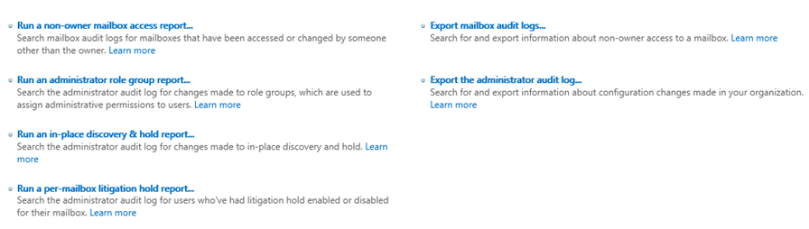

Also, click on the tab Data Loss prevention and here you have an option to create a new policy from a template. There are several templates to choose from with pre-configured information security laws of country specific legal requirements.

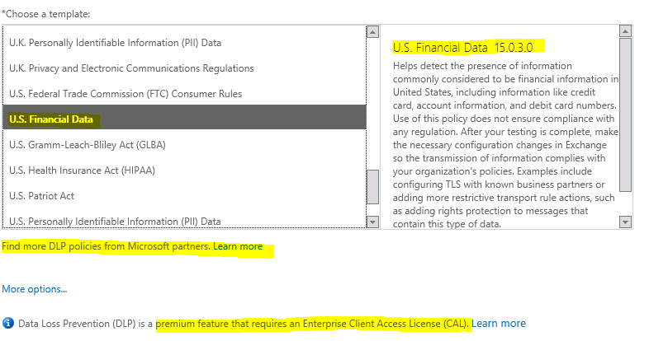

To configure an MRM policy or Archive policy with Exchange 2013, click the tab retention policies:

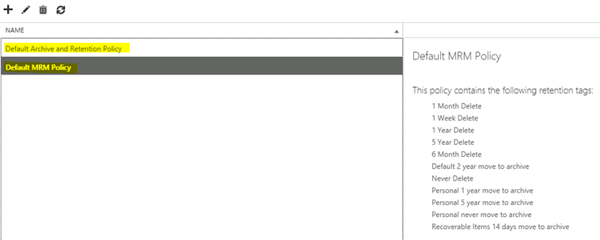

You may also create retention tags and Journal rule here.

In this part of article we took a look at 3 major features of Exchange 2013 EAC.

To be continued…

### Exchange 2007/2010/2013: ActiveSync asking for Domain Name on Mobile Device

**Issue:**

Post migration from Exchange 2010 to 2013, mobile devices are not connecting with out domain name.

**Cause:**

Unable to query domain and authentication failed.

**Resolution:**

There is no solution for it. It is by design as there is no field for the domain name in the Exchange Active Sync configuration.

**Workaround:**

1. Login to the CAS server

2. Open IIS Manager

3. Expand Default website

4. Highlight the Microsoft- Server-Activesync and select authentication on the right side

[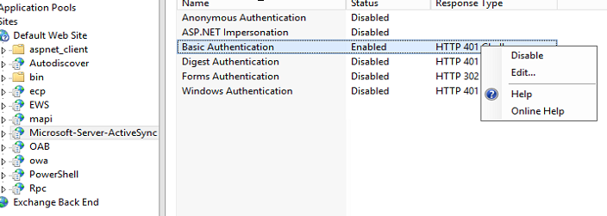](http://msexchangeguru.com/wp-content/uploads/2013/08/IIS1.png)

5. Go to the properties of the authentication

6. Right Click on Basic Authentication and click edit.

7. Type backward slash in Default Domain “”  and type your domain name in the Realm

[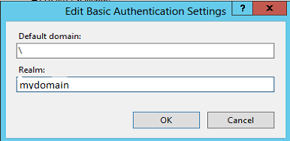](http://msexchangeguru.com/wp-content/uploads/2013/08/IIS2.png)

8. Reset IIS by the cmd – “IISRESET /NOFORCE /TIMEOUT:120”

### Exchange 2013: Pop/Imap clients unable to Authenticate

Lets take a look at an issue in E2013 where Pop/Imap clients unable to Authenticate

**Environment:**

Exchange 2010 SP3: 2 mailbox server in DAG, 2 CAS/HT with windows NLB

Exchange 2013 CU1: 2 mailbox server in DAG, 2 CAS with windows NLB

**Issue:**

During the co-existence phase during Exchange 2010 to 2013 migration, Pop/Imap clients are unable to authenticate.

In the log file we can see the following message. No other message.

NLB IP:993,ClientIP:55612,,112,27,23,login,Loginid password,”R=””05up NO LOGIN failed.””;Msg=””User:username:2796642b-68aa-49cc-93c0-0414276541fe:SDB1:mailbox server FQDN;Proxy:mailbox server FQDN:143:SSL;NotAuthenticated”””

By default logging is disabled and you need to enable by running the below cmd:

**Set-imapsettings -server CASServerName –ProtocolLogEnabled $true**

**Set-popsettings -server CASServerName –ProtocolLogEnabled $true**

Default Imap Log File Location  is **C:Program FilesMicrosoftExchange ServerV15LoggingImap4**

Default Pop Log File Location  is **C:Program FilesMicrosoftExchange ServerV15LoggingPOP3**

You might also see the following events in the system log:

Log Name: System  
Source: Schannel  
Date: 8/4/2013 1:00:33 AM  
Event ID: 36888  
Task Category: None  
Level: Error  
Keywords:  
User: SYSTEM  
Computer:  
Description:  
A fatal alert was generated and sent to the remote endpoint. This may result in termination of the connection. The TLS protocol defined fatal error code is 10. The Windows SChannel error state is 10.

**Cause:**

This is a bug in Exchange 2013 CU1.

**Resolution:**

Install Cumulative update 2 for Exchange 2013 on all the Exchange 2013 Servers starting from Mailbox role.

**Additional Config:**

For sending emails when you use SMTP we will be using the CAS client connector and might need to run the below cmd.

**Set-ReceiveConnector “*CASHostnameClient Frontend CASHostname” -AdvertiseClientSettings $True -FQDN NLBUrl**

I am using windows NLB so I am used NLBUrl in the cmd to get high availability.

I have asked Microsoft to fix the cmd in the below link:

<http://technet.microsoft.com/en-us/library/jj657728(v=exchg.150).aspx#settings>

**Conclusion:**

I would recommend moving to CU2 if you have pop/imap users.

### Exchange 2013-2010 Co-existence: Mail Flow is not working “451 4.4.0”

This is to address an issue where Exchange 2010 queue has messages in retry status to Exchange 2013 with below Error message **“451 4.4.0 Primary target IP address responded with: “451 5.7.3 Cannot achieve “Exchange Server authentication”**

**Issue:**

Mail is not flowing between Exchange 2013 to 2010

Mail is not flowing between Exchange 2010 to 2013

Mail is not flowing within Exchange 2013 different mailboxes

Mail is not flowing to self on Exchange 2013

Exception:

Sending an email using Telnet working from and to all Exchanges.

Mail is only working within Exchange 2010

Internet mail is flowing to and fro Exchange 2010

**Error:**

No error or ndr

Exchange 2013 queue is empty

Exchange 2010 queue has messages in retry status to Exchange 2013 with below Error message  
**“451 4.4.0 Primary target IP address responded with: “451 5.7.3 Cannot achieve “Exchange Server authentication”.” Attempted failover to alternate host, but that did not succeed. Either there are no alternate hosts, or delivery failed to all alternate hosts”**  
**Troubleshooting Steps:**

Telnet to the Exchange 2013 on port 25

Type ehlo

Check the exchange verb. None of the exchange verbs were visible.

Disabled the additional receive connector and restart transport service.

telnet again to the port 25

Run the cmd ehlo

Check the verb.

I would like to see if all exchange verbs starting with X are showing in the screenshot.

[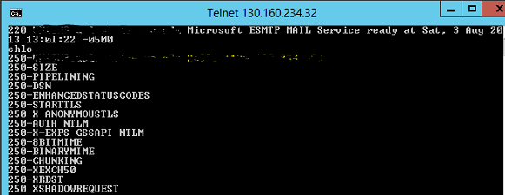](http://msexchangeguru.com/wp-content/uploads/2013/08/Exchange-Verbs.png)

**Resolution:**

In my case we had a **same IP range was added in additional connector** as the IP of the mailbox server and this connector had only anonymous users and TLS was selected in Security.

I removed he IP range and restarted Microsoft Exchange Transport service and this had started showing my verbs and started the mail flow.

The most import thing to pick up from here is **ehlo should show Exchange Verbs**. If they are not visible then need to disable the additional connector or remove the changes to the default connector until you see the Exchange verbs.

Also **don’t forget to restart Microsoft Exchange Transport Service** because your changes will not be applied until you restart Microsoft Exchange Transport Service.

### AutoDiscover Troubleshooting- Default authentication for Exchange VDir’s aka Virtual directories on CAS and Mailbox role

With AutoDiscover is highlight in E2K7 and E2010, we know how important is to understand and troubleshoot this feature.

Test E-mail AutoConfiguration is an inbuilt tool in Outlook which lets you know whether AutoDiscover is working as expected from a client machine.

**Internal Clients** – Outlook looks for SCP (Service connection point) in AD which contains the URL for the Autodiscover residing on the CAS server’s IIS and outlook ultimately establishes a connection with the CAS Server.

Internal AutoDiscover URL looks like – <https://mydomain/autodiscover/autodiscover.xml>

**External Clients** – In this case, outlook is not in the domain and would be utilizing RPC-HTTP and Outlook so uses DNS to resolve the external AutoDiscover URL specified for your organization.

External AutoDiscover URL looks like – <https://autodiscover.mydomain/autodiscover/autodiscover.xml>

If you are looking at this article before setting up Autodiscover URL’s, it is recommended to have it setup this way.

To get details on Autodiscover VDir, type this cmdlet:

**Get-AutodiscoverVirtualDirectory |FL**

Now, to run Test E-mail AutoConfiguration, the pre-requisite is that your mailbox should be on an E2K7/E2010 server for which you think AutoDiscover has encountered an issue. E2K3 users do not use this service.

Now press the **CTRL**button on the key-board and**right-click the Outlook icon** in the System tray.

You will now see a pop-up screen with your email address. Only check the box which says “Use Autodiscover” and click Test.

Once the test completes, you should not see any errors.

Now, if you have clients complaining AutoDiscover works internally and not externally, the best way to start troubleshooting is to go to[www.testexchangeconnectivity.com](http://www.testexchangeconnectivity.com/) and perform an AutoDiscover test there.

Now, if it is not working internally or externally the first action should be to mandatorily check the Authentication’s for Exchange virtual directories on your CAS servers. Now, if you ask me as to what changes it – it could be a patch which was recently installed/human error/something which I dont know. Please be sure to check these on all your CAS servers individually if it is a set of clients complaining of having this issue.

I have made a checklist of the authentication types for Exchange VDir’s on the CAS and Mailbox roles for Exchange 2007 and 2010 servers.

We begin with the default settings on a CAS, followed by the settings on a Mailbox server for both E2K7 and E2010 and the setting bear no changes with Service pack upgrades.

|  |  |  |  |
| --- | --- | --- | --- |
| **Exchange 2007 CAS Role** | | | |
| **VDir** | **Authentication** | **SSL** | **Management done through** |
| Default Web Site | Anonymous | Yes | IIS and HTTP Keep Alive should be on |
| /Owa | Basic | Yes | EMC/Powershell |
| /Exchange | Basic | Yes | EMC/Powershell |
| /Public | Basic | Yes | EMC/Powershell |
| /Exchweb | Basic | Yes | EMC/Powershell |
| /Oab | Integrated | No | EMC/Powershell |
| /Autodiscover | Basic and Integrated | Yes | Powershell |
| /Ews | Integrated | Yes | Powershell |
| /UnifiedMessaging | Integrated | Yes | Powershell |
| /Microsoft-Server-Activesync | Basic | Yes | EMC/Powershell |
| /Rpc | Basic and Integrated | Yes |  |

|  |  |  |  |
| --- | --- | --- | --- |
| **Exchange 2007 Mailbox Role** | | | |
| **VDir** | **Authentication** | **SSL** | **Management done through** |
| Default Web Site | Anonymous | No | IIS |
| /Exadmin | Basic and Integrated | No | IIS |
| /Exchange | Basic and Integrated | No | EMC |
| /Public | Basic and Integrated | No | EMC |

|  |  |  |  |
| --- | --- | --- | --- |
| **Exchange 2010 CAS Role** | | | |
| **VDir** | **Authentication** | **SSL** | **Management performed through** |
| Default Web Site | Anonymous | Yes | IIS |
| aspnet_client | Anonymous | Yes | IIS |
| Autodiscover | Anonymous / Basic / Windows Authentication | Yes | Powershell |
| ECP | Anonymous / Basic | Yes | EMC or Powershell |
| EWS | Anonymous / Windows Authentication | Yes | Powershell |
| Microsoft-Server-ActiveSync | Basic | Yes | EMC or Powershell |
| OWA | Basic | Yes | EMC or Powershell |
| Powershell | Anonymous | No | EMC or Powershell |
| RPC | Basic / Windows Authentication | Yes | Powershell |
| RpcWithCert | Everything Disabled | Yes (128 encryption not enabled) | N/A |
| OAB | Windows Authentication | No | EMC or Powershell |

|  |  |  |  |
| --- | --- | --- | --- |
| **Exchange 2010 Mailbox Role** | | | |
| **VDir** | **Authentication** | **SSL** | **Management done through** |
| Default Web Site | Anonymous | Yes | IIS |
| PowerShell | Anonymous | No | Powershell |

**These are the Powershell CMDlet’s to edit settings for the ones only with Shell:**

[Set-AutoDiscoverVirtualDirectory](http://technet.microsoft.com/en-us/library/aa998601.aspx)

[Set-WebServicesVirtualDirectory](http://technet.microsoft.com/en-us/library/aa997233.aspx)

[Set-PowershellVirtualDirectory](http://technet.microsoft.com/en-us/library/dd298108.aspx)

[Set-OutlookAnywhere](http://technet.microsoft.com/en-us/library/bb123545.aspx) (RPC VDir)

Once you confirm these entire Authentications are displayed properly, next step is to do:

**Test-OutlookWebServices** and ensure you get an error free output.

**To re-create your Autodiscover VDir, follow this:**

1. Take a backup of IIS

##As simple as a right click backup in IIS 6

##To backup IIS 7, you need to follow this:

To add a backup, run this command:

%windir%\system32\inetsrv\appcmd.exe add backup ” IISbkp_Date ”

To restore a backup, run this command:

%windir%\system32\inetsrv\appcmd.exe restore backup ” IISbkp_Date ”

To delete a backup, run this command:

%windir%\system32\inetsrv\appcmd.exe delete backup ” IISbkp_Date ”

To list all backup’s, run this command:

%windir%\system32\inetsrv\appcmd.exe list backup

2. Remove-AutodiscoverVirtualDirectory –Identity “CAS-servername\Autodiscover (Default Web Site)”

3. New-AutodiscoverVirtualDirectory -WebsiteName “Default Web Site” -WindowsAuthentication $true -BasicAuthentication $true

4. Perform an IISReset

These are the basic troubleshooting for if AutoDiscover stops functioning. Understanding the concepts are extremely important as they drive resolution further.

### HA, SR, RPO, RTO, OLA, SLA and the 9’s of availability…!!!

Business efforts small, privately owned, multinational, service- oriented, all demand accessibility between clientele, employees, management and any other miniscule component on a 24/7 basis.

**Click the below link to download this whitepaper in PDF format offline reading:**

Databases and basic communication schemes like e-mail are all dependent on server based systems and hence, productivity depends on the ability of such systems to recover from failures and downtimes whether planned or unplanned. More specifically, if these systems have any shortcomings due to damage as in a fire or faulty hardware or IT- related maintenance activities.

To allow business goals to be effectively met by the IT infrastructure, anyone part of the so called IT world, not just the exchange or AD guy has to look deep into some technicalities that would ensure optimal results. Plus, the company management needs to be on the same page as you. For instance, the Microsoft Exchange application is dependent on a number of other factors like Active Directory, Storage, Network, DNS and so on… If the Network is broke, Exchange is broke and there isn’t a thing the Exchange team can do about it.

So, here’s something that will complement the effort and would probably even aid you in job interviews and to be at par with the so- called genius of the ITIL folks….

**High Availability:**

Server systems including Microsoft Exchange are designed to be ‘highly available’ so that they continue service despite failure. However, the scope of this availability depends on the requirements specific to the particular enterprise. Any mishap is succeeded by automatic efforts to rectify or find alternate options.

Simply, High Availability or HA for exchange means how “highly available” your exchange infrastructure is and how “quick” it will come back up in the event of a failure “Or” – How long will it take for your exchange 2010 DAG to come online if one/multiple members fail?

**Site Resiliency:**

Site resiliency determines how efficient your system can function in the event of a catastrophic failure like a WAN outage or natural disasters like earthquake or flood usually concentrated on specific geographical locations where the primary datacentre resides. It could also be caused due to network failure or power outage. The point here is that you need to decide whether the system you design should failover to a secondary datacenter and continue servicing automatically or with manual intervention.

In Microsoft exchange terms, you may have a stretched DAG across multiple datacenters – one in New York and one in California, both equipped with their own supporting systems and processes in place – ready to be activated in the event one goes down.

**Difference between High Availability and Site Resilience:**

Systems based on high availability are automated or self-driven as when a passive database pops up when the active fails while manual action has to initiate corrective efforts in site resilience.

There are demands placed, often, to ensure high availability and site resiliency within the same datacenter. After reading details on HA and SR you know that it isn’t possible or logically doable. High availability basically focuses on how quick you can get your system back up and running in the event of a failure and site resiliency is a solution you have in place to deal with possible prolonged outages. You need to sit and discuss with your management whether to activate a ‘site resilient’ solution or measure the intensity of the damage done to your HA solution and calculate the time for it to come back up. You also make the decision on how long you can afford to be “down” with no service and the data you may lose due to this outage.

Now, to put this in technical terms, you basically develop a document where you have a **Recovery Time Objective** (RTO) and **Recovery Point Objective** (RPO). We ‘l come to that a little further down.

**OLA and SLA:**

The most important factor in the design of any system are a set of requirements that are specific to the company or job at hand. It is important to be able to precisely define needs like ‘increased availability’ and the like. It is also necessary to know the functions and responsibilities of different sections of a company.

It is the **Operational Level Agreement (OLA)** that specifies the area of control of each department so that the source or cause of failure or mistake can be handled by the particular department. For instance, which section should handle DNS failures and who should take responsibility of the Exchange server being down. These decisions should be properly documented, agreed upon and signed off by the business unit head or the respective application owner. It is equally important to have this information communicated to the helpdesk or the Incident Management team which handles all initial communications. Say, have a toll free number which all IT teams know to contact when they want help. The representative who picks up the call should be competent enough to understand technical terminologies and log a support incident to track changes and time taken to resolve the issue and he should refer to the OLA document to involve the right people from the right team. It’s when you don’t have this process in place, that the IT management system goes haywire not knowing what to do in the event of an outage, not knowing what the issue is and whom to contact and how.

The **Service Level Agreement (SLA)** is infact an understanding of the level of the service provided to the customer by the IT infrastructure and hence, defines the requirements of the system like the time constraints on the revival of normal functioning after downtimes. SLA may be between the domain users of a company and their internal IT team, between a client company and a vendor providing hosted service. For example, Microsoft Office 365 SLA is between Microsoft and the company they are hosting emails for.

It is often a financial agreement that requires the service provider to pay up if promised service levels are not met or if they aren’t able to meet the promised 9’s of availability.

**Requirements and the 9’s of Availability:**

How do we come to an SLA?

It is impossible to design a system unless there exists a definite understanding of requirements centering the availability to be ensured. An SLA may be described in terms of 9’s. But each organisation or even technician associates to it in their own terms. It is easy to calculate what the 9’s would amount to

* 99.999%  =    5.26 minutes / year   =    25.9 seconds / month
* 99.99%    =    52.56 minutes / year =    4.32 minutes / month
* 99.95%    =    4.38 hours / year      =    21.56 minutes / month
* 99.9%      =    8.76 hours / year      =    43.2 minutes / month

However, it is ignorant not to anticipate the impact the number of 9’s will practically have on availability. For instance, the time limit on a database failover or a Patch Tuesday (how much time can be spent on any particular breakdown). Infact, it’s how these terms are associated with everyday situations that will help gain perspective on requirements. It might be just one system among numerous others that underperforms. There is no argument to the fact that simply knowing the seconds or minutes lost does not help anticipate the effect on availability in a real-life situation or on one particular day when something goes wrong.

**RTO and RPO:**

Since the 9’s of availability are a difficult choice to make, availability is more conveniently described in terms of **Recovery Time Objective** (RTO) and **Recovery Point Objective** (RPO). The former (RTO) gives the time limit on recovery from a failure and the latter (RPO), the amount of data that can be afforded to be lost due to the failure. So it’s easy to define the time to get back service and account for the data lost for every possible real-life scenario of a mishap. Take for instance, the loss of a single disc. The RTO can well be expected at 30 seconds and the RPO, less than 30 seconds.  
Activating a site resilient solution is not an easy decision to make. You don’t want to activate your secondary datacenter if it will only take about 2-3 hours for the HA solution to be back up. However that is completely your decision to make. Availability of a system can be often directly proportional to the kind of business you do. For example, 100% email availability is vital for users in majority of industries like banking, order processing, service based companies who have signed contracts with other companies etc.

**Expectations on application availability:**

While placing demands on application availability or coming to an agreement on the level of service that can be provided, it’s important to understand several inter-connected factors that come into play- people, process and technology. Standard hardware has obvious advantages, factors like WAN bandwidth can determine RPO in the loss of a primary datacenter. In fact, technology is one of the easier parts not undermining the effect of the resources at hand while defining a process tailor-made to meet availability requirements.  
Now, the process developed must be inherently simple meaning that there will definitely be compromises between availability and the extent of systems that can be incorporated to meet failovers. Including too much precautionary measures can render a facility far more complex than actually necessary for normal functioning. This will only render the solution impractical. Similar are the effects of having too rigid a process.  
An efficient and trained workforce add to the viability of any high availability or site resilient design. The very choice between the two is also dependent on the kind of workforce. Factors that influence system design are whether administrators should be available on a 24/7 basis, the kind and extent of training and experience required, especially in decision-making.  
These factors infact operate in a cycle with the level of service provided. The answer lies in striking the right balance. Any management needs to comprehend the interplay of these factors in achieving their desired output as in whether they should opt for a data failover process in case of a mere WAN outage of 15 minutes and even who makes such decisions, the amount of data replication necessary and so on.

**Conclusion**

Hopefully, you have come to an understanding that it is vital to communicate needs and expectations but before getting into all that perhaps, you should take time out for some perspective on the kind of agreements you can settle on, giving proportionate significance to all factors that contribute to satisfactory performance. Robust hardware, a workable taskforce, and a properly worked out availability requirement coupled with the choice of suitable or tailor- made system design should do the trick!

### RecoverServer Error: Exchange server is a member of a database availability group

Exchange server recovery process aborts with the error “Exchange server is a member of a database availability group”

Setup.com /m:RecoverServer

Performing Microsoft Exchange Server Prerequisite Check

Configuring Prerequisites COMPLETED

Language Pack Checks COMPLETED

Hub Transport Role Checks COMPLETED

Client Access Role Checks COMPLETED

Mailbox Role Checks FAILED

**Exchange server is a member of a database availability group.**

The Exchange Server setup operation didn’t complete. More details can be found in ExchangeSetup.log located in the <SystemDrive>:\ExchangeSetupLogs folder.

Exchange Server setup encountered an error.

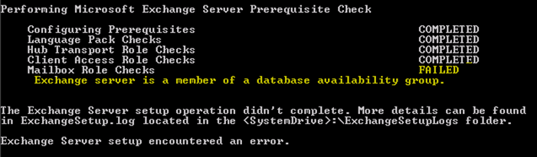

[PS] C:\Windows\system32>Remove-DatabaseAvailabilityGroupServer –Identity DAG1 -MailboxServer EXCH-03 -ConfigurationOnly

WARNING: The operation wasn’t successful because an error was encountered. You may find more details in log file “C:\ExchangeSetupLogs\DagTasks\dagtask_2013-10-29_13-42-12.346_remove-databaseavailabiltygroupserver.log”.

Remove-DatabaseAvailabilityGroupServer : Mailbox server ‘EXCH-03’ cannot be removed from the database availability group because mailbox database ‘Database3’ has multiple copies. Use Remove-MailboxDatabaseCopy either to remove the copy from this server or to remove the copies from other servers in the database availability group.

At line:1 char:39

+ Remove-DatabaseAvailabilityGroupServer <<<< -Identity DAG1 -MailboxServer EXCH-03 -ConfigurationOnly

+ CategoryInfo : InvalidArgument: (:) [Remove-DatabaseAvailabilityGroupServer], RemoveDagServer…icatedException

+ FullyQualifiedErrorId : 5FB7622C,Microsoft.Exchange.Management.SystemConfigurationTasks.RemoveDatabaseAvailabilityGroupServer

**Details:**

In theory, if the crashed server is a part of a DAG we cannot recover it before we remove it from the DAG. However, if the mailbox server is holding any MailboxDatabaseCopy we cannot remove it from the DAG. So, we need to first remove all Database copies hosted on that server and then remove it from the DAG.

If you lost just one server from a group of servers in DAG, we can remove database copies of the crashed server from an existing server and then remove the server from DAG. Then run the setup again.

EXCH-03 is my crashed server here.

To do this,

**Get-MailboxDatabaseCopyStatus *\EXCH-03**

**Get-MailboxDatabaseCopyStatus *\EXCH-03 | Remove-MailboxDatabaseCopy -Confirm**

**Remove-DatabaseAvailabilityGroupServer -Identity DAG1 -MailboxServer EXCH-03 –ConfigurationOnly**

ConfigurationOnly switch will clean the configuration from Active Directory

If you do not have any Exchange servers left or your one and ONLY exchange server crashed then you need to delete the configuration after you make a note of all databasenames and other details.

This is an equal as starting fresh. If you have a backup, you may attempt to restore it “after” we are done with the recovery process.

So, install Exchange Management tools on a machine in domain for us to run Exchange management Shell.

Before you proceed, please make a note of the msexchInstallPath (ADSIEdit: CN=ExServerName,CN=Servers,CN=First Administrative Group,CN=Administrative Groups,CN=ExOrg Name,CN=Microsoft Exchange,CN=Services,CN=Configuration,DC=DomainName,CN=Com) and ensure it is set to the correct value or use the /TargetDir Setup switch to specify the location of the Exchange program files. If you don’t use the /TargetDir switch, the Exchange program files will be installed in the default location (%programfiles%\Microsoft\Exchange Server\V15).

Now reset the server’s computer account in Active Directory.

Add-PSSnapin Microsoft.Exchange.Management.PowerShell.E2010

**Get-MailboxDatabaseCopyStatus *\EXCH-03 (will get you a list of all databases which used to reside on that server. Make a copy NOW)**

**Get-MailboxDatabaseCopyStatus *\EXCH-03 | Remove-MailboxDatabaseCopy –Confirm (Know what you are doing)**

**Remove-DatabaseAvailabilityGroupServer -Identity DAG1 -MailboxServer EXCH-03 –ConfigurationOnly**

Now Start the recovery again and it should work alright:

Preparing Exchange Setup

Copying Setup Files COMPLETED

The following server roles will be recovered

Languages

Hub Transport Role

Client Access Role

Mailbox Role

Management Tools

Performing Microsoft Exchange Server Prerequisite Check

Configuring Prerequisites COMPLETED

Language Pack Checks COMPLETED

Hub Transport Role Checks COMPLETED

Client Access Role Checks COMPLETED

Mailbox Role Checks COMPLETED

Configuring Microsoft Exchange Server

Preparing Setup COMPLETED

Stopping Services COMPLETED

Copying Exchange Files COMPLETED

Language Files…………………………….

Once recovery is completed, add the server back to DAG and add all mailboxdatase copies and let it seed.

**Add-DatabaseAvailabilityGroupServer -Identity DAG1 -MailboxServer EXCH-03**

**Add-MailboxDatabaseCopy -Identity Database3 -MailboxServer EXCH-03**

Once the database is seeded alright, perform a failover off business hours and ensure all is up and running.

### How to recover a Single DAG Mailbox Server Member

Whoa!!! One of my servers in DAG crashed and it’s crashed for good (RIP)… what next???

The steps outlined in this document is a “MUST-MUST HAVE” for all Exchange pro’s as a part of your DR documentation. I can tell you with confidence that you don’t want to wait for a server to crash and then go haywire looking for this. Read and understand every single information outlined here and try to replicate it in a lab if you have any… Let’s get started…!

In case of single server failure there will not be any impact to the production as the DB’s copies will come online on the other member in DAG. We still need the server back to the production so that we can continue providing the agreed DAG infrastructure. The following step will guide the recovery of the single server failure in the Exchange 2010 DAG.

So, I have a 2 member DAG setup and one of them failed. Following are the steps if you want to recover that server. Yes – I know you can add a different server as a member of DAG, but knowing this process won’t hurt.

**Note:**

If Exchange is installed in a location other than the default location, you must use the /TargetDir Setup switch to specify the location of the Exchange program files. If you don’t use the /TargetDir switch, the Exchange program files will be installed in the default location (%programfiles%MicrosoftExchange ServerV14).

    To determine the install location, follow these steps:

1. Open ADSIEDIT.MSC or LDP.EXE.
2. Navigate to the following location: CN=ExServerName,CN=Servers,CN=First Administrative Group,CN=Administrative Groups,CN=ExOrg Name,CN=Microsoft Exchange,CN=Services,CN=Configuration,DC=DomainName,CN=Com
3. Right-click the Exchange server object, and then click Properties.
4. Locate the msExchInstallPath attribute. This attribute stores the current installation path.

**Steps of DAG Single server recovery**

Clean-up of the crashed server data from Exchange DAG:

Retrieve any replay lag or truncation lag settings for any mailbox database copies.

**Get-MailboxDatabase DB1 | Format-List *lag\***

Remove any mailbox database copies

**Remove-MailboxDatabaseCopy DB1MBX1**

Remove the failed server’s configuration from the DAG.

**Remove-DatabaseAvailabilityGroupServer -Identity DAG1 -MailboxServer MBX1 ConfigurationOnly**

Evict the node from failover cluster- Open the Failover cluster and evict the crashed node from the cluster.

Now proceed with steps below:

1. Reset the server’s computer account in Active Directory
2. Join the server to the domain with the same name.
3. Install IIS.
4. Install .net framework 3.51
5. Install Office Filter Pack
6. Open a Command Prompt window with run as administrator.
7. Run the exchange setup with the below cmdlet.

**Setup.com /m:RecoverServer**

1. When the Setup recovery process is completed. Open the Exchange management shell and run the below cmdlet.

**Add-DatabaseAvailabilityGroupServer -Identity DAG1 -MailboxServer MBX1**

1. After the server has been added back to the DAG, reconfigure mailbox database copies using below 3 cmdlets

**Add-MailboxDatabaseCopy -Identity <DBName> -MailboxServer <destination mailboxservername> -ReplayLagTime 0.00:01:00 –truncationlagtime 0.00:01:00 -ActivationPreference number**

**Suspend-MailboxDatabasecopy –identity <DBNamedestinationservername>**

**Update-MailboxDatabaseCopy -Identity <DBNamedestinationservername> -SourceServer <sourcemailbox server> -DeleteExistingFiles**

Note: Wait for the seeding to complete which might take more than 24hrs (depending on the DB)

### Exchange 2013: Creating and testing Database Availability Groups (DAG)

Exchange can be used to reduce the cost and complexity of messaging systems that provide high availability levels and mailbox capacity.The new Exchange allows users to deploy an economical messaging continuity service in their organization.

In this article, we shall deal with the use of the new Exchange Administration Center (EAC) in creating a mailbox database and a new DAG.

Database Availability Group feature of the Exchange can be viably used to increase reliability and availability in organizations.

Note: We can check which mailbox is already running on your system by opening

**Task Manager->Processes.**

There, locate **Microsoft Exchange Store Worker Process**. Each instance of this process is associated with a mailbox database.

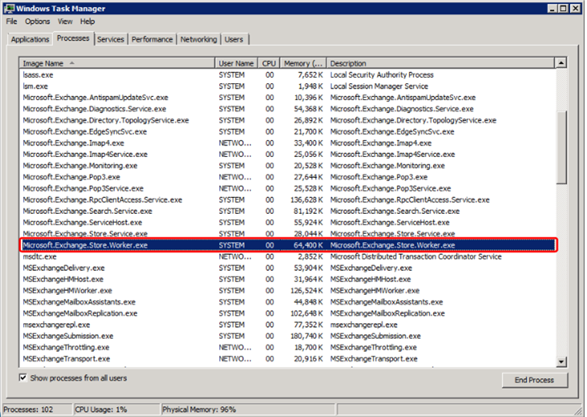

Here only one Store Worker process is running indicating that only one mailbox database is being used by the exchange.

We begin by signing in to the Exchange Administration Center (EAC).

Now locate **Servers** page on the left pane of our homepage and go to **Databases Tab.**

We can now see a list of available mailboxes. Clicking on a particular mailbox will allow us to review the mailbox.

We shall now see how to configure Exchange for high availability.

We begin by **clicking on + (New)**.

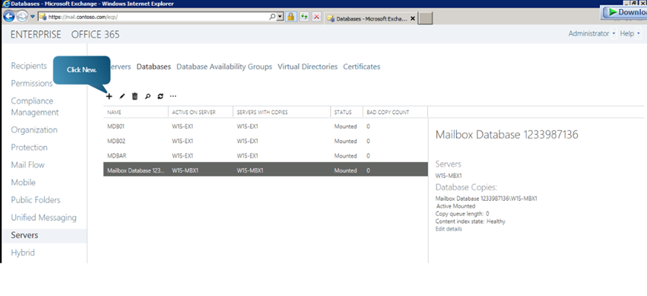

We can now see a pop up window where we can define the properties of the new mailbox. Fill in the **name** and select the **server** on which the mailbox is to be hosted.

After choosing the server, we can now specify the **paths for database and log folder**.

Please note that we have to select **Mount this database** option.

Now click on **Save.**

This will create a new mailbox database

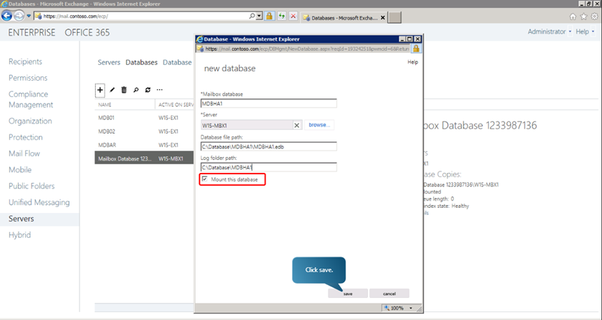

We can verify that the new mailbox has been created by going to **task manager-> Processes** and locating **Microsoft Exchange Worker Processes** instances just as we did before.

In Exchange, it is database availability group (or DAG), that enables high availability and site resilience. A DAG is a collection of Mailbox servers that can manage a set of databases providing automated, database-level failure recovery that may affect individual databases, networks, or servers. The number of mailboxes can be up to 16 in a DAG.

Any mailbox database from a server in a DAG can be accessed from any other server in the DAG. Other servers within the DAG can provide automatic recovery from failures that affect mailbox databases, such as a disk failure or server failure, to any new or existing server added to the DAG.

**Steps to Create a New DAG in Exchange 2013**

In the EAC home page, go to **Servers**from the left pane.

Click on **Database Availability Groups**tab.

Click on the **+ (NEW)**button.

In the new pop up window, we can define the parameters of the DAG like name, ip address, witness server etc. A witness resource is used in DAGs to make sure that only one collection of the members in the DAG is considered official.

Click on **Save.**

A warning message will be displayed. Click **OK.**

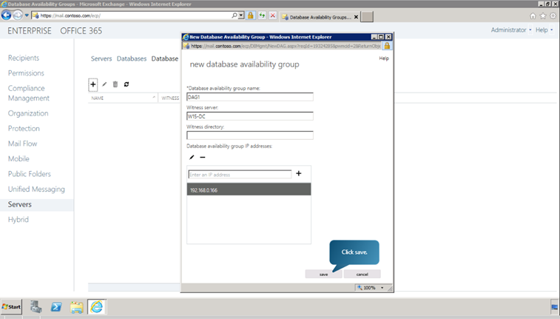

Now we can see the newly created DAG listed. We can review and edit the information about the DAG by clicking edit button. This is illustrated in the following figure.

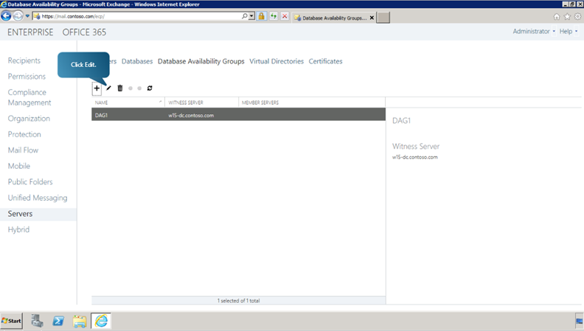

Next, we need to add a server to the DAG. It can be done by clicking on **Manage Membership** button on the DAG page in the EAC. The following figure illustrates this.

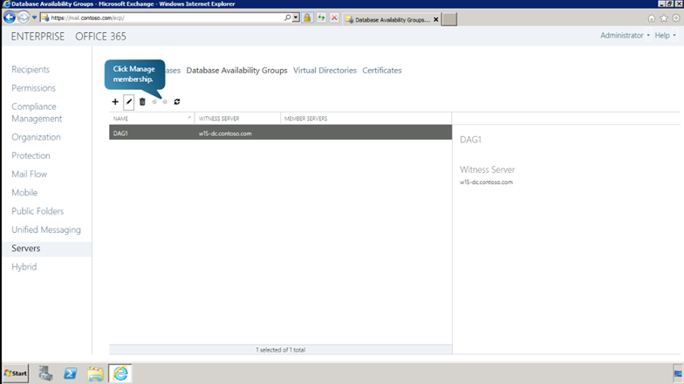

Once you click the **Manage Membership**button, a new pop up window opens listing the current servers in the DAG. To add a new server click on the **+ (Add)**button, select the desired server from the newly populated list, click **OK**, and finally **Save.**Now a message will be displayed notifying that the saving has been completed successfully. Click **Close**.

We can add as many servers to the DAG as we desire by repeating the procedure.

Once servers are added to the DAG, we can see in the DAG window that the added servers have been listed as Member Servers.

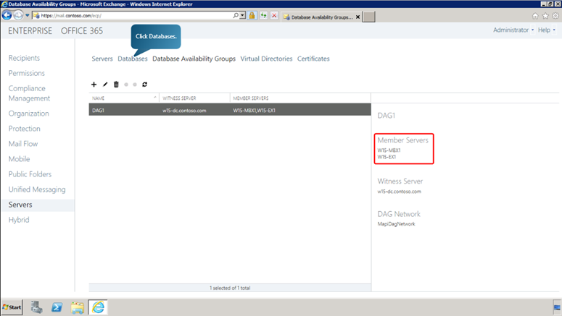

If we navigate back to the database pane, we can see that the newly added database has been listed as a part of the newly created DAG.

Now, we can add a copy of the database to another server. To do this, follow the following steps.

Click on **Add database copy**button.

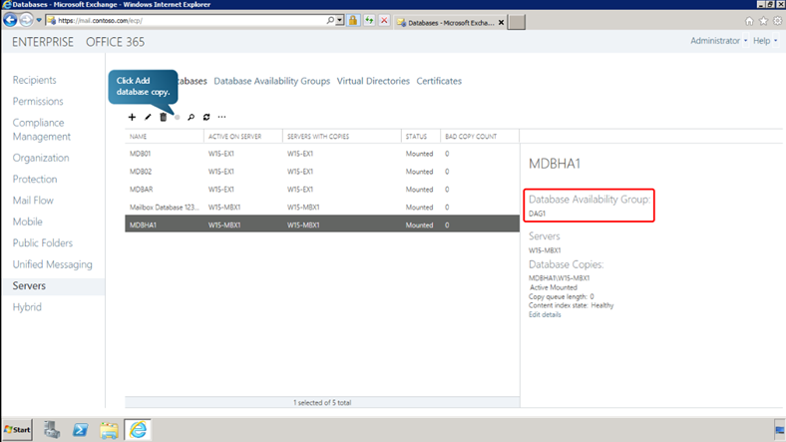

In the pop up window, specify the **Mailbox Server** for the copy database. Here, we can also define the activation preference number of the server.

Click **Save**

After the database copy has been successfully created, click **Close**.

We can view and edit the information about the mailbox database from the details pane by clicking on **Edit Details** button. We can also manage aspects of the database copy, like suspending the copy, activating the copy or removing the copy, from the details pane.

**Checking the Status of the DAG in Exchange 2013**

After deploying and assigning mailbox servers to a DAG, we can check the status of the DAG through Exchange Management Shell.

The following cmdlet returns the status of the DAG named DAG1.

**Get-DatabaseAvailabilityGroup -Identity DAG1 –Status**

The following cmdlet returns the status of the database copy called MDBHA1

**Get-MailboxDatabaseCopyStatus MDBHA1**

We can create a new mailbox for a user in the mailbox using the following cmdlet.

**New-Mailbox-Alias SpencerL -Name “Spencer Low” -Firstname Spencer -LastName Low -DisplayName “Spencer Low” -UserPrincipalName SpencerL@contoso.com -Password <ConvertTo-SercureString -String ‘password’ -AsPlainText -Force> -Database MDBHA1**

Here, we have created a mailbox for user Spencer Low in the mailbox MDBHA1.

We can verify that the mailbox for Spencer Low has been created, by going back to the EAC. In the EAC navigate to **Recipients** and in the populated list, **search** for the name Spencer. We can view and edit the details of the mailbox by clicking on the edit button as shown here.

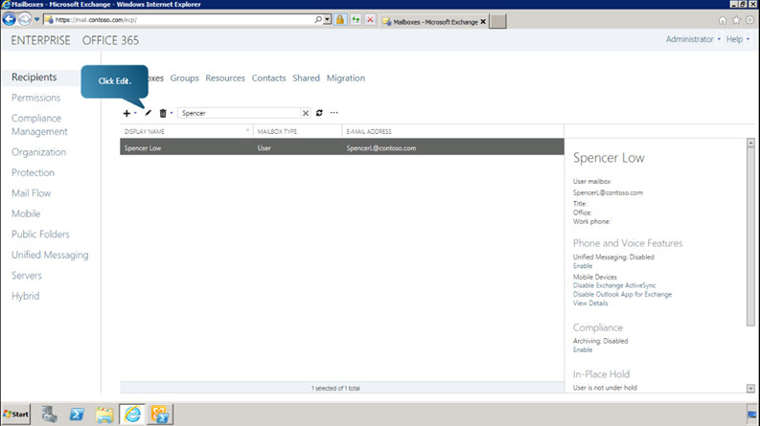

**Testing Database Availability Group (DAG) Switchover and Failover in Exchange 2013**

**Switch Over**

Now we can examine how we can test a DAG for reliability by performing Switchover and Failover tests.

Let us begin by sending a text message between two Exchange users using the Outlook WebApp.

Log in to the outlook web app as the first user (Henceforth known as Spencer Low)

Send a text message to a second user whose mailbox is located in a different mailbox database. (The second user shall henceforth be known as Alex Darrow)

Now just to verify that the message has been received, sign out of the web app and sign in as Alex Darrow.

Now return to the EAC, go to **Servers** and open **Database** tab.

Now select the required mailbox database.

Click on **Activate**in the details pane as shown to switch over to the database.

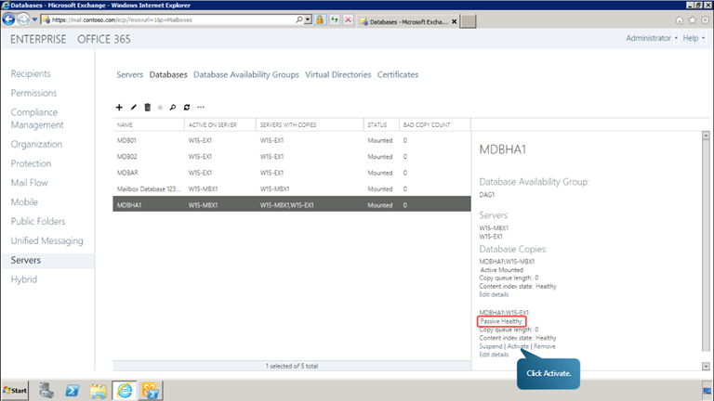

Click **Yes**on the warning message.

When it shows that operation is successful, click **Close.**

Now we have successfully completed a switch over.

Now we can return to the outlook web app to reply to the message sent to Alex as Spencer.

To verify that the replying was successful, in the outlook web app log out and log in as Spencer.

**Automatic Service Recovery**

Now let us find out more about automatic service recovery. Let us terminate a process and see if it is reinstated automatically by the exchange.

Open the exchange management shell

Terminate the inetinfo process using the following command

TaskKill /F /IM inetinfo.exe

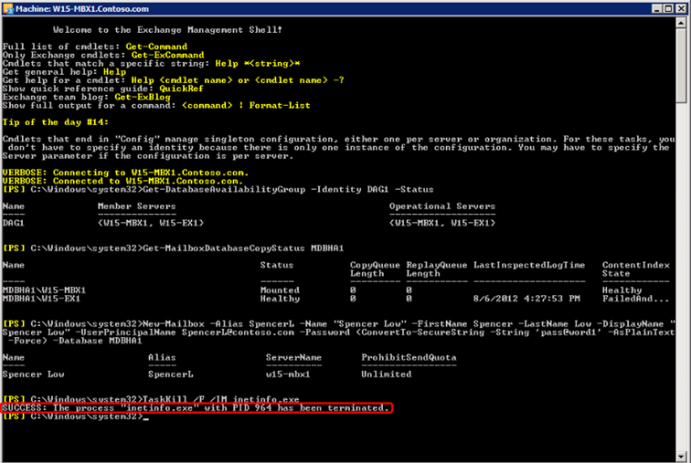

Now open event viewer from **Start Menu->Administrative Tools->Event Viewer** to find out how the event was handled.

Select the event logged as an Error to see more details.

Now just above the Error Log, an information log has been registered which shows that the service was reinstated into running state. This happened because the inetinfo process was being monitored by the managed availability feature in Exchange.

With managed availability, internal monitoring and recovery-oriented features are tightly integrated to help prevent failures, proactively restore services, and initiate server failovers automatically or alert administrators to take action. The focus is on monitoring and managing the end-user experience, rather than just server and component uptime, to help keep the service continuously available.

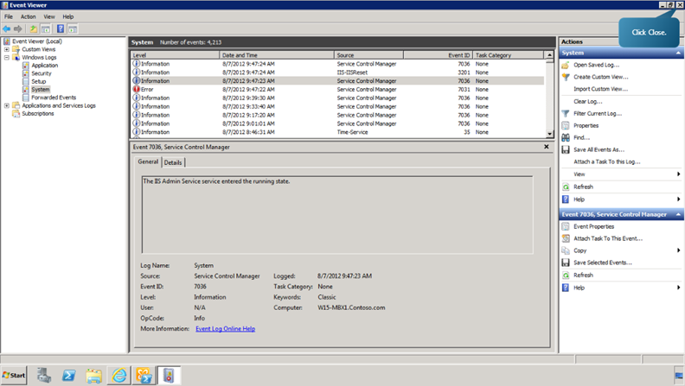

Now, we can test the DAG for a failover. The automatic activation of one or more mailboxes after a failure event is known as failover.

We begin by triggering a failover by stopping an Exchange Store Worker process.

This can be done by the following command.

**Get-Process Microsoft.Exchange.Store.Worker | Stop-Process –Force**

After entering the command we can check the status of the database copy of the mailbox database. This is done using the command:

**Get-MailboxDatabaseCopyStatus -Identity MDBHA1**

Now we can see that the failover has been successful

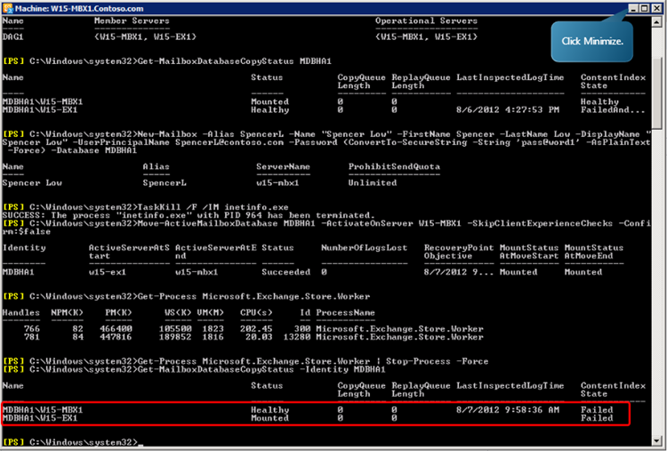

This can be further verified by going to the outlook web app and sending a message to Spencer as Alex. The failover will be successful if Spencer receives the message.

# **Checklist for troubleshooting Outlook connectivity in Exchange 2013 and 2016 (on-premises)**

Some of relatively common and difficult issues we see in support are related to Outlook connectivity to Exchange.  There are several variations that we classify as connectivity (related to server performance or otherwise).  They can include:

* Clients prompting for credentials (intermittently or continuously)
* Clients getting disconnected
* Clients are unable to establish a connection
* Clients freezing or going unresponsive

There are many factors that can contribute to these symptoms, and each one can lead down a completely different troubleshooting path. In this particular post we will focus on methods and tools to troubleshoot these. There are too many potential underlying causes to cover them all but hopefully this will serve as a good starting point for troubleshooting.

This post is not meant to be a post that you necessarily read from start to finish, but rather serve as a guidance for when you need to troubleshoot hard to find issues related to client connectivity. It can be a bit overwhelming, sure, but depending on the depth that you need to get into – it might be all worth it!

### Client configuration

Here are some examples of things to consider when troubleshooting these issues.

* Are the clients connecting with Outlook Anywhere or MAPI/HTTP? Try to use the Outlook “Connection Status” window to access more information on the user’s connection by holding down the CTRL key and clicking the Outlook icon in the system tray so that the “Connection Status” window appears. Here you can see the protocol, the connection type, and so on RPC/HTTP indicates Outlook Anywhere, whereas HTTP indicates MAPI/HTTP.

[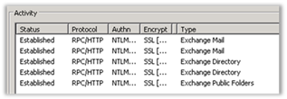](https://msdnshared.blob.core.windows.net/media/2016/05/image939.png)

* Are clients online or in cached mode? Cached mode is recommended. Moving critical users to cached mode to improve their experience might be a good thing. You can enable BitLocker if there are local storage considerations. What devices are clients traversing to hit the CAS? Run Tracert to the CAS to determine the devices in the path of the client.
* Test several clients with a hosts file pointing to the IP address of CAS using the external host name. The Hosts file is located in C:\Windows\System32\Drivers\etc directory.
* What is the user attempting to do when they experience issues? Accessing a calendar, public folders or just moving around in the Inbox?
* Are effected mailboxes on the same database, same server?
* What is the Outlook full build number? Always make sure that you are working with an updated client. Information about recent updates can be found in the following references:
  + [How to install the latest applicable updates for Microsoft Outlook](http://support.microsoft.com/en-us/kb/2625547/en-us)
  + [Outlook and Outlook for Mac Update File Versions](http://social.technet.microsoft.com/wiki/contents/articles/31133.outlook-and-outlook-for-mac-update-build-numbers.aspx)
* Using the OffCAT output, examine which add-ins are being used and consider disabling those for testing. Make sure that you restart Outlook and verify the add-ins remain disabled.
* Try running Outlook in safe mode for a few clients. Not all add-ins are removed when using safe mode so ensure you have verified they are no longer loaded with [Process Explorer](https://technet.microsoft.com/en-us/sysinternals/bb896653) if you suspect they are still loaded.
* Enable Outlook logging.

### CAS configuration

The first step for the Exchange server checks is to review all the settings noted in TechNet article, [Exchange 2013 Sizing and Configuration Recommendations](https://technet.microsoft.com/en-us/library/dn879075(v=exchg.150).aspx). Several items such as setting power management to “High Performance” and verify the OS isn’t turning off power to the NIC. Making sure the server is running updated and supported .NET version, and so on are extremely important:

* Run the [Exchange Performance Health Checker](https://gallery.technet.microsoft.com/Exchange-2013-Performance-23bcca58) script. Review the output for any results that have to be updated.
* As of right now, Exchange 2013 should be running .NET 4.5.2. Please see the [Supportability Matrix](https://technet.microsoft.com/en-us/library/ff728623(v=exchg.150).aspx) for current version supported.
* [Turn off hyper-threading](http://blogs.technet.com/b/exchange/archive/2015/09/15/ask-the-perf-guy-what-s-the-story-with-hyperthreading-and-virtualization.aspx)
* [Update outdated Outlook clients](https://support.microsoft.com/en-us/kb/2625547)
* Update NIC drivers
* Eliminate any slow disk issues identified in Perfmon
* Set Power Management to “High Performance”
* Locate the NIC “Properties |Configure | Power Management” and verify the box for “[Allow the computer to turn off this device to save power](http://blogs.technet.com/b/exchange/archive/2013/10/22/do-you-have-a-sleepy-nic.aspx)” is unchecked.
* Verify [RSS and Chimney offload on CAS](http://blogs.technet.com/b/exchange/archive/2013/07/30/a-reminder-on-real-life-performance-impact-of-windows-snp-features.aspx).
* Verify that all the noted hotfixes are installed from [Exchange 2013 Sizing and Configuration Recommendations](https://technet.microsoft.com/en-us/library/dn879075(v=exchg.150).aspx).
* CAS Keep Alive values should be set to 30 minutes and no less than 15 minutes. If there’s no entry in the registry for KeepAliveTime then the value is 2 hours. This value, if not set correctly, can affect both connectivity and performance as noted in KB, [Unable to connect using Exchange ActiveSync due to Exchange resource consumption](https://support.microsoft.com/en-us/kb/2469722). You must make sure that the load balancer and any other devices in the path from client to CAS be set correctly. More information on load balancer settings are listed later in this document under Load Balancing Configuration section. The goal is to set CAS with the lowest value so that client sessions when ended, are ended by the CAS and not by a device.

Path: HKEY_LOCAL_MACHINE\System\CurrentControlSet\Services\Tcpip\Parameters\  
Value name: KeepAliveTime  
Value Type: 1800000 (30 minutes, in milliseconds) (Decimal)

* Max Core Count – In Exchange 2013 and 2016, you can encounter performance problems if you go too far off of the preferred architecture, particularly when referring to core count. This can even include having too many cores. The maximum number of cores on a server should be no more than 24. Hyper-threading can artificially inflate this value so it’s important to disable it as mentioned. For more information, refer to following articles:
  + [Troubleshooting High CPU utilization issues in Exchange 2013](http://blogs.technet.com/b/exchange/archive/2015/04/30/troubleshooting-high-cpu-utilization-issues-in-exchange-2013.aspx)
  + [Ask the Perf Guy: How big is too BIG?](http://blogs.technet.com/b/exchange/archive/2015/06/19/ask-the-perf-guy-how-big-is-too-big.aspx)
* As a general statement, [Preferred Architecture](http://blogs.technet.com/b/exchange/archive/2014/04/21/the-preferred-architecture.aspx) should be your guidance.

### Load balancer configuration

Please note that for 3rd party load balancer configuration, you should always refer to product documentation / guidance. The following are some general best practices and things we see misconfigured:

1. Verify the client TCP Idle Time-Out is a slightly larger value than the Keep Alive setting on CAS, as noted earlier.

In this example, we are using the 30-minute Keep Alive on CAS and we have both a firewall and load balancer in front of the clients. Here is the connection path.

Clients > Firewall > Load Balancer > CAS

In this example, if you have a firewall in the path from client to CAS, we are referencing the firewall “idle” time out and not the persistence time out. This value should be greater than the load balancer and the load balancer time out should be greater than CAS. Note that it is not recommended to go below 15 minutes for Keep Alive on CAS or TCP idle timeout on the load balancer.

Firewall time out = 40 minutes  
LB TCP Idle time out = 35 minutes  
CAS Keep Alive = 30 minutes

2. If the load balancer supports it, the preferred option is to configure it to use “Least Connections” with “Slow start” during typical operation.

*With the “least connections” method, be mindful it is possible for a CAS to become overloaded and unresponsive during a CAS outage or during patching/maintenance. In the context of Exchange performance, authentication is an expensive operation.*

The TechNet article [Exchange 2013 Sizing and Configuration Recommendations](https://technet.microsoft.com/en-us/library/dn879075(v=exchg.150).aspx) describes the differences as:

*A hardware or software load balancer should be used to manage all inbound traffic to Client Access servers. The selection of the target server can be determined with methods such as “round-robin,” in which each inbound connection goes to the next target server in a circular list, or with “least connections,” in which the load balancer sends each new connection to the server that has the fewest established connections at that time. These methods are detailed further in the following blog*[*Load Balancing in Exchange 2013*](http://blogs.technet.com/b/exchange/archive/2014/03/05/load-balancing-in-exchange-2013.aspx)*and TechNet*[*Load balancing*](https://technet.microsoft.com/en-us/library/jj898588(v=exchg.150).aspx)*.*

3. For ActiveSync persistence setting, set the load balancer to use “Authorization header cookie” to avoid one CAS becoming overloaded because source IP will send all the connections to one server as [per this](https://blogs.technet.microsoft.com/mikehall/2012/09/05/why-the-correct-load-balancing-persistence-is-so-important-in-exchange-server-2010/).

### Additional troubleshooting steps

If you have completed the previous steps and you are still experiencing issues, the following data is necessary:

* Start Perfwiz on CAS and Mailbox server to run for 4 hours during the busiest part of the day (assuming this is when issues are happening). Download ExPerfwiz from [here](http://experfwiz.codeplex.com/). Example command line: *\experfwiz.ps1 -server MBXServer -interval 10 -filepath D:\Logs.*Once you have the performance data, see blog on [Troubleshooting High CPU Utilization issues in Exchange 2013](http://blogs.technet.com/b/exchange/archive/2015/04/30/troubleshooting-high-cpu-utilization-issues-in-exchange-2013.aspx)
* Review the application logs for any 4999 events that occurred around the time of problems.
* In the Application log, review the 2080 event to make sure that all domain controllers are responding with correct Boolean values. If there are any responses that are not accurate, the DC’s should be repaired or excluded.

Expected values are“**CDG 1 7 7 1 0 1 1 7 1**” as shown in the following table.

[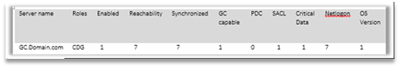](https://msdnshared.blob.core.windows.net/media/2016/05/image940.png)

For testing, a DC can be excluded by using the Set-Exchangeserver –StaticExcludedDomainControllers parameter as shown in this section, however, troubleshooting [Global Catalog access](https://support.microsoft.com/en-us/kb/298879) should also be done as soon as your testing is completed. Statically excluding a GC takes effect immediately and will be viewable on the next 2080 Event ID with all zero values. Some additional resources on the subject:

* + - [The PDC column should show 0 and not be used by Exchange](https://support.microsoft.com/en-us/kb/298879)
    - More information for Set-ExchangeServer is located [here](http://technet.microsoft.com/en-us/library/bb123716.aspx)
    - More information about Event ID 2080 from MSExchangeDSAccess can be found [here](http://support.microsoft.com/kb/316300/EN-US)

* When in Application log, also check for Event ID 2070 or 2095. A 2070 event occurs when Exchange tries to query a DC and fails and it cannot contact/communicate with a DC. If this event occurs during the time when clients have issues (or frequently), then it should be investigated. If you only see this event occasionally over several days, it could be a result of the DC being restarted during maintenance. The same is true with event 2095; infrequent isn’t a concern but continued logging of this event could be a sign of a problem.
* Always ensure MaxConcurrentApi bottlenecks are not present in the environment. To avoid this problem now or in future review the following information:
  + [You are intermittently prompted for credentials or experience time-outs when you connect to Authenticated Services](http://support.microsoft.com/kb/975363)
  + [Updated – NTLM and MCA Concerns](http://blogs.technet.com/b/ad/archive/2008/09/23/ntlm-and-maxconcurrentapi-concerns.aspx)
  + [Quick Reference: Troubleshooting, Diagnosing, and Tuning MaxConcurrentApi Issues](https://blogs.technet.microsoft.com/askpfeplat/2014/01/12/quick-reference-troubleshooting-diagnosing-and-tuning-maxconcurrentapi-issues/)
* LDAP latencies can impact server and client performance. When you work with client connectivity issues, the LDAP counter can help point delays with communications to the DC’s. These are under the *MSExchange ADAccess Domain Controllers(*) LDAP Read Time* and *LDAP Search Time*, and is recommended that the average be within 50ms and spikes no greater than 100ms. More information [here](http://blogs.technet.com/b/askpfeplat/archive/2015/05/11/how-to-find-expensive-inefficient-and-long-running-ldap-queries-in-active-directory.aspx).

### Coexistence with Exchange 2010 and 2007

In order to coexist with newer versions of Exchange, certain configuration steps are necessary. This section outlines typical organization changes that are needed to connect through an Exchange 2013 CAS.

* Verify that legacy servers are at the latest available Service Pack and RU.
* If Outlook Anywhere is not enabled on legacy Exchange servers, we recommend that you enable Outlook Anywhere on every CAS in the organization with NTLM authentication for ClientAuthenticationMethod and NTLM and Basic for IISAuthenticationMethods. The external host name should be the DNS name of the Exchange 2013 CAS external URL.

Example:  
Enable-OutlookAnywhere -Server ‘ConE10′ -ExternalHostname Mail.Contoso.com’ -ClientAuthenticationMethod ‘Ntlm’ -SSLOffloading $false –IISAuthenticationMethod Basic, NTLM

* Configure the Exchange 2010 SCP for AutoDiscover to point to Exchange 2013 CAS. The AutoDiscover SCP is used for the internal clients only. In some cases, you can just update DNS to point to Exchange 2013. DNS would have to point AutoDiscover to Exchange 2013 for all the external clients also. We do not recommend that you use separate URL’s for legacy mailboxes. All connections should use an Exchange 2013 CAS.

To set the SCP for AutoDiscover (example):  
Set-ClientAccessServer ConE10 -AutoDiscoverServiceInternalUri[https://Mail.Contoso.com/autodiscover/autodiscover.xml](https://mail.contoso.com/autodiscover/autodiscover.xml)

* Verify all legacy CAS are pointed to 2013 for the SCP AutoDiscover URI.

Example:  
Get-ClientAccessServer |fl *uri*  
AutoDiscoverServiceInternalUri : [https://Mail.Contoso.com/autodiscover/autodiscover.xml](https://mail.contoso.com/autodiscover/autodiscover.xml)

* Be aware that Exchange 2007 mailboxes will access EWS and OAB by using “Legacy.Domain.com” as discussed [here](http://blogs.technet.com/b/exchange/archive/2014/03/12/client-connectivity-in-an-exchange-2013-coexistence-environment.aspx).

#### **Known issues in coexistence**

* [Mailboxes located on 2010 Unable to Connect through Exchange 2013](https://support.microsoft.com/en-us/kb/2990117)
* Users may be prompted for credentials when accessing additional mailboxes, calendars or Public Folders on Exchange 2010 server. See #2 in the previous section indicating that NTLM is not enabled on legacy CAS for Outlook Anywhere.

### Troubleshooting Logs and Tools

**HTTP Proxy RPCHTTP Logs**

In Exchange 2013, there are several logs in the logging folder. For Outlook clients one of the first logs to examine are the HTTP Proxy logs on CAS. The connection walk-through section shows the process that is used to connect to Exchange 2013. This complete process is logged in the HTTP Proxy log. Also, if it is possible, add Hosts file to the client for one specific CAS to reduce the number of logs.

The logs on CAS are located here by default: *C:\Program Files\Microsoft\Exchange Server\V15\Logging\HttpProxy\RpcHttp*

**HTTP Proxy AutoDiscover Logs**

Exchange 2013 has HTTP Proxy logs for AutoDiscover that are similar to the logs shown earlier that can be used to determine whether AutoDiscover is failing.

The logs on CAS are located here by default: *C:\Program Files\Microsoft\Exchange Server\V15\Logging\HttpProxy\AutoDiscover*

***HTTP Error Logs***

HTTP Error logs are failures that occur with HTTP.SYS before hitting IIS. However, not all errors for connections to web sites and app pools are seen in the httperr log. For example, if ASP.NET threw the error it may not be logged in the HTTP Error log. By default, HTTP error logs are located in*C:\Windows\System32\LogFiles\HTTPERR*. Information on the httperr log and codes can be found[here](https://support.microsoft.com/en-us/kb/820729/).

***IIS Logs***

IIS logs can be used to review the connection for RPC/HTTP, MAPI/HTTP, EWS, OAB, and AutoDiscover. The full data for the MAPI/HTTP and RPC/HTTP is not always put in the IIS logs. Therefore, there is a possibility that the 200 connection successful may not be seen. [IIS codes](https://support.microsoft.com/en-us/kb/943891).

In Exchange 2013 IIS logs on the CAS should contain all user connections on port 443. IIS logs on the Mailbox server should only contain connections from the CAS server on port 444.

Most HTTP connections are first sent anonymously which results in a 401 challenge response. This response includes the authentication types available in the response header. The client should then try to connect again by using one of these authentication methods. Therefore, a 401 status found inside an IIS log does not necessarily indicate an error.

Note that an anonymous request is expected to show a 401 response. You can identify anonymous requests because the domain\username is not listed in the request.

***RPC Client Access (RCA) Logs***

The RCA logs can be used to find when a user has made a connection to their mailbox, or a connection to an alternate mailbox, errors that occur with the connection, and more information. RCA logs are located in the logging directory which is located at*%ExchangeInstallPath%\Logging\RpcClientAccess*. By default, these logs have a maximum size of 10MB and roll over when size limit is reached or at the end of the day (based on GMT), and the server keeps 1GB in the log directory.

***Outlook ETL Logging (requires a support case with Microsoft to analyze the log)***

ETL logs are located in %temp%/Outlook Logging and are named Outlook-#####.ETL. The numbers are randomly generated by the system.

To enable Outlook logging

In the Outlook interface:

* Open Outlook.
* Click **File**, **Options**, **Advanced**.
* Enable “Enable troubleshooting logging (requires restarting Outlook)”
* Restart Outlook.

How to enable Outlook logging in the registry:

* Browse to HKEY_CURRENT_USER\Software\Microsoft\Office\xx.0\Outlook\Options\Mail
* DWORD: EnableLogging
* Value: 1
* Note: xx.0 is a placeholder for your version of Office. 15.0 = Office 2013, 14.0 = Office 2010

***ExPerfwiz (Perfmon for Exchange)***

You can use Perfmon for issues that you suspect are caused by performance.<http://experfwiz.codeplex.com/>

Exchange 2013 has daily performance logs that captures the majority of what is needed. These logs are by default located in C:\Program Files\Microsoft\Exchange Server\V15\Logging\Diagnostics\DailyPerformanceLogs

***Log Parser Studio***

[Log Parser Studio](https://gallery.technet.microsoft.com/office/Log-Parser-Studio-cd458765) is a GUI for Log Parser 2.2. LPS greatly reduces complexity when parsing logs. Additionally, it can parse many kinds of logs including IIS Logs, HTTPErr Logs, Event Logs (both live and EVT/EVTX/CSV), all Exchange protocol logs from 2003-2013, any text based logs, CSV logs and ExTRA traces that were converted to CSV logs. LPS can parse many GB of logs concurrently (we have tested with total log sizes of >60GB).

Blog with tips/how to about LPS: <http://blogs.technet.com/b/karywa/>

***Exmon tool (aka Microsoft Exchange Server User Monitor)***

We use [this tool](http://blogs.technet.com/b/exchange/archive/2016/02/16/exchange-2013-and-2016-exmon-tool-is-now-available.aspx) to get detailed information about client traffic.

Hopefully this is helpful; we expect that we will make some updates to this checklist as time goes on!

Thanks to Brendon Lee, Marc Nivens, Nasir Ali, Louise Budrow and [The Exchange Performance V-Team](http://aka.ms/exchangeperf) for technical review.

## **Common Configuration Issues**

<https://blogs.technet.microsoft.com/exchange/2015/04/30/troubleshooting-high-cpu-utilization-issues-in-exchange-2013/>

Those of us that have worked enough performance issues start by following a list of things to check first. This was actually the main motivation for a TechNet article we recently published called [Exchange Server 2013 Sizing and Configuration Recommendations](https://technet.microsoft.com/en-us/library/dn879075(v=exchg.150).aspx). I'm not going to duplicate everything in the article here, I would suggest that you read if you are interested in this topic. I will however touch on a few of the high points.

*.NET Framework version*

Exchange 2013 runs on version 4.5 of the .NET Framework. The .NET team has published updates to .NET 4.5, released as versions 4.5.1 and 4.5.2. All of these versions are supported on Exchange 2013. However, I would strongly recommend that 4.5.2 be the default choice for any Exchange 2013 installation unless you have very specific reasons not to use it. There have been multiple performance related fixes from version to version, some of which impact Exchange 2013 fairly heavily. We've seen more than a few of these in support. You can save yourself a lot of trouble by upgrading to 4.5.2 as soon as possible, if you are not already there. It should also be noted that 4.5.2 is the latest version as of the publishing of this blog post. Future releases will contain even more improvements so be sure to always check for the latest available version. You can read more about the different versions of the .NET Framework [here](https://msdn.microsoft.com/en-us/library/ms171868(v=vs.110)).

*Power Management*

I started losing count a while back of the number of high CPU cases I encountered that were caused by misconfigured power management. Power management sounds like a good thing, right? In many cases it is. Power management allows the hardware or the OS to, among other things, throttle power to the CPU and turn off an idle network card when it isn't in use. On workstations and perhaps on certain servers this can be a good thing. It saves power, lowers the electric bill, gives you a nice low carbon footprint, and makes vegetables taste good. So why is this a bad thing? Consider this. You have a server running at about 80% CPU throughout the work day consistently. You've ran the sizing numbers over and over and you should be closer to 55%. You don't see any unusual client activity. Everything looks great except the CPU utilization. Now what if you were to find out that your 2.4GHz cores are only operating at 1.2GHz most of the time? That might make a difference in your reported CPU utilization. For Exchange the guidance is straight forward. If hardware power management is an option, don't use it. You should allow the operating system to manage power and you should always use the "High performance" power plan in Windows. Even if you aren't using hardware based power management, just having the power plan set to the default "Balanced" can be enough to throttle the CPU power.

How do you know if this is happening? On a physical server the answer is easy. There is a counter in performance monitor called "Processor Information(_Total)\% of Maximum Frequency". This should always be at 100. Anything lower indicates that the CPU is being throttled which is usually a result of some kind of power management, either at the hardware or OS level. On a virtual server things get a bit more complicated. To the Exchange server, a VM guest, it is difficult to completely trust the CPU performance numbers. If power is being throttled at the VM Host layer, it will not be overly apparent to the Guest OS. You need to use the performance monitoring tools of the VM Host to check for processor power throttling.

*Health Checker*

We've recently published a PowerShell script on the [TechNet gallery](https://gallery.technet.microsoft.com/Exchange-2013-Performance-23bcca58) that makes checking for common configuration issues easy. The script reports Hardware/Processor information, NIC settings, Power plan, Pagefile settings, .NET Framework version, and some other items. It also has a Client Access load balancing check (current connections per server) and a Mailbox Report (active/passive database and mailbox total per server). It can be executed remotely and can run against all servers in the Organization at once, to save the trouble of having to check all of these settings individually on each server. The TechNet gallery posting contains more details on the script as well as some common usage syntax.

### Exchange Server – Troubleshooting internal/external mail flow issues

Let’s take a look at some mail flow basics and how to troubleshoot and resolve issues involving improper reception of incoming mails.

Sometimes for a properly working mail flow structure with a valid SMTP domain which is in the list of accepted domain, internal mail may not reach the recipient properly. This may be due to a number of reasons. To resolve this issue, we first check if a Non Delivery Report has been received by the sender.

In the absence of Non delivery report being received by the sender, we can check for any of the following options so as to resolve the issue:

**MX Record**

An MX record or a Mail Exchange Record is basically a record which redirects an email which is being sent to a user to that particular user’s computer. So it instructs the mail deliver agent the system to which the email is to be routed. If the MX record does not specify the correct IP address of the recipient, incoming mail will not be received by them. To check if the MX Record is pointing to the correct IP, we use the NSLOOKUP.

The NSLookup tool is used to check the configuration of the mail exchange records.

**Performing the NSLookup**

* Go to Command Prompt
* Key in **NSLOOKUP** and Press Enter
* Enter **server {required IP of DNS server}**
* Press Enter
* Enter the following
  + **Set q=MX**
* Now if you enter the domain name required and press enter, its particular MX record will be shown. This ensures that MX record has been properly configured.

Example:

C:\> NSLOOKUP

Default Server: ns1.domain.com

Address: 10.0.0.1

> set q=mx

> domain.com

Server: ns1.domain.com

Address: 10.0.0.1

mailhost.domain.com MX preference = 0, mail exchanger = mailhost.domain.com

**Blacklist check**

If the MX Record is properly configured, we check for any blacklisting issues. Usually blacklisting is checked for when there are multiple domains from which mail is not incoming. To run a blacklist check, we need a black list tool for the outbound IP address and the domain name of the remote server, which can be obtained from[http://www.mxtoolbox.com](http://www.mxtoolbox.com/)

Once we obtain the tool, we check for any blacklists marked against the different domains IP addresses which are having inbound mailflow issues. If there is a blacklisting, we need to contact the providers of Blacklist so that we can resolve the issue by removing the domain from the blacklist. This will obviously require some time as per the blacklist server. If the issue needs to be resolved urgently, we can always try to change the outbound IP address and take a look into the reason behind blacklisting.

**Submit email using Telnet**

Next test is to use Telnet to submit an email. For this, we first go for a network which is also an exchange/HUB server that can have proper inbound mail reception and use telnet to resubmit the email. By doing this, we can ensure that the port 25 traffic is properly received by the server. After this test is passed, we check for the MX record of port 25 to obtain its IP address.

Check the port 25 listening accessibilities and find out if exchange is listening on port 25 or is it some other hosts. If an exchange verb is obtained as the response to the EHLO command in case of the MX showing an exchange/HUB server.

If the host is not exchange, then the issue might be in the configurations of the smart host. If there are no issues in the configuration of the smart host, the SMTP logs may be checked for errors against submission of inbound mail to exchange.

**EXRCA**:

Next, we check the SMTP verbs are properly returned by the tool <https://www.testexchangeconnectivity.com/>

**Receive Connector (E2k7 & E2k10)**

Next, if the exchange server is 2007 or 2010, we check the receive connector. This is done if a particular error is shown by the sender’s server namely, “530 5.7.1 Client was not authenticated and generate NDR”. Under such circumstances, we do the following

* Check the properties of the receive connector.
* Check if NIC specified for the receive connector is correct.
* Check if the IP address specified in the receive connector is configured properly
* Check if anonymous permissions are available for the receive connector configurations. This should be made available.
* The receive connector should have SMTP protocol logging enabled to Verbose and check if the SMTP traffic is actually hitting the server.
* The receive protocol logs may be verified so that there are no errors in them.

**Default SMTP Virtual Server Properties (E2k3):**

If the exchange version is 2003, we follow the following steps to check the SMTP virtual server properties:

* Ensure that the IP address port binding is properly configure.
* Verify the Default Virtual server IP address.
* Check for the port configuration from General-> Advanced. The port should be configured as 25.
* Navigate to Authentication from Access on the Default Virtual server properties and make sure that the Anonymous permission is enabled.
* Check the connection control configurations from Properties → Access
* Make sure that NCSA logging is enabled and find errors in them.

**Backpressure**:

Backpressure issues account to most of the email queue building issues. In simple words, backpressure means exchange is unable to process emails due to resource bottleneck issues.

Backpressure events look like this:

Log Name: Application  
Source: MSExchangeTransport  
Date: 4/17/2013 7:00:34 AM  
Event ID: 15004  
Task Category: ResourceManager  
Level: Warning  
Keywords: Classic  
User: N/A  
Computer: HUBServerName  
Description:  
Resource pressure increased from Normal to Medium.

Resource utilization of the following resources exceed the normal level:  
Version buckets = 123 [Medium] [Normal=80 Medium=120 High=200]

Back pressure caused the following components to be disabled:  
Inbound mail submission from the Internet  
Mail submission from the Pickup directory  
Mail submission from the Replay directory  
Mail delivery to remote domains

The following resources are in the normal state:  
Queue database and disk space (“Q:\Program Files\Microsoft\Exchange Server\TransportRoles\data\Queue\mail.que”) = 3% [Normal] [Normal=95% Medium=97% High=99%]  
Queue database logging disk space (“Q:\Program Files\Microsoft\Exchange Server\TransportRoles\data\Queue\”) = 4% [Normal] [Normal=95% Medium=97% High=99%]  
Private bytes = 16% [Normal] [Normal=71% Medium=73% High=75%]  
Physical memory load = 40% [limit is 94% before message dehydration occurs.]

So, make sure that there are no 1500x events listed in the application logs of the event logs.

The following links are good resource for troubleshooting-

<http://technet.microsoft.com/en-us/library/bb201658(v=exchg.141).aspx>

**Known issues**

These are some known issues in improper inbound mail flow.

* NDR of Sender shows the error “550-5.1.1 User unknown”

    Resolution

    This may be an AD Replication issue or an Edge Sync issue

* Firewall issues
  + <http://technet.microsoft.com/en-us/library/dd277550(v=exchg.80).aspx>
  + <http://support.microsoft.com/kb/320027>

Quite often, clients may face issues were multiple users within the exchange are unable to make email communications within the network or to other networks or sometimes both. Here, we shall look into the troubleshooting and resolution of such issues.

Under such circumstances, we take into account, some key information we collect from the client. They are

* Availability of Non Delivery Report for senders. If there is an NDR available, we obtain the NDR and look up the error generated in the NDR and the generating server.
* In the absence of an NDR, we need to know if the failed email has been housed in the users Outbox or in the Sent Items folder.
* Next, we need to know if the user is able to get Incoming emails.
* We also check if there is an issue with outbound email. In case of an issue, we need to know if the user is facing issues for all internet domains or just some specific domains.
* Next, we need to gather some information regarding the environment. Is the environment a Mixed Environment or not, the number of Active directory sites in the environment etc.
* Next, we need information regarding the configuration of the mailflow on which the user is facing issues. If it is inbound mailflow issues, ask for the MXrecord pointer.
* Finally, check the type of connecter used for the internet- DNS or Smart Host. If the user is using a smart-host, the type and details of the smart-host is also required.

Now, we begin troubleshooting based on the type of mail flow that has been impacted. 

**Mail being blocked at Exchange 2003 server:**

In case of mail being stuck at the exchange server, we follow these steps:

* Use the exchange system manager to check the queue.
* Check the **additional information**for the queue where the mail is being blocked. **Additional Information**can be found on the bottom left corner of the exchange system manager.
* Check the anti-virus the server houses. If the antivirus has made any exclusions, disable them.
* Check for the type of queue where the mail is being blocked. Use the following cases to solve for the appropriate queue viewer error.

Error- Unable to bind destination server in DNS.

In such cases, we utilize the NSLOOKUP tool to obtain the name resolution of the remote domain or remote bridgehead server.

Error – Connection was dropped off due to SMTP Protocol Event Sink

If the error returned is that the connection was dropped due to SMTP protocol event sink, we utilize Telnet to check the SMTP verbs of the remote server. Here we first check if anonymous submission of messages is pliable. If so then we have to verify the logs of NCSA protocols to check for the command at which we face the error.

If there are no information on the NCS log files, we verify that Netmon captures are available on the sending and recipient servers, preferably simultaneously.

Error in queue – Unable to open the message for delivery.

For such an error, we begin by verifying the queue for errors or warnings. If there are no events in the queue, we retry the queue after changing the transport component’s diagnostics logging to expert level.

Error in queue – The remote server did not respond to connection attempt.

Here, we once again utilize the NSLOOKUP tool to ensure that the resolution is towards the proper server. We also utilize Telnet to check the SMTP connectivity of the remote server and anonymous submission capabilities.

Error in Queue – An SMTP protocol error occurred.

Verify SMTP verbs and anonymous message submission capabilities using Telnet. If anonymous submission is available, check for the logs of NCSA protocol and verify the command at which error occurred.

If there are no information on the NCS log files, we verify that Netmon captures are available on the sending and recipient servers, preferably simultaneously.

**Mail being blocked at Exchange 2007/2010 server:**

* Use the exchange system manager to check the queue. Find the queue in which the failed message is there and check for its status-Retry or Active.
* Check the **additional information**for the queue where the mail is being blocked. Repeat the above section’s procedures for different types of errors.
* In the SMTP virtual server, try enabling NCSA Logs.
* Check the anti-virus the server houses. If the antivirus has made any exclusion, disable them.
* Verify that the properties of the Routing Group Connector are properly configured. The cmdlet for this is:

**Get-RoutingGroupConnector “Name of routing group connector” | fl**

* Enable the logging for Receive Connectors protocol at the recipient server to check the receive connector that has been chosen for Exchange 2003 server and find any errors in the SMTP communication.

The cmdlet for checking the location of the Receive connector protocol log file is,

**Get-TransportServer “Name of Hub transport server” | fl**

* Verify errors on the Application and system logs of the Exchange 2007/2010 target transport servers at the destination server.
* Go to the receive connector logs location to obtain logs by going using the cmdlet,

**Get-transportserver | fl**for both the receiving server.

**Mails stuck on E2k7/2010 for Exchange 2003.**

* Use the queue viewer     to check the queue.
* Check the **Queue type, Last error and Next Hop Domain**for the queue where the mail is being blocked. Use appropriate tool like nslookup, Intra-orgs send connector protocol logging, Telnet, netmon, Eventviewer, diagnostics logging based on the **Last Error**type to resolve the issue.
* At the send connector, intra-org logging for can be increased using the command:

**Set-TransportServer “Hub server where message are queued up” –IntraOrgConnectorProtocolLoggingLevel**

* Verify the source and the destination servers using the **Get-RoutingGroupConnector | fl** command.
* Verify the port 25 using telnet and verify the verbs.

**Mails stuck on E2k7/10 for Exchange 2007/2010.**

* Use the queue viewer     to check the queue.
* Check the **Queue type, Last error and Next Hop Domain**for the queue where the mail is being blocked. Use appropriate tool like nslookup, Intra-orgs send connector protocol logging, Telnet, netmon, Eventviewer, diagnostics logging based on the **Last Error**type to resolve the issue.
* Check the status of the queue using **get-queue | fl** command.
* At the send connector, intra-org logging for can be increased using the command:
* **Set-TransportServer “Hub server where message are queued up” –IntraOrgConnectorProtocolLoggingLevel**
* At the destination end (exchange 2007/10) server, verbose logging must be enabled.
* Check for the properties of the Receive Connector on the target server i.e. Exchange 2007/10. The properties to be verified are:
  + Navigate to the RemoteIPRanges list. Find the various IPs listed there. Check if the Sending server’s IP is properly configured on the list.
  + Ensure that the exchange server authentication is enabled at the Authentication tab.
  + Navigate to Permission Groups and make sure that the option selected is Exchange server
* Use the following powershell cmdlet to facilitate Diagnostic Logging for MSExchangeTransport components at the target server:

**Get-EventLogLevelMSExchangeTransport\* | Set-EventLogLevel –Level Expert**

* Verify that errors like Back pressure (15004, 15005), temporary authentication failures (Kerberos), ADTopolgy events (2080) are absent in the Application and System Logs for events related to transport. If you see these, resolve these issues first.
* Checking the Last error in queue can also be helpful in resolving the issue.

**Sender receive NDR:**

If the sender is receiving a non delivery report, obtain the following information from the NDR:

* Whether more than one user is getting an NDR.
* Is the NDR limited to users on a particular mailbox server or does this happen to multiple mailbox server.
* Does mails sent to a particular recipient/DL/mailbox server/site/domain result in the NDR
* Does the NDR appear for all instances of communications or do they happen at random points
* In case of random NDRs find the frequency of occurrence of NDR
* Was mail communication to the affected recipient in a working condition before the occurrence of NDR? Check for the duration from which the NDR was first seen and also check for changes made in the environment that resulted in the NDR.

Obtain an NDR copy that can be saved.  
Verify the recipient information, generating server and the diagnostic information from the NDR

After obtaining the NDR, check the delivery status notification and the server generating NDR to resolve the issue. Also we can utilise the diagnostic logging at the application event logs to resolve the issue.

For the codes in the NDR, we can refer the article – http://technet.microsoft.com/en-us/library/bb124840(EXCHG.65).aspx

**Mails getting stuck in Outbox and Drafts.**

In the absence of NDRs and email tracking, check where the email is stuck. It should be in the Outbox in case of outlook and in the drafts folder for Outlook web app.

Further, verify the following details

* Check if the issue persists for every mailbox in the server. Under such circumstances, follow:
  + Check if the submission service is working fine and properly configured for the sender’s mailbox server
  + Make sure that the transport service is working fine.
  + Restart the Microsoft exchange mail submission service.
  + Mail Submissions service running on the MBX server is the one responsible for alerting the HUB server to pick up the email
  + In the MSExchangeMailSubmission service check for any occurrences of 1009

If the issue is occurring for isolated mailboxes, then the issue may be because of different add-ins in the outlook or because of connectivity problems at the client side. Try sending emails from OWA under such circumstances.

**Message Tracking:**

During the absence of NDRs tools like Message tracking comes in very handy.

Tracking should be begun from the mailbox server of the sender. The server name under the tracking tool should be updated to the mailbox server of the sender. Any HUB transport server in sender’s site can be used to run the tracking.

We can also use power shell to perform message tracking.

<http://blogs.technet.com/b/messaging_with_communications/archive/2011/04/22/how-to-track-message-in-exchange-2003-2007-2010.aspx>

**Troubleshooting Outbound Mail flow issues**

Up until now, we were discussing issues with inbound mail messages. Now we shall look into troubleshooting of outbound mail issues.

There are three main characteristic natures by which we can distinguish an outbound email issue

In the first scenario, the sender is unable to send emails and the sender receives an NDR regarding the issue.

In the next scenario, sender is unable to send the email and he can see that the message is blocked in the queue.

And finally, the sender is able to send email but the delivery of the email message is uncharacteristically delayed.

Before we begin troubleshooting, we need to gather some basic info regarding the issue from the client.

* Check if the internal mail flow was facing any issues. Also check if inbound mails are properly receiving by the user.
* Find out the time from which the user started facing the issue and if the user was able to send emails prior to that. Also find out if any changes were made to the exchange environment which may have triggered the issue.
* Find out whether the user has configured any smarthost or antispam apps for the outbound emails.
* Also check if the user received any NDR or delayed deliver report regarding the failed email. If yes, collect the report.
* Also find out if the issue is reproducible or not.
* Check where the sent email (which failed) has been housed by outlook (sent Items/Outbox)
* Ask if the issue persists for a single domain or multiple domains.
* In case the user did not receive any NDR, ask if the email is blocked in the queue of the exchange server. If yes,
  + Track the email using message tracking tools
  + Collect the queue information like the queue name etc
  + Collect the error message written against the email in the queue
  + Ask for the result of the cmdlet execution Get-Queue|fl.
* Ask for the send connector configurations (it can be obtained by executing Get-sendconnector | fl Cmdlet)
* Find out if the user has installed antivirus or antispam software on the server. If there is one, try disabling it

**Exchange 2003: E-mails stuck in queue**

* Use the exchange system manager to check the queue.
* Check the additional information for the queue where the mail is being blocked. Additional Information can be found on the bottom left corner of the exchange system manager.
* Find out the following details from the properties of SMTP Connector
  + The connector’s Address Space and Delivery Restrictions
  + Any smart host that the user is using to route the emails
    - If so, to the IP or FQDN of the smart host, perform Telnet and find the output
    - If connection is not going through, check whether the port 25 of the smart host is enabled to recieve emails from the server
    - If you are unable to complete the telnet to remote bridgehead, perform the telnet to some other target routing group server
  + If the user is using DNS to route the emails
    - Check if the issue is faced for all domains or just specific domains
    - Check if the MX record specify the correct IP address of the recipient using the NSLOOKUP tool.

**Performing the NSLookup**

* Go to Command Prompt
* Key in **NSLOOKUP** and Press Enter
* Enter **server {required IP of DNS server}**
* Press Enter
* Enter the following
* **Set q=MX**

Now if you enter the domain name required and press enter, its particular MX record will be shown. This ensures that MX record has been properly configured

* Make sure that NCSA logging is enabled and find errors in them.
* From the Exchange Transport regedit, activate the diagnostic logging feature

**Exchange 2007/2010: E-mails stuck in queue**

* Check the information for the queue and error message details using the cmdlet Get-Queue |fl
* Find out if the send connector is based on DNS or Smart Host
* Find out the configurational details of the send connector using Get-sendconnector | fl
* If the client is running a smart host,
  + If so, to the IP or FQDN of the smart host, perform Telnet and find the output in the source server
  + If connection is not going through, check whether the port 25 of the smart host is enabled to recieve emails from the server
  + If you are unable to complete the telnet to remote bridgehead, perform the telnet to some other target routing group server
* If the user is using DNS to route the emails
  + Check if the issue is faced for all domains or just specific domains
  + Check if the MX record specify the correct IP address of the recipient using the NSLOOKUP tool.
    - Performing the NSLookup
    - Go to Command Prompt
    - Key in NSLOOKUP and Press Enter
    - Enter server {required IP of DNS server}
    - Press Enter
    - Enter the following
    - Set q=MX
    - Now if you enter the domain name required and press enter, its particular MX record will be shown. This ensures that MX record has been properly configured
* Resubmit the email using telnet from the server with HUB Transport. Check for the SMTP verbs and the IP address of the Outbound Service.
* Also enable the Verbose Logging on the Sending Exchange 2007/2010 server
* Make use of the message tracking tools to track the message
* In case of remote/local server resetting the connection before completing the message transmission, using Netmon verify if any data packets were lost or retransmitted

**NDR is received by the sender of the e-mail**

If the sender is receiving a non delivery report, obtain the following information from the NDR:

* The type of client from which the message was send-OWA/Outlook version etc.
* Whether more than one user is getting an NDR.
* Is the NDR limited to users on a particular mailbox server or does this happen to multiple mailbox server.
* Does mails sent to a particular recipient/DL/mailbox server/site/domain result in the NDR
* Does the NDR appear for all instances of communications or do they happen at random points
* In case of random NDRs find the frequency of occurrence of NDR
* The manner in which the recipient was chosen for the message( like from global address book, manual typing etc)

Once you get these basic information, fetch a copy of the NDR. Based on the NDR, check the User and Diagnostic Information.

Also make sure to note the delivery status notification code in the NDR and from the application event log keep the diagnostic logging of the message categorizer at level 7 / Expert level and obtain the application logs.

For the codes in the NDR, we can refer following table to troubleshoot accordingly and to find the cause.

|  |  |  |  |
| --- | --- | --- | --- |
| **Enhanced status code** | **Description** | **Possible cause** | **Additional information** |
| 4.3.1 | Insufficient system resources | An out-of-memory error occurred. A resource problem, such as a full disk, can cause this problem.  Instead of getting a disk full error, you might be getting an out-of- memory error. | Ensure that your Exchange server has enough disk storage. |
| 4.3.2 | System not accepting network messages | This NDR is generated when a queue has been frozen. | You can resolve this condition by unfreezing the queue. |
| 4.4.1 | Connection timed out | The destination server is not responding. Transient network conditions can cause this error. The Exchange server tries automatically to connect to the server again and deliver the mail. If delivery fails after multiple attempts, an NDR with a permanent failure code is generated. | Monitor the situation. This may be a transient problem that may correct itself. |
| 4.4.2 | Connection dropped | A connection dropped between the servers. Transient network conditions or a server that is experiencing problems can cause this error. The sending server will retry delivery of the message for a specific time period, and then generate further status reports. | Monitor the situation as the server retries delivery. This may be a transient problem that may correct itself.  This situation can also occur when the message size limit for the connection is reached, or if the message submission rate for the client IP address has exceeded the configured limit. |
| 4.4.7 | Message expired | The message in the queue has expired. The sending server tried to relay or deliver the message, but the action was not completed before the message expiration time occurred. This message can also indicate that a message header limit has been reached on a remote server, or some other protocol time-out occurred while communicating with the remote server. | This message usually indicates an issue on the receiving server. Check the validity of the recipient address, and determine if the receiving server is configured correctly to receive messages.  You may have to reduce the number of recipients in the message header for the host about which you are receiving this error. If you send the message again, it is placed in the queue again. If the receiving server is available, the message is delivered. |
| 5.0.0 | HELO / EHLO requires domain address | This situation is a permanent failure. Possible causes include:   * There is no route for the given address space; for example, an SMTP connector is configured, but this address does not match. * DNS returned an authoritative host that was not found for the domain. * An SMTP error occurred. | Some potential resolutions include:   * On one or more SMTP connectors, add an asterisk (*) value as the SMTP address space. * Verify that DNS is working. |
| 5.1.0 | Sender denied | This NDR is caused by a general failure (bad address failure). An e-mail address or another attribute could not be found in Active Directory. Contact entries without the targetAddress attribute set can cause this problem. Another possible cause could be that the homeMDB attribute of a user could not be determined. The homeMDB attribute corresponds to the Exchange server on which the user’s mailbox resides.  Another common cause of this NDR is if you used Microsoft Office Outlook to save your e-mail message as a file, and then someone opened the message offline and replied to the message. The message property only preserves the legacyExchangeDN attribute when Outlook delivers the message, and therefore the lookup could fail. | Either the recipient address is incorrectly formatted, or the recipient could not be correctly resolved. The first step in resolving this error is to check the recipient address and send the message again. |
| 5.1.1 | Bad destination mailbox address | This failure may be caused by the following conditions:   * The recipient e-mail address was entered incorrectly by the sender. * No recipient exists in the destination e-mail system. * The recipient mailbox has been moved and the Microsoft Office Outlook recipient cache on the sender’s computer has not updated. * An invalid legacy domain name (DN) exists for the recipient mailbox Active Directory. | This error typically occurs when the sender of the message incorrectly enters the e-mail address of the recipient. The sender should check the recipient’s e-mail address and send again. This error can also occur if the recipient e-mail address was correct in the past but has changed or has been removed from the destination e-mail system.  If the sender of the message is in the same Exchange organization as the recipient, and the recipient mailbox still exists, determine whether the recipient mailbox has been relocated to a new e-mail server. If this is the case, Outlook may not have updated the recipient cache correctly. Instruct the sender to remove the recipient address from sender’s Outlook recipient cache and then create a new message. Resending the original message will result in the same failure.  Other issues may cause this error, such as an invalid legacy distinguished name (DN) in Active Directory. Examine and correct the legacy DN of the recipient’s mailbox. Then instruct the sender to remove the recipient address from sender’s Outlook recipient cache and then create a new message. Resending the original message will result in the same failure. |
| 5.1.2 | Invalid X.400 address | The recipient has a non-SMTP address that can’t be matched to a destination. The address does not appear to be local, and there are no connectors configured with address spaces that contain the recipient’s address. | Verify that the recipient’s address was entered correctly. If the recipient’s address is in a non-SMTP e-mail system that you specifically want to provide mail delivery to, you will need to add the appropriate type of connector to your topology and configure it to provide service to the recipient’s e-mail system. |
| 5.1.3 | Invalid recipient address | This message indicates that the recipient address appears incorrectly on the message. | Either the recipient address is formatted incorrectly, or the recipient could not be correctly resolved. The first step in resolving this error is to check the recipient address and send the message again.  Also, examine the SMTP recipient policy and ensure that each mail domain for which you want to accept mail appears correctly. |
| 5.1.4 | Destination mailbox address ambiguous | Two or more recipients in the Exchange organization have the same address. | This error typically occurs because of a misconfiguration in Active Directory. Possibly because of replication problems, two recipient objects in Active Directory have the same SMTP address or Exchange Server (EX) address. |
| 5.1.7 | Invalid address | The sender has a malformed or missing SMTP address, the mail attribute in the directory service. The mail item cannot be delivered without a valid mail attribute. | Check the sender directory structure, and determine if the mail attribute exists. |
| 5.2.1 | Mailbox cannot be accessed | The mailbox cannot be accessed. The mailbox may be offline, disabled, or the message has been quarantined by a rule. | Check to see if the recipient database is online, the recipient mailbox is disabled, or the message has been quarantined. |
| 5.2.2 | Mailbox full | The recipient’s mailbox has exceeded its storage quota and is no longer able to accept new messages. | This error occurs when the recipient’s mailbox has exceeded its storage quota. The recipient must reduce the size of the mailbox or the administrator must increase the storage quota before delivery can be successful. If the recipient resides in the local Exchange 2010 organization, see [Configure Storage Quotas for a Mailbox](http://technet.microsoft.com/en-us/library/aa998353(v=exchg.141).aspx). |
| 5.2.3 | Message too large | The message is too large, and the local quota is exceeded. For example, a remote Exchange user might have a restriction on the maximum size of an incoming message. | Send the message again without attachments, or set the server or the client-side limit to allow a larger message size limit. |
| 5.2.4 | Mailing list expansion problem | The recipient is a misconfigured dynamic distribution list. Either the filter string or the base DN of the dynamic distribution list is invalid. | Set the categorizer event logging level to at least the minimum level, and send another message to the dynamic distribution list. Check the application event log for a 6025 event or a 6026 event detailing which attribute is misconfigured on the dynamic distribution list object. |
| 5.3.3 | Unrecognized command | When the Exchange remote server reaches capacity of its disk storage to hold mail, it could respond with this NDR. This error usually occurs when the sending server is sending mail with an ESMTP BDAT command. This error also indicates a possible SMTP protocol error. | Ensure that the remote server has enough storage capacity to hold mail. Check the SMTP log. |
| 5.3.4 | Message too big for system | The message exceeds a size limit configured on a transport or mailbox database and can’t be accepted. This failure can be generated by either the sending e-mail system or the recipient e-mail system. | This error occurs when the size of the message that was sent by the sender exceeds the maximum allowed message size when passing through a transport component or mailbox database. The sender must reduce the size of the message for the message to be successfully delivered. For more information about how to configure message size limits in an Exchange 2010 organization, see [Configure Message Size Limits for a Mailbox or a Mail-Enabled Public Folder](http://technet.microsoft.com/en-us/library/bb124708(v=exchg.141).aspx). |
| 5.3.5 | System incorrectly configured | A mail-looping situation was detected, which means that the server is configured to loop mail back to itself. | Check the configuration of the server’s connectors for loops, and ensure that each connector is defined by a unique incoming port. If there are multiple virtual servers, ensure that none are set to “All Unassigned.” |
| 5.4.4 | Invalid arguments | This NDR occurs if no route exists for message delivery, or if the categorizer could not determine the next-hop destination. | Check that the domain name specified is valid, and that a mail exchanger (MX) record exists. |
| 5.4.6 | Routing loop detected | A configuration error has caused an e-mail loop. By default, after 20 iterations of an e-mail loop, Exchange interrupts the loop and generates an NDR to the sender of the message. | This error occurs when the delivery of a message generates another message in response. That message then generates a third message, and the process is repeated, creating a loop. To help protect against exhausting system resources, Exchange interrupts the mail loop after 20 iterations. Mail loops are typically created because of a configuration error on the sending mail server, the receiving mail server, or both. Check the mailbox rules configuration of the recipient and sender to determine whether automatic message forwarding is enabled. |
| 5.5.2 | Send hello first | A generic SMTP error occurs when SMTP commands are sent out of sequence. For example, a server attempts to send an AUTH (authorization) command before identifying itself with an EHLO command.  It is possible that this error can also occur when the system disk is full. | View the SMTP Log or a Netmon trace, and ensure that there is adequate disk storage and virtual memory available. |
| 5.5.3 | Too many recipients | The combined total of recipients on the To, Cc, and Bcc lines of the message exceeds the total number of recipients allowed in a single message. | This error occurs when the sender has included too many recipients on the message. The sender must reduce the number of recipient addresses in the message or the maximum number of recipients must be increased to allow the message to be successfully delivered. To configure the maximum number of recipients that can be included in a message, use the RecipientLimits parameter on the Set-Mailboxcmdlet. For more information, see [Set-Mailbox](http://technet.microsoft.com/en-us/library/bb123981(v=exchg.141).aspx). |
| 5.5.4 | Invalid domain name | The message contains either an invalid sender or an incorrect recipient address format.  One possible cause is that the recipient address format might contain characters that are not conforming to Internet standards. | Check the recipient address for nonstandard characters. |
| 5.5.6 | Invalid message content | This message indicates a possible protocol error. | Check Event Log for possible failures. |
| 5.7.1 | Delivery not authorized | The sender of the message is not allowed to send messages to the recipient. | This error occurs when the sender tries to send a message to a recipient but the sender is not authorized to do this. This frequently occurs when a sender tries to send messages to a distribution group that has been configured to accept messages only from members of that distribution group or other authorized senders. The sender must request permission to send messages to the recipient. On an Exchange 2010 server, the following cmdlets accept the AcceptMessageOnlyFrom and AcceptMessagesOnlyFromDLMembers parameters. These enable you to determine who is authorized to send messages to the recipients that you configure:   * [Set-Mailbox](http://technet.microsoft.com/en-us/library/bb123981(v=exchg.141).aspx) * [Set-MailUser](http://technet.microsoft.com/en-us/library/aa995971(v=exchg.141).aspx) * [Set-MailContact](http://technet.microsoft.com/en-us/library/aa995950(v=exchg.141).aspx) * [Set-DistributionGroup](http://technet.microsoft.com/en-us/library/bb124955(v=exchg.141).aspx) * [Set-DynamicDistributionGroup](http://technet.microsoft.com/en-us/library/bb123796(v=exchg.141).aspx)   This error can also occur if an Exchange 2010 transport rule rejects a message because the message matched conditions that are configured on the transport rule. For more information about transport rules, see [Understanding Transport Rules](http://technet.microsoft.com/en-us/library/dd351127(v=exchg.141).aspx). |
| 5.7.1 | Unable to relay | The sending e-mail system is not allowed to send a message to an e-mail system where that e-mail system is not the final destination of the message. | This error occurs when the sending e-mail system tries to send an anonymous message to a receiving e-mail system, and the receiving e-mail system does not accept messages for the domain or domains specified in one or more of the recipients. The following are the most common reasons for this error:   * A third party tries to use a receiving e-mail system to send spam, and the receiving e-mail system rejects the attempt. By the nature of spam, the sender’s e-mail address may have been forged and the resulting NDR could have been sent to the unsuspecting sender’s e-mail address. It is difficult to avoid this situation. * A domain name service (DNS) mail exchanger (MX) record for a domain points to a receiving e-mail system where that domain is not accepted. The administrator responsible for the specific domain name must correct the DNS MX record or configure the receiving e-mail system to accept messages sent to that domain, or both. For more information about how to accept messages for a domain, see [Managing Accepted and Remote Domains](http://technet.microsoft.com/en-us/library/dd302431(v=exchg.141).aspx). * A sending e-mail system or client that should use the receiving e-mail system to relay messages does not have the correct permissions to do this. For more information about transport permissions, see[Understanding Permissions](http://technet.microsoft.com/en-us/library/dd297943(v=exchg.141).aspx). |
| 5.7.1 | Client was not authenticated | The sending e-mail system did not authenticate with the receiving e-mail system. The receiving e-mail system requires authentication before message submission. | This error occurs when the receiving server must be authenticated before message submission, and the sending e-mail system has not authenticated with the receiving e-mail system. The sending e-mail system administrator must configure the sending e-mail system to authenticate with the receiving e-mail system for delivery to be successful. This error can also occur if you try to accept anonymous messages from the Internet by using a Hub Transport server that has not been configured to do this. We recommend that you put an Edge Transport server in a perimeter network between the Hub Transport server and the Internet. For more information, see the following topics:  [Configure Internet Mail Flow Directly Through a Hub Transport Server](http://technet.microsoft.com/en-us/library/bb738138(v=exchg.141).aspx)  [Configure Internet Mail Flow Through a Subscribed Edge Transport Server](http://technet.microsoft.com/en-us/library/bb738158(v=exchg.141).aspx) |
| 5.7.3 | Not Authorized | The sender prohibited reassignment to the alternate recipient. |  |

**Take a look at these Additional Information:**

Using NSlookup:

<http://support.microsoft.com/kb/200525>

Using Telnet:

<http://support.microsoft.com/kb/153119>

EHLO Verbs between two Exchange servers:

<http://support.microsoft.com/kb/812455>

List of SMTP Verbs:

<http://smtpfilter.sourceforge.net/esmtp.html>

Enabling Protocol Logging on the Receive/Send Connector

<http://technet.microsoft.com/en-us/library/bb124531.aspx>

Definition of Queue : Queue Viewer

<http://technet.microsoft.com/en-us/library/bb125105(v=exchg.65).aspx>

Error Codes for NDR: Please refer to the KB 2297581

### Backpressure in Exchange Server

Microsoft Exchange Server versions 2007 and 2010 with HUB or EDGE transport server roles installed comes with a feature that facilitates monitoring of the system resources by the transport service. This feature is known as Back Pressure.

Backpressure can be used to monitor key resources like the hard disk space available, availability of memory, version buckets etc. The transport server temporarily prevents establishment of fresh connections and messages from some sources if the system resource utilization exceeds certain threshold. This can hence reduce the overloading of the transport service thus ensuring proper delivery of messages. The establishment of connections and messages are resumed once the system resource utilization is reduced to normal levels.

Nonetheless at some circumstances, manual recovery is required due to excessive overloading of server. Here we discuss the actions necessary under such circumstances.

A list of changes that are made to the message queue database is kept in memory until those changes can be committed to a transaction log. Then the list is committed to the message queue database itself. These outstanding message queue database transactions that are kept in memory are known as version buckets. The number of version buckets may increase to unacceptably high levels because of an unexpectedly high volume of incoming messages, spam attacks, problems with the message queue database integrity, or hard disk performance.

When Exchange starts receiving messages, these messages are grouped together in batches and then prepared as version buckets. If an incoming message has a large attachment, it can be separated into multiple batches. These batches that are being processed are known as batch points. The number of outstanding batch points can exceed the set thresholds, especially when there's an unexpectedly high volume of incoming messages with large attachments.

### Exchange 2013: HTTP redirection issues with ECP virtual directory – /owa/ecp

When you try to access ECP on Exchange 2013, browser redirects to /owa/ecp and shows “Bad Request”

You will see this if HTTP redirection is applied on Default website and those settings got replicated to all Virtual directories underneath.

Let’s look at How to enable HTTP redirect on Exchange 2013.

To enable HTTP to HTTPS redirection on exchange 2013, on IIS VDir highlight Default website and click HTTP Redirect:

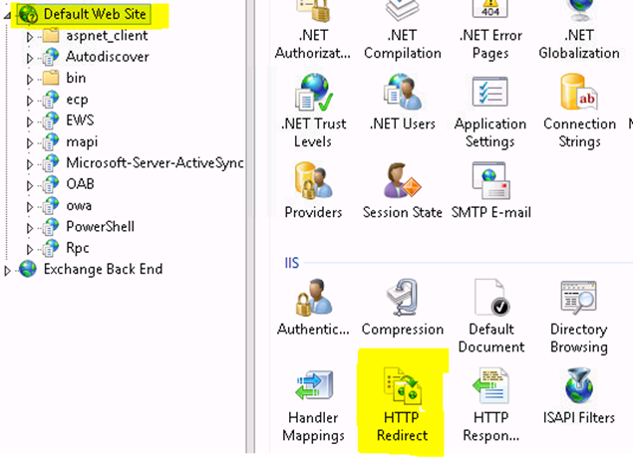

Change the settings as shown:

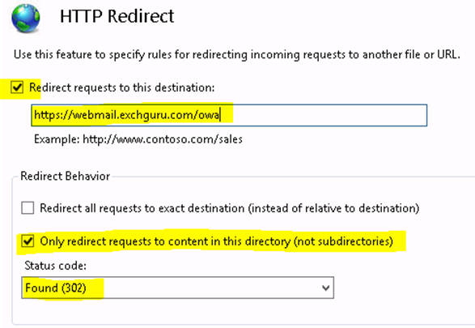

The issue addressed in this article will happen if the ECP Vdir has an HTTP redirect set on it:

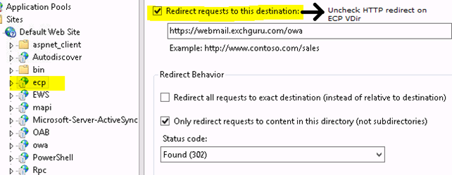

Let’s recap the SSL Settings and HTTP redirect settings for all Virtual directories in Exchange 2013 and ensure it is set properly:

|  |  |  |
| --- | --- | --- |
| **Vitual Directory** | **SSL enabled** | **HTTP Redirect** |
| Default website | **NO** | **Yes** |
| aspnet_client | Yes | NO |
| Autodiscover | Yes | NO |
| ecp | Yes | NO |
| EWS | Yes | NO |
| owa | Yes | NO |
| Microsoft-Server-ActiveSync | Yes | NO |
| OAB | Yes | NO |
| PowerShell | **NO** | NO |
| Rpc | Yes | NO |

# [Microsoft Exchange Interview Questions](http://career.guru99.com/top-13-ms-exchange-interview-questions/)

<https://labbots.com/microsoft-exchange-interview-questions/>

**1) Mention what are the new features in MS Exchange 2013?**

* **Integration with Lync and SharePoint:** With site mailboxes and in-place eDiscovery, it offers a greater integration with [Microsoft](http://career.guru99.com/category/microsoft/)Sharepoint and Lync
* **Provide a resilient solution:** It built upon the exchange server 2010 and redesigned for simplicity of scale, feature isolation and hardware utilization
* **Supports a multigenerational workforce:** From multiple sources users can merge contacts as well as smart search allows to search people in the network
* **Provide an engaging experience:** MS web app focused on a streamlined user interface that supports the use of touch, enhancing the use of mobile devices
* **Meet the latest demand:** With improved search and indexing, you can search across Lynch 2013, Exchange 2013, SharePoint 2013, etc.
* **DAG system:** A new evolution of exchange 2010 DAG

**2) Mention what is recommended when you are using an exchange account for your work, when you are offline?**

It is suggested that you use Cached Exchange Mode when you are using an exchange account for your work, as it eliminates all the reason to work offline. With Cache Exchange Mode, you can keep continuing working even if you are disconnected with the network.  Cache Exchange Mode uses a folder file (.ost) and manages a synchronized copy of the items in all folder in the mailbox, when you are offline.  As soon as you are connected to the network, it syncs your data automatically to the server without losing any data.

**3) Mention what are the roles in MS exchange 2013?**

In MS exchange 2013, there are two roles Client Access Server and Mailbox Server.

**4) Mention what is the role of Client Access Server?**

The Client Access Server gives connectivity to various services like

* [Microsoft Office](http://career.guru99.com/category/microsoft-office/) Outlook
* Outlook Web App
* Mobile devices
* POP & SMTP
* Accepts mail from delivers mail to other mail hosts on the internet
* Gives unified namespace, network security and authentication
* Handles all client requests for Exchange
* Routes requests to the correct mailbox server
* Allows the use of layer 4 (TCP affinity) routing

**5) Mention what is the role of Mailbox server?**

Mailbox servers help in

* e-mail storage
* Host public folder databases
* Host mailbox databases
* Calculate e-mail address policies
* Performs multi-mailbox searches
* Provide high availability and site resiliency
* Provide messaging records management and retention policies
* Handle connectivity as clients don’t connect directly to the mailbox services
* For given mailbox, it provides all core exchange functionality
* When a [database](http://career.guru99.com/category/database/) fails over, it also fails access to the mailbox

**6) Explain what are the important features of Transport Pipeline?**

Transport pipeline is made up of three different services:

* **Front end transport service:** It does basic message filtering based on domains, connectors, senders and recipients. It only connects with the transport service on a mailbox server and does not backlog any messages locally
* **Transport service:**It runs on all mailbox servers, and it handles SMTP mail flow. It helps in message categorization and content inspection. The transport services routes messages between the Mailbox Transport service, the Transport Service and Front End Transport service.This service does not queue messages locally
* **Mailbox Transport:**This system includes receiving and sending SMTP to the transport service from mailbox using RPC (Remote Procedure Call).

**7) Explain what is the role of categorizer?**

Categorizer performs following functions

* **Recipient Resolution:** The e-mail address of the recipient is resolved to decide whether the recipient has got a mailbox in the Exchange Organization or an external e-mail address
* **Routing Resolution:** Once the information regarding the recipient is resolved, the ultimate destination for the mail is routed, and the next hop are determined
* **Content Conversion:** Once the mail has reached its determined address, the SMTP is converted into readable format like HTML, rich text format or plain text

**8) Explain the term DAG (Data Availability Group)?**

DAG or Data Availability Group is a framework build is MS Exchange 2013.  It is a group of upto 16 mailbox server that hosts a set of databases and provides automatic database level recovery due to failure of servers of databases.

**9) Mention how many types of delivery groups found in MS Exchange 2013?**

In MS Exchange 2013, there are five types of delivery groups

* Routing DAG
* Mailbox delivery groups
* Connector source service
* AD site
* Server List

**10) Explain how message is delivered to the mailbox database in Exchange 2013?**

In exchange 2013, after the message reaches the target mailbox server in the destination AD site, the transport service avails SMTP to carry the message to the mailbox.  After that, using RPC, Transport Service delivers the message to the local mailbox.

**11) What action does Front End Transport service does?**

Front end transport service does one of the following actions based on the number and type of the recipients

* For the message with a single mailbox recipient, choose a mail box server in the target delivery group and based on the proximity of the AD site, give preference to the mail box server
* For the message with multiple or several mailbox recipients, it uses the first 20 recipients to select a mailbox in a closest proximity or delivery group, based on the AD site proximity
* If the message has no mailbox recipients, it choose a random mailbox server in the local AD site

**12) Mention what is the function of mailbox Transport Submission service?**

Mailbox Transport Submission service does one of the following actions based on the number and type of recipients.

* For the message having only one mailbox recipient, it chooses a mailbox server in the target delivery group and give priority to the mailbox server based on the AD site proximity
* With multiple mailbox recipients, it uses first 20 recipients to choose a Mailbox server in the closest delivery group, based on the AD site proximity
* If there is no mailbox recipient, select a mailbox server in the local delivery group

**13) How the flow of the mail is tracked in MS Exchange 2013?**

To track message flow in MS Exchange 2013, Delivery Reports are used.  It is applicable for Outlook and Outlook web only.  However, Message Tracking Logs are also helpful to know the flow of the mail.

1. **What are the prerequisites needed to install exchange Server 2013 SP1 (CPU, Memory, Disk & OS )**
   * **Microsoft Operating System:** Windows Server 2012 R2, Windows Server 2012 and Windows Server 2008 R2 with Service Pack 1 (SP1) operating system
   * **Components**
     + Microsoft .NET Framework 4.5
     + Windows Management Framework 4.0
     + Remote Tools Administration Pack
     + ADLDS for Exchange Server 2013 Edge Server Role
   * **Memory**
     + Mailbox 8GB minimum
     + Client Access 4GB minimum
     + Mailbox and Client Access combined 8GB minimum
     + Edge Transport 4GB minimum
   * **Disk space**
     + At least 30 GB on the drive on which you install Exchange
     + An additional 500 MB of available disk space for each Unified Messaging (UM) language pack
     + 200 MB of available disk space on the system drive
     + A hard disk that stores the message queue database on with at least 500 MB of free space.
2. **Where Exchange Server stores the Exchange related information in Active Directory**
   * **Domain Partition** – Mail enable recipient, groups and contact related to domain level are stored
   * **Configuration Partition** – Stores the Exchange configuration information like, policies, global settings, address list, connecters and it contains the information related to forest level
   * **Schema Partition** – stores the Exchange specific classes and attributes
3. **List out the purpose of running prepare schema and prepare AD switches in Exchange server 2013**
   * **Prepare Schema** – After running the Prepare Schema switch, the Active directory will contain the classes and attributes required to support Exchange environment
   * **Prepare AD** – after running the Prepare AD switch, new container will be created to hold the details of the information from server to databases to connectors. This process also created universal security groups to manage Exchange and   
     sets appropriate permissions on objects to allow them to be managed.
4. **What is the purpose of Autodiscover service & Availability service**
   * **Auto discover service**— The Autodiscover service does the following:
     + Automatically configures user profile settings for clients running Microsoft Office Outlook 2007, Outlook 2010, or Outlook 2013, as well as supported mobile phones.
     + Provides access to Exchange features for Outlook 2007, Outlook 2010, or Outlook 2013 clients that are connected to your Exchange messaging environment.
     + Uses a user's email address and password to provide profile settings to Outlook 2007, Outlook 2010, or Outlook 2013 clients and supported mobile phones. If the Outlook client is joined to a domain, the user's   
       domain account is used.
   * **Availability service**—The Availability service is the replacement for Free/Busy functionality responsible for making a user’s calendar availability visible to other users making meeting requests.   
     + Retrieve current free/busy information for Exchange 2013 mailboxes
     + Retrieve current free/busy information from other Exchange 2013 organizations
     + Retrieve published free/busy information from public folders for mailboxes on servers that have previous versions of Exchange
     + View attendee working hours
     + Show meeting time suggestions
5. **What are the DNS host record required to receiving email from the internet**

A mail exchange (MX) record that contains information about which mail server the domain uses to receive mail.

1. **Explain the list of files will be there under Exchange 2013 database folder**
   * **\*.edb File** - A mailbox database is stored as an Exchange database (.edb) file.
   * **Checkpoint file** .chk, keeps track of which transactional logs moves into database files. Keep on check the log file entering the database in a current order
   * **Transactional log** – eoo.log file which write the current transactions into transactional logs. If it reaches 1 MB, it will rename the log file into E00000001.log
   * **Temp.EDB** – Temporary database file, which will process the transactional logs that are to be to write in .EDB Database file
   * **JRS – Reserved Log files** – if the size of the disk is full and you can’t write any mails as transactional logs these files will help into action
2. **What you mean by database portability**

Database portability is a feature that enables a Microsoft Exchange Server 2013 mailbox database to be moved to or mounted on any other Mailbox server in the same organization running Exchange 2013 that has databases with the same database schema version. Mailbox databases from previous versions of Exchange can't be moved to a Mailbox server running Exchange 2013. By using database portability, reliability is improved by removing several error-prone,manual steps from the recovery processes. In addition, database portability reduces the overall recovery times for various failure scenarios.

1. **Explain the mail flow in Exchange server 2013**

The below diagram provides more detail on the mail flow in Exchange server 2013. 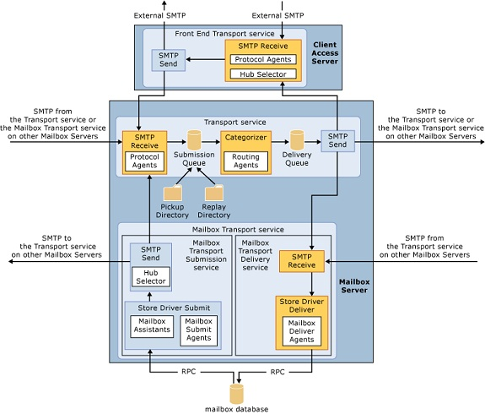

1. **What is S/MIME certificate and how to send email using S/MIME certificate**
   * S/MIME (Secure/Multipurpose Internet Mail Extensions)used for users to encrypt outgoing messages and attachments so that only intended recipients who have a digital identification (ID), also known as a certificate, can read them. With   
     S/MIME, users can digitally sign a message, which provides the recipients with a way to verify the identity of the sender   
     and that the message hasn't been tampered with.
   * Setting up S/MIME for Outlook Web App needs Exchange 2013 SP1 which can be configured using Powershell command Get-SmimeConfig and Set-SmimeConfig
2. **How Activesync works in Exchange Server 2013**
   * Microsoft ActiveSync provides for synchronized access to email from a handheld device, such as a Pocket PC or other Windows Mobile device. It allows for real-time send and receives functionality to and from the handheld, through the   
     use of push technology.
   * A mobile device that's configured to synchronize with an Exchange 2013 server issues an HTTPS request to the server. This request is known as a PING. The request tells the server to notify the device if any items change in the next 15   
     minutes in any folder that's configured to synchronize. Otherwise, the server should return an HTTP 200 OK message.   
     The mobile device then stands by. The 15-minute time span is known as a heartbeat interval.
   * If no items change in 15 minutes, the server returns a response of HTTP 200 OK. The mobile device receives this response, resumes activity (known as waking up), and issues its request again. This restarts the process.
   * If any items change or new items are received within the 15-minute heartbeat interval, the server sends a response that informs the mobile device that there's a new or changed item and provides the name of the folder in which the new or changed item resides. After the mobile device receives this response, it issues a synchronization request for the folder that has the new or changed item. When synchronization is complete, the mobile device issues a new PING request and the whole process starts over.
3. **What is the purpose of retention policy tag**
   * Retention tags are used to apply retention settings to folders and individual items such as e-mail messages and voice mail. These settings specify how long a message remains in a mailbox and the action to be taken when the message reaches the specified retention age. When a message reaches its retention age, it's moved to the user’s In-Place Archive or deleted.
   * Unlike managed folders (the MRM feature introduced in Exchange Server 2007), retention tags allow users to tag their own mailbox folders and individual items for retention. Users no longer have to file items in managed folders provisioned by an administrator based on message retention requirements.
4. **Difference between proxy and re-direction terminology in Exchange Server 2013**
   * Microsoft Client Access server can act as a proxy for other Client Access servers within the organization. This is useful when multiple Client Access servers exist in different Active Directory sites in an organization, and at least one of those sites isn't exposed to the Internet.
   * A Client Access server can also perform redirection for Microsoft Office Outlook Web App URLs and for Exchange ActiveSync devices. Redirection is useful when users connect to a Client Access server that isn't in their local Active Directory site, or if a mailbox has moved between Active Directory sites. It's also useful if users should actually be using a more effective URL. For example, users should be using a URL that's closer to the Active Directory site in which their mailbox resides.
   * **What is the purpose of File Share Witness**

A witness server is a server outside a DAG that's used to achieve and maintain quorum when the DAG has an even number of members. DAGs with an odd number of members don't use a witness server. All DAGs with an even number of members must use a witness server. The witness server can be any computer running Windows Server. There is no requirement that the version of the Windows Server operating system of the witness server matches the operating system used by the DAG members.

1. **List out the different type of quorum model used in Exchange server 2013**
   * Even - Node and File Share Majority quorum mode Odd - Majority quorum mode
   * DAGs with an even number of members use the failover cluster's Node and File Share Majority quorum mode, which employs an external witness server that acts as a tie-breaker. In this quorum mode, each DAG member gets a vote. In addition, the witness server is used to provide one DAG member with a weighted vote (for example, it gets two votes instead of one). The cluster quorum data is stored by default on the system disk of each member of the DAG, and is kept consistent across those disks. However, a copy of the quorum data isn't stored on the witness server. A file on the witness server is used to keep track of which member has the most updated copy of the data, but the witness server   
     doesn't have a copy of the cluster quorum data. In this mode, a majority of the voters (the DAG members plus the witness server) must be operational and able to communicate with each other to maintain quorum. If a majority of the voters can't communicate with each other, the DAG's underlying cluster loses quorum, and the DAG will require administrator intervention to become operational again.
   * DAGs with an odd number of members use the failover cluster's Node Majority quorum mode. In this mode, each member gets a vote, and each member's local system disk is used to store the cluster quorum data. If the configuration of the DAG changes, that change is reflected across the different disks. The change is only considered to have been committed and made persistent if that change is made to the disks on half the members (rounding down) plus one. For example, in a five-member DAG, the change must be made on two plus one members, or three members total.
2. **Difference between Primary Active Manager and Standby Active Manager**
   * **Primary Active Manager** which runs inside the Microsoft Exchange Replication Service used to notify and react in case of server failure. The PAM owns the cluster quorum resource and holds the information about active, passive and   
     mounted databases.
   * **Standby Active Manager** provides information of the server hosting the active copy of a mailbox database to the Client Access or Transport services.
3. **What is the purpose of safety-net and transport dumpster**
   * Transport dumpster helps to protect against data loss by maintaining a queue of successfully delivered messages that hadn't replicated to the passive mailbox database copies in the DAG. When a mailbox database or server failure required the promotion of an out-of-date copy of the mailbox database, the messages in the transport dumpster were automatically resubmitted to the new active copy of the mailbox database.
   * The transport dumpster has been improved in Exchange 2013 and is now called Safety Net.

Similarity between Safety Net and transport dumpster in Exchange 2010:

* + Safety Net is a queue that's associated with the Transport service on a Mailbox server. This queue stores copies of messages that were successfully processed by the server.
  + You can specify how long Safety Net stores copies of the successfully processed messages before they expire and are automatically deleted. The default is 2 days.

Here's how Safety Net is different in Exchange 2013:

* + Safety Net doesn't require DAGs. For Mailbox servers that don't belong to a DAGs, Safety Net stores copies of the delivered messages on other Mailbox servers in the local Active Directory site.
  + Safety Net itself is now redundant, and is no longer a single point of failure. This introduces the concept of the Primary Safety Net and the Shadow Safety Net. If the Primary Safety Net is unavailable for more than 12 hours, resubmit requests become shadow resubmit requests, and messages are re-delivered from the Shadow Safety Net.
  + Safety Net takes over some responsibility from shadow redundancy in DAG environments. Shadow redundancy doesn't need to keep another copy of the delivered message in a shadow queue while it waits for the delivered message to replicate to the passive copies of mailbox database on the other Mailbox servers in the DAG. The copy of the delivered message is already stored in Safety Net, so the message can be resubmitted from Safety Net if necessary.
  + In Exchange 2013, transport high availability is more than just a best effort for message redundancy. Exchange 2013 attempts to guarantee message redundancy. Because of this, you can't specify a maximum size limit for Safety Net. You can only specify how long Safety Net stores messages before they're automatically deleted.

1. **What is the purpose of crimson log channel in Exchange Server 2013**
   * The HighAvailability channel contains events related to startup and shutdown of the Microsoft Exchange Replication service and other components that run within it, such as Active Manager or VSS writer for example. The HighAvailability channel is also used by Active Manager to log events related to Active Manager role monitoring and database action events, such as a database mount operation and log truncation, and to record events related to the DAG's underlying cluster.
   * The MailboxDatabaseFailureItems channel is used to log events associated with any failures that affect a replicated mailbox database.
   * The ActiveMonitoring channel contains definition and result events for Managed Availability probes, monitors and responders.
   * The ManagedAvailability channel contains recovery action logs and results and related events.
2. **Difference between accepted domain and remote domain in Exchange Server 2013**
   * Remote domains are SMTP domains that are external to your Microsoft Exchange organization. You can create remote domain entries to define the settings for message transferred between your Exchange organization and specific external domains. The settings in the remote domain entry for a specific external domain override the settings in the default remote domain that normally apply to all external recipients. The remote domain settings are global for the Exchange organization
   * An accepted domain is any SMTP namespace for which a Microsoft Exchange Online organization sends or receives email. Accepted domains include those domains for which the Exchange organization is authoritative. An Exchange organization is authoritative when it handles mail delivery for recipients in the accepted domain. Accepted domains also include domains for which the Exchange organization receives mail and then relays it to an email server that's outside the organization for delivery to the recipient.
3. **What are the High Availability features introduce in Exchange Server 2010?**
   * **Mailbox resiliency** – unified high availability and site resiliency
   * **Database Availability Group** – a group of up to 16 Mailbox servers that holds the set of replicated databases
   * **Mailbox database copy** – a mailbox database (.edb files and log file) that is either active or passive copy of the mailbox database
   * **Database Mobility** – the ability of a single mailbox database to be replicated to and mounted on other mailbox servers
   * **RPC Client Access Service** – a Client Access Server feature that provides a MAPI endpoint for outlook clients
   * **Shadow redundancy** – a transport feature that provides redundancy for messages for the entire time they are in transit
   * **Incremental deployment** – the ability to deploy high availability or site resilience after the exchange is installed
   * **Exchange third party replication API** – an exchange provided API that enables use of third party replication for DAG
4. **What is Exchange Control Panel?**   
   **ECP** it’s a new and simplified web based management console and it’s a browser based management client for end user, administrators and specialist, ECP can be accessible via URL, browsers and outlook 2010, ECP deployed as part of the client access server role, Simplified user administration for management tasks and it’s RBAC aware.
5. **Who can use ECP and what are the manageable options?**
   * **Specialist and administrators** – administrator can delegate to specialist e.g. help desk operators – Change user name password etc., department administrator – change OU and e-discovery administrators – legal department.
   * **End users** – comprehensive self-service tools for end users – fetch phone number, changing name and create groups.
   * **Hosted customers** – tenant administrators and tenant end users.
6. **What is federated sharing?**   
   Federated Sharing allows easy sharing of availability information, calendar, and contacts with recipients in external federated organizations
7. **What are the options shared in federated sharing?**
   * Free busy information
   * Calendar and contact sharing
   * Sharing policy
8. **What is Microsoft Federation Gateway?**

Exchange Server 2010 uses Microsoft Federation Gateway (MFG), an identity service that runs in the cloud, as the trust broker. Exchange organizations wanting to use Federation establish a Federation Trust with MFG, allowing it to become a federation partner to the Exchange organization. The trust allows users authenticated by Active Directory , known as the identity provider (IP), to be issued Security Assertion Markup Language (SAML) delegation tokens by MFG. The delegation tokens allow users from one federated organization to be trusted by another federated organization. With MFG acting as the trust broker, organizations are not required to establish multiple individual trust relationships with other organizations. Users can access external resources using a single sign-on (SSO) experience

1. **What is Federation Trust?**

A Federation Trust is established between an Exchange organization and MFG by exchanging the organization’s certificate with MFG, and retrieving MFG’s certificate and federation metadata. The certificate is used for encrypting tokens

1. **What is Sharing Policy?**

Sharing policies allow you to control how users in your organization can share calendar and contact information with users outside the organization. To provision recipients to use a particular sharing policy

1. **Why Archive?**
   * Growing E-Mail Volume – everyone wants to have more E-mail because of this the storage, Backup disk should be increases
   * Performance and storage issue – increase in Storage costs
   * Mailbox quota – users are forced to manage quota
   * PSTs – quota management often results in growing PSTs – outlook Auto Archive
   * Discovery and Compliance issues – PSTs difficult to discovery centrally, regulatory retention schedules contribute to further volume/storage issues
2. **What are the archiving options introduced in Exchange Server 2010?**
   * **Personal Archive** – secondary Mailbox Node, they are the PST files of primary Mailbox
   * **Retention Policies** – folder/item level and archive/delete policies
   * **Multi-Mailbox search** – Role based GUI, admin can assign this permission to legal team
   * **Legal Hold** – monitor or control a user from delete a mail by legal hold and searchable with Multi Mailbox Search
   * **Journaling** – Journal de-duplication (unwanted journaling on distributed mails). One copy of journal per database and
   * **Journal decryption** – HT role will do the decryption and send the decrypted copy for journaling
3. **What are the Retention Policies in Exchange Server 2010?**
   * **Move Policy** – automatically moves messages to the messages to the archive Mailbox with the options of 6 months, 1 year, 2 years, 5 years and never – 2 years is default. Move mailbox policies helps keep mailbox under quota. This works like outlook Auto Archive without creating PSTs
   * **Delete Policy** – automatically deletes messages. Delete policies are global. Removes unwanted items
   * **Move + Delete policy** – automatically moves messages to archive after X months and deletes from archive after Y Months. We can set policy priority: Explicit policies over default policies; longer policies apply over shorted policies
4. **What is journaling and what are the journaling features in Exchange Server 2010?**   
   Journaling is an option to track mails from particular user or from a group of users. The New Features in Journaling for Exchange server 2010 are
   * **Transport Journaling** – ability to journal individual Mailboxes or SMTP address and also this gives a detailed report per To/Cc//Bcc/Alt-Recipient and DL expansion
   * **Journal report de duplication** – reduces duplication of journal reports. Exchange server 2010 creates one report per message.
5. **What are the different Exchange Recipient types?**
   * **User mailbox**: This mailbox is created for an individual user to store mails, calendar items, contacts, tasks, documents, and other business data.
   * **Linked mailbox**: This mailbox is created for an individual user in a separate, trusted forest. For example AD account is created in A.COM and Mailbox is created in B.COM Exchange Server.
   * **Shared mailbox**: This mailbox is not primarily associated with a single user and is generally configured to allow logon access for multiple users.
   * **Legacy mailbox**: This mailbox is resides on a server running Exchange Server 2003 or Exchange 2000 Server.
   * **Room mailbox**: This mailbox is created for a meeting location, such as a meeting or conference room, auditorium, or training room. When we create this mailbox, by default a disabled user object account is created.
   * **Equipment mailbox**: A resource mailbox is created for a non-location specific resource, such as a portable computer projector, microphone, or a company car. When we create this mailbox, by default a disabled user object account is created. Equipment mailboxes provide a simple and efficient way for users to use resources in manageable way.
6. **What is a Smart Host? Where would you configure it?**

A smart host is a type of mail relay server which allows an SMTP server to route e-mail to an intermediate mail server rather than directly to the recipient’s server. Often this smart host requires authentication from the sender to verify that the sender has privileges to have mail forwarded through the smart host. This is an important distinction from an open relay that will forward mail from the sender without authentication. Common authentication techniques include SMTP-AUTH and POP.

Smart host is used for the following purposes:

* + Used for backup mail (secondary MX) services.
  + Used in spam control efforts.

1. **What are the new features introduced in Exchange Server 2010 on overview perspective?**
   * Protection and compliance
     + Email Archiving
     + Protect Communication
     + Advanced Security
   * Anywhere Access
     + Manage Inbox Overload
     + Enhanced Voice Mail
     + Collaborate efficiently
   * Flexible and reliable
     + Continuous Availability
     + Simplified Administration
     + Flexible deployment of Exchange Server 2010
2. **What’s New in Exchange Server 2010 in Client Access Server Level?**

Client Access Server level improvements in Exchange Server 2010 are Federation certificates, Exchange ActiveSync, SMS Sync, Integrated Rights Management, Microsoft Office Outlook Web App, and virtual directories.

* + **Federation certificates** can be a self signed certificate instead of a certificate issued by a CA to establish federation trust.
  + **Exchange Active sync** devices can be managed using Exchange Control Panel like manage default access level for all phones, set up and email alert when a device is quarantined and create and manage active sync device access rules
  + **SMS sync** is a new feature is exchange active sync that works with Windows mobile 6.1 with outlook mobile update and windows mobile 6.5, it will give an ability to synchronize messages between a mobile phone or a device and exchange 2010 inbox
  + New outlook feature like* OWA themes* and an option to customize the themes. User will have an option to reset the expired password from OWA
  + **Reset OWA Virtual directory** wizard will resolve the damaged file on a virtual directory
  + **Client throttling policies** will help you manage performance of your Client Access servers. Only the policies to limit the number of concurrent client connections were enabled by default. Exchange 2010 SP1 all client throttling policies are enabled by default.

1. **What are the new Transport Server level features in Exchange Server 2010?**

Below are the new Transport functionality

* + MailTips access control over organizational relationships
  + Enhanced monitoring and troubleshooting features for MailTips and Message Tracking
  + Message throttling enhancements
  + Shadow redundancy promotion
  + SMTP failover and load balancing improvements
  + Support for extended protection on SMTP connections
  + Send connector changes to reduce NDRs over well-defined connections

## **Reference**

* [Top 13 Exchange interview questions](http://career.guru99.com/top-13-ms-exchange-interview-questions/) - Career Guru99.
* [Exchange interview question pdf](https://gallery.technet.microsoft.com/exchange/Exchange-Server-2013-a4a6d0af) - Technet Microsoft.
* [Exchange 2010 Interview questions](http://documents.tips/documents/exchange-server-2010-interview-questions-and-answerspdf.html) - documents.tips.
* [Exchange 2010 Interview question and answers](http://www.nextstep4it.com/exchange-server-interview-questions-answers-part-1/) - nextstep4it.
* [Top 10 features in Exchange 2010](http://www.techrepublic.com/blog/10-things/top-10-new-features-in-exchange-server-2010/) - Techrepublic.
* [What's new in Microsoft Exchange 2010](https://technet.microsoft.com/en-GB/library/dd298136(v=exchg.141).aspx) - Technet Microsoft.

**Some emails are not getting delivered to one  external domain (from any user)**

**Issue:**Users may experience issues with not being able to send mails to one specific external domain. The issue occurs for many users & is not user specific.

**Resolution:**

=> Check if the problematic domain is blocking mails & have them white list.

=> Check if any antivirus / anti spam software is blocking it.

# **Exchange Server Error Guide: Failed to Mount Database**

n this post we will see the root cause and solution of Exchange Server Error “failed to Mount Database”. Also this post covers manual method of resolving the unable to mount database in Exchange which is recommended by Microsoft itself. So, lets get started with the problem itself.

## **Problem <Failed to Mount Database/Could not mount the database>**

Failed to mount database ‘Mailbox Database’ Mailbox Database <Some Number> Failed

Error: Couldn’t mount the database that you specified.

Specified database: Mailbox Database;

Error code: An Active Manager operation failed.

Error: The database action failed.

Error: Operation failed with message: MapiExceptionCallFailed: Unable to mount database.

## **Root Cause of Dismounted Database**

There are two main possible causes for the failed to mount database problem in Exchange Server:

* Due to Corrupt Database or,
* Corrupt logs

## **Solution**

To confirm the issue behind the “failed to mount database error” we need to perform some troubleshooting methodologies mentioned below:

### ****Check the Database State: Dirty Shutdown Problem****

Dirty Shutdown problem in Exchange Server is root problem for most the issues. So, what is Dirty Shutdown actually? For Exchange Server to work fine it is very important that it should be shutdown properly.

### ****How to find your Exchange Database suffers from Dirty Shutdown Problem?****

Simply type the command: **eseutil /mh “database name”** in command prompt. This will give you the status whether or not your database suffers from dirty shutdown.

[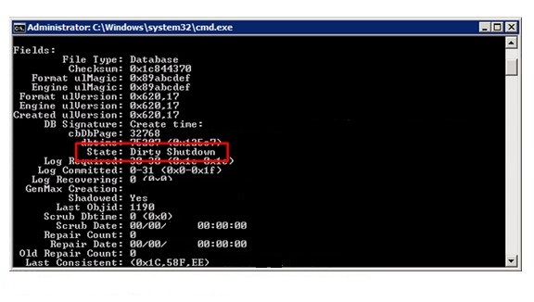](http://www.pcvita.com/blog/wp-content/uploads/2015/05/Screenshot_2.jpg)

### ****How to Change Database State: From Dirty Shutdown to Clean Shutdown?****

You can use **ESEUtil /r** command in order to perform soft recovery of your database. If this works then you can easily mount the database.

In case soft recovery (using ESEUtil /r) doesn’t work then you need to perform hard recovery. To perform Hard Recovery of your Exchange Database use **ESEUtil /p** command.

## **Repair Database Logs Files**

First of all check the Exchange Logs using the command ESEUtil /ml (with E00 as starting sequence for the logs).

eseutil /ml “<Mailbox Path>\E00”

After running the above command you will be presented full detail of errors (if present) and database state (clean or dirty shutdown).

## **ESEUtil fails to Repair the database: What to do?**

In case the above method fails to resolve the issue “failed to mount the Database” then you can try [EDB Converter](http://www.pcvita.com/edb-converter.html) which is proven to resolve issues when ESEUtil fails to repair the database.

**What is Dirty System Shutdown?**

The Exchange Server database is based on Joint Engine Technology (JET engine) where log files is responsible to keep a track of input and output operations in the database file. ESE uses the concept of mailbox database cache so as to reduce the input-output operation count.

When an operation is loaded to the cached memory and it is not committed to the information store, the JET engine marks it as DIRTY. Until the pending transaction is committed to the database, it is not considered as updated and till the time dirty pages are there in the database, it is considered as inconsistent.

Until the transaction could have completed, if the system shuts down accidently, the database remain attached to the log file due to which DIRTY SYSTEM SHUTDOWN error is received on screen.

* **Mailbox Database 0242942819.edb** – this is the actual Mailbox Database file that contains all the messages. The random number “0242942819” is generated during creation of the Mailbox Database and is used to create an unique name within the Exchange Organization
* **E00.log -** a log file currently in use by the database engine
* **E00000003A.log, E00000003B.log, E00000003C.log…** – these are log files stored on the disk and can be used for recovery purposes. Please note that a hexadecimal numbering is used
* **E00.chk** – this is a checkpoint file used for keeping track of the relation between the log files and the mailbox database file
* **E00res00001.log and E00res00002.log** – these are pre created log files that are used when the disk drive containing the log files is full
* **E00tmp.log** – a new log file that is currently being created
* The database engine is processing data in so called “pages”, each of which is 32KB in size. This 32KB is the page size in Exchange Server 2010; Exchange Server 2007 uses an 8KB page size
* The pages are not written immediately to the database file but only after some time. They will stay in memory just in case Exchange needs the page again. This way a valuable disk I/O is saved since it is still in memory.
* When the page is saved into the database file, the checkpoint file is updated. The checkpoint file keeps track which pages are written into the database. Pages “under” the checkpoint file are written into the database file, pages “above” the checkpoint file are still in memory and not yet written into the database file.
* Where’s the actual data? It’s in the server’s memory, it’s inside the log files or it is inside the mailbox database.
* Mail data is initially processed in memory, separated into pages.
* Updated pages, forming a transaction, are written to the log file.
* If pages are no longer needed by Exchange these pages are written to the database.
* The checkpoint file is updated to reflect the new location of the checkpoint.

## ESEUTIL

ESEUTIL is an Exchange database utility located in the \bin directory of Exchange server. A number of switches are possible with ESEUTIL:

* ESEUTIL /D – Used for offline defragmentation of a Database
* ESEUTIL /R – Used for recovery purposes of a Database
* ESEUTIL /g – Performs an integrity check  of a Database
* ESEUTIL /k – Performs a checksum test of a Database
* ESEUTIL /p – Repairs a Database when it’s corrupt (and beyond recovery)
* ESEUTIL /m – can dump header information of a Database and Log Files
* ESEUTIL /y – can copy large files like Mailbox Database files efficiently
* ESEUTIL /c – Is used to ‘hard recover’ a database during an online backup
* To read header information from a database file you can use the following command:
  + *“ESEUTIL /MH “Mailbox Database 0872095299.edb”*
* To check the header of the log file you can use the following command:
  + *ESEUTIL /ML E00.log*
* To check a sequence of log files belong to each other you can enter the following command:
  + *ESEUTIL /ML E00*
* This command will read all log files and show immediately if they are in the same sequence, if the sequence is complete and if all log files are ok. If a log file is corrupt it will be shown here. To check the header information of the checkpoint file you can use the following command:
  + *ESEUTIL /MK E00.chk*
* Therefore it is recommended to perform an offline defragmentation (which will create a brand new Mailbox Database!) immediately after repairing a Mailbox Database using ESEUTIL /P.
* But wait, there’s more. ESEUTIL repairs the Mailbox Database on a low level, so it repairs all tables, indices and pointers within the Database file. But ESEUTIL doesn’t understand things like mailboxes, folders, messages etc. After repairing and defragmenting your database after a corruption you have to scan (and fix) it on a logical level using ISINTEG. For ISINTEG to run properly, the Mailbox Database has to be on its original location.
* When you run ISINTEG (ISINTEG –fix –test alltests) you will see numerous messages. Just repeat running ISINTEG until everything is fine and you don’t see any error messages.
* 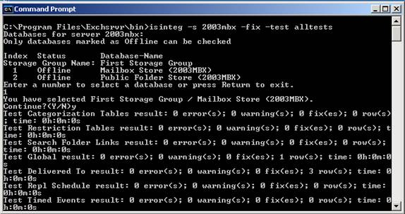  
  **Figure 2**: Running ISINTEG on an Exchange 2003 Mailbox Server
* **Please be aware that ISINTEG is going to be discontinued in Exchange Server 2010 Service Pack 1. Its functionality is replaced by a new cmdlet: New-MailboxRepairRequest.**

# **Using Test-MRSHealth to Verify the Mailbox Replication Service**

The [Test-MRSHealth PowerShell cmdlet](http://exchangeserverpro.com/troubleshooting-exchange-server-2013-with-test-cmdlets/) can be used to verify that the Mailbox Replication Service on Exchange Server 2013 Mailbox servers is healthy. This service is responsible for processing mailbox move requests, so a healthy MRS will be important any time you are performing migrations. Running the cmdlet on a Mailbox server will test the local server.

[PS] C:\>Test-MRSHealth

With those three attributes in mind it is quite easy to test multiple Mailbox servers with a single cmdlet and output a neat report with the results.

[PS] C:\>Get-MailboxServer | Test-MRSHealth | Select Identity,Check,Passed,Message | ft -auto

# **Using Test-ReplicationHealth to Troubleshoot Database Availability Groups**

Database availability groups are reasonably smart and robust systems, but they do need monitoring, or else you might find one day they are not providing the HA that you need them to. One of the useful PowerShell cmdlets for keeping an eye on things is Test-ReplicationHealth. It can be used to help troubleshoot [database availability groups](http://exchangeserverpro.com/exchange-server-2013-database-availability-groups/) by running it locally or against a remote server.

[PS] C:\>Test-ReplicationHealth

To test a remote server, use the -Identity parameter.

[PS] C:\>Test-ReplicationHealth -Identity E15MB2

The cmdlet also accepts pipeline input, however if you were to simply pipe Get-MailboxServer into it and you have Mailbox servers in the organization that are not DAG members then you risk seeing errors in your results that just get in the way. Instead you can pipe only the members of a database availability group into Test-ReplicationHealth using the following method:

[PS] C:\>Get-DatabaseAvailabilityGroup | select -ExpandProperty:Servers | Test-ReplicationHealth

There’s a lot of output to look at, so it’s often easier to filter the results to only those that have not passed.

[PS] C:\>Get-DatabaseAvailabilityGroup | Select -ExpandProperty:Servers | Test-ReplicationHealth | Where {$_.Result.Value -ne "Passed"}

The error details are usually truncated, so outputting the results as a list will let you see more information.

[PS] C:\>Get-DatabaseAvailabilityGroup | Select -ExpandProperty:Servers | Test-ReplicationHealth | Where {$_.Result.Vale -ne "Passed"} | Format-List

# **Exchange Server 2013: Using Test-Mailflow to Verify End to End Mail Delivery**

The [Test-Mailflow PowerShell cmdlet](http://exchangeserverpro.com/troubleshooting-exchange-server-2013-with-test-cmdlets/) allows you to test the delivery of email between two mailboxes. The test will be performed using system mailboxes or you can optionally specify other mailboxes to test.

Running the cmdlet on a Mailbox server will test the local server.

[PS] C:\>Test-Mailflow

Notice that the output includes the result (eg, “Success”) as well as the message latency. So not only can are you able to test that mail flow is working, but you can also see whether email delivery is slow, possibly indicating a server or network issue somewhere.

The Test-MailFlow cmdlet can be used to test mail flow between two Mailbox servers, as long as each server has at least one active mailbox database at the time (so that there is a system mailbox available on each server).

[PS] C:\>Test-Mailflow E15MB1 -TargetMailboxServer E15MB2

In addition to specifying a server to test, you can also specify a database.

[PS] C:\>Test-Mailflow E15MB1 -TargetDatabase "Mailbox Database 2"

Or you can be even more specific by testing mail flow to an email address.

[PS] C:\>Test-Mailflow E15MB1 -TargetEmailAddress paul.cunningham@exchange2013demo.com

# **Exchange Server 2013: Using Test-OutlookWebServices to Verify Web Services Functionality**

The [Test-OutlookWebServices PowerShell cmdlet](http://exchangeserverpro.com/troubleshooting-exchange-server-2013-with-test-cmdlets/) allows you to test the functionality of the following services:

* Autodiscover
* Exchange Web Services
* Availability Service
* Offline Address Book

Running the cmdlet on a Client Access server will test the local server using the test mailbox user created earlier.

[PS] C:\>Test-OutlookWebServices

You can also perform the test for a specific mailbox by using the –Identity and –MailboxCredential parameters.

[PS] C:\>Get-ClientAccessServer | Test-OutlookWebServices -Identity paul.cunningham@exchange2013demo.com -MailboxCredential (Get-Credential)

**Issue:** Outlook Web App isn’t available. If the problem continues, please contact your helpdesk. Users get this error when trying to login to the OWA in an environment with multiple CAS servers where CAS proxying is used

**Resolution:**

On the target CAS server, Ensure that Windows Integrated Authentication is the only the authentication method enabled on the OWA and ECP virtual directories.

**Issue:** Exchange 2010 issue where GAL is blank when running Outlook in online mode.

Issue with blank GAL when running Outlook in online mode after migrating from Exchange 2003 to Exchange 2010 SP1.

**Resolution**:

=> In the ADSI EDIT we have to clear the value “**msExchQueryBaseDN**” for the affected user.

**Single User Outlook 2013 new setup fails on “Logging on to the mail server”**

**Issue:**

Issue with one user not able to login to outlook 2013. User attempts to connect & it fails with the following error:

“The Connection to Microsoft Exchange is unavailable.  Outlook must be online or connected to complete this action”. The user is unable to access outlook but can access OWA to check mails.

**Resolution:**

=> Recycle AppPools for both Autodiscover and RPCProxy.

=> Run Get-CasMailbox <user> | fl . Check if MAPIBlockOutlookRpcHttp is set to true.

=> If it is set to true , run Set-CASMailbox <user> -MAPIBlockOutlookRPCHttp $false.

**Find oldest email date on a particular mailbox through exchange management shell command ?**

**Issue:**

How to find oldest email date on a particular mailbox through exchange management shell command ?

**Resolution:**

Get-MailboxFolderStatistics -IncludeOldestAndNewestItems -Identity <mailbox> |

    Where OldestItemReceivedDate -ne $null |

    Sort OldestItemReceivedDate |

    Select -First 1 OldestItemReceivedDate

**Exchange 2013: Public Folder Mailbox cannot be deleted:”Cannot open Mailbox”.**

**Issue:**

Unable to delete the public folder Mailbox we get the following error. Also the same happens when trying to delete using the Shell & web interface.

“Cannot open mailbox /o=Test Lab/ou=Exchange Administrative Group … /cn=Servers/cn=EXServer/cn=Microsoft System Attendant”

**Resolution:**

=> Run Remove-Mailbox with -force parameter.

**After migration from exch 2007 to 2013 “show this folder as an e-mail address book not available” client 2007**

**Issue:** After we migrated our exchange from 2007 to 2013 and we are facing some issues with our public folders

we have an address book at our public folders (migrated from 2007)  when i look for “”show this folder as an e-mail address book” tab on outlook 2007 clients its missing , when i look for it on outlook 2013 clients its there, why?

**Resolution:**

=> It is by design that there is no Outlook Address Book tab with the Show this folder as an e-mail Address Book check box for Public Contact in Outlook 2007. Need to update the Outlook 2007 to Outlook 2010 or higher version as a workaround.

# **Perform Dial Tone Recovery Feature in Exchange Server 2013 Edition**

Exchange server 2013 has a feature called Dial Tone Portability. This function provides a solution for limited business stability for failures that influence a mailbox database. Exchange administrators can have a temporary mailbox which can be used for receiving & sending e-mails while mailbox is being repaired or restored. It is compulsory that the temporary mailbox should be on same server of Exchange 2013 in the organization. The method for using this dial tone portability feature is called dial tone recovery which includes creating a blank database on a mailbox server to be replaced with failed database.

Perform Dial Tone Recovery with three different options:

* Perform dial-tone recovery on server that has failed database
* Use alternate server for dial tone database recovery
* Use an alternate server for creating dial-tone and database and recovery

These above mentioned option follow the same concept:

* Create blank database for Dial tone recovery and replace with failed database
* Restore the database (if you’re using same server for dial tone recovery then need to restore database to RDB)
* Swap the dial tone database with restored database.
* Marge the database

**Execute Dial Tone Recovery Process on a Particular Server using EMS (Exchange Management Shell)**

Make a duplicate copy or backup of the existing database files. It helps later for further recovery task

* **Create Dial Tone Database**
  + Run following command for creating dial tone database

[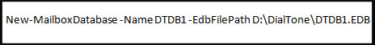](http://www.blog.edbtopst.org/wp-content/uploads/2014/12/1-create-dial-tone-database.jpg)

* **Now rehome the recovered mailboxes using Set-Mailbox cmdlet**
  + Use Set-Mailbox command to Robin user mailboxes hosted on the database

[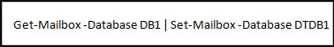](http://www.blog.edbtopst.org/wp-content/uploads/2014/12/2-set-mailbox-database-cmd.jpg)

* **Mount the Database**

Use Mount-Database command which grant the permission to access database and send & receive messages to client computer

[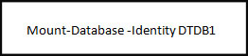](http://www.blog.edbtopst.org/wp-content/uploads/2014/12/3-mount-the-database.jpg)

* **Create Recovery Database**

Now to create RDB where you can restore the copy of the database & log file including data which you want to recover into Recovery database

* **Let’s See how to create RDB** >> Run this following command which helps to create Recovery database of RDB1 on the mailbox server MBX2

[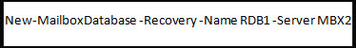](http://www.blog.edbtopst.org/wp-content/uploads/2014/12/4-create-RDB.jpg)

* Follow this command for creating Recovery database of RDB2 on the mailbox server MBX1 by using custom path for the database and log folder

[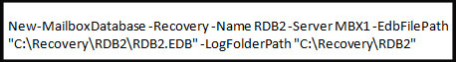](http://www.blog.edbtopst.org/wp-content/uploads/2014/12/5-create-RDB.jpg)

* Now to check if Recovery database is created or not, run this command which shows the complete configuration details of the Recovery database

[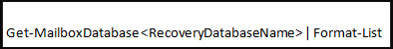](http://www.blog.edbtopst.org/wp-content/uploads/2014/12/6-check-RDB.jpg)

* The data is copied to the recovery database but before starting the mounting process of restored database you need to copy any log file from the failed database to RDB log folder which helps to played against the restored database.
* Now Mount the Recovery database and then need to dismount it using Dismount-database command

[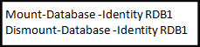](http://www.blog.edbtopst.org/wp-content/uploads/2014/12/7-mount-and-dismount-the-database.jpg)

* Once the recovery database is dismounted, move database along with log file within the RDB folder. This task is done in preparation for swapping the restored database along with dial tone database.
* Need to dismount the dial tone database using this following command.

[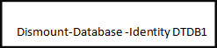](http://www.blog.edbtopst.org/wp-content/uploads/2014/12/8-dismount-the-database.jpg)

* Now transfer the database along with log files from the dial tone database folder into the recovery database folder.
* Mount the database after moving the database and log files into the dial tone database from the safe location including the recovered database.

[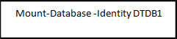](http://www.blog.edbtopst.org/wp-content/uploads/2014/12/9-mount-the-database.jpg)

* Run this following command which helps to mount the recovery database

[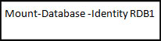](http://www.blog.edbtopst.org/wp-content/uploads/2014/12/10-mount-the-recovery-database.jpg)

* Run the **Get-Mailbox and New-MailboxRestoreRequest** command which helps to export data from recovery database and helps to import data into the recovery database. It will import the entire sent and received messages using the dial tone database into the production database.

[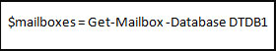](http://www.blog.edbtopst.org/wp-content/uploads/2014/12/11-get-mailbox.jpg)

[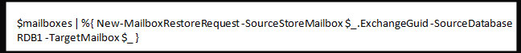](http://www.blog.edbtopst.org/wp-content/uploads/2014/12/12-new-mailboxrestorerequest1.jpg)

* Once the entire process is accomplished, you can remove and dismount the recovery database using this following command

[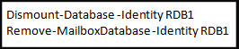](http://www.blog.edbtopst.org/wp-content/uploads/2014/12/13-remove-and-dismount-rdb.jpg)

Now need to verify that mailbox successfully moved:

* Access the mailbox through the MS Office Outlook Web App
* Access the mailbox through the Outlook

**Summery**

In this blog post we learn about dial tone portability feature in Exchange 2013 server when mailbox database doesn’t work successfully and any failure reason occur in the mailbox. At that time this function helps to create temporary mailbox for sending and receiving emails and continue working flow.

## [Discontinued Features in Exchange 2013 from Exchange 2010](https://charlesgate86.wordpress.com/2013/01/20/discontinued-features-in-exchange-2013-from-exchange-2010/)

***Exchange Roles***

* **HUB Transport Role :**The HUB Transport role is longer in Exchange 2013 and is replaced with the Transport Service on Mailbox Server and the Front End Transport Service on CAS server.
* **Unified Messaging Role :**The Unified Messaging is longer in Exchange 2013 and is replaced with the Microsoft Exchange Unified Service on both Mailbox and the CAS server.

***Management Features***

Exchange Management Console and Control Panel is now replaced with Exchange Administrative Console in Exchange 2013.

***Email Clients***

* Outlook 2003 – In Exchange 2013 the use of autodiscover is required and since Outlook 2003 doesn’t use Autodiscover hence it is not supported.
* RPC/TCP – It is now replaced with RPC/Http

***Transport***

* **Linked Connectors** – In Exchange 2010 we used these connectors to link send connector to receive connector which is no longer available in Exchange 2013.
* **Anti-spam Agent** – In Exchange 2010 you could manage Anti-spam agent when enabled via both Exchange Management Console as well as Exchange Management Shell however in Exchange 2013 when you enable you can only manage via Exchange Management Shell. (You cannot manage using EAC)
* **Connection Filtering** – In Exchange 2010 when you enable Anti-spam agent it was the only attachment filtering agent that wasn’t available but in Exchange 2013 when you enable Anti-spam agent both the attachment filtering agent as well as connection filtering agent is not available.

***Exchange Retired Tools***

* **Exchange Best Practice Analyzer** – used to analyze whether the configuration was in line with MS best practices
* **Mail Flow Troubleshooter** – used to troubleshoot common mail flow problems
* **Performance Tool** – used to collection performance report for the Exchange Server
* **Performance Troubleshooter** – used to locate and identify performance related issues that could impact Exchange Servers
* **Routing Log Viewer** – used to help viewing routing topology from a routing log file

***Messaging and Compliance***

* **Managed Folders** – In Exchange 2010 we used Managed folders for Messaging Retention Management which is now longer supported instead we have to use retention policies.
* **Port Managed Folder Wizard** – Since there is no support for Managed folders to create retention tags we now have to use New-RetentionPolicyTag using Exchange Management Shell.

***Outlook Web App features that Isn’t Supported in Exchange 2013***

* Shared Email Folders – Using this feature we could access other mailbox shared folders
* *Distribution List Moderation – Used to approve/reject email sent to a specific DL group*
* *Spell Check – OWA now relies on the web browser spell check services*
* *Reading Pane @bottom of the Page – There is no display of reading pane at bottom of the page using OWA*
* *Reply to Embedded Emails – Users won’t be able to reply emails that are sent as attachments.*

# **Re-create OWA virtual Directories in Exchange 2013**

Some times, you may be fed up with some sort of issues related to ‘owa’ , ‘ecp’ or any other virtual directories. Any repair or fine tuning mayn’t fix the issue and you will have to re-create the virtual directories from the scratch.

The difference in Exchange 2013 is that, it has got 2 websites hosted at IIS (Default Website and Exchange Back End).

I am presenting a simple scenario in which I describes**how to remove the owa virtual Directories and how to re-create the owa virtual directories in Exchange 2013** for both Default Website and Exchange Back End

**Remove the owa virtual Directories**

[PS] C:\Windows\system32>Remove-OwaVirtualDirectory “ServerName\owa (Default Web Site)”

Confirm Are you sure you want to perform this action? Outlook Web App virtual directory “ServerName\owa (Default Web Site)” is being removed. [Y] Yes  [A] Yes to All  [N] No  [L] No to All  [?] Help (default is “Y”): y

[PS] C:\Windows\system32>Remove-OwaVirtualDirectory “ServerName\owa (exchange back end)”

Confirm Are you sure you want to perform this action? Outlook Web App virtual directory “ServerName\owa (exchange back end)” is being removed. [Y] Yes  [A] Yes to All  [N] No  [L] No to All  [?] Help (default is “Y”): y

**Re-Create the owa virtual Directories**

[PS] C:\Windows\system32>New-OwaVirtualDirectory  -InternalUrl “[https://ServerName/owa](https://adhd.copx.local/owa)” -ExternalUrl “[https://mail](https://mail/). domain.com/owa”

[PS] C:\Windows\system32>New-OwaVirtualDirectory  -InternalUrl “[https://ServerName/owa](https://adhd.copx.local/owa)” -ExternalUrl “[https://mail](https://mail/). domain.com/owa” -WebSiteName “Exchange Back End”

Hope you are now free from the owa virtual directories remove/recreate troubles

Troubleshooting tools for transport services in Exchange. Some of those are developed by Microsoft such as

The remote connectivity analyzer. Web based tool to troubleshoot and test connectivity to our Exchange Server whether that be a client connectivity test such as an Outlook connectivity or an auto discover test. We can also perform SMTP tests verifying if e-mail messages are supposed to get into our organization.

A tool here called the MX Toolbox. This is a third party tool, to troubleshoot SMTP settings.

## [**Transport service on Mailbox servers**](javascript:void(0))

Every message that's sent or received in an Exchange 2013 organization must be categorized in the Transport service on a Mailbox server before it can be routed and delivered. After a message has been categorized, it's put in a delivery queue for delivery to the destination mailbox database, the destination database availability group (DAG), Active Directory site, or Active Directory forest, or to the destination domain outside the organization.

The Transport service on a Mailbox server consists of the following components and processes:

* **SMTP Receive**   When messages are received by the Transport service, message content inspection is performed, transport rules are applied, and anti-spam and anti-malware inspection is performed if they are enabled. The SMTP session has a series of events that work together in a specific order to validate the contents of a message before it's accepted. After a message has passed completely through SMTP Receive and isn't rejected by receive events, or by an anti-spam and anti-malware agent, it's put in the Submission queue.
* **Submission**   Submission is the process of putting messages into the Submission queue. The categorizer picks up one message at a time for categorization. Submission happens in three ways:
  + From SMTP Receive through a Receive connector.
  + Through the Pickup directory or the Replay directory. These directories exist on Mailbox servers and Edge Transport servers. Correctly formatted message files that are copied into the Pickup directory or the Replay directory are put directly into the Submission queue.
  + Through a transport agent.
* **Categorizer**   The categorizer picks up one message at a time from the Submission queue. The categorizer completes the following steps:
  + Recipient resolution, which includes top-level addressing, expansion, and bifurcation.
  + Routing resolution.
  + Content conversion.

Additionally, mail flow rules that are defined by the organization are applied. After messages have been categorized, they're put into a delivery queue that's based on the destination of the message. Messages are queued by the destination mailbox database, DAG, Active Directory site, Active Directory forest or external domain.

* **SMTP Send**   How messages are routed from the Transport service depends on the location of the message recipients relative to the Mailbox server where categorization occurred. The message could be routed to one of the following locations:
  + To the Mailbox Transport service on the same Mailbox server.
  + To the Mailbox Transport service on a different Mailbox server that's part of the same DAG.
  + To the Transport service on a Mailbox server in a different DAG, Active Directory site, or Active Directory forest.
  + For delivery to the Internet through a Send connector on the same Mailbox server, through the Transport service on a different Mailbox server, through the Front End Transport service on a Client Access server, or through the Transport service on an Edge Transport server in the perimeter network.

## [**Transport service on Edge Transport servers**](javascript:void(0))

The components of the Transport service on Edge Transport servers are identical to the components of the Transport service on Mailbox servers. However, what actually happens during each stage of processing on Edge Transport servers is different. The differences are described in the following list.

* **SMTP Receive**   When an Edge Transport server is subscribed to an internal Active Directory site, the default Receive connector is automatically configured to accept mail from internal Mailbox servers and from the Internet. When Internet messages arrive at the Edge Transport server, anti-spam agents filter connections and message contents, and help identify the sender and the recipient while the message is being accepted into the organization. The anti-spam agents are installed and enabled by default. Additional attachment filtering and connection filtering features are available, but built-in malware filtering is not. Also, transport rules are controlled by the Edge Rule agent. Compared to the Transport Rule agent on Mailbox servers, only a small subset of transport rule conditions are available on Edge Transport servers. But, there are unique transport rule actions related to SMTP connections that are available only on Edge Transport servers.
* **Submission**   On an Edge Transport server, messages typically enter the Submission queue through a Receive connector. However, the Pickup directory and the Replay directory are also available.
* **Categorizer**   On an Edge Transport server, categorization is a short process in which the message is put directly into a delivery queue for delivery to internal or external recipients.
* **SMTP Send**   When an Edge Transport server is subscribed to an internal Active Directory site, two Send connectors are automatically created and configured. One is responsible for sending outbound mail to Internet recipients; the other is responsible for sending inbound mail from the Internet to internal recipients. Inbound mail is sent to the Transport service on an available Mailbox server in the subscribed Active Directory site.

The following types of delivery groups exist in Exchange 2013:

* **Routable DAG**   This is a collection of Exchange 2013 Mailbox servers that belong to one DAG. The mailbox databases in the DAG are the routing destinations that are serviced by this delivery group. After the message arrives at the Transport service on a Mailbox server that belongs to the DAG, the Transport service routes the message to the Mailbox Transport service on the Mailbox server in the DAG that currently holds the active copy of the destination mailbox database. The Mailbox Transport service on the destination Mailbox server then delivers the message to the local mailbox database. Although a DAG may contain Mailbox servers located in different Active Directory sites, the DAG is the delivery group boundary.
* **Mailbox delivery group**   This is a collection of Exchange servers of the same version located in one Active Directory site. The Active Directory site is the delivery group boundary. The routing destinations and the delivery groups that service them are separated by the major release versions of Exchange in the Active Directory site. The mailbox databases located on Exchange 2010 Mailbox servers are serviced by the Exchange 2010 Hub Transport servers located in the Active Directory site. The mailbox databases located on Exchange 2007 Mailbox servers are serviced by the Exchange 2007 Hub Transport servers located in the Active Directory site. The mailbox databases located on Exchange 2013 Mailbox servers in Active Directory site that don't belong to a DAG are serviced by the Transport service on Exchange 2013 Mailbox servers in the Active Directory site. How the message is delivered to the mailbox database depends on version of Exchange:
  + **Exchange 2013**   After the message arrives at the destination Mailbox server in the destination Active Directory site, the Transport service uses SMTP to transfer the message to the Mailbox Transport service. The Mailbox Transport service then delivers the message to the local mailbox database using RPC.
  + **Exchange 2010 or Exchange 2007**   After the message arrives at a random Hub Transport server of the same version in the destination Active Directory site, the store driver on the Hub Transport server uses RPC to write the message to the mailbox database.
* **Connector source servers**   This is a mixed collection of Exchange 2010 or Exchange 2007 Hub Transport servers, or Exchange 2013 Mailbox servers that are scoped as the source server for a Send connector, a Delivery Agent connector or a Foreign connector. The connector is the routing destination that's serviced by this routing group. When a connector is scoped to a specific server, only that server is allowed to route messages to destination defined by the connector. This delivery group may contain Exchange 2010 or Exchange 2007 Hub Transport servers, or Exchange 2013 Mailbox servers located in different Active Directory sites.
* **AD site**   In some circumstances, an Active Directory site isn't the ultimate destination of a message, but the message must pass through an Exchange 2010 or Exchange 2007 Hub Transport server or Exchange 2013 Mailbox server in that Active Directory site. Those circumstances include:
  + When the Active Directory site is configured as a hub site. When the hub site exists on the least-cost routing path for message delivery, the messages queue and are processed by a transport server in the hub site before they're relayed to their ultimate destination.
  + When an Edge Transport server is subscribed to the Active Directory site. These subscribed Edge Transport servers aren't directly accessible from other Active Directory sites. Note that the Edge Transport server could be Exchange 2013, Exchange 2010 or Exchange 2007.

**Server list**   This is a collection of one or more Exchange 2010 or Exchange 2007 Hub Transport servers or Exchange 2013 Mailbox servers that are configured as distribution group expansion servers. The distribution group expansion server is the routing destination serviced by this delivery group.

|  |  |  |
| --- | --- | --- |
| **Exchange 2013 Mailbox server** | **Exchange 2010 or Exchange 2007 Hub Transport server** | **Edge Transport server in the perimeter network** |
| Mailbox database in a DAG | Routable DAG | Mailbox delivery group | n/a |
| Mailbox database not in a DAG | Mailbox delivery group | Mailbox delivery group | n/a |
| Connector | Connector source servers | Connector source servers | AD site |
| Distribution group expansion server | Server list | Server list | n/a |

In an Exchange organization, the mailbox server and the client access server work together in delivering and receiving messages from the Internet, from other Exchange Servers in the organization and also delivering and sending messages between recipients on the same server or between Exchange Servers.

**On the mailbox server**, we have **two services primarily** that **handle** the **delivery** of **email** messages. *As well, we have one service that handles the communication outside that has external components to deliver and receive email messages.*

two first services, the **Mailbox Transport Service**, as well as **the Mailbox Transport Delivery Service**, so *transport delivery and transport submission.*

**Transport delivery** will **handle inbound messages** that are being delivered in to my Exchange Server, so this service will **communicate directly with the local components on my database server**, and

**transport submission** will **pick up messages that are going to be sent out**. Now, if the messages are coming in through transport delivery or going out through transport submission, they will all be handled through the Microsoft Exchange Transport Service.

So think of this one as the overall transport service that handles the SMTP components. So the Microsoft Exchange Transport Service communicates with these two other services to handle the processing of messages. Within the Exchange Transport Service is where we have a lot of the transport agents that will run and a lot of the actions that will be performed against the messages in our organization as they flow in and out.

Client Access Server, I've got the same thing here on my Client Access Server, except I only have **one service, the Microsoft Exchange Front End Transport Service**. Even though I have three connectors by default that are created on the server, I only have one service, *and this service here handles essentially*

*the proxying of SMTP connections from the outside world to my internal organization*. *As well, it can handle outbound delivery of SMTP messages.*

Remember that the primary difference between this service and the services that run on the mailbox server is that the Client Access Server does not have any queues.

It does not store any email messages. Therefore, the only type of agents that run on the Client Access Server are the agents that will not have to work against the messages. They will work against the connections, so the transport services will run agents that will verify the IP address, whether or not that server is allowed to connect to the organization, but they won't filter for content or for information that is stored inside the body or the envelope of an email message.

**In Exchange Server 2013, the transport pipeline is the flow of messages** and actions that are performed on those messages as they are transported through the Exchange Server components.

There are transport agents that are performing actions on messages. These transport agents are custom pieces of software that are either developed by Microsoft or third parties to function against or with messages in your organization.

As messages are coming into your organization and the various Exchange services are handling those messages, transport agents may perform actions upon those messages.

Exchange transport services is probably one of those functionalities of Exchange where you have the least amount of graphical interface management.

A lot of what you can do and a lot of the power in managing transport can be done from the Exchange management shell.

get transport agent commandlet,

. Now, the transport agents here perform specific tasks. Malware agents verifies for malware. Other agents that will look at messages for the IP address of the connecting server that is trying to deliver a message. There are other agents that are handling specific tasks at different stages of the SMTP transport process, and that transport process is called the transport pipeline. So if I want to see my pipeline and where these agents run in my pipeline,

get transport pipeline commandlet.

default transport agents, available in Exchange 2013.

**Get-TransportPipeline** cmdlet shows information about the following types of transport agents in the transport pipeline:

* Agents based on the **SmtpReceiveAgent**, **RoutingAgent**, **DeliveryAgent**, and **StorageAgent** classes in the Transport service on Mailbox servers.
* Agents based on the **SmtpReceiveAgentClass** in the Mailbox Transport Delivery service on Mailbox servers.
* Agents based on the **SmtpReceiveAgentClass** in the Front End Transport service on Client Access servers.

The get transport service commandlet provides a lot of the same functionality as used to run in get transport server. So if I run get transport servers, I see the two servers that are running transport services, which is my two mailbox servers. So what I'm going to do here is I want to pull out just the information for one of those servers. And I'm going to do it for lawn-mdx1 and I'm going to pipe it to FL so I can see all of the information for that server. anti-spam agents. Perform your anti-spam tasks, such as content filtering, where it will analyze the internal message content to see if the message is going to be allowed or not, or if it's going to go into a junk mail folder. So that's one of the anti-spam agents. Here, they are disabled by default.

Other options here that I can look at for my transport service is I've got Maximum outbound connections. This is actually a setting that ensures that your server is not overloaded.

the pipeline is that flow of tasks or SMTP events that run in order to transport a message through our server. Now, if you have a specific problem with an event and you may have multiple events, and you may have multiple agents that run at those events.

You're not sure which one is really failing. You may want to enable pipeline tracing. Now, I'm using here the get transport service so you would use the set transport service to enable pipeline tracing. Then with pipeline tracing enabled, you can actually go out and look at the logs and see specifically here under the pipeline tracing path, this is where the logs would be.

Troubleshooting Exchange transport services where a specific agent, maybe a third party agent or another component that was installed on top of Exchange might have caused an issue and using this pipeline tracing really allowed you to identify the problem for that connection inside your transport delivery.

Another setting I want to show you here, I've got the queue log. So the queue log is interesting as well, because this will give you information about what's going on inside of your transport queues.

The transport queues is where the messages will be held as they're being processed before they're delivered. So here, if you have any issues in your logs, in your queues, this is where you would see the log information. Now, you have a specific maximum log file size, which is 10MB.

but this is a setting that is customizable again under the transport service setting.

Remember that that list of agents can be updated by installing additional agents as third party agents or agents that are made available by Microsoft as you update Exchange to later versions.

In order to better understand and better troubleshoot routing and transport in an Exchange organization, it's very important **to understand the mail flow of messages in between servers and within servers in an Exchange organization**.

There are two transport service functionalities that reside, one of them on the client access server and the other one on the mailbox server.

The **CAS** runs a service **called the Front End Transport Service**. Now, the Front End Transport Service has the **proxy ability to proxy email messages going out to the Internet and email messages coming in** from the Internet.

As well, on the **Exchange mailbox servers**, we've got the **Mailbox Transport Service**, which is **in charge of running all of the transport agents, categorization** and lots of tasks against the email messages, and we have the **Mailbox Transport Submission Service, as well as the Mailbox Transport Delivery Service**, which are two other services that interact directly with the mailbox databases.

* **Transport submission** will **pick up messages and will send them out to the Internet**, and **transport delivery** will **receive messages and deliver them to the mailbox database**.
  + Now, talking about the **mail flow**, when *an email message comes in from the Internet, that email message is first handled by the Front End Transport Service*. It has *various protocol agents that run within the server and that will verify if,* for example, the server is allowed to deliver mail to this organization.
* **CAS and the Front End Transport Service, they do not have a queue***. Therefore, they will not store any email messages.* If a server is allowed to connect, then the connection will be made to SMTP send portion of the Front End Transport Service, because it actually has to communicate inbound over SMTP to the SMTP receive portion of the mailbox server, essentially the transport service.
* And at this point, there will be **protocol agents that will be run and content filtering** will occur. At the same time, email messages will be stored in queues, categorization will happen, where the definition as to where the email message is supposed to go.
* SMTP send portion of the Transport Service will either connect outbound and connect to another server in Exchange organization or connect inbound and connect with another service on the same server. Now, note that that *means that any message that is delivered to another server in my organization that will be done over SMTP*, whether that server is in the same site, in another site or even in another organization.
* The inbound message going into my organization will then be **received by the SMTP receive portion** of the delivery service, and then the delivery service will communicate with the store driver that **will communicate directly with the mailbox database over RPC.**
* *There may be other agents that will run at this point or various rules that may run at this point, as well. Journaling may occur, for example, at this point, or you may have a transport rule that may act against the message.*
* If a message is going to be going out of our organization, it will be picked up from the mailbox database, specifically over RPC by the store driver, so the store driver is going to be notified of a new message coming out. The store driver will communicate with the SMTP send portion of the server, and if the SMTP send portion deems that the outbound message needs to go to another mailbox server, then that will communicate directly with another mailbox server in our site or in another Active Directory site. If it needs to be going out to another server out through mail routing, because that email message is destined to an outbound domain, for example, then it will be sent out to the SMTP receive, where the protocol agents will run. And note that you may have multiple protocol agents that will run at this point, and again, if the message needs to be delivered and sent out through the SMTP components of the transport service, because it needs to be categorized, then it will be routed this way and outbound through SMTP. If not, it can also be sent out of our organization through an external SMTP link that will be going out through our client access server. Now, note that this will only happen if you have the front end proxy enabled on the properties of your sent connector. So the mailbox server may send mail directly out to the Internet or to other mailbox servers, or it may send that mail out to a front end proxy server, only if the front end proxying checkbox is enabled in the properties of your sent connector.
* SMTP is really the protocol that is used for email delivery.
* RPC is used, but only when communicating with your mailbox databases locally.
* Various agents run at various portions of the mail flow process, and that is really defined based on what task is being run by that agent.

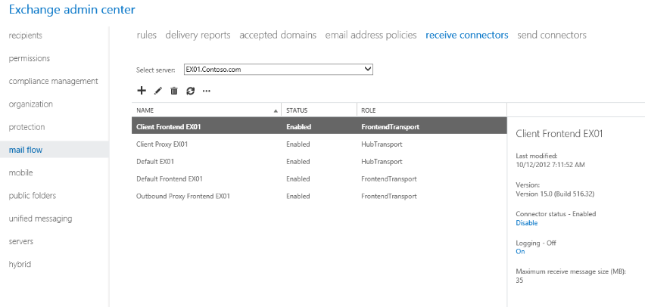

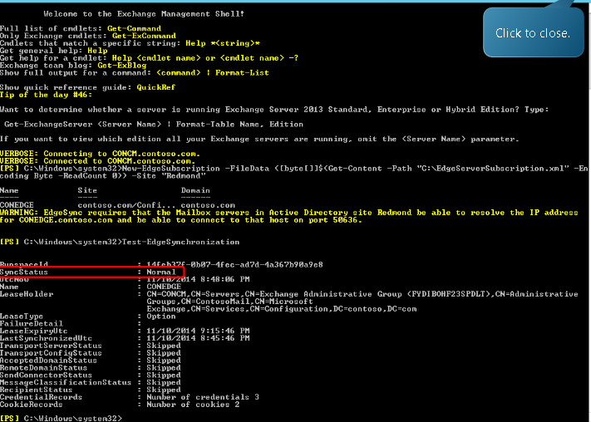

# Steps To recover Exchange server

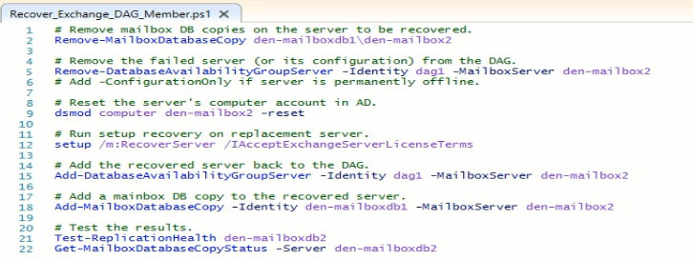

## [Understanding Exchange 2013 Mail Flow – ExchangeMs.In](https://charlesgate86.wordpress.com/2013/02/17/understanding-exchange-2013-mail-flow-exchangems-in/)

Posted on [February 17, 2013](https://charlesgate86.wordpress.com/2013/02/17/understanding-exchange-2013-mail-flow-exchangems-in/)by [charlesgate86](https://charlesgate86.wordpress.com/author/charlesgate86/)

With Exchange 2013 now there is no HUB Transport Role in other words it is divided and merged between Client Access & Mailbox Server Role. There are very good reasons and benefits too behind the architectural changes but at the same time Exchange Admins has to update its knowledge with this new mail flow concept.

While going through the TechNet documentation I found it to be interesting and enjoyed going through each topics on mail flow, thought of sharing the knowledge of basic mail flow how it works in an Exchange 2013 via this article.

**There are three main services with regards to mail flow in Exchange 2013 as mentioned below**:

* **Front End Transport Service** – This is runs on CAS Servers and acts as a stateless proxy server. It takes care of all the inbound and outbound external SMTP traffic for Exchange 2013 Organizaiton
* **Transport Service** – This service runs on Mailbox Servers and is virtually identical to the HUB Transport role in previous version. This service handles all the mail flow for the organization
* **Mailbox Transport Service** – This service runs on Mailbox Server and consist of two separate types: the Mailbox Transport Submission & Mailbox Delivery Transport Service. Since Transport service never communicate directly with mailbox database, the task is now handled by the Mailbox Transport Service.

**Below is the mail flow topology diagram of Exchange 2013 Organization @High Level**

[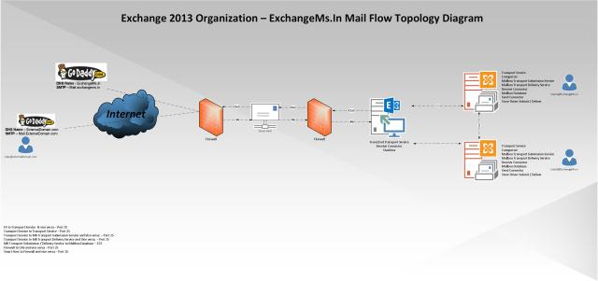](https://charlesgate86.wordpress.com/2013/02/17/understanding-exchange-2013-mail-flow-exchangems-in/mail-flow/)

**Scenario A – User@externaldomain.com sends email to UserA@exchangems.in**

1. Externaldomain.com SMTP Server queries internet domain exchangems.in for MX record and it sees pointed to the firewall listening on port 25
2. Since we have Smart Host setup in the DMZ network – the email is forwarded to the CAS server behind the DMZ network on port 25
3. Exchange 2013 CAS accepts the email using receive connector (by default it has anonymous option checked unlike its previous version Exchange 2007/10).
4. Exchange 2013 being stateless doesn’t hold the email which then proxies the SMTP request using Front End Transport Service to Transport service (Equivalent to MS Transport Service in legacy version – 2007/10) on the Mailbox Server role.
5. The Transport service on Mailbox Server then categorizes the email, performs message content inspection, etc. Since it doesn’t connects directly to Mailbox database it sends email to the Mailbox Transport Service over port 25
6. The Mailbox Transport Service is again divided into two service out of which Mailbox Transport Delivery service receives SMTP message from Transport service
7. The Mailbox Transport Delivery Service using Store Driver would connect to the mailbox database via RPC and deliver the e-mail to the mailbox database

**Note:** If the mailbox is in different mailbox server DB – The message received at Transport service would route the email to Transport Service on the destination Mailbox Server via SMTP on port 25 and the process continues from Transport service to Mailbox Transport Delivery service as mentioned above.

**Scenario B – UserB@exchangems.in sends email to User@externaldomain.com**

1. The Mailbox Transport Submission service using Store Driver would connect to the mailbox database via RPC and pull the e-mail
2. The Mailbox Transport submission would try to resolve the recipient to its mailbox database and look up for the delivery group
3. The Transport service on the mailbox server will receive the e-mail sent over SMTP from the Mailbox Transport Submission service using its default receive connector (on port 25)
4. The categorizer then picks up message from submission queue and since it is external domain (outbound to internet) the message is routed to the Front End transport service on CAS server using the send connector
5. Since we have configured the Smart Host on the Send Connector, the CAS Server Front End Service would route the email to Smart Host on port 25
6. Smart Host would then query on the internet for the MX record of externaldomain.comfor message delivery

**Note:**If the recipient was of the same organization(UserA@exchangems.in) but on the other mailbox server database, the transport service instead of forwarding message to CAS server frond end service it would directly connect to other mailbox server transport service on port 25 and the process continues as above mentioned in scenario A delivering message to database.

## [Deep Diving with Mail Routing Scenarios – Microsoft Exchange Server 2013](https://charlesgate86.wordpress.com/2013/10/17/deep-diving-with-mail-routing-scenarios-microsoft-exchange-server-2013/)

Posted on [October 17, 2013](https://charlesgate86.wordpress.com/2013/10/17/deep-diving-with-mail-routing-scenarios-microsoft-exchange-server-2013/)by [charlesgate86](https://charlesgate86.wordpress.com/author/charlesgate86/)

[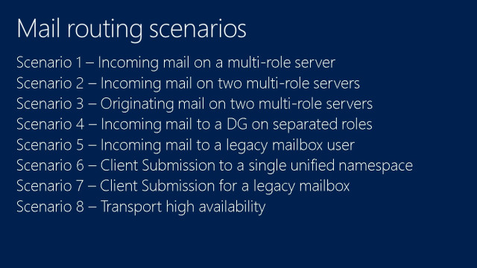](https://charlesgate86.wordpress.com/2013/10/17/deep-diving-with-mail-routing-scenarios-microsoft-exchange-server-2013/attachment/0/)

**Scenario 1 – Incoming mail on multi-role server**

Internet email is received on port 25 of Frontend transport service running on CAS server and then it proxies to the Transport component of mailbox server on port 2525, the transport component processes and routes it to the transport delivery on server(mailbox server) where the mailbox is active. Mailbox transport service then listens/receives email on port 475 and delivers email local active mailbox database.

[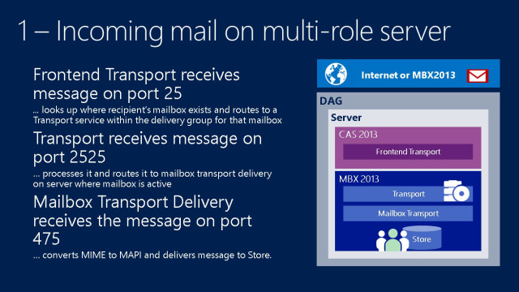](https://charlesgate86.wordpress.com/2013/10/17/deep-diving-with-mail-routing-scenarios-microsoft-exchange-server-2013/1-2/)

**Scenario 2 – Incoming mail on two multi-roles**

Internet email is received to Hardware Load balancer/NLB on port 25 and at the backend which ever CAS server is available it receives email, further it delivers to the one of the CAS server’s frontend transport service on port 25 in this case meaning as per the slide it choose server2. Here we notice the recipients are two sitting individual on both the server, since CAS is nothing but stateless and proxies the request. It then passes the email to Transport service component of the mailbox server(server2) before it sends to the transport service(of mailbox server) it checks the recipient type if it is mailbox or mail enabled, if mailbox then its versions, no. of recipients, distribution group, so on and accordingly it routes to the best available transport service of any mailbox server(in this case it delivered on the server1 CAS/MBX server, it could have equally delivered to its local server1 also but it doesn’t matter at all, what CAS server looks is for the Transport service of the mailbox server locally or remotely which ever it finds and **best** available).

Transport service on Server1 is going to categorize the message and checks there are two recipients, located on two different mailbox server active databases, bifurcate that into 2 copies and submits that to the mailbox transport service on each mailbox server that is local to the active database copy for message delivery.

Mailbox transport service then does the content conversion and delivers the copy to the local active mailbox database via RPC.

[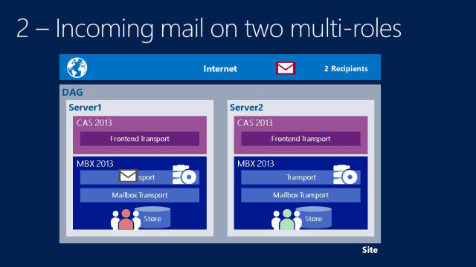](https://charlesgate86.wordpress.com/2013/10/17/deep-diving-with-mail-routing-scenarios-microsoft-exchange-server-2013/2-2/)

**Scenario 3 – Originating mail on two multi-roles**

Let us know consider the same scenario like second instead of mail coming on premise we will see email going out of premises originating from mailbox server roles.

Message originating from server1 send email to 3 recipients (one on the same server1, second on the server2 and third on the internet)

User when tries to send an email the mailbox submission service submits the message to the mailbox transport service via RPC, once the transport service on mailbox server1 receives the message it will then choose any of the  local or remote mailbox server transport service. In this scenario the message from Transport service of server1 connects to the transport service of server2, transport service on mailbox server2 categorizes and sees there are three recipients (2 internal and 1 external), bifurcates the recipients and delivers(one on server1 FE transport service, one on server1 mailbox transport service and local server mailbox transport service) the message accordingly. Then the mailbox transport service will  deliver the message to the local active mailbox database copy via RPC and to the FE service on Server1(assuming that we configured on send connector with proxy enabled server1 for outgoing) for external delivery.

**[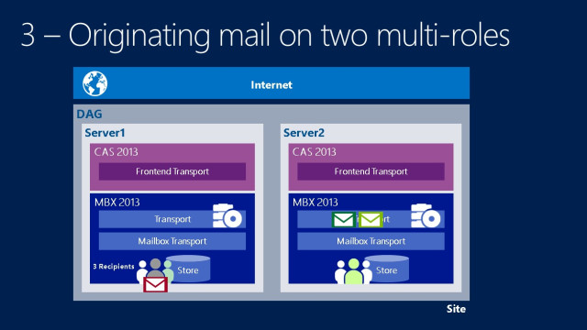](https://charlesgate86.wordpress.com/2013/10/17/deep-diving-with-mail-routing-scenarios-microsoft-exchange-server-2013/3-2/)**

**Scenario 4 – Incoming to DG on separated roles**

Here we have now four sites having 1 CAS and 1 MBX server as separate role on each sites.

So now internet users wants to target this four recipients sitting on each site mailbox server sending email.

Having MX pointed to one of the sites and behind the CAS if there is load balancer it will deliver to one of the available CAS servers to that particular site. In this scenario let us choose the third CAS right corner of the slide.

Frontend transport receives that message, it checks there are multiple recipients having mailbox enabled which needs to be delivered, so it choose the local site available transport service as its best for that particular CAS server and delivers it to the transport service on the mailbox server to that local site. The transport service is then going to bifurcate that message, will create 4 copies and delivers that to the mailbox transport component (one locally and 3 to the remotel site mailbox server transport service). Then finally the mailbox transport service on each mailbox server delivers to the local mailbox database copy via RPC.

[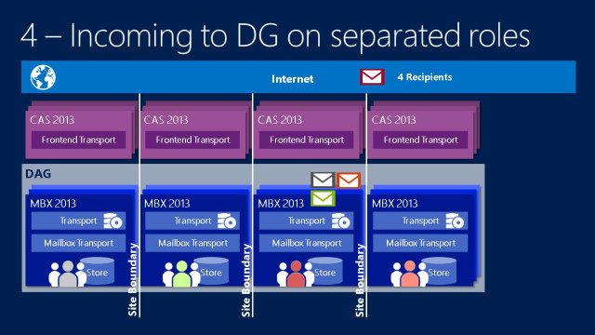](https://charlesgate86.wordpress.com/2013/10/17/deep-diving-with-mail-routing-scenarios-microsoft-exchange-server-2013/4-2/)

**Scenario 5 – Incoming mail to legacy mailbox**

So the fifth scenario is very much similar to the fourth but what change happens here is there comes the fifth site having Exchange 2010 HUB / MBX server.

Similarly as mentioned above the message coming from internets delivers the message to the CAS2013 on site 3 and the process is almost same until it delivers to the mailbox transport component of mailbox server site 3 and see what’s next further.

So now the transport service instead of creating 4 copies it will now create 5 copies, now the first four copies whose mailbox is on Exchange 2013 server it will deliver same as mentioned above in scenario 4 but for fifth copy its final delivery seems to be different from other than 4 copies (DAG delivery group) that is mailbox server delivery group (Exchange 2010 HUB server).

Since the mailbox transport doesn’t connects directly to the 2010 mailbox server hence it will route the message to the 2010 HUB server on the fifth site. Then the transport service of the Exchange 2010 HUB server will deliver the email to the final delivery that is the 2010 mailbox server.

[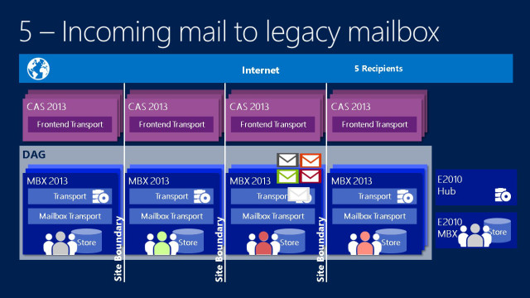](https://charlesgate86.wordpress.com/2013/10/17/deep-diving-with-mail-routing-scenarios-microsoft-exchange-server-2013/5-3/)

**6 – Client submission to single namespace**

In this scenario the user Diana has her mailbox to be located at site A mailbox server1. She is a roaming user and travels often now not it happens to be in another site B for some work and wants to send email to the internet. Let’s see how it goes.

When Diana accesses here mailbox she connects to the local site CAS server(Site B) and tries to send email, the CAS server checks the mailbox location where it belongs and since it finds the users in mailbox server1 in site A, the front end transport service of CAS on site B directly connects to the transport service on site A mailbox server1. Since it has already authenticated at site B CAS server the transport service on mailbox server1 simply sends out the email as front end proxy to its local site A CAS server(as configured in send connector) frontend transport service and from their it goes out to the internet from site A.

**[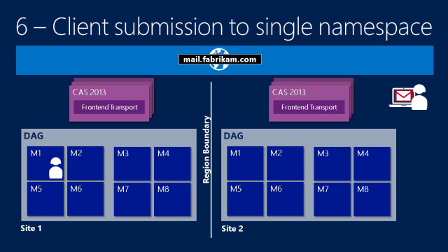](https://charlesgate86.wordpress.com/2013/10/17/deep-diving-with-mail-routing-scenarios-microsoft-exchange-server-2013/6-3/)**

**7 – Client submission for legacy mailbox**

Ok, now again similar scenario as sixth but instead of the mailbox version 2013 it is now Exchange 2010.

When Diana accesses her mailbox she would be connecting to site B 2013 CAS server, frontend transport service will authenticates and lookup for the location of the mailbox and its version. Since the CAS FE doesn’t directly talks to the mailbox server of Exchange 2010 MBX it will then connects to the Exchange 2013 mailbox server to its local site’s transport service.

The transport service on Exchange 2013 mailbox server on site B then categorizes the message and connects to the 2010 HUB server on site B based on the AD cost and then it will deliver the email to the mailbox on site A HUB to MBX 2010.

[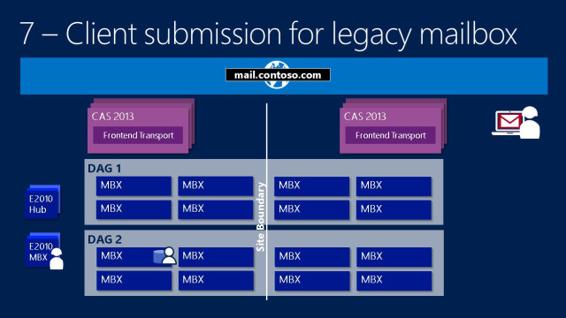](https://charlesgate86.wordpress.com/2013/10/17/deep-diving-with-mail-routing-scenarios-microsoft-exchange-server-2013/7-2/)

**8 – Transport high availability**

Exchange 2013 replaces shadow redundancy with new feature called Safety Net.

In Exchange 2010 when the message was sent from one HUB server to relay out to the next (first) hop the shadow queue was used to generate on the source (previous hop) server but in 2013 the shadow queue is created on the first hop right from the server where the mail is generated for guaranteed redundancy.

In 2013 now DAG is the transport boundary for high availability as compared to transport dumpster which was single point of failure meaning if the shadow queue on which mail.quewas generated and in the event of lossy failover and Transport dumpster on which it is configured(HUB) failed too then you could not recover email.

So now when DAG is a HA boundary any message coming into DAG group now the message is queued not only in local site shadow queue but also remote site meaning in the event of local site failure you can resubmit the email at the time of failover or manually mounting the databases. Resubmit is also possible by doing manually using PowerShell command.

So that HA queue is nothing but called safety net which was introduced in 2010 exchange online and revealed it later with Exchange 2013 as new feature.

Safety Net retains data for a set of period of time (Time bases, default is 2days), regardless of whether the message has been successfully replicated to all database copies or delivered to final destination.

FYI – Safety Net period should be at least equal or greater than your LAGGED database time to prevent data loss.

**1** – Mailbox01 receives message from a server outside the transport high availability boundary

**2** – Before acknowledging receipt, Mailbox01 initiates and succeeds in making the message redundant on Mailbox03’s shadow queues

**3a** – Transport on Mailbox01 processes message and attempts delivery via mailbox transport

**3b** – Mailbox transport on Mailbox01 in turn delivers the message to Store

**3c** – Transport on Mailbox01 queues a discard status for Mailbox03 (Shadow) and moves the message to Primary Safety Net.

**4** – Mailbox03 (Shadow) periodically polls for delivery status on the primary copy of the message

**5** – When Mailbox03 determines Mailbox01 has successfully processed the primary copy of the message, it moves the message to its Shadow Safety Net.

[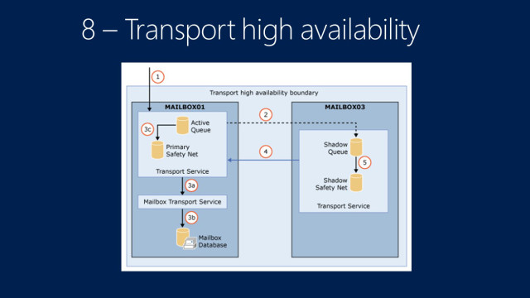](https://charlesgate86.wordpress.com/2013/10/17/deep-diving-with-mail-routing-scenarios-microsoft-exchange-server-2013/8-2/)

Inspired by Ross Smith’s IV presentation on Transport Architecture and thought of an interest to blog the same. You can check his presentation [@TechEd Session](http://channel9.msdn.com/Events/TechEd/NorthAmerica/2013/OUC-B319#fbid=Kc-39WO0Nbv)

# https://technet.microsoft.com/en-us/library/jj619301(v=exchg.150).aspx **Exchange 2013 virtualization**

# **Exchange Server 2013 Database Availability Groups**

<http://exchangeserverpro.com/exchange-server-2013-database-availability-groups/>

<http://exchangeserverpro.com/installing-an-exchange-server-2013-database-availability-group/>

# **Exchange admin center in Exchange 2013**

<https://technet.microsoft.com/en-us/library/jj150562(v=exchg.150).aspx>

# **Mail flow**

<https://technet.microsoft.com/en-us/library/aa996349(v=exchg.150).aspx>

# Active Directory 2003 Interview Question and Answer

<https://viralr.wordpress.com/active-directory-2003-interview-question-and-answer/>

# **The Preferred Architecture**

<https://blogs.technet.microsoft.com/exchange/2014/04/21/the-preferred-architecture/>

# **Database Availability Groups – Storage Swing Migrations**

<https://blogs.technet.microsoft.com/timmcmic/2014/02/25/database-availability-groups-storage-swing-migrations/>

### Exchange 2010 Cross Site DAG Disaster Recovery: Data Center/AD Site failure Part 1

<http://msexchangeguru.com/2012/10/25/exchange-2010-dag-dr/>

### Exchange 2013: Create IP Less DAG with SP1 – Another Step to Simplification

<http://msexchangeguru.com/2014/03/21/e2013sp1-ip-less-dag/>

### Exchange 2013 mailflow explained

<http://msexchangeguru.com/2012/08/09/e2013-mailflow/>

### Working with EAC or Exchange administration center in Exchange 2013 – Part1

<http://msexchangeguru.com/2013/01/16/eac-exchange-2013/>

# **Overview of Exchange Server Backup Methods**

https://technet.microsoft.com/en-us/library/aa996125(v=exchg.65).aspx